Tribute to the Fallen

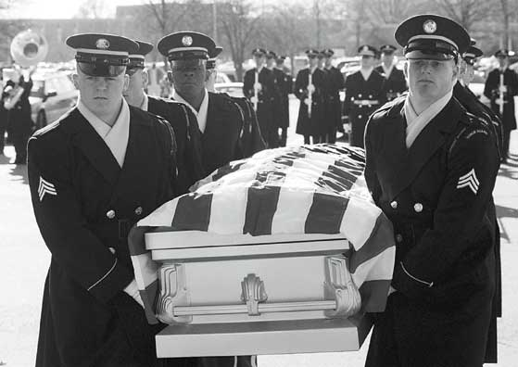

WHERE: The Clocktower
WHEN: Today, September 30
at 10:50AM

Come to the clocktower in between classes as we remember and honor all of those who have died in Iraq. A short ceremony will be followed by a reading of the names of the deceased U.S. soldiers.

