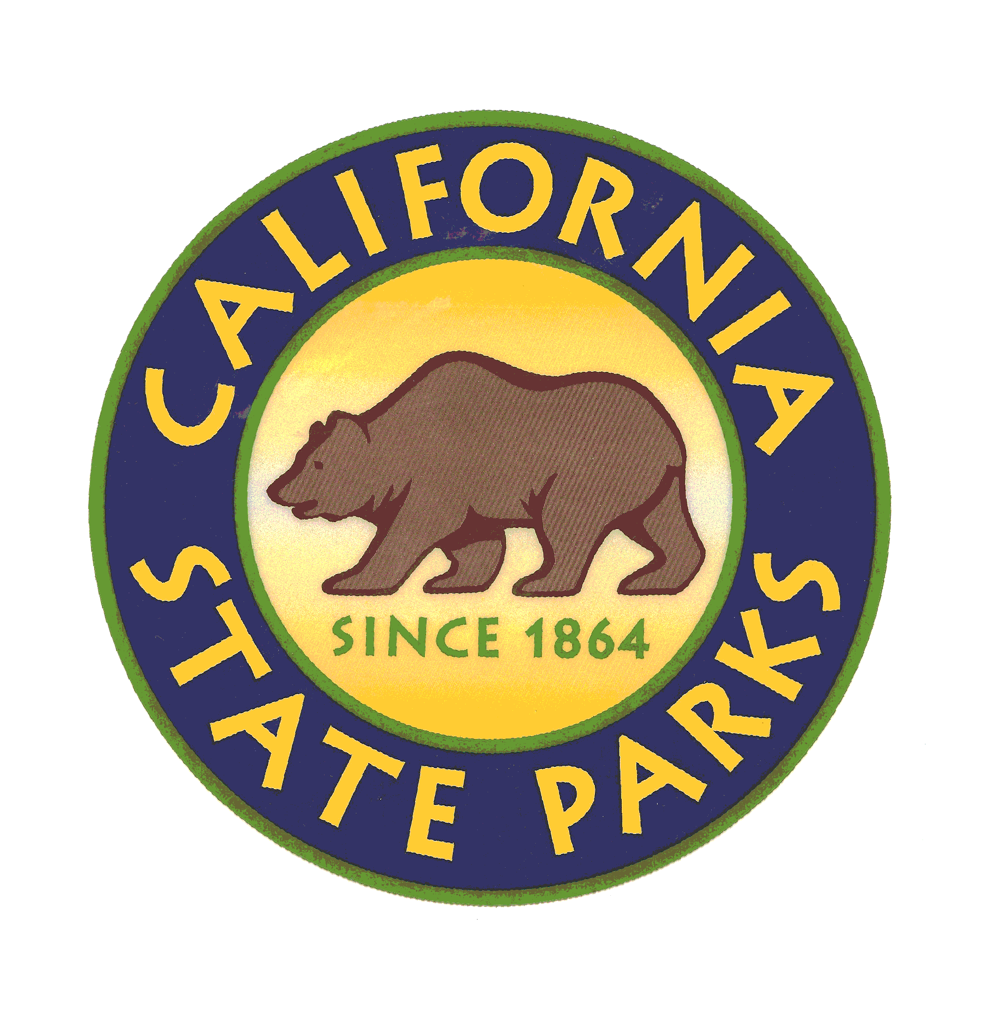
Lake Tahoe Sector
Office of Special Events

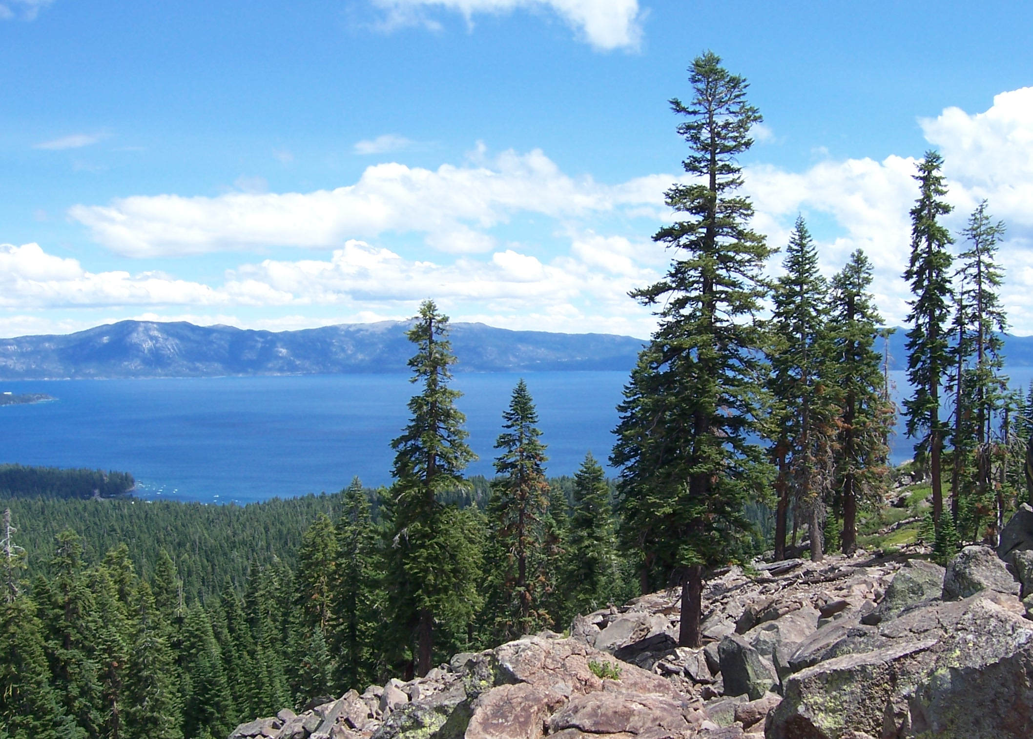

Special Event Permit Application

Where will the hundreds of California State Parks take you today?
www.parks.ca.gov
DEPARTMENT OF PARKS AND RECREATION
State of California

The Lake Tahoe Sector of California State Parks is composed of several parks that celebrate numerous special events. From historic and cultural events to community based functions, educational programs and athletic activities, the Lake Tahoe Sector is proud to host many of these events each year.

Lake Tahoe Sector State Parks may be utilized as a venue for private and community functions, which can range from small and intimate in scale to larger, festival-like events. Each park in the Lake Tahoe Sector offers a unique setting in which to host an event.

A State Park Monitor(s) will be assigned to your event. One responsibility of the Special Event Coordinator and/or State Park Monitor is to ask the public to respect your function. California State Parks will allow the public on the property through the entirety of your event while concurrently assuring that they do not interfere with any activities. As the permittee, you DO NOT have exclusive use of California State Parks.

The following pages include the Lake Tahoe Sector Special Event Permit Application and accompanying instructions developed to guide you through the permit process to successfully plan your event.

After you complete the Permit Application, please return it to the Special Events Office. A representative will contact you upon receipt of the application and thereafter will serve as your primary point of contact for the processing of your permit. Please be aware that in some cases you may have to contact federal, county or city agencies in addition to the state for your event.

On behalf of California State Parks, Lake Tahoe Sector, we thank you for contributing to the spirit and vitality of our community through the staging of your event. Best wishes for a successful event!

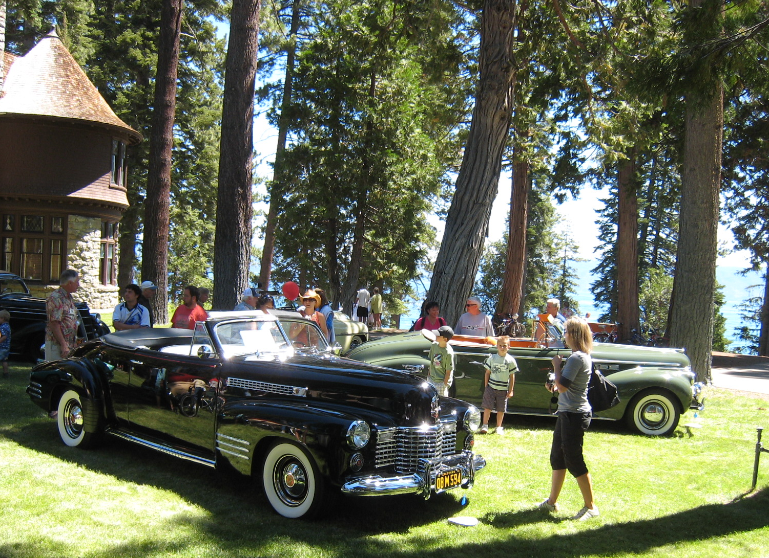

i

STATEMENT OF PURPOSE
Special Event Permits allow short-term use of State Park lands or facilities for such purposes as sporting events, historical pageants, cultural celebrations, fiestas, musical concerts, weddings, receptions, banquets, craft shows, or similar activity. Special events should be viewed as a way to promote California State Parks, encourage public uses consistent with State Park’s mission, create and improve community and other constituency ties, and encourage new users to Parks, thus increasing attendance and revenue. Special events held in the parks of the Lake Tahoe Sector are to be compatible and in keeping with the classification of the specific park and location, with special binding agreements, and with any General Plan guidelines. We expect the permit user to be aware of their obligation to protect the park's unique features. In general, any organized activity involving the use of, or having impact upon, public property, public facilities, parks, campgrounds, picnic areas or sidewalks in a manner that varies from its current land use, requires a permit.

It is our goal to assist event organizers in planning safe and successful events that create a minimal impact on the park and the community surrounding the event. We hope that you find these instructions helpful in completing your Special Event Permit Application.

AVAILABILITY
Events may be scheduled year round, but are generally limited to the months between May and October due to weather. From Memorial Day through Labor Day, public tours and other park events take precedence to special events – thus special events (including set-up and clean-up) will not be scheduled until after park events have ended for the day. No event shall go beyond 10 p.m. without written approval from the District Superintendent.

RESERVATIONS
Reservations may be made up to one (1) year in advance of the requested event date. A request date will be tentatively held for fourteen (14) calendar days to allow an applicant to assess conditions, fill out the Special Event Application and pay the Processing Fee. Once the processing fee is paid, State Parks will begin requesting additional materials in order to complete the permit. An event deposit is due
ii

within 30 days of paying the processing fee to hold the date. If the non-refundable processing fee is not received within fourteen (14) days, the event will be removed from the calendar. The requested date is not “reserved / secured” until all paperwork and a Special Event Permit is officially approved by the Sector Superintendent. If an event is cancelled, a cancellation fee may be collected where loss of availability of the facility has occurred.

PERMIT PROCESS
Permit applications must be received by the Special Event Office no later than sixty (60) days prior to the actual date of your event and may be submitted as early as one (1) year before your event. The permit application process begins when you submit to the Special Event Office a completed Special Event Permit Application and the Processing Fee. Keep in mind that acceptance of your application should in no way be construed as final approval or confirmation of your request. Upon receipt of your application you will be assigned a liaison to help guide you through the permit process. Copies of the application are forwarded and reviewed by all affected departments within the Lake Tahoe Sector and/or public agencies. Throughout the review process you will be notified if your event requires any additional information, fees, maps, permits, licenses or certificates. During our initial application screening process you will be allowed time to provide us with all pending documents (e.g., certificate of insurance, secondary permits, etc.). We must receive these items before issuing a Special Event Permit. Delays in providing these items often delay our ability to finish our review process and approve your application in a timely manner. Special Event Permits are issued after all necessary documents and fees have been received and the Permit has been approved and signed by the Sector Superintendent.

MISSION STATEMENT
The Mission of the California Department of Parks and Recreation is to provide for the health, inspiration, and education of the people of California by helping to preserve the state’s extraordinary biological diversity, protecting its most valued natural and cultural resources, and creating opportunities for high-quality outdoor recreation.

Special Event Application – Lake Tahoe Sector
Applicant and Host Organization Information

A written communication from the Chief of the Host Organization authorizing the applicant and/or professional event organizer to apply for this Special Event Permit on their behalf must be submitted with your permit application.

Host Organization: _________________________________________________________________

Chief Officer of Host Organization: _____________________________________________________

Applicant Name: ___________________________________________________________________

Address: Street _____________________________________________________________

City State________________ Zip________________

Telephone: Day______________________ Evening_____________________ Fax_____________________

Mobile Phone ______________________ E-Mail ______________________________________

Please list any professional event organizer, event service provider, or commercial fund-raiser hired by you that is authorized to work on your behalf to plan, produce and/or manage your event.

Applicant Name: ___________________________________________________________________

Address: Street _____________________________________________________________

City State________________ Zip________________

Telephone: Day______________________ Evening_____________________ Fax_____________________

Mobile Phone ______________________ E-Mail ______________________________________

Organization Status / Proceeds / Reporting
Yes No

Is the Host Organization a commercial entity?

Is the Host Organization a bona fide tax exempt, nonprofit entity? If yes, you must attach to this
application a copy of your IRS 501(C)(3) tax exemption letter providing proof and certifying your current tax exempt, nonprofit status.

Are patron admission, entry or participant fees required?
If yes, please provide amounts: ______________________________________________
How will fees be collected:__________________________________________________

Are vendor or other fees required?
If yes, please provide amounts: ______________________________________________
How will fees be collected? _________________________________________________

Estimated gross receipts for this event: $

Estimated net profits for this event: $
1
SUMMARY OF EVENT

Event Title: _____________________________________________________________

Description (This should be promotional in nature):
________________________________________________________________________
________________________________________________________________________ ________________________________________________________________________
________________________________________________________________________
________________________________________________________________________
Location: □Sugar Pine Point State Park □Burton Creek State Park
□DL Bliss State Park □Donner Memorial State Park
□Emerald Bay State Park □Tahoe State Recreation Area
□Ward Creek State Park □Washoe Meadows State Park

Event Category: □Athletic/Recreation □Concert/Performance □Dance
□Exhibits / Misc. □Theater Performance □Conference
□Festival/Celebration □Wedding/Reception □Craft Fair
□Parade/Procession/March □Outdoor Market □Other

Anticipated
Attendance: Total__________________ Per Day_____________________

Anticipated
Participants: Total__________________ Per Day_____________________

Admission _____________________________________________________________
Method: _____________________________________________________________

DATE / TIME (If additional dates/times, please submit a detailed schedule):

Setup: Date___________________ Time: From______________ To__________________

Event (Day 1): Date___________________ Time: Start______________ End__________________

Event (Day 2): Date___________________ Time: Start______________ End__________________

Breakdown: Date___________________ Time: From______________ To__________________

2
SITE PLAN / ROUTE MAP

To ensure appropriate review of your event, it is preferred that you submit blueprints or computer assisted drawings (CAD) of your event site plan. Some maps may also be provided to you from the Special Event Office. This is applicable for moving routes and fixed venues. If blueprint or CAD plans are not submitted, your site plan should be produced in a clear and legible manner. Site plans should be submitted in an 8 ½” x 11” or 8 ½” x 14” standard format.

Information on your site plan should include the location of booth set-up, food set-up, music, fence/barricade set-up, stage set-up, tent set-up, traffic flow restrictions, portable toilet placement, dumpster placement, entrance and exits, and any other information regarding the event should be detailed on the map. The site map will be analyzed for potential problems and hazards. Where appropriate, an on-site meeting will be scheduled with the Applicant to discuss specifics.

Should the scope of work proposed for the event include portable structures, prefabricated structures or site built structures such as bleachers, stages, elevated platforms, temporary pedestrian bridges, tents and membrane structures as well as other similar structures, additional information may be required for approval of the Permit. Based on your event site plan and components, the North Tahoe Fire Department or the California Department of Forestry may require an inspection of your venue before or during the event. For more information or assistance, please contact the Special Event Office at 530-525-5060.

Your event site plan / route map should be submitted in blueprint or CAD format or on a map from the Special Events Office and should include, but is not limited to:

An outline of the entire event venue including the names of all streets or areas that are part of the venue and the surrounding area. If the event involves a moving route of any kind, indicate the direction of travel and all street or lane closures.

The location of fencing, barriers and/or barricades. Indicate any removable fencing for emergency access.

The provision of emergency access lanes throughout the event venue.

Re-routing or restrictions to normal traffic flow.

The location of first aid facilities and ambulances.

The location of all stages, platforms, scaffolding, bleachers, grandstands, canopies, tents, portable toilets, booths, cooking areas, alcohol sales, trash containers, dumpsters, and other temporary structures.

A detail or close-up of the food booth and cooking area configuration, including booth identification of all vendors cooking with flammable gases or barbeque grills.

Generator locations and/or source of electricity.

Placement of vehicles and/or trailers, buses, security vehicles.

Exit locations for outdoor events that are fenced and/or locations within tents and tent structures.

Identification of all event components that meet accessibility standards.

Other related event components not listed above.

3

NARRITIVE

To supplement your site plan or route map, please provide a detailed narrative of your event including a description of activities within the event. This information will better assist us in understanding and reviewing the components and activities of your event. You may provide this information as an attachment if necessary.

4
SECURITY PLAN

As an event organizer, you are required to provide a safe and secure environment for your event. This is accomplished through sound preplanning by anticipating potential problems and concerns related to the event activities and surrounding environment. The size, type, time of day and location of your event, as well as the overall activities, are all areas that need to be analyzed in-depth and addressed through your security plan. In addition, any goods, merchandise, equipment or other items left overnight on State Park property, requires that security must be provided.

Most events require the services of a professional security company licensed by the State of California to help develop an appropriate security plan. A representative of this company, commonly known as a security consultant, will work closely with you to review and analyze your proposed event. The security consultant will determine points of concern and anticipate potential problems. The consultant will make preliminary recommendations to rectify the concerns and/or potential problems and recommend the number of licensed private security guards needed at your event. Once your security plan has been submitted, the Special Event staff and the Sector Superintendent will determine the minimum number of licensed private security guards and peace officers required to adequately staff your event. The Sector Superintendent of Lake Tahoe State Parks has final authority to determine your event security requirements. If the prescribed number of licensed private security guards are not provided or prove inadequate, the Sector Superintendent maintains the right to shut down any or all components of the event and/or provide additional police services that will be billed directly to the Host Organization.

Yes No

Have you hired a licensed professional security company to develop and manage your event’s
security plan? If yes, you are required to provide a copy of the security company’s valid Private Patrol Operator’s License issued by the State of California.

Security Organization: ______________________________________________________________

Address: Street _____________________________________________________________

City State________________ Zip________________

Telephone: Day______________________ Evening_____________________ Fax_____________________

Mobile Phone ______________________ E-Mail ______________________________________

Private Patrol Operator License # __________________________________________________

Please describe your security plan including crowd control, internal security or venue safety, or attach the plan to this application.
________________________________________________________________________________________________________________________________________________________________________________________________________________________________________________________________________________________________________________________________________________________________________________________________________________________________________________________________________________________________

5

MEDICAL PLAN

In an effort to help you determine the appropriate medical services for your event, an Emergency Medical Services Resources matrix has been developed. This matrix is intended to serve as a guideline for planning your event. The Sector Superintendent has final authority to determine your event medical services requirements. Please call 530-525-5060 for more information.

Yes No

Have you hired a licensed professional emergency medical services provider to develop and manage your event’s medical plan? If yes, please provide the following:

Medical Services Provider: ___________________________________________________________

Address: Street _____________________________________________________________

City State________________ Zip________________

Telephone: Day______________________ Evening_____________________ Fax_____________________

Mobile Phone ______________________ E-Mail ______________________________________

Please describe your medical plan including your communications plan, the number, certification levels (MD, RN, Paramedic, EMT) and types of resources that will be at your event and the manner in which they will be managed and deployed. Your plan should include hours of setup and breakdown of medical aid areas. You may attach the plan to this application if necessary.

6

ACCESSIBILITY PLAN

As an event organizer, you are required to comply with all City, County, State and Federal Disability Access Requirements applicable to your event.

All temporary venues, related structures, and outdoor sites for special events shall be accessible to persons with disabilities. If a portion of the area cannot be made accessible, an alternate area shall be provided with the same activities that are in the inaccessible areas. It cannot, however, be offered only to patrons with disabilities. Disability access may include parking, restrooms, clear paths of travel, transportation, signage, accessible vendors and booths. If all areas are not accessible, a map or program must be provided to attendees indicating the accessible rest rooms, parking, etc.

A checklist has been provided for planning your event and is included in this application. This checklist is intended to serve as a planning guideline and may not be inclusive of all City, County, State and Federal Disability Access Requirements. You may attach more detailed information if necessary.

Yes No

Will there be a Clear Path of Travel throughout your event venue? Please describe:

Will a minimum of 10% of portable restrooms at your event be accessible? Please describe:

Will all food, beverage and vending areas be accessible? Please describe:

Will all signage be provided in highly contrasting colors and placed so pedestrian flow will not obstruct its visibility? Please describe:

If an information center is provided at your event, will customer service representatives be available to assist disabled individuals? Please describe:

If all areas of your event venue cannot be made accessible, will maps or programs be made available to show the location of accessible restrooms, venues, first aid stations, etc? Please describe:

7

PARKING, TRAFFIC AND SHUTTLE PLAN

It is important that you plan for the safe arrival and departure of event attendees, participants, and vendors. As an event organizer, you should develop a parking, traffic and/or shuttle plan that is suitable for the environment in which your event will take place and remember that parking, traffic congestion, pedestrian traffic and environmental pollution are all factors of concern with events. Most park units in the Lake Tahoe Sector have limited parking and pedestrian access. You should include the use of carpools, public transportation and alternate modes of nonpolluting transportation whenever possible.

Traffic flow through most of the park units is 15 mph, in the historic zone of Sugar Pine Point it is 5mph. NO VEHICLES WILL BE ALLOWED TO PARK AT EVENT SITES DURING EVENT HOURS (exceptions may be granted with prior, written approval). A vehicle may be permitted at specified park units for overnight security personnel. No overnight camping by vendors is allowed. State Parks does not provide parking for Permittee, participants or vendors unless prior arrangements have been made. Failure to pay parking fees may result in citation. All vehicles shall be parked in designated parking spaces. Prior arrangements must be made with the Special Event Office for events that require drop off and pick-up of equipment and/or persons.

Please describe or provide an attachment of your parking, traffic, and/or shuttle plan:

SAFETY EQUIPMENT

If your event involves road closures, you will be required to get a City, County or State permit. Contact the Office of Special Events for more information. You will be required to obtain traffic safety equipment for the safe closure of your venue and ensure proper detour and parking information is posted. Depending upon the type of event, you may need barricades, traffic cones, directional signage, etc. It is your responsibility to obtain and properly place this equipment prior to the beginning of your event. A traffic planner from the Sheriff’s Department or Caltrans will send you a list of required safety equipment before your event.

Yes No

Will your event involve the use of traffic safety equipment?

Equipment Company: ___________________________________________________

Address: Street _____________________________________________________

City State ___________ Zip ___________

Telephone: Day ________________________ Mobile Phone _____________________________

Equipment Setup: Date: __________________ Time: ___________________
Equipment Pickup: Date: __________________ Time: ___________________
8

ENTERTAINMENT AND RELATED ACTIVITIES

As an event organizer, you must be certain that all event-related activities comply with the local and State laws applicable to noise abatement. Please be aware that loud and unreasonable noise (including music) is a violation of State law. A Peace Officer or State Park Monitor, who determines that noise from your event is offensive to others, may require you to lower or discontinue the noise. Also, Peace Officers may order musical entertainment to end if it incites a crowd or has the potential for unruly and risky behavior. California State Parks, Lake Tahoe Sector, does not allow slam dancing, crowd surfing, mosh pits or other similar activities.

Banners, pennants, flags, signs, streamers, inflatable displays and similar devices are also regulated by local and State ordinance. The number and location for these items must be included in your site map and must receive approval from the Special Events Office. In certain areas, and under certain conditions, these items are prohibited. Body piercing, tattooing, and chiropractic adjustments are not permitted at special events on public property. Due to liability issues and in keeping with the state’s purpose of the park unit, any inflatable bounce toys or similar attractions for kids will not be allowed on State Park property.

Massage, provided as part of a special event (e.g. at the finish area of a 5K run), may be performed without restriction by a licensed Holistic Health Practitioner. Massage provided by any other person, such as a chiropractor, sports trainer, licensed massage technician, or by a student from a massage school, must be done free of charge. Donations or tips may be accepted but not made mandatory. Students must be supervised by a licensed instructor. Inclusion of this type of activity at your event may have additional insurance requirements.

Yes No

Are there any musical entertainment features related to your event? Acoustic or amplified? If yes, complete the following information or provide an attachment listing all bands/performers, type of music, sound check and performance schedule.
Number of Stages: _______________________________________________________
Number of Performers / Bands: ______________________________________________

Will sound checks be conducted prior to the event? If yes:
Start time: Finish time:

Will sound amplifications be used? If yes:
Start time: Finish time:

Do you plan to have a patron dance component to either live or recorded music at your event? If yes, please describe:

Will inflatable objects, hot air balloons, or similar devices be used at your event? If yes, please describe:

Does your event include the use of fire, fireworks, rockets, lasers, or other pyrotechnics? If yes, please describe:

Will your event include the use of any signs, banners, decorations, or special lighting? If yes, please describe:

Will there be massage activities at your event? If yes, please describe:

Does your event plans include any casino games, bingo games, drawings or lottery opportunities? If yes, please describe:
9

ALCOHOL

If you plan to sell or furnish alcoholic beverages at your event, you will be required to obtain a permit from the State Department of Alcoholic Beverage Control (ABC). In many areas of city and State property, the consumption of alcohol is regulated. The Special Event Permit you receive from State Parks will allow the sale and consumption of alcohol inside a designated area only. For events of four (4) days or less, you will be required to submit to State Parks, Special Event Office, at least sixty (60) days in advance, a copy of the ABC license authorizing the sale of alcohol and compliance with all terms and conditions that ABC and the State may require. Short-term ABC licenses are only issued to IRS 501 (C) (3) non-profit organizations by the Department of Alcoholic Beverage Control. The Special Event Office will review your request and may place conditions on your permit depending on the size and scope of your event. A copy of the ABC license application must accompany the Special Event application for our review and approval. It must also be available at the event for inspection. If your event includes the use of alcohol on State property, Liquor Liability Coverage must be included on your Certificate of Insurance.

Once the Special Event Office receives a copy of the ABC license, a Notice of Hearing will be posted for thirty (30) days. Any person may file a written statement on said Special Event by writing the Lake Tahoe Sector or by presenting oral or written statements or arguments at a hearing date specified on the Notice of Hearing.

Alcohol sales and consumption is strictly limited to beer and wine. No hard alcohol or distilled spirits will be permitted. Beer and white wine are allowed on the porch of the Pine Lodge. Red wine is discouraged because it is costly to clean if it spills. Alcohol sales must end one (1) hour prior to the end of the event. Other restrictions may apply depending on the size and scope of your event. All park rules and regulations apply, as well as all penal and vehicle code laws.

Yes No

Does your event involve the use of alcoholic beverages? If yes, please check all that apply:

Free/Host Alcohol Alcohol Sales Host and Sale Alcohol

Beer Beer and Wine Beer, Wine and Distilled Spirits

Please describe your security plan to ensure the safe sale or distribution of alcohol at your event:

10
FOOD CONCESSIONS AND PREPARATION

Guidelines for food facilities may be obtained by local city and county offices. These guidelines should assist you in developing plans for food handling, preparation and distribution in the most responsible and legal manner. In addition, all State Park terms and conditions shall be adhered to.

You may be required to apply for a health permit if food or beverages are sold or given away during your special event. If applicable, be sure to include your organization’s 501(C) (3) identification number in order to receive a “nonprofit” classification number by the County Department of Health. Different permits, policies and procedures depend on your classification and the number of days of your event.

For events at Pine Lodge all food preparation must take place either in the rear of the building or to the north corner of the building. This is to minimize the grease and smell around the Pine Lodge Mansion. Bears are particularly attracted to cooking smells in and around the building. In order to discourage bear break-ins at the Pine Lodge barbequing is strictly limited to areas to the north end of the building or in the parking area by the Children’s House. All food and garbage must be removed from State Park property at the end of the event.

It is the applicant’s responsibility to communicate the set-up and breakdown times to their service providers. If service providers delay in the set-up or breakdown of your event, additional fees and fines may apply. Set-up for receptions may start no earlier than 4:30 PM. All events must end at 10:00 PM. Clean-up may occur from 10:00 PM but go no later than 12 Midnight. Please communicate this to your rental and catering companies and any additional service providers that you hire. As the permit holder you are ultimately responsible for the services you hire. If a rental company arrives late to pick up items, you are responsible for any monitor or facility fees that may be applied. Damage to State Park property will be taken out of your security deposit. Hire reputable and licensed companies to ensure quality service.

Yes No

Does your event include food concession and/or preparation areas? If yes, please describe how food will be served and/or prepared:

List Name of Vendors/Caterers to be used during event (You may attach a list if necessary). Please include contact information:

Do you intend to cook food in the event area? If yes, please specify method:

Gas Charcoal Electric Other (specify)

Will your venue require the use of a generator(s)? If yes, please explain:
11
CONCESSIONAIRES

If any items are to be sold during a special event, the event organizer must obtain a Business License from the City and/or county offices. In addition, if any type of food, candy, produce, fruit, or beverage is to be sold, the event organizer must contact the County Health Department no less than ten (10) days prior to the day of the event.

The interest of the Permittee created by this agreement may be subject to property taxation. Permittee agrees to pay any possessor interest tax or any other tax levied on such interest and to indemnify the State from any damage or loss arising, by reason of such tax or Revenue Taxation Code Section 107.6. Commercial events may be charged a set fee and/or a percentage (10-25%) of gross revenue made from the event, this percentage will be determined by the Special Event Office.

Under no condition is the sale of historic artifacts, fossils, relics or any object of historical significance permitted. In addition, unless approved specifically by the District Superintendent or authorized representative, the sale of any item or product that claims will treat, cure or provide a remedy for any physical condition will not be permitted.

Permittee or their designated representative (contact person) must remain on site during the entire event; this includes all pre and post event activities. In the event there is a violation of any rule or regulation of the Department of Parks and Recreation or any condition or term as stated herein, the District Superintendent or authorized representative may terminate without prior notice any special event activity whole or in part.

Yes No

Will items or services be sold at your event? If yes, please describe or attach a complete list of vendors and include a sample of the vendor pass that will be used:

Do any of these proposed items include artifacts? If yes, please explain:

Is the handiwork/merchandise sold during the shows or exhibitions created by the participants of
the show? If no, please explain:

Will items or services sold at your event present unique liability issues (e.g. body piercing, massage, animal rides, etc.)? If yes, please describe or attach a complete list of vendors:
12
MARKETING AND PUBLIC RELATIONS

Please ensure that you have conditional approval of your event before you begin to promote, market or advertise the event. Conditional approval may be made after your Special Event Permit Application has been submitted to the Special Event Office and initially screened by your State Park liaison and you have paid the processing and deposit fee and you have met with the entities that may be impacted by your event. Acceptance of your Special Event Permit Application by the State is not a guarantee of the date and location, or an automatic approval of your event. The event organizer must complete the application requirements entirely before the State will issue a Special Event Permit.

All event advertising, including press releases/conferences, banners, posters or any other medium in which the public is notified directly or indirectly that the event location, whole or in part, will be or is the identity of the park unit being used. For example, when identifying the event’s location as Sugar Pine, it should be described as “Ed Z’berg Sugar Pine Point State Park” and never as “Sugar Pine” alone. The official/approved logo for California State Parks may be substituted in lieu of park unit name on a case by case basis. The State reserves the right to review and approve all promotional material to protect the interest of the Department. Attach a sample copy of brochures, flyers, posters, etc.

If you plan to include radio, television or other product promotions within your venue, it is important that you limit the placement and/or distribution of signs, banners, flags, stickers and other promotional items. Items of particular concern are those that may damage public or private property, violate city or state sign code ordinances, or which may be difficult to clean or remove from the venue.

Yes No

Will this event be marketed, promoted, or advertised in any manner? If yes, please describe (Attach sample copy of brochures, flyers, posters, etc.):

Will there be live media coverage during the event? If yes, please describe:

Will media vehicles be parked within the event venue? If yes, please describe safety plan and location:

Do you plan to place and/or distribute signs, banners, flags, stickers and other promotional items? If yes, please describe:

Please list all organizations involved whether sponsors, recipients or promotional firms. Commercial sponsors must specifically be listed:
13
SANITATION AND RECYCLING

As an event organizer, you must properly dispose of waste and garbage throughout the term of your event. It is your responsibility for all garbage collection and removal at the conclusion of the event. The use of State Park receptacles is prohibited. Please explain the method of garbage collection and removal from State Park property. Immediately upon conclusion of the event, the area must be returned to a clean condition. If you, as an event organizer, set a standard of leaving the venue better than you found it, you can have a highly beneficial impact on the park units of the Lake Tahoe Sector.

The California Black Bear is part of the natural environment of Lake Tahoe. The entire Sierra Mountain range is its habit. In order to protect these animals, all park rules and regulations are enforced as well as Fish and Game violations. Food left out unattended or improperly disposed off may result in citation and confiscation per C.CR sec 4323(b):

No person shall store food, lawfully taken fish or wildlife, garbage or equipment with food residue, other than in the sealed compartment of a vehicle incapable of being opened by wild animals, in a food storage unit designated by the Department, in accordance with posted instructions, or, in areas where bears are a problem, suspended at least ten (10) feet above any material that would support the weight of a bear and separated horizontally by at least four (4) feet from any post, tree trunk or other object. This restriction does not apply to food that is actively being carried, consumed or prepared for human or pet consumption. This regulation applies 24 hours a day.

Violations of this section may result in a citation being issued and / or arrest and eviction from the park unit. If your event should require the delivery of additional trash receptacles, THEY MUST BE BEAR PROOF and must be removed from the premises at the Park’s discretion.

Should you fail to perform adequate cleanup or damage occurs to State property and facilities due to your event, you will be billed at full cost recovery rates plus overhead for cleanup and repair. In addition, such failure may result in denial of future approval for a Special Event Permit. The State does not provide for steam cleaning of facilities for special events, so please plan accordingly.

State law requires 50% of waste be recycled from special events. To reach this goal, everyone must participate. You can help by planning recycling strategies for the waste generated at your event. For more information or assistance, please contact your local Recycling Department.

Sanitation Company: ___________________________________________________

Address: Street _____________________________________________________

City State ___________ Zip ___________

Telephone: Day ________________________ Mobile Phone _____________________________

Equipment Setup: Date: Time:
Equipment Pickup: Date: Time:

Number of Trash Cans: Number of Recycling Containers:

Number, Type and Placement of Dumpsters:

Please describe your plan for cleanup and removal of recyclable goods, waste and garbage during and after your event:
14

PORTABLE RESTROOMS

Portable sanitary facilities are the responsibility of the event organizer for any event which draws greater than 250 persons. For each 250 persons anticipated, State guidelines recommend one (1) chemical or portable toilet for every 250 people, or portion thereof who attend your event. Ten percent (10%) of these facilities must be ADA accessible. This figure is based upon the maximum number of attendees at your event during peak time. Portable toilets shall be serviced a minimum of one (1) time per day by a licensed company. The Special Event Office may determine the total number of required restroom facilities on a case-by-case basis based on the size, scope, and duration of an event.

Yes No
□ □ Do you plan to provide portable restroom facilities at your event? If yes:

Total number of portable toilets:

Number of ADA accessible portable toilets:

If no, Please explain:

Sanitation Company: ___________________________________________________

Address: Street _____________________________________________________

City State ___________ Zip ___________

Telephone: Day ________________________ Mobile Phone _____________________________

Equipment Setup: Date: Time:
Equipment Pickup: Date: Time:

INSURANCE REQUIREMENTS

Before final permit approval, you will need general liability insurance for one million dollars ($1,000,000). If your event will include alcohol, liquor liability coverage must be included on your Certificate of Insurance. The State of California must be named as the certificate holder. Insurance coverage must be maintained for the duration of the event, including setup and breakdown dates.

Your proof of insurance must have this special endorsement on the contract:

*The State of California, its officers, agents, employees, and servants are included as additional insured, but only with respect to work performed for the State of California under this contract.

An original Certificate of Insurance or ACCORD form must be received by the Special Events Office, prior to the issuance of your Special Event Permit.

15

ADDITIONAL INFORMATION

APPLICANT
This must be the Chief Officer or a representative of the Host Organization who has been authorized by the Chief Officer to apply for the permit to plan the event. This person must be available to work closely with the State Park Special Event staff throughout the permitting process.

PROFESSIONAL EVENT ORGANIZER
The Chief Officer of the Host Organization may contract with a professional event organizer or service provider to represent the sponsoring organization. This person or entity may be authorized to plan the event and work with the State Park Special Event staff in implementing the plan. The professional event organizer must be available to work closely with the Special Event staff throughout the planning process. A letter from the Chief Officer of the Host Organization authorizing the applicant or professional event organizer to apply for a Special Event Permit on their behalf is required and must be attached to the submitted application.

COMMERCIAL ENTITY
All entities or organizations without IRS 501(C) 3 valid tax exemption status are considered to be commercial in nature.

TAX EXEMPT, NONPROFIT
This refers to an organization that has been recognized as tax exempt by the Internal Revenue Service at least six (6) months prior to your event date and is in good standing with the IRS. If you are a bona fide tax exempt nonprofit organization, a copy of the IRS 501(C) 3 tax exemption letter certifying your current tax exempt, nonprofit status is required.

CANCELLATION POLICY
On the day of a scheduled event, if the Permittee, his designees or representative do not show up, every attempt will be made to contact the Permittee to find out the status of the event. If the Permittee, his designees or representative are unavailable, after a period of 4 (four) hours with continued attempts to contact Permittee, the event will be assumed cancelled. Fees for monitor hours and cancellation fee will be charged.

The Sector Superintendent has the authority to charge a cancellation fee when loss of availability of the facility is due to a reservation cancellation. If an event is cancelled, a cancellation fee will be charged. Failure to pay cancellation fees may preclude future use of the facility. Any events cancelled 31 days or longer prior to the event will have all fees refunded minus any processing fee plus $250.00 or 25% of your facility fees (which ever is greater). Please allow up to six weeks for any refunds. Any event cancelled 30 days or less prior to the event may result in the forfeit of all paid fees and deposits.

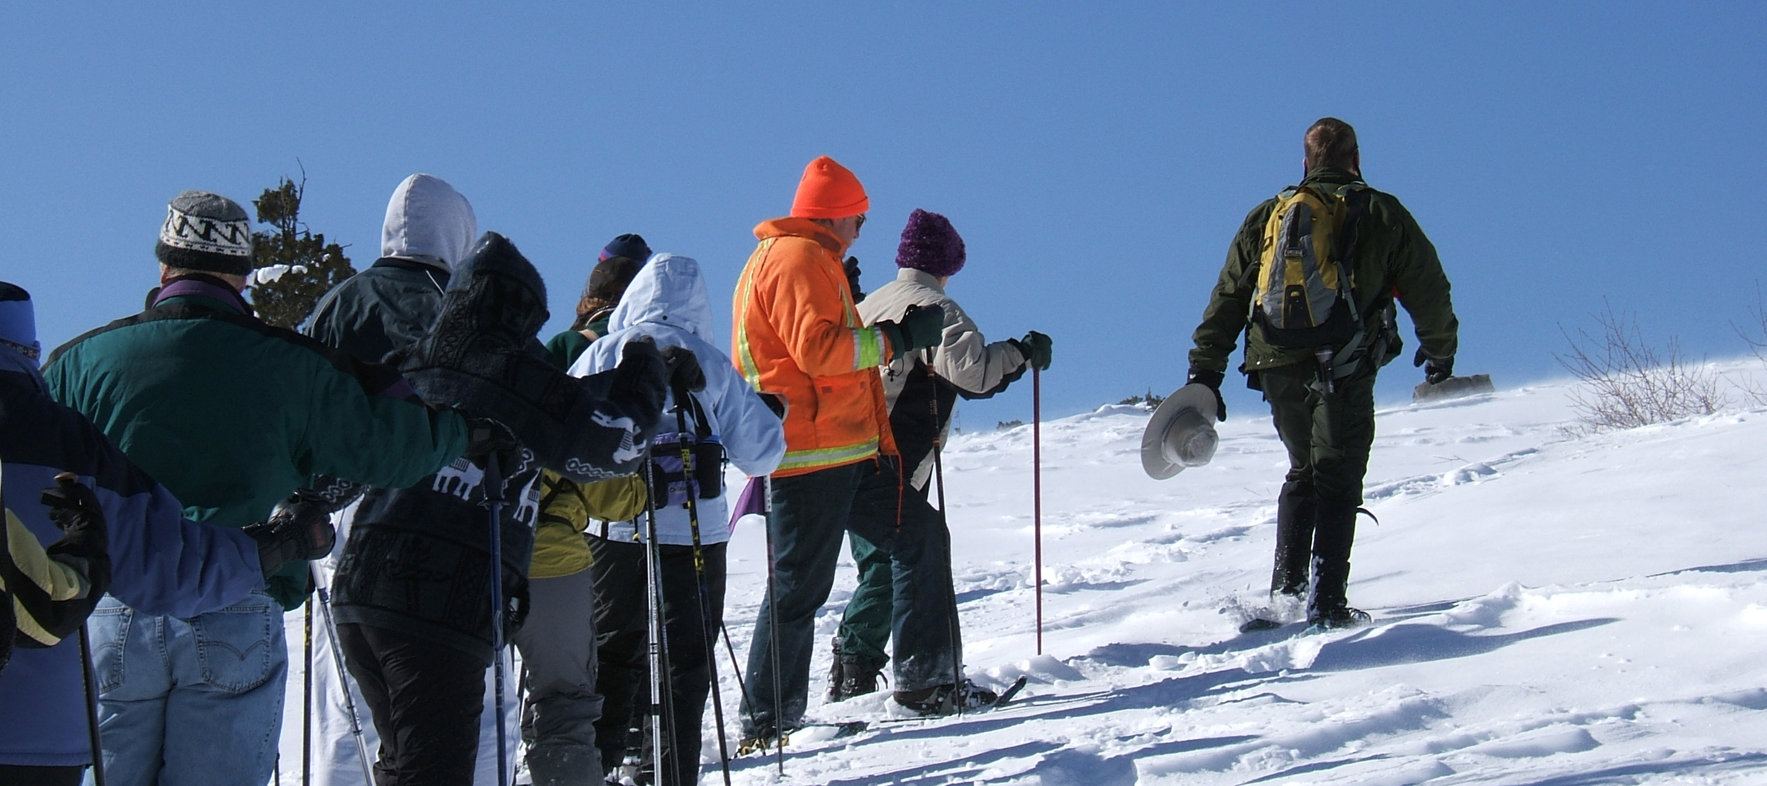

16
AFFIDAVIT OF APPLICANT

I certify that the information contained in the foregoing application is true and correct to the best of my knowledge and belief, that I have read, understand and agree to abide by the rules and regulations governing the proposed Special Event under the California Code of Regulations, and I understand that this application is made subject to the rules and regulations established by the State of California. Applicant agrees to comply with all other requirements of the City, County, State, Federal Government, and any other applicable entity which may pertain to the use of the event venue and the conduct of the event. I agree to abide by these rules and further certify that I, on behalf of the Host Organization, am also authorized to commit that organization and therefore agree to be financially responsible for any costs and fees that may be incurred by or on behalf of the event to the State of California.

Print Name of Applicant / Host Organization:

SIGNATURE:

TITLE: DATE:

Thank you for completing your Special Event Permit Application. Before you submit your application to the Special Events Office, please ensure that it is completed and all supplemental material has been included. For any questions please contact us at 530-525-5060 or by e-mail at LSSEC@parks.ca.gov. Submit completed and signed application, along any processing fees, to:

California State Parks
P.O. Box 266
Tahoma, CA 96142
ATTN: Special Events Office

17

