Building GTK+FB For ARM

The libraries that are listed below have to be installed in the following order
to build GTK+FB for ARM :
1.pkg-config-0.20
2.expat-1.95.8
3.zlib-1.2.3
4.freetype-2.1.10
5.fontconfig-2.3.2
6.glib-2.8.4
7.atk-1.10.3
8.cairo-1.0.2
9.Directfb-0.9.24
10.pango-.1.10.2
11.gtk+-2.8.3

Introduction:

1.pkg-config-0.20:

pkg-config is a helper tool used when compiling applications and libraries. It helps you insert the correct compiler options on the command line so an application can use gcc -o test test.c `pkg-config --libs --cflags glib-2.0` for instance, rather than hard-coding values on where to find glib (or other libraries).

It is language-agnostic, so it can be used for defining the location of documentation tools, for instance. pkg-config works on multiple platforms: Linux and other UNIX-like operating systems, Mac OS X and Windows. It does not require anything but a reasonably well working C compiler and a C library, but can use an installed glib if that is present.

2. expat-1.95.8:

The expat package contains a stream oriented C library for parsing XML.It will install a program called "xmlwf" which is a non-validating utility to check whether or not XML documents are well formed.

3.zlib-1.2.3:

zlib is designed to be a free, general-purpose, legally unencumbered -- that is, not covered by any patents -- lossless data-compression library for use on virtually any computer hardware and operating system.The zlib data format is itself portable across platforms.

Unlike the LZW compression method used in Unix compress(1) and in the GIF image format, the compression method currently used in zlib essentially never expands the data. (LZW can double or triple the file size in extreme cases.) zlib's memory footprint is also independent of the input data and can be reduced, if necessary, at some cost in compression.

4.freetype-2.1.10:

It's a software library that can be used by all kinds of applications to access and manage the content of font files in a very easy way. Most notably, it supports the following "features":
a. It provides a uniform interface to access font files. It supports both bitmap and scalable formats, including TrueType, OpenType, Type1, CID, CFF, Windows FON/FNT, X11 PCF.
b. It supports high-speed anti-aliased glyph bitmap generation with 256 levels of gray.
c. It is extremely modular, each font format being supported by a specific module. A build of the library can be tailored to support only the formats you need, thus reducing code size (a minimal anti-aliasing build of FreeType can be less than 30 Kb)

5.fontconfig-2.3.2:

Fontconfig is a library designed to provide system-wide font configuration, customization and application access.It contains two essential modules, the configuration module and the font matching module.

The Font configuration module builds an internal configuration from XML files.It consists of the FcConfig datatype, libexpat and FcConfigParse which walks over an XML tree and amends a configuration with data found within. From an external perspective, configuration of the library consists of generating a valid XML tree and feeding that to FcConfigParse.

The Font Matching module accepts font patterns and returns the nearest matching font. Applications needing to do their own matching can access the available fonts from the library and perform private matching. The intent is to permit applications to pick and choose appropriate functionality from the library instead of forcing them to choose between this library and a private configuration mechanism.

6.glib-2.8.4:

GLib is the low-level core library that forms the basis of GTK+ and GNOME. It provides data structure handling for C, portability wrappers, and interfaces for such runtime functionality as an event loop, threads, dynamic loading, and an object system.

It is an utility library for Gtk which provides list, tree, hash, thread and allocation handling, data types, type conversions, portability macros and functions, string, debugging , logging and profiling utilities, a lexical scanner.

7.atk-1.10.3:

The Atk library provides a set of interfaces for accessibility. By supporting the Atk interfaces, an application or toolkit can be used with such tools as screen readers, magnifiers, and alternative input devices.

8.cairo-1.0.2:

Cairo is a 2D graphics library with support for multiple output devices. Currently supported output targets include the X Window System, win32, and image buffers. Experimental backends include OpenGL (through glitz), Quartz, XCB, PostScript and PDF file output.

Cairo is designed to produce consistent output on all output media while taking advantage of display hardware acceleration when available (eg. through the X Render Extension).

The cairo API provides operations similar to the drawing operators of PostScript and PDF. Operations in cairo including stroking and filling cubic splines, transforming and compositing translucent images, and antialiased text rendering. All drawing operations can be transformed by any affine transformation (scale, rotation, shear, etc.) Cairo is implemented as a library written in the C programming language, but bindings are available for several different programming languages.

9.Directfb-0.9.24:

DirectFB is a thin library that provides hardware graphics acceleration, input device handling and abstraction, integrated windowing system with support for translucent windows and multiple display layers on top of the Linux Framebuffer Device.

It is a complete hardware abstraction layer with software fallbacks for every graphics operation that is not supported by the underlying hardware. DirectFB adds graphical power to embedded systems and sets a new standard for graphics under Linux.

DirectFB provides the following graphics operations:

* Rectangle filling/drawing
* Triangle filling/drawing
* Line drawing
* Flat shaded triangles
* Simple blitting
* Stretched blitting
* Textured triangles (perspective correct)
* Blending with an alphachannel (per pixel alpha)
* Blending with an alpha factor (alpha modulation)
* Nine source and destination blend functions
* Porter/Duff rules are supported
* Premultiplied alpha supported
* Colorized blitting (color modulation)
* Source color keying
* Destination color keying

Frame Buffer(FB):

The frame buffer device provides an abstraction for the graphics hardware. It
represents the frame buffer of some video hardware and allows application
software to access the graphics hardware through a well-defined interface, so

the software doesn't need to know anything about the low-level (hardware
register) stuff.

The device is accessed through special device nodes, usually located in the
/dev directory, i.e. /dev/fb*.

10.pango-.1.10.2:

Pango is a library for laying out and rendering of text, with an emphasis on internationalization. Pango can be used anywhere that text layout is needed, though most of the work on Pango so far has been done in the context of the GTK+ widget toolkit.

Pango forms the core of text and font handling for GTK+-2.x.Pango is designed to be modular; the core Pango layout engine can be used with different font backends. There are two basic backends, with multiple options for rendering with each:

a.Client side fonts using the FreeType and fontconfig libraries. Rendering can be with with Cairo or Xft libraries, or directly to an in-memory buffer with no additional libraries.
b.Native fonts on Microsoft Windows. (Optionally using Uniscribe for complex-text handling). Rendering can be done via Cairo.

11.gtk+-2.8.3:

GTK+ is a multi-platform toolkit for creating graphical user interfaces. Offering a complete set of widgets, GTK+ is suitable for projects ranging from small one-off projects to complete application suites.GTK+ is based on three libraries developed by the GTK+ team:
a.Glib, b.Pango, c.ATK

GTK+ has been designed from the ground up to support a range of languages, not only C/C++. Using GTK+ from languages such as
Perl and Python (especially in combination with the Glade GUI builder) provides an effective method of rapid application development.

Installation Steps:
The steps that are to be followed inorder to install the above listed libraries are:
Before starting installation of packages,Do “source ingenient-env” to setup the default project directories, path, and toolchain for the particular BSP

1.pkg-config-0.20:

a. Run “./configure”
b. Do a “make”
c.Do a “make install”
d. Export the “pkg-config” path as shown below
( for example:
export PKG_CONFIG_PATH=/home/durai/ingenient-bsp/toolchain/gtk/lib/pkgconfig )

2. expat-1.95.8:
a. Dowload the package “expat-1.95.8” in the gunzip format
using the link:
http://prdownloads.sourceforge.net/expat/expat-1.95.8.tar.gz

b.untar the package downloaded as given below:

tar –zxvf expat-1.95.8.tar.gz

c. Create a file named “mk” in the uncompressed directory and export all the variables required for cross-compilation(as shown in the step:d)

d. The content of “mk” script file for the package is given below:
#!/bin/sh
export GCC=arm-linux-gcc
export CC=arm-linux-gcc
export CXX=arm-linux-gcc
export LD=arm-linux-ld
export NM=arm-linux-nm
export RANLIB=arm-linux-ranlib
export AS=arm-linux-as
export AR=arm-linux-ar

./configure --cache-file=arm_cache.conf --host=arm-linux \
--bindir=$ROOTFS/fs/bin --sbindir=$ROOTFS/fs/sbin \
--libexecdir=$TOOLCHAIN/gtk/lib \
--datadir=$TOOLCHAIN/gtk --libdir=$TOOLCHAIN/gtk/lib \
--includedir=$TOOLCHAIN/gtk/include \
--infodir=$TOOLCHAIN/gtk/docs \
--mandir=$TOOLCHAIN/gtk/docs --enable-static=yes \
--enable-shared=no

e. Run “./mk”
f. Do a “make”
g. Do a “make install”

3.zlib-1.2.3:
a.Dowload the package “zlib-1.2.3” in the gunzip format
using the link:
http://www.zlib.net/zlib-1.2.3.tar.gz

b.untar the package downloaded as given below:
tar –zxvf zlib-1.2.3.tar.gz
c. Create a file named “mk” in the uncompressed directory and export all the variables required for cross-compilation(as shown in the step:d)
d.The content of “mk” script file for the package is given below:

#!/bin/sh
export GCC=arm-linux-gcc
export CC=arm-linux-gcc
export CXX=arm-linux-gcc
export LD=arm-linux-ld
export NM=arm-linux-nm
export RANLIB=arm-linux-ranlib
export AS=arm-linux-as
export AR=arm-linux-ar

./configure --libdir=$TOOLCHAIN/gtk/lib \
--includedir=$TOOLCHAIN/gtk/include \
--prefix=$TOOLCHAIN/gtk/include

e.Run “./mk”
f.After doing “./mk”, goto “zlib-1.2.3/Makefile” ,
change the line
“AR= arm-linux-ar” to “AR=arm-linux-ar rcs”.
g.Do a “make”
h.Do a “make install”

4. freetype-2.1.10:

a. Dowload the package “freetype-2.1.10” in the gunzip format
using the link:

http://download.savannah.nongnu.org/releases/freetype/freetype-2.1.10.tar.gz

b. untar the package downloaded as given below:

tar –zxvf freetype-2.1.10.tar.gz

c. Create a file named “mk” in the uncompressed directory and export all the variables required for cross-compilation(as shown in the step:d)

d. The content of “mk” script file for the package is given below:

#!/bin/sh
export GCC=arm-linux-gcc
export CC=arm-linux-gcc
export CXX=arm-linux-gcc
export LD=arm-linux-ld
export NM=arm-linux-nm
export RANLIB=arm-linux-ranlib
export AS=arm-linux-as
export AR=arm-linux-ar

./configure --cache-file=arm_cache.conf --host=arm-linux \
--bindir=$ROOTFS/fs/bin --sbindir=$ROOTFS/fs/sbin \
--libexecdir=$TOOLCHAIN/gtk/lib \
--datadir=$TOOLCHAIN/gtk --libdir=$TOOLCHAIN/gtk/lib \
--includedir=$TOOLCHAIN/gtk/include \
--infodir=$TOOLCHAIN/gtk/docs \
--mandir=$TOOLCHAIN/gtk/docs \
--prefix=$TOOLCHAIN/gtk --enable-static=yes \
--enable-shared=no

e. Run “./mk”
f. Do a “make”
g. Do a “make install”

5.fontconfig-2.3.2:

a. Dowload the package “fontconfig-2.3.2” in the gunzip format
using the link:

http://fontconfig.org/release/fontconfig-2.3.2.tar.gz

b.untar the package downloaded as given below:

tar –zxvf fontconfig-2.3.2.tar.gz

c. Create a file named “mk” in the uncompressed directory and export all the variables required for cross-compilation(as shown in the step:d)

d. The content of “mk” script file for the package is given below:

#!/bin/sh
export GCC=arm-linux-gcc
export CC=arm-linux-gcc
export CXX=arm-linux-gcc
export LD=arm-linux-ld
export NM=arm-linux-nm
export RANLIB=arm-linux-ranlib
export AS=arm-linux-as
export AR=arm-linux-ar

./configure --cache-file=arm_cache.conf --host=arm-linux \
--bindir=$ROOTFS/fs/bin --sbindir=$ROOTFS/fs/sbin \
--libexecdir=$TOOLCHAIN/gtk/lib \
--datadir=$TOOLCHAIN/gtk --libdir=$TOOLCHAIN/gtk/lib \
--includedir=$TOOLCHAIN/gtk/include \
--infodir=$TOOLCHAIN/gtk/docs \
--mandir=$TOOLCHAIN/gtk/docs \
--prefix=$TOOLCHAIN/gtk \
--with-freetype-config=$ROOTFS/fs/bin/freetype-config \
--with-expat-includes=../expat-1.95.8/lib \
--with-expat-libs=$TOOLCHAIN/gtk/lib \
--with-expat=$TOOLCHAIN/gtk \
--enable-static=yes --enable-shared=no

e. Run “./mk”
f. Do a “make”
g. Do a “make install”

6. glib-2.8.4:

a. Dowload the package “glib-2.8.4” in the gunzip format
using the link:

ftp://ftp.gtk.org/pub/gtk/v2.8/glib-2.8.4.tar.gz

b.untar the package downloaded as given below:
tar –zxvf glib-2.8.4.tar.gz
c. Create a file named “mk” in the uncompressed directory and export all the variables required for cross-compilation(as shown in the step:d)
d. The content of “mk” script file for the package is given below:

#!/bin/sh
export GCC=arm-linux-gcc
export CC=arm-linux-gcc
export CXX=arm-linux-gcc
export LD=arm-linux-ld
export NM=arm-linux-nm
export RANLIB=arm-linux-ranlib
export AS=arm-linux-as
export AR=arm-linux-ar

./configure --cache-file=arm_cache.conf --host=arm-linux \
--bindir=$ROOTFS/fs/bin --sbindir=$ROOTFS/fs/sbin \
--libexecdir=$TOOLCHAIN/gtk/lib --datadir=$TOOLCHAIN/gtk \
--libdir=$TOOLCHAIN/gtk/lib \
--includedir=$TOOLCHAIN/gtk/include \
--infodir=$TOOLCHAIN/gtk/docs \
--mandir=$TOOLCHAIN/gtk/docs --prefix=$TOOLCHAIN/gtk \
--enable-static=yes --enable-shared=no --disable-dynamic

e.create a file with the name“arm_cache.conf” and add the following lines into the file:
glib_cv_stack_grows=no
glib_cv_uscore=yes
ac_cv_func_posix_getpwuid_r=yes
f.Run “./mk”
g. Do a “make”
h. Do a “make install

7. atk-1.10.3:

a. Dowload the package “atk-1.10.3” in the gunzip format
using the link:

ftp://ftp.gtk.org/pub/gtk/v2.8/atk-1.10.3.tar.gz

b. untar the package downloaded as given below:
tar –zxvf atk-1.10.3.tar.gz

c. Create a file named “mk” in the uncompressed directory and export all the variables required for cross-compilation(as shown in the step:d)

d. The content of “mk” script file for the package is given below:

#!/bin/sh
export GCC=arm-linux-gcc
export CC=arm-linux-gcc
export CXX=arm-linux-gcc
export LD=arm-linux-ld
export NM=arm-linux-nm
export RANLIB=arm-linux-ranlib
export AS=arm-linux-as
export AR=arm-linux-ar

./configure --cache-file=arm_cache.conf --host=arm-linux \
--bindir=$ROOTFS/fs/bin --sbindir=$ROOTFS/fs/sbin \
--libexecdir=$TOOLCHAIN/gtk/lib \
--datadir=$TOOLCHAIN/gtk --libdir=$TOOLCHAIN/gtk/lib \ --includedir=$TOOLCHAIN/gtk/include \
--infodir=$TOOLCHAIN/gtk/docs \
--mandir=$TOOLCHAIN/gtk/docs \
--prefix=$TOOLCHAIN/gtk \
--enable-static=yes --enable-shared=no --disable-dynamic

e. Run “./mk”
f. Do a “make”
g. Do a “make install

8. cairo-1.0.2:

a. Download the cairo-dfb patch using the link given below:

http://www.directfb.org/cgi-bin/viewcvs.cgi/cairodfb/cairodfb.tar.gz?tarball=1

b. Untar the patch downloaded.
c. Dowload the package “cairo-1.0.2” in the gunzip format
using the link:

http://cairographics.org/releases/cairo-1.0.2.tar.gz

and save it into uncompressed patch directory “cairodfb”.

d. Run “./mkpatch get_cairo” in “cairodfb” directory.
e. Goto “cairodfb/cairo-1.0.2” directory
f. Create a file named “mk” and export all the variables required for cross-compilation(as shown in the step:d)
g. The content of “mk” script file for the package is given below:

#!/bin/sh
export GCC=arm-linux-gcc
export CC=arm-linux-gcc
export CXX=arm-linux-gcc
export LD=arm-linux-ld
export NM=arm-linux-nm
export RANLIB=arm-linux-ranlib
export AS=arm-linux-as
export AR=arm-linux-ar

./autogen.sh --host=arm-linux --bindir=$ROOTFS/fs/bin \
--sbindir=$ROOTFS/fs/sbin \
--libexecdir=$TOOLCHAIN/gtk/lib \
-- datadir=$TOOLCHAIN/gtk \
--libdir=$TOOLCHAIN/gtk/lib \
--includedir=$TOOLCHAIN/gtk/include \
--infodir=$TOOLCHAIN/gtk/docs \
--mandir=$TOOLCHAIN/gtk/docs --disable-png \
--prefix=$TOOLCHAIN/gtk --enable-static=yes \
--enable-shared=no --disable-dynamic

./configure --host=arm-linux --bindir=$ROOTFS/fs/bin \
--sbindir=$ROOTFS/fs/sbin --libexecdir=$TOOLCHAIN/gtk/lib \
--datadir=$TOOLCHAIN/gtk --libdir=$TOOLCHAIN/gtk/lib \
--includedir=$TOOLCHAIN/gtk/include \
--infodir=$TOOLCHAIN/gtk/docs \
--mandir=$TOOLCHAIN/gtk/docs --disable-png \
--prefix=$TOOLCHAIN/gtk --enable-static=yes \
--enable-shared=no --disable-dynamic

h. Run the command
“chmod ugo+x autogen_sh”
i. Run “./mk”
j.Do a “make”
k. Do a “make install

NOTE:
After installing cairo-1.0.2,”pkgconfig/cairo.pc” will be generated in the specified path as shown below
(for example in the path
“/home/durai/ingenientbsp/toolchain/gtk/lib/pkgconfig/cairo.pc”).

Edit “cairo.pc” file as shown below:

change the line
from
“Libs: -L${libdir} –lcairo”
to
“-L${libdir} –lcairo –lfontconfig –lfreetype –lexpat
-ldirectfb –lfusion –ldirect”

9. Directfb-0.9.24:

a. Dowload the package “Directfb-0.9.24” in the gunzip format
using the link:

http://www.directfb.org/downloads/Core/DirectFB-0.9.24.tar.gz

b. untar the package downloaded as given below:

tar –zxvf Directfb-0.9.24.tar.gz

c. Create a file named “mk” in the uncompressed directory and export all the variables required for cross-compilation(as shown in the step:d)

d. The content of “mk” script file for each package is given below:

#!/bin/sh
export GCC=arm-linux-gcc
export CC=arm-linux-gcc
export CXX=arm-linux-gcc
export LD=arm-linux-ld
export NM=arm-linux-nm
export RANLIB=arm-linux-ranlib
export AS=arm-linux-as
export AR=arm-linux-ar

./configure --cache-file=arm_cache.conf --host=arm-linux \
--bindir=$ROOTFS/fs/bin --sbindir=$ROOTFS/fs/sbin \
--libexecdir=$TOOLCHAIN/gtk/lib --datadir=$TOOLCHAIN/gtk \
--libdir=$TOOLCHAIN/gtk/lib \
--includedir=$TOOLCHAIN/gtk/include \
--infodir=$TOOLCHAIN/gtk/docs \
--mandir=$TOOLCHAIN/gtk/docs \
--disable-sdl --prefix=$TOOLCHAIN/gtk --with-gfxdrivers=none \
--enable-static=yes --enable-shared=no --disable-dynamic

e. Export the variables listed
FREETYPE_CFLAGS
FREETYPE_LIBS
FREETYPE_CONFIG_PATH

This exporting of variables can be done(for example) as shown below:

export FREETYPE_CFLAGS=’-I/home/durai/ingenient- bsp/toolchain/gtk/include/freetype2 -I/home/durai/ingenient-bsp/toolchain/gtk/include’

export FREETYPE_LIBS=’-L/home/durai/ingenient-b sp/toolchain/gtk/lib –lfreetype’

export FREETYPE_CONFIG_PATH=/home/durai/ingenient- bsp/rootfs/fs/bin/freetype-config

f. Run “./mk”
g. Do a “make”
h. Do a “make install”

10.pango-1.10.2:

a. Dowload the package “pango-1.10.2” in the gunzip format
using the link:

ftp://ftp.gtk.org/pub/gtk/v2.8/pango-1.10.2.tar.gz

b.untar the package downloaded as given below:
tar –zxvf pango-1.10.2.tar.gz

c. Create a file named “mk” in the uncompressed directory and export all the variables required for cross-compilation(as shown in the step:d)

d. The content of “mk” script file for each package is given below:

#!/bin/sh
export GCC=arm-linux-gcc
export CC=arm-linux-gcc
export CXX=arm-linux-gcc
export LD=arm-linux-ld
export NM=arm-linux-nm
export RANLIB=arm-linux-ranlib
export AS=arm-linux-as
export AR=arm-linux-ar

./configure --cache-file=arm_cache.conf --host=arm-linux \
--build=i686-linux --bindir=$ROOTFS/fs/bin \
--sbindir=$ROOTFS/fs/sbin --libexecdir=$TOOLCHAIN/gtk/lib \
--datadir=$TOOLCHAIN/gtk --libdir=$TOOLCHAIN/gtk/lib \
--includedir=$TOOLCHAIN/gtk/include \
--infodir=$TOOLCHAIN/gtk/docs \
--mandir=$TOOLCHAIN/gtk/docs --without-x --enable-static=yes \
--enable-shared=no --prefix=$TOOLCHAIN/gtk

e. export the variable named “FREETYPE_CONFIG” to the specified path as shown below :
export FREETYPE_CONFIG=/home/durai/ingenient-bsp/rootfs/fs/bin/freetype-config
f. Run “./mk”
g. Goto “pango-1.10.2/pango/Makefile”
and uncomment the following lines as shown below:
am__append_11=pangocairo.h
am__append_12=libpangocairo-1.0.la
h. Then goto “pango-1.10.2/Makefile” and uncomment the line as shown below:
am__append_1=pangocairo.pc

i. Do a “make”
j.Do a “make install”

11. gtk+-2.8.3:

a. Dowload the package “gtk+-2.8.3” in the gunzip format
using the link:

ftp://ftp.gtk.org/pub/gtk/v2.8/gtk+-2.8.3.tar.gz

b. untar the package downloaded as given below:
tar –zxvf gtk+-2.8.3.tar.gz
c. Download the gdk-patch using link given below:

http://www.directfb.org/snapshots/gdk-directfb-2005-12-27-05-25-19-UTC.tar.gz

d. Untar the patch downloaded.

e. Place this patch directory into the gdk subdirectory of your gtk+-2.8.3 directory(i.e) into “gtk+-2.8.3/gdk” directory and rename it to directfb.
f. Open “mkpatch” file and comment the configure lines in the mkpatch file as given below:

# ( cd ../../ ; ./configure)
# (cd ../../ ; ./configure –with-gdktarget=directfb)
g. Apply gtk-directfb.patch by running the mkpatch shell script which should correctly automate creating the directfb target via:

./mkpatch apply
NOTE:
For the patch to be applied correctly,automake-1.7 is required.

h. Goto to top level directory(i.e) “gtk+-2.8.3” directory.

i.Create a file named “mk” and export all the variables required for cross-compilation(as shown in the step:d)

j. The content of “mk” script file for the package is given below:

#!/bin/sh
export GCC=arm-linux-gcc
export CC=arm-linux-gcc
export CXX=arm-linux-gcc
export LD=arm-linux-ld
export NM=arm-linux-nm
export RANLIB=arm-linux-ranlib
export AS=arm-linux-as
export AR=arm-linux-ar

./configure --host=arm-linux --build=i686-linux \
--libdir=$TOOLCHAIN/gtk/lib \
--includedir=$TOOLCHAIN/gtk/include/ \
--prefix=$TOOLCHAIN/gtk --bindir=$ROOTFS/fs/bin \
--sbindir=$ROOTFS/fs/sbin \
--libexecdir=$TOOLCHAIN/gtk/lib \
--datadir=$TOOLCHAIN/gtk \
--infodir=$TOOLCHAIN/gtk/docs \
--mandir=$TOOLCHAIN/gtk/docs --without-libtiff \
--without-x --without-libjpeg --without-libpng \
--with-gdktarget=directfb --enable-shared=no \
--enable-static=yes

k. Run “./mk”
l. Do a “make”
m. Do a “make install”
Creating an Application using Glade:

a.The Glade Interface:

i).The Main Window:
The main window will be similar to what you see below at right[Glade: <untitled>]. It is where you specify the options for your project, save the project, load a project, and build the project. It also includes a listing of each separate window you have built for your application.
The Project menu contains self-explanatory entries. The edit menu is the same. With the views menu you can open several windows to give access to different aspects of your project. Glade automatically opens the Palette and Properties windows when it starts. It is helpful to have the Widget Tree window open as well.
The settings menu lets you change different aspects of Glade. It's best to experiment with these to find out which you prefer. Finally the help menu should be self-explanatory.
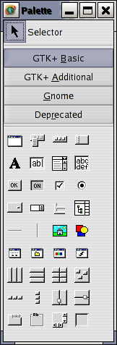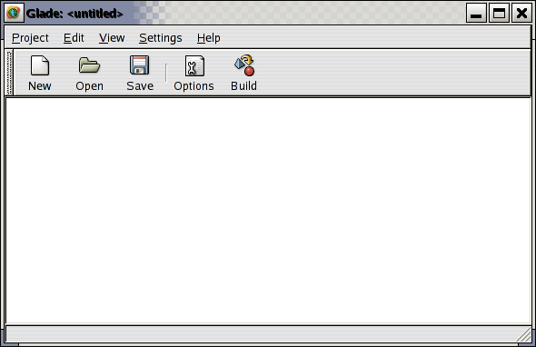

Fig(i).Palette Fig(ii).The Glade Interface

Window

ii)The Palette Window:

The Palette contains the arrays of widgets which Glade can use. There are several different 'pages' of widgets, accessible by clicking on the different buttons labeled 'Gtk+ Basic', 'Gtk+ Additional', Gnome' and 'Deprecated'. The deprecated page contains widgets which are being withdrawn, these include the old Gtk1 style list and tree widgets, and various redundant Gnome Widgets.
A widget is selected by clicking on it in the palette and then clicking again on the spot where you wish to add it to the application interface you are building. You must start building by choosing a window to contain the other widgets you might want.

iii)The Widget Tree window:

The widget tree is accessible from the view menu in the main window. It lists all the widgets you've used in your application, their names, and gives a dependency tree. Right clicking on any widget in the tree allows you to select it, any of its parents, cut it, copy it, delete it, etc. This is an easy way to move widgets around if the application requires rebuilding, without redoing all the names, signal handlers, sizing options and so on. Note however, that if you copy a widget from one place to another, the copy will have default names and values. This is because each widget must have an unique name.
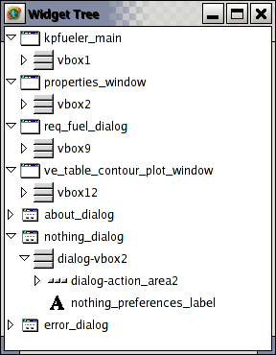
Fig(iii).The Widget Tree Window

iv)The Properties Window:

The Properties window is where you can adjust and set the properties of the various widgets in your application. Here you should probably at least give each major input/output widget a name. You can also set default sizes, decide whether a widget is editable or not (if it is a text type widget), decide if it's 'sensitive' to mouse clicks, change the sizes of container widgets and so on. You can also set titles and headers for each widget.

There are several notebook tabs in this window: Widget, Packing, Common, Signals and Accessibility (as given by the international symbol for handicapped). The specifics under each tab change with widget type, so they will not be detailed here. Under Widget you can set the name and basic look of the widget. Packing lets you move widgets around in the container widgets, and set how they expand and contract with changes in window size. Common allows more specific parameters to be set, for instance if you must have a fixed size window, and so on. Signals is an important tab, as this is where you set the callback function or signal handler for each signal event you wish to capture. The accessibility tab is new with Glade2 and allows you to set parameters which will then comply with the Gnome accessibility guidelines. This makes it much easier for your application to be used with voice synthesizers, etc.
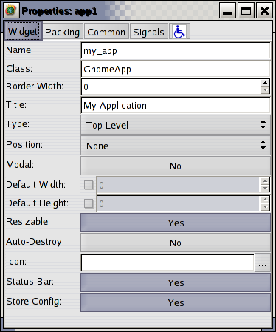
Fig(iv).The Properties Window

b.Gtemp: An Example of Interface Building with Glade

i)Objective:
The objective of this example is to give a good understanding on how GUI can be developed using Glade and this application will take a value in C or F and convert it to the other scale. It will do so without any other user input, but a carriage return.
If the user enters anything rather than a number an error message will be sent to the status bar of the application. This is the only foreseeable user created error.
ii)Creating the GUI:
Open glade2 by selecting Glade from the programming subsection of the main menu (this is under Redhat). Click on the 'new' button. A window will open asking if this is to be a gtk or gnome project. Select gtk. Doing this provides access to the gtk widgets, which are convenient to use and easy ways to keep inside at least the first part of the gtk guidelines.
Click the 'options' button on the main glade window. This will open a window which looks like the screenshot shown below. There are several tabs to consider, the default is the 'general' tab. Backspace over the project1 section of the project directory entry and add gtemp. This will set the other name variables to gtemp as well.
Set the subdirectories for source and pixmaps if you wish to change them from the default, and select the preferred language. Glade comes with C and C++ native to it, other languages are available as add-ons. Then move to the C options tab.
On the C options page turn off gettext support for now. Gettext supplies support for internationalization, but in my experience is the number one source of autogen and configure problems with Glade. For this tutorial we won't deal with it. Leave the other options as they are. If you were to create an application which used several different glade files, you'd want to change these options as needed.
Examine the libglade tab. This option allows you to save strings for translators. This is important if you are creating an international application. For this tutorial application, we'll leave the settings at default for this.

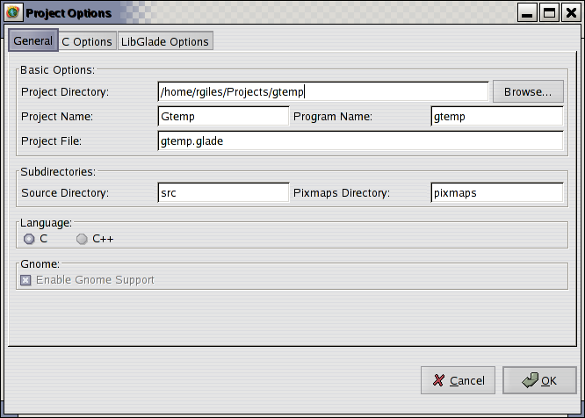

Fig(i).The Glade Window

iii).Setting up the First Window:
Go to the Palette window of Glade. Click on Gnome to change to the gnome widget palette, then click on the first widget in the upper left. This is the gnome application window widget. It'll set up an empty window with all the standard gnome menubar and toolbar, with the standard gnome entries on each. The widget you created should look like the picture to the left.
In the properties window, with the application window widget selected, rename it to something like 'gtemp_app'. The rest of the properties entries for this window can be left as they are, for now.
You can explore the default entries already set into the menus on the menubar and see the buttons on the toolbar. The Gtemp application is so simple it doesn't need most of these options. In fact, the only ones it'll use under present design concerns are the exit open under the file menu, the help menu, and it'll need an exit button on the button bar. There is nothing to save, as the results the program gives are loaded to the window immediately. There is no file to open, as input to the program is taken directly from the window. There is nothing to edit, and nothing to view.. yet. So we'll take out the commands which will always be unused, and set those that are not used yet to be insensitive (inactive/greyed out). Later on, we can set them to active if we decide to use them.

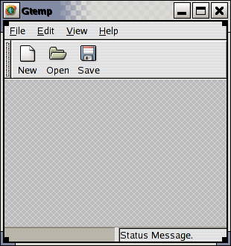

Fig(ii).Gtemp Window

First highlight (click in) the toolbar. This is the rectangular section in which the stock buttons (New, Open, and Save) are residing. You'll see toolbar1 appear under 'name' in the properties window. Notice that it specifies the toolbar size as 3. We only want one button, a quit button. So set this size to 1. This should leave you with only the 'new' button on the toolbar. Now highlight (click on) that 'new' button. It should be called 'button1' in the properties window. Change the name to 'quit_button'. Go down to the stock button selection and hit the down arrow. This will bring up a stock button selection menu. Select the quit icon. Give the button a border width, 5 or 3 looks nice. Click the save button in the main glade window to save what you've done so far.

iv)Menu Editor:
Now, back in the gtemp application window, click on the 'file' menu selection. The menubar should be highlighted, and the properties window should show 'menubar1'. Click the edit menus button in the properties window. You should see a new window appear, one which looks like that to the right. It will be labeled, 'menu editor'.
You should notice that the layout on the menubar is replicated by the layout and indentations in the window of the menu editor. File is a header on the menubar. Clicking on it opens a submenu which lists 'new', 'open', 'save', 'save as', a menu separator (line) and 'quit'. We'll just need quit. Select each option that we don't need in the menu editor and delete it by hitting the delete button to the right.
Under the Edit menu header there is little we need. But we might possibly want to add preferences and properties later on, so we'll keep those in the menu. Delete everything else under 'edit'. You can click 'apply' and go back to the gtemp application window to see the results of what you are doing.
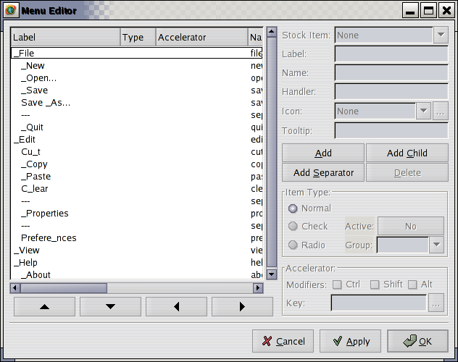

Fig(iii).Menu Editor Window

v)Resultant Gtemp Window:

When you've finished you should have a gtemp application window that looks like the screenshot shown below. We still haven't done anything about data or setting up what the application does, but hopefully you've learned how to call up the menu editor, how to set a few parameters using the property window, and that it's ok to click and explore at random with glade. If you really hate what you do, you can always go back to the backup *.glade file which glade writes each time you save, or just reload the application, or go ahead and undo all you did in glade.

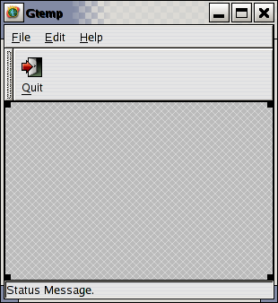

Fig(iv).Gtemp window

Building an Application:

1.create a file named “mk” and export all the variables required for cross-compilation(as shown below in step:2)

2.The “mk” file should contain:
#!/bin/sh
export GCC=arm-linux-gcc
export CC=arm-linux-gcc
export CXX=arm-linux-gcc
export LD=arm-linux-ld
export NM=arm-linux-nm
export RANLIB=arm-linux-ranlib
export AS=arm-linux-as
export AR=arm-linux-ar

./autogen.sh --host=arm-linux --build=i686-linux \
--libdir=$TOOLCHAIN/gtk /lib \
--includedir=$TOOLCHAIN/gtk/include \
--prefix=$TOOLCHAIN/gtk --bindir=$ROOTFS/fs/bin \
--sbindir=$ROOTFS/fs/sbin --libexecdir=$TOOLCHAIN/gtk/lib \
--datadir=$TOOLCHAIN/gtk --infodir=$TOOLCHAIN/gtk/docs

3.Run “./mk”.

4.Do a “make”.

Now you will have to upload the binary of the application to the ingenient-bsp flash and run it , to verify the working of the application.

