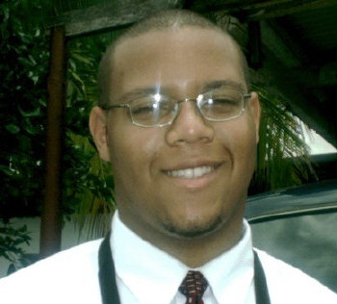

Who am I: | Hi, My name is Dwayne McFarlane. I am a Computer Science major here at the University of Maryland. Although I will get my Bachelors Degree (BS) in Computer Science in about a year, I plan to obtain my Masters of Business Administration (MBA) soon after. I see this internship as a great way to earn the experience needed to run my own business. I have aspirations to start a computer consultant firm within 10 years.
My Education: | As I said, I am a Computer Science major at Maryland. I currently have a 3.11 GPA. Before starting at Maryland, I was in the inaugural class of the Montgomery Scholars at Montgomery College in Rockville, which included a full 2-year academic scholarship. The scholarship also paid for a study abroad trip to The University of Cambridge in England.
My Experience: | I am currently a driver for the University of Maryland Shuttle Service. Everyday I am responsible for the lives of countless passengers and in control of vehicles worth well over $100,000.  However, before working with Shuttle, I was a Manager for After Hours Formalwear in Wheaton Plaza. I did everything in my power to give my customers “The Perfect Wedding,” and I will put the same level of effort into your house. The 3 most important events in a person life are when they get married, buy a house, and have a baby. I have already done much work in my life helping people with all three (I love kids and babysitting).

Sincerely,

Dwayne A. McFarlane

