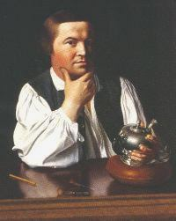

Open Meeting - Presiding Officer Bob Pickett

Inspiration - Surprise Performance

Toastmaster - Mark Kramer

Andrea Johnson speaking on
"Wedding On A Shoestring"
C&L Manual #4

Wayne Andersen speaking on
"Why So Many Rods?"
C&L Manual #8

Table Topics led by Alice Lewis

Evaluation Opening Remarks - Aurora Recepcion

Andrea's Evaluator - Randy Rimple

Wayne's Evaluator - Moira Regan

Ah Counter Report - Sylvia Salomon

Grammarian Report - Marc Weyl

Timer Report - Megan Hsin

General Evaluator's Report - Aurora Recepcion

Request For Ballot's - Aurora Recepcion

Vice President Education's Report - Mark Kramer

Awarding Of Awards - Mark Kramer

Adjourn Meeting - Presiding Officer Bob Pickett

Andrea’s Objectives for “Wedding On A Shoestring” (C&L Manual Project #4 – Show What You Mean, 5-7 minutes):
- To organize your thoughts into a logical sequence that leads the audience to a clearly defined goal.
- To build a speech outline that includes an opening, body, and conclusion

Wayne’s Objectives for “Why So Many Rods?” (C&L Manual Project #8 – Add Impact To Your Speech, 5-7 minutes):
- To learn the value of props in speaking.
- To learn how to use props effectively in your presentations.

