Garden~
~Garden Walk
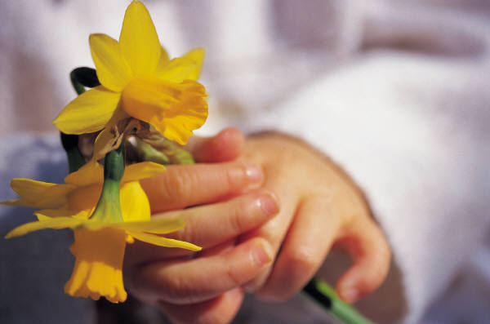

Prestwick Hights Garden club.

Join us on Saturday, September 13, for a self-guided tour of nine gardens and a wholesale nursery. Your entire family will enjoy the spectacular gardens and songbirds of Prestwick Hights.

The Botanic Cafeteria will serve a special lunch featuring edible flowers from 11:00 a.m. to 1:00 p.m. Garden Club members receive a 20 percent discount!

Call 555-3350 for more information.

David Yul.

