Strategic Marketing

For ABE Advance Diploma

Lecture 1
Planning: It is to decide in advance about future actions.
Planning Process:
- Present position
- Expected position
- Ways to reach
- Selection of the best way
- Evaluation of our movement
Guidelines for successful planning:
- Involve the right people in the planning process
- Write down the planning information and communicate
- Goals and objectives must be SMART
- Build in accountability
- Evaluate the planning process and the plan
- Note deviations from the plan and re-plan accordingly
- Reduce the planning gap as much as possible
Importance of Planning:
- To reduce risk & uncertainty
- Easy management of targets and standards
- Proper coordination and guidance
- Better accountability & motivation
- Improved decision making

Developing Plan:
A plan is the outcome of the planning process. Plan can be in detail or in outline.
What so ever it is at every level in the organization a plan needs to include its;
- Objective
- Strategies
- Program
- Control
Objective: It is usually a quantified or qualitative aim of the organization; also it is a clear approach that the organization wishes to achieve in a given period. It is told that Objectives a require to be SMART (Specific, Measurable, Achievable, Realistic and Timed)

Strategy: A strategy is a long term plan of action designed to achieve a particular objective.

Program: This is the action plan what needed to be followed in due course to achieve the planned objectives. In reality these are the detail plan that state the amount of accountability, punctuality, resources require to reach the target.
Control: It is to measure or follow-up an action plan. Controls can be use as a tool to realize the standard and actual actions.

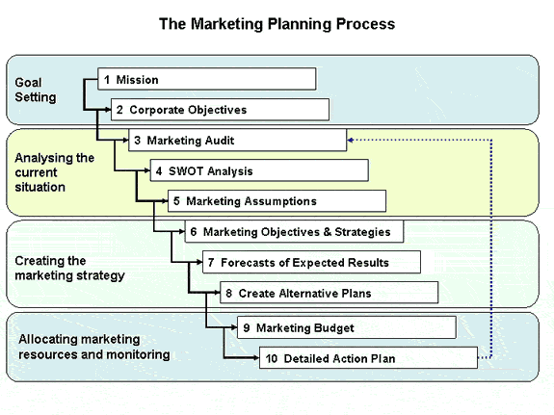
- Market audit: 1.External: Macro-environment (Economical, social, Technical etc) and the market (Size, growth, customer, Competition, Distribution, suppliers etc)
- 2. internal: Operating results, strategic issues, Market mix, Market structure, Marketing systems (info, planning, control etc.)
Lecture – 2

Types of Plan:
- Corporate Plan
The result of a process in which an organization, institution or business analyzes its objectives, priorities, strategies and environment in light of its directives. A corporate plan looks at the present as well as the future.
- Strategic Plan
A long-term flexible plan that does not regulate activities but rather outlines the means to achieve certain results, and provides the means to alter the course of action should the desired ends change.
- Functional Plan
A program of action, that effectively provides for present and future demands for movement of people and goods in any organization. It defines an operationally sound and flexible ultimate strategic plan along with more detailed plans for interim stages.
- Contingency Plan
It is an alternative for action if things don't go as planned or if an expected result fails to materialize.
- Term Plan (Short/Medium/Long)
A plan for which can be short, medium and long duration in action.

Planning Structure:
- Vertical (tall)
- Horizontal (flat)

Hierarchical involvement in planning:
BOD
CEO
Managers
Superintendent
Supervisor
Managements
Administration

Strategic Planning:
Strategic planning is an organisation's process of defining its strategy and making decisions on allocating its resources to pursue this strategy, including its capital and people.
The outcome is normally a strategic plan which is used as guidance to define functional and divisional plans, including Technology, Marketing, etc.

Aspects in the Strategic Planning:
- Developing company’s mission statement
A mission statement is a brief description of a company’s fundamental purpose. The mission statement articulates the company’s purpose both for those in the organization and for the public.

Contents of Mission Statement:
  - Aim of the company
  - History of the company
  - The market of the company
  - The product of the company
  - The technology behind the establishment

* Vision: The vision statement includes vivid description of the organization as it effectively carries out its operations
- Preparing Strategic Business Units (SBU)
Strategic Business Unit or SBU is understood as a business unit within the overall corporate identity which is distinguishable from other business because it serves a defined external market where management can conduct strategic planning in relation to products and markets. When companies become really large, they are best thought of as being composed of a number of businesses (or SBU).
- Establishing corporate objectives and strategies
As objectives are the aim that the organization is meant for thus there are certain factors to look after while establishing the same.

Internal Factors | External Factor
Employee | Competitors
Finance | Customers
Capability | Bankers
Stake holders | Suppliers
Unions | Government

With objectives strategies as well need to flow along the SBU:
Corporate Objective
Corporate Strategies
SBU
Objective
SBU
Objective

- Individual planning for SBU
Strategic Business Units are large enough and homogeneous enough to exercise control over most strategic factors affecting their performance. They are managed as self contained planning units for which discrete business strategies can be developed. A Strategic Business Unit can encompass an entire company, or can simply be a smaller part of a company set up to perform a specific task. The SBU has its own business strategy, objectives and competitors and these will often be different from those of the parent company
Lecture 3
Marketing and Market:
Marketing is to generate the demand and satisfy the demand by an organization.
Some critics say it is the means of all odd in the society and some praise it as fund generator or problem solver.
According to Chartered institute of marketing UK; “Marketing is the management process responsible for identifying, anticipating and satisfying customer requirements profitably”.

Concept of market:
Market is consists of combination of people who try to satisfy their need and want. People satisfy these needs in many ways like;
Idea, threat, Pleading and by exchange something of values
While exchanging parties must (1) have something of value added, (2) Must communicate accordingly and (3) must be free to accept or reject the situation.
If there is a need for a product and it is available with some one that means there is a market for it.
Market can be referred on the basis of good, service, people (teenager, ageing, infant etc), and Geographical location (Indian, Chinese etc). But to define theoretically we have only an industrial market and a consumer market.

Industrial vs. Consumer market:
Industrial | Consumer
Specific promotion | Mass promotion
Flexible pricing and high | MRP pricing and low
Qualified sales person | No specific qualification is require
After sales service and offering | Warranty or guarantees offer *
Technical advertising | Mass media advertising
Selected volume | Mass volume
*Types of Warranties:
- Express warranty or guarantee: An express warranty is typically a guarantee from the seller of a product that specifies the extent to which the quality or performance of the product is assured and states the conditions under which the product can be returned, replaced, or repaired. However, a warranty may also arise by operation of law based upon the seller's description of the goods, and perhaps their source and quality, and any material deviation from that specification would violate the guarantee. For example, an advertisement describing a product is often full of express warranties; the product must substantially conform to what is advertised.
- Implied warranty: An implied warranty is one that arises from the nature of the transaction, and the inherent understanding by the buyer, rather than from the express representations of the seller.
- Extended Warranty: It is a lengthened warranty offered to purchaser of products. It can be offered direct from the administrator, the retailer selling the product or by the manufacturer for an additional fee. These warranties are normally offered for above and beyond the time period of the manufacturers standard warranty.

Types of marketing:
- Multinational marketing : It is an adaptation of some of a company's marketing activities to appeal to local culture and differences in taste
- Multilevel or Network marketing: Multi-level marketing (MLM) (also called network marketing (NM) or matrix marketing) is a business model which utilizes a combination of direct marketing and franchising. Typically, independent business owners (IBO) become associated with a parent company in a contractor-like relationship.
- Social marketing: A marketing message designed to promote a social concern or political idea as well as a product.
- Consumer marketing:
- Relationship marketing: Relationship marketing is a business philosophy which aims to develop strong relationships with a range of stakeholders, such as suppliers, media, intermediaries and public organizations, as well as with customers.
- Internal marketing: Internal marketing (IM) is an ongoing process that occurs strictly within a company or organization whereby the functional process aligns, motivates and empowers employees at all management levels to consistently deliver a satisfying customer experience.
- Direct marketing: Direct marketing is a discipline within marketing that involves contacting individual customers' (business-to-business or consumer) directly and obtaining their responses and transactions for the purpose of developing and prolonging mutually profitable customer relationships.
Elements of marketing:
- Customer: A customer is someone who makes use of or receives the products or services of an individual or organization. Customers can be classified into two main groups: internal and external. Internal customers work for the same organization as the supplier of the goods or services, possibly in another department or another branch. External customers do not work for the same organization; they may be another organization or a member of the public.
- Consumer: They are individuals or households that purchase and use goods and services generated within the economy. The concept of a consumer is used in different contexts like economics, sales, marketing etc. so that the usage and significance may vary.
- Product: In marketing, a product is anything that can be offered to a market that might satisfy a want or need. However it is much more than just a physical object. It is the complete bundle of benefits or satisfactions that buyers perceive they will obtain if they purchase the product. It is the sum of all physical, psychological, symbolic, and service attributes.
- Production: Activities involved in creating a product. As consumer wish to have quality product in lesser price, it is important for manufacturer to have a better production strategy.
- Selling: Sales, or the activity of selling, forms an integral part of commercial activity. It includes contacting potential customers, presenting and demonstrating products, taking of orders, delivery of goods and the collection of payment.
- Market: It is a mechanism that, allows people to trade, normally governed by the theory of supply and demand, so allocating resources through a price mechanism and bid and ask matching so that those willing to pay a price for something meet those willing to sell for it.
Decision unit and decision process:
A decision making unit or DMU is the group of people in a company that is involved in making a buying decision for a business product. Where as a decision making process or DMP is a combine process that, start with communication and ends with evaluation of the task.
Marketing Mix:
MARKETING MIX includes a combination of product, packaging, price, channels of distribution, advertising, promotion, and personal selling to get the product in the hands of the customer.
The marketing mix approach to marketing is one model of crafting and implementing marketing strategies. It stresses the "mixing" of various decision factors in such a way that both organizational and consumer objectives are attained.
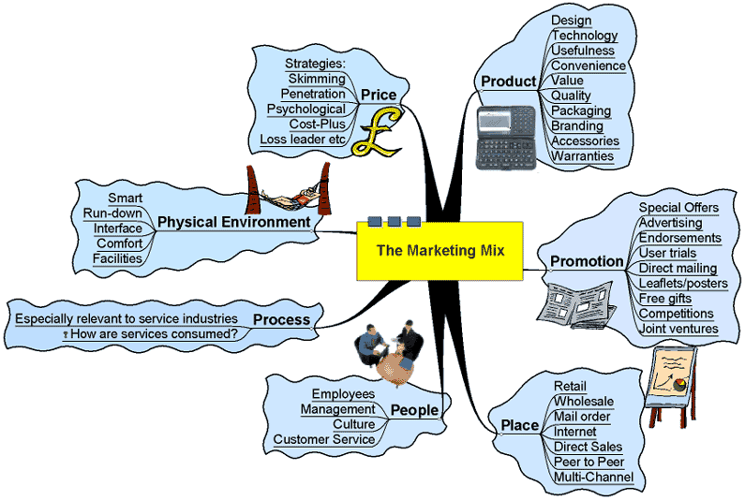
Four Ps
In popular usage, "marketing" is the promotion of products, especially advertising and branding. However, in professional usage the term has a wider meaning which recognizes that marketing is customer centered. Products are often developed to meet the desires of groups of customers or even, in some cases, for specific customers.
The four Ps are:
Product: The Product management and Product marketing aspects of marketing deal with the specifications of the actual good or service, and how it relates to the end-user's needs and wants.
Pricing: This refers to the process of setting a price for a product, including discounts.
Promotion: This includes advertising, sales promotion, publicity, and personal selling, and refers to the various methods of promoting the product, brand, or company.
Placement: Placement or distribution refers to how the product gets to the customer; for example, point of sale placement or retailing. This fourth P has also sometimes been called Place, referring to the channel by which a product or service is sold (e.g. online vs. retail), which geographic region or industry, to which segment (young adults, families, business people), etc.
These four elements are often referred to as the marketing mix.[7] A marketer can use these variables to craft a marketing plan. The four Ps model is most useful when marketing low value consumer products. Industrial products, services, high value consumer products require adjustments to this model. Services marketing must account for the unique nature of services. Industrial or B2B marketing must account for the long term contractual agreements that are typical in supply chain transactions. Relationship marketing attempts to do this by looking at marketing from a long term relationship perspective rather than individual transactions.

As a counter to this, Morgan, in Riding the Waves of Change (Jossey-Bass, 1988), adds "Perhaps the most significant criticism of the 4 Ps approach, which you should be aware of, is that it unconsciously emphasizes the inside–out view (looking from the company outwards), whereas the essence of marketing should be the outside–in approach". Even so, having made this important caveat, the 4 Ps offer a memorable and quite workable guide to the major categories of marketing activity, as well as a framework within which these can be used.

Seven Ps
As well as the standard four Ps (Product, Pricing, Promotion and Place), services marketing calls upon an extra three, totaling seven and known together as the extended marketing mix. These are:

People: Any person coming into contact with customers can have an impact on overall satisfaction. Whether as part of a supporting service to a product or involved in a total service, people are particularly important because, in the customer's eyes, they are generally inseparable from the total service. As a result of this, they must be appropriately trained, well motivated and the right type of person. Fellow customers are also sometimes referred to under 'people', as they too can affect the customer's service experience, (e.g., at a sporting event).

Process: This is the process involved in providing a service and the behavior of people, which can be crucial to customer satisfaction.

Physical evidence: Unlike a product, a service cannot be experienced before it is delivered, which makes it intangible. This, therefore, means that potential customers could perceive greater risk when deciding whether or not to use a service. To reduce the feeling of risk, thus improving the chance for success, it is often vital to offer potential customers the chance to see what a service would be like. This is done by providing physical evidence, such as case studies, or testimonials.

Eight P's
As well as the other 7, Packaging has been added to this list by some people. The rationale is that it is very important how the product is presented to the customer, and the packaging is often the first contact that a customer has with a product. Although some disagrees, as packaging is seen as a subfield of promotion itself.

"PHILOSOPHY" is the potential 8th P of marketing. Products (or services) should reflect the underlying philosophy or ethos of the organization. It should also be clear what the philosophy behind the introduction of the particular product is, as well.

Marketing Environment:
Marketing does not occur in a vacuum. The marketing environment consists of external forces that directly and/or indirectly impact the organization.
Changes in the environment create opportunities and threats for the organizations.

Example:
Hutch (Telecom service) ran a commercial 24 hours after the Tsunami to inform customers/potential customers that they could contact friends/family in India through its service when all the telephone lines were jammed. This illustrates a company (Hutch), reactively responding to an environmental factor (nature), to further market its services to attract new customers.

To track these external forces a company uses environmental scanning. Continual monitoring of what is going on.

Environmental scanning collects information about external forces. Environmental analysis determines environmental changes and predicts future changes in the environment. The marketing manager should be able to determine possible threats and opportunities from the changing environment. This will help avoid crisis management.

Six Environmental Forces:
Environmental scanning is a concept from business management by which businesses gather information from the environment, to better achieve a sustainable competitive advantage. To sustain competitive advantage the company must also respond to the information gathered from environmental scanning by altering its strategies and plans when the need arises.

Methods:
There are three ways of scanning the business environment:

Continuous scanning - (also called continuous learning) - continuous structured factors. Most commentators feel that in today's turbulent business environment the best scanning method available is continuous scanning. This allows the firm to act quickly, take advantage of opportunities before competitors do, and respond to environmental threats before significant damage is done.

The Macro environment:
Environmental scanning usually refers just to the macro environment, but it can also include industry and competitor analysis, consumer analysis, product innovations, and the company's internal environment. Macro environmental scanning involves analyzing:

The Economy:
- GNP or GDP per capita
- Economic growth
- Unemployment rate
- Inflation rate
- Consumer and investor confidence
- Inventory levels
- Currency exchange rates
- Merchandise trade balance
- Financial and political health of trading partners
- Balance of payments
- Future trends
Government:
- Political climate - amount of government activity
- Political stability and risk
- Government debt
- Budget deficit or surplus
- Corporate and personal tax rates
- Payroll taxes
- Import tariffs and quotas
- Export restrictions
- Restrictions on international financial flows
Legal:
- Minimum wage laws
- Environmental protection laws
- Worker safety laws
- Union laws
- Copyright and patent laws
- Anti- monopoly laws
- Municipal licenses
- Laws that favor business investment
Technology:
- Efficiency of infrastructure, including: roads, ports, airports, rolling stock, hospitals, education, healthcare, communication, etc.
Industrial productivity
- New manufacturing processes
- New products and services of competitors
- New products and services of supply chain partners
- Any new technology that could impact the company
- Cost and accessibility of electrical power
Socio-Cultural:
- Demographic factors such as:
- Population size and distribution
- Age distribution
- Education levels
- Income levels
- Ethnic origins
Attitudes towards:
- Materialism, capitalism, free enterprise
- Individualism, role of family, role of government, collectivism
- Importance of work, pride of accomplishment
Labor supply:
- Quantity of labor available
- Quality of labor available
- Stability of labor supply
- Wage expectations
- Employee turn-over rate
- Strikes and labor relations
- Educational facilities
- Material suppliers
- Quality, quantity, price, and stability of material inputs
- Level of competition among suppliers
Scanning these macro environmental variables for threats and opportunities requires that each issue be rated on two dimensions. It must be rated on its potential impact on the company, and rated on its likeliness of occurrence. Multiplying the potential impact parameter by the likeliness of occurrence parameter gives us a good indication of its importance to the firm.
Marketing Functions:
Marketing function is a major specialized activity performed in marketing. The word marketing was a recent addition to the ever increasing list of industrial and technical terms. Understanding of the ideology and strategic role of marketing provides better focus on the subject.
- Marketing Ideology:
  - Rooting: It is the purpose of production and marketing that root the organization towards a strong base.
  - Development: Development and addition of new qualified or quantified production which, keep the organization in market.
  - Reinforcement: Review and innovation as per the trend keeps the organization focused towards its mission.
- Strategic Role:

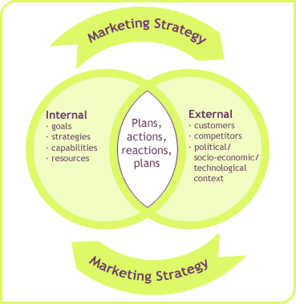
Marketing Objectives:
Marketing success can be measured on several non-financial market metrics. These measure are important since these often shed light on underlying conditions and circumstances facing the company that are not easily seen within financial measures. For instance, a company may report strong sales for a product but market share information may suggest the product is losing ground to competitors. Thus we may need to consider on enlarging the market, increasing market share and to improve profitability. The marketing objectives section will indicate targets to be achieved across several marketing decision areas as follows;
Target market objectives
- market share
  - by segments
  - by channel
- customers
  - number/percentage new
  - number/percentage retained
- purchases
  - rate of purchases
  - size/volume of purchases
Promotional objectives
- level of brand/company awareness
- traffic building
(E.g., store traffic, website traffic)
- product trials
(E.g. sales promotions, product demonstrations)
- sales force
(E.g. cycle time, cost per call, closing rate, customer visits, etc.)
Channel objectives
- dealers
  - number/percentage new
  - number/percentage retained
- order processing and delivery
  - on-time rate
  - shrinkage rate
  - correct order rate
Market research objectives
- studies initiated
- studies completed
R&D objectives
- product development
Miscellaneous objectives
- partnerships developed
Ansoff’s Matrix on marketing objective and development:
Ansoff's matrix offers strategic choices to achieve the objectives. There are four main categories for selection.

Ansoff's Product/Market Matrix
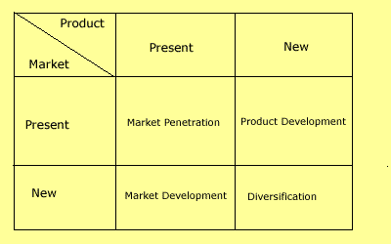
Market Penetration:
Here we market our existing products to our existing customers. This means increasing our revenue by, for example, promoting the product, repositioning the brand, and so on. However, the product is not altered and we do not seek any new customers.
Market Development:
Here we market our existing product range in a new market. This means that the product remains the same, but it is marketed to a new audience. Exporting the product, or marketing it in a new region, we can say as examples of market development.
Product Development:
This is a new product to be marketed to our existing customers. Here we develop and innovate new product offerings to replace existing ones. Such products are then marketed to our existing customers. This often happens with the auto markets where existing models are updated or replaced and then marketed to existing customers.
Diversification:
This is where we market completely new products to new customers. There are two types of diversification, namely related and unrelated diversification. Related diversification means that we remain in a market or industry with which we are familiar. For example, a soup manufacturer diversifies into cake manufacture (i.e. the food industry). Unrelated diversification is where we have neither previous industry nor market experience. For example a soup manufacturer invests in the rail business.
Ansoff's matrix is one of the most well know frameworks for deciding upon strategies for growth.
Influencer on marketing objectives:
Marketing objective depends certain external factors like; environmental change, Government legislation, competitive activity, technological change, demography and buying behavior, economic reasons etc externally and Corporate objectives, planning skill, idea development, resources, lack of creativity, lack of knowledge etc internally.
Marketing Strategy:
Marketing strategy is a process that can allow an organization to concentrate its (always limited) resources on the greatest opportunities to increase sales and achieve a sustainable competitive advantage.
Marketing strategy is most effective when it is an integral component of corporate strategy, defining how the organization will engage customers, prospects and the competition in the market arena for success.
Nature & Purpose:
Strategies are the ladder to reach objectives or aim with efficiency and effectiveness. In marketing objectives strategies shows the main credibility towards its Segmentation, Target and positioning.
Forms of marketing strategy:
Every marketing strategy is unique, but if we abstract from the individualizing details, each can be reduced into a generic marketing strategy. Marketing strategy can be differentiated, undifferentiated and concentrated. Let us have a discussion on its carious forms;

Strategies based on market dominance - In this scheme, firms are classified based on their market share or dominance of an industry. Typically there are four types of market dominance strategies:
- Leader
- Challenger
- Follower
- Niche
Porter generic strategies - Michael Porter assessed strategy on the dimensions of strategic scope and strategic strength.
- Cost leadership
- Product differentiation
- Market segmentation
Innovation strategies - This deals with the firm's rate of new product development and business model innovation.
- Pioneers
- Close followers
- Late followers
Growth strategies - In this scheme we ask the question, “How should the firm grow?” There are a number of different ways of answering that question, but the most common gives four answers:
- Horizontal integration
- Vertical integration
- Diversification (or conglomeration)
- Intensification
Aggressiveness strategies - This asks whether a firm should grow or not, and if so, how fast. One scheme divides strategies into:
- Building
- Holding
- Harvesting
Warfare based strategies - This scheme draws parallels between marketing strategies and military strategies. There are many types of marketing warfare strategies, but they can be grouped into:
- Offensive marketing warfare strategies
- Defensive marketing warfare strategies
- Flanking marketing warfare strategies
- Guerrilla marketing warfare strategies

Porter’s Generic Strategy Model and profitability curve:

Michael Porter has described a category scheme consisting of three general types of strategies that are commonly used by businesses. These three generic strategies are defined along two dimensions: strategic scope and strategic strength. Strategic scope is a demand-side dimension and Strategic strength is a supply-side dimension.

Overall
Cost Leadership

Cost Focus

Differentiation Focus

Differentiation
NARROW

BROAD
Low Cost
High Cost
Competitive Advantage
Competitive Scope

Cost Leadership:
This strategy emphasizes efficiency. By producing high volumes of standardized products, the firm hopes to take advantage of economies of scale and experience curve effects. Maintaining this strategy requires a continuous search for cost reductions in all aspects of the business. The associated distribution strategy is to obtain the most extensive distribution possible. Promotional strategy often involves trying to make a virtue out of low cost product features.

To be successful, this strategy usually requires a considerable market share advantage or preferential access to raw materials, components, labor, or some other important input. Without one or more of these advantages, the strategy can easily be mimicked by competitors. Successful implementation also benefits from:

Differentiation Strategy
Differentiation involves creating a product that is perceived as unique. The unique features or benefits should provide superior value for the customer if this strategy is to be successful. However there are usually additional costs associated with the differentiating product features and this could require a premium pricing strategy.

Segmentation Strategy
In this strategy the firm concentrates on a select few target markets. It is also called a focus strategy or niche strategy. It is hoped that by focusing your marketing efforts on one or two narrow market segments and tailoring your marketing mix to these specialized markets, you can better meet the needs of that target market. The firm typically looks to gain a competitive advantage through effectiveness rather than efficiency. It is most suitable for relatively small firms but can be used by any company.

PIMS (Profit Impact on Market Strategy):
The model or program of PIMS leads us to such considerations while deciding on strategies like;
- Forecasting Profit
- Allocating resources
- Measuring performances
- Appraising new business proposition
The final move of PIMS program gives emphasis on Competitive position, Product structure and the attractiveness of the target market.

BCG Matrix:
The BCG Matrix was created by The Boston Consulting Group (BCG) and it became on of the most well-known portfolio management Decision Making Tools in the early 1970's. It is based on the product life cycle theory, and it is used to prioritize the product portfolio in a company or department. There are two dimensions - market share and market growth. The basis premise in using the Matrix is that the higher the market share a product has, the higher the growth rate and the faster the market for that product grows.

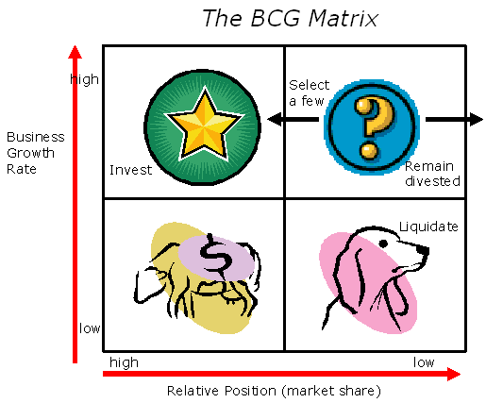

Four segments in the BCG matrix:
1. Cash Cows (high market share, low growth) - Keep investments low, while keeping profits high. Profits and cash generation should be higher because of low growth.
2. Dogs (low market share, low growth) - Liquidate, if they are not delivering cash. Avoid and reduce the number of these an organization maintains. Keep an eye out for expensive revival strategies - a dog is typically always a dog.

3. Stars (high market share, high growth) - Invest further in these - they incur high costs, but they are market leaders and should also generate lots of cash. Stars may balance on net cash flow, but the organization should try to maintain market share on this would because rewards are likely

4. Question marks (low market share, but high growth) - These have poor cash inflow, but have high demands and low returns due to low market share. Efforts should be made to change market share. If this isn't possible, this will likely turn into a dog as growth slows.

Caution should be taken as high market share isn't the only consideration. High market share doesn't necessarily mean profit. Growth isn't necessarily the only valid measurement factor. Occasionally, dogs can earn more cash than cash cows.

Product portfolio strategy:

The business portfolio is the collection of businesses and products that make up the company. The best business portfolio is one that fits the company's strengths and helps exploit the most attractive opportunities.

The company must:

(1) Analyze its current business portfolio and decide which businesses should receive more or less investment, and

(2) Develop growth strategies for adding new products and businesses to the portfolio, whilst at the same time deciding when products and businesses should no longer be retained.

Using the BCG Box to determine portfolio strategy

Once a company has classified its SBU's, it must decide what to do with them.
It must allocate objectives, strategies etc. for each. Conventional strategic thinking suggests there are four possible strategies for each SBU:

(1) Build Share: here the company can invest to increase market share (for example turning a "question mark" into a star)

(2) Hold: here the company invests just enough to keep the SBU in its present position

(3) Harvest: here the company reduces the amount of investment in order to maximize the short-term cash flows and profits from the SBU. This may have the effect of turning Stars into Cash Cows.

(4) Divest: the company can divest the SBU by phasing it out or selling it - in order to use the resources elsewhere (e.g. investing in the more promising "question marks").
The General Electric Business Screen Matrix”
The General Electric Business Screen was originally developed to help marketing managers overcome the problems that are commonly associated with the Boston Matrix (BCG), such as the problems with the lack of credible business information, the fact that BCG deals primarily with commodities not brands or Strategic Business Units (SBU's), and that cashflow if often a more reliable indicator of position as opposed to market growth/share.
The GE Business Screen introduces a three by three matrix, which now includes a medium category. It utilizes industry attractiveness as a more inclusive measure than BCG's market growth and substitutes competitive position for the original's market share.

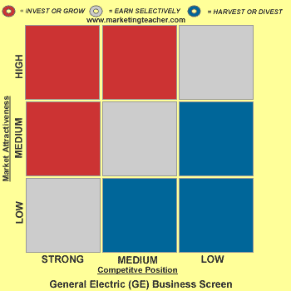

In come Strategic Business Units (SBU's). A large corporation may have many SBU's, which essentially operate under the same strategic umbrella, but are distinctive and individual. A loose example would refer to Microsoft, with SBU's for operating systems, business software, consumer software and mobile and Internet technologies.

Growth/shares are replaced by competitive position and market attractiveness. The point is that successful SBU's will go and do well in attractive markets because they add value that customers will pay for. So, weak companies do badly for the opposite reasons. To help break down decision-making further, you then consider a number of sub-criteria:
For market attractiveness:
- Size of market.
- Market rate of growth.
- The nature of competition and its diversity.
- Profit margin.
- Impact of technology, the law, and energy efficiency.
- Environmental impact.

For competitive position:
- Market share.
- Management profile.
- R & D.
- Quality of products and services.
- Branding and promotions success.
- Place (or distribution).
- Efficiency.
- Cost reduction.

At this stage the marketing manager adapts the list above to the needs of his strategy. The GE matrix has 5 steps:

- One - Identify your products, brands, experiences, solutions, or SBU's.
- Two - Answer the question, What makes this market so attractive?
- Three - Decide on the factors that position the business on the GE matrix.
- Four - Determine the best ways to measure attractiveness and business position.
- Five - Finally rank each SBU as either low, medium or high for business strength, or low, medium and high in relation to market attractiveness.

Now follow the usual words of caution that go with all boxes, models and matrices. Yes the GE matrix is superior to the Boston Matrix since it uses several dimensions, as opposed to BCG's two. However, problems or limitations include:

- There is no research to prove that there is a relationship between market attractiveness and business position.
- The inter-relationships between SBU's, products, brands, experiences or solutions are not taken into account.
- This approach does require extensive data gathering.
- Scoring is personal and subjective.
- There is no hard and fast rule on how to weight elements.
- The GE matrix offers a broad strategy and does not indicate how best to implement it.
ADL Matrix, Gap Analysis and Five Forces Model
The Arthur D Little (ADL) Strategic Condition Matrix offers a different perspective on strategy formulation. ADL has two main dimensions - competitive position and industry maturity.

Competitive position is driven by the sectors or segments in which a Strategic Business Unit (SBU) operates. The product or service which it markets, and the accesses it has to a range of geographically dispersed markets that are what makes up an organization's competitive position i.e. product and place.

Industry maturity is very similar to the Product Life Cycle (PLC) and could almost be renamed an 'industry life cycle.' Of course not only industries could be considered here but also segments.

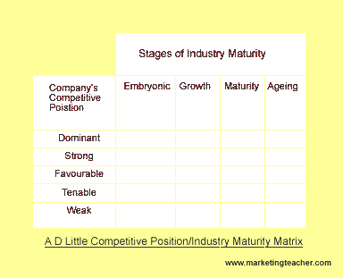
It is a combination of the two aforementioned dimensions that helps us to use ADL for marketing decision-making. Now let's consider options in more detail. Competitive position has five main categories:

1. Dominant - This is a particularly extraordinary position. Often this is associate with some form of monopoly position or customer lock-in e.g. Microsoft Windows being the dominant global operating system.
2. Strong - Here companies have a lot of freedom since position in an industry is comparatively
powerful e.g. Apple's iPod products.
3. Favourable - Companies with a favourable position tend to have competitive strengths in segments of a fragmented market place. No single global player controls all segments. Here product strengths and geographical advantages come into play.
4. Tenable - Here companies may face erosion by stronger competitors that have a favourable, strong or competitive position. It is difficult for them to compete since they do not have a sustainable competitive advantage.
5. Weak - As the term suggests companies in this undesirable space are in an unenviable position. Of course there are opportunities to change and improve, and therefore to take an organization to a more favourable, strong or even dominant position.
From here the strategic position of an organisation can be established. Managers then need to decide upon the best strategic direction for the business. For example they might use a Gap Analysis. According to ADL, there are six generic categories of strategy that could be employed by individual SBU's:
- Market strategies.
- Product strategies.
- Management and systems strategies.
- Technology strategies.
- Retrenchment strategies.
- Operations strategies.

Gap analysis is a very useful tool for helping marketing managers to decide upon marketing strategies and tactics. Again, the simple tools are the most effective. There's a straightforward structure to follow. The first step is to decide upon how you are going to judge the gap over time. e.g. by market share, by profit, by sales etc.

This will help you to write SMART objectives. Then you simply ask two questions - where are we now? And, where do we want to be? The difference between the two is the GAP - this is how you are going to get there. Take a look at the diagram below. The lower line is where you'll be if you do nothing. The upper line is where you want to be.

Gap Analysis
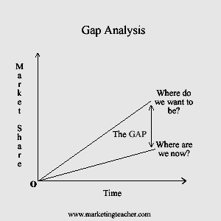
Your next step is to close the gap. Firstly decide whether you view from a strategic or an operational/tactical perspective. If you are writing strategy, you will go on to write tactics - see the lesson on marketing plans. The diagram below uses Ansoff's matrix to bridge the gap using strategies:
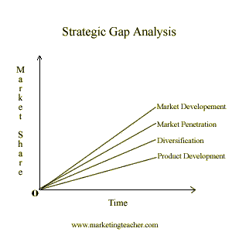
Strategic Gap Analysis:
You can close the gap by using tactical approaches. The marketing mix is ideal for this. So effectively, you modify the mix so that you get to where you want to be. That is to say you change price, or promotion to move from where you are today (or in fact any or all of the elements of the marketing mix).
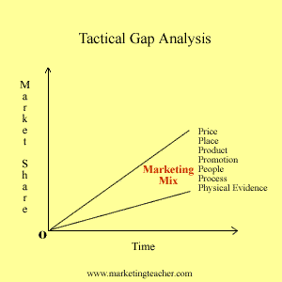
Tactical Gap Analysis:
This is how you close the gap by deciding upon strategies and tactics - and that's gap analysis.

Five Forces Analysis:
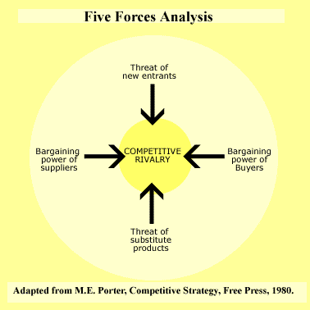
The Five Forces Analysis helps the marketer to contrast a competitive environment. It has similarities with other tools for environmental audit, such as PEST analysis, but tends to focus on the single, stand alone, business or SBU (Strategic Business Unit) rather than a single product or range of products.

Five forces analysis looks at five key areas namely the threat of entry, the power of buyers, the power of suppliers, the threat of substitutes, and competitive rivalry.

The threat of entry:
- Economies of scale e.g. the benefits associated with bulk purchasing.
- Cost of entry.
- Ease of access to distribution channels
- Cost advantages not related to the size of the company
- Competitors
- Government action
- Differentiation
The power of buyers:
- This is high where there a few, large players in a market
- If there are a large number of undifferentiated, small suppliers
- The cost of switching between suppliers is low.
The power of suppliers:
The power of suppliers tends to be a reversal of the power of buyers.

Where the switching costs are high
Power is high where the brand is powerful
There is a possibility of the supplier integrating forward
Customers are fragmented (not in clusters) so that they have little bargaining power
The threat of substitutes:
Where there is product-for-product substitution
Where there is substitution of need
Where there is generic substitution (competing for the currency in your pocket) e.g. Video suppliers compete with travel companies.
Competitive Rivalry:
This is most likely to be high where entry is likely; there is the threat of substitute products, and suppliers and buyers in the market attempt to control. This is why it is always seen in the center of the diagram.

The Innovation Diffusion Model:
Diffusion of innovations theory was formalized by Everett Rogers in a 1962 book called Diffusion of Innovations. Rogers stated that adopters of any new innovation or idea could be categorized as:
- Innovators - Least
- Early adopters - Improved
- Early majority – Max range
- Late majority – Max range
- Laggards – Above improved
Each adopter's willingness and ability to adopt an innovation would depend on their awareness, interest, evaluation, trial, and adoption. Some of the characteristics of each category of adopter include:

Innovators - venturesome, educated, multiple info sources, greater propensity to take risk.
Early adopters - social leaders, popular, educated
Early majority - deliberate, many informal social contacts
Late majority - skeptical, traditional, lower socio-economic status
Laggards - neighbors and friends are main info sources, fear of debt.

Rogers Five stage model for the diffusion of innovation:

- Knowledge - learning about the existence and function of the innovation.
- Persuasion - becoming convinced of the value of the innovation.
- Decision - committing to the adoption of the innovation.
- Implementation - putting it to use.
- Confirmation - the ultimate acceptance (or rejection) of the innovation.

Kotler’s Competitor Expansion Grid:
According to competitors expansion grid model a firm need to assume the competitor move on the base point. Base points Includes:
- Product criteria
- Price and cost
- Distribution
- Market attractiveness
- Competitive scope etc.
An Example of Grid:

Factor to Evaluate | Firm 1 | Firm A | Firm B | Firm C
Price
Quality
Distibution network
Customer loyalty
Market share
Customer relationship
…….

Defense Strategy Models etc:

Types of defensive strategies
The main types of defensive marketing warfare strategies are:

Position defense - This involves the defense of a fortified position. It includes increasing brand equity, customer satisfaction, customer loyalty, or repeat purchase rate, exclusive distribution contracts, patent protection, market monopoly, or government protected monopoly status. It is best used in homogeneous markets where the defender has dominant market position and potential attackers have very limited resources.

Mobile defense - This involves constantly shifting resources and developing new strategies and tactics. A mobile defense is intended to create a moving target that is hard to successfully attack. In business this would entail introducing new products, introducing replacement products, modifying existing products, changing market segments, changing target markets, repositioning products, or changing promotional focus. This defense requires a very flexible organization with strong marketing, entrepreneurial, product development, and marketing research skills.

Flank position - This involves the re-deployment of your resources to deter a flanking attack. You protect against potential loss of market share in a segment, by strengthening your competitive position in this segment with new products and other tactics.
Counter offensive - This involves countering an attack with an offense of your own. If you are attacked, retaliate with an attack on the aggressor’s weakest point.

Unit-4
Situational Analysis:
This explains the present and future of the environment. A proper scan and analysis of the strategy gives a proper idea of it. External and Internal environment and their scopes makes the firm analyze their SWOT to reach at given goal.
Competitive Analysis Principles:

The most important thing you can do is to explicitly understand your areas of strategic vulnerability. Listen to your customers and channel partners as honestly as possible.

The following are some guidelines that will help discover a company's potential vulnerabilities:

- Don't rely on intuition.
- Never rely solely on experts
- Don't allow past investments to influence your views

When outlining strategic vulnerabilities, remember it should be specific. No one business can anticipate threats on all fronts. Organizations need to have a finite number of critical things to watch.

Clearly, customers are critical to success, but what kind of customers? Children, married women, diabetics, and men over 60 all fall under the category of customers, but they are quite different. Knowing your lead users (or future profitable segments) enables you to focus on them. Of course, knowing what to look for is only half the battle in developing an action plan. Understanding how and where to look is vital.

Scope of analysis:
Internal: Organizational structure, Sales volume, Market share under the umbrella, profit margin, communication process, personnel, range of products, stocks, services offered, distribution and promotional tools, pricing policies, product development, employee relation and morale.
External: General environment (PEST), market, Competition etc.
Classification of analysis:
Listing
PEST
McKinsey’s Seven S’s:
It provides a useful framework for analyzing the strategic attributes of an organization. The McKinsey Consulting Firm identified strategy as only one of seven elements exhibited by the best managed companies.

Strategy, structure and systems can be considered the "hardware" of success whilst style, staff, skills and shared values can be seen as the "software".

Companies, in which these soft elements are present, are usually more successful at the implementation of strategy.
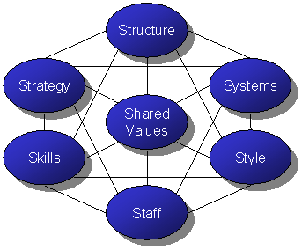
The 7-Ss:
- Shared Values:
This means that the employees share the same guiding values. Values are things that you would strive for even if they were demonstrably not profitable. (Example: Honesty.)
E.G. 'The "famous" Johnson & Johnson Tylenol case is an example where a credo helped provide guidelines for practical decision making. When tainted Tylenol was discovered, J&J's leaders could quickly make a decision to immediately, publicly, remove all Tylenol from the nation's shelves, because they were following the organisation's credo - which said that J&J's first responsibility was to provide quality products to doctors, nurses and patients. This dramatic action helped unsure a reinstatement of both public trust and employee pride in the integrity of the company, and led to higher long term sales.'
- Strategy:
The integrated vision and direction of the company, as well as the manner in which it derives, articulates, communicates and implements that vision and direction.
- Structure:
The policies and procedures which govern the way in which the organization acts within itself and within its environment
- Systems:
The decision making systems within the organization can range from management intuition, to structured computer systems to complex expert systems and artificial intelligence. It includes
Computer Systems,
Operational Systems,
HR Systems,
- Style:
Style refers to the employees shared and common way of thinking and behaving - unwritten norms of behavior and thought:
Leadership Style:
Organizational Culture
- Skills:
Skills refer to the fact that employees have the skills needed to carry out the company's strategy. Training and Development - ensuring people know how to do their jobs and stay up to date with the latest techniques.
- Staff:
Staff means that the company has hired able people, trained them well and assigned them to the right jobs. Selection, training, reward and recognition, retention, motivation and assignment to appropriate work are all key issues.
Shell Matrix:
The Shell Directional Policy Matrix is another refinement upon the Boston Matrix. Along the horizontal axis are prospects for sector profitability, and along the vertical axis is a company's competitive capability. As with the GE Business Screen the location of a Strategic Business Unit (SBU) in any cell of the matrix implies different strategic decisions. However decisions often span options and in practice the zones are an irregular shape and do not tend to be accommodated by box shapes. Instead they blend into each other.

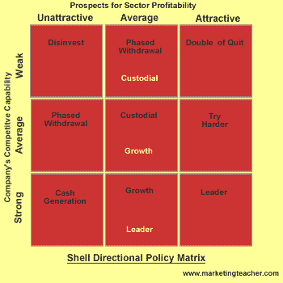
Each of the zones is described as follows:
- Leader - major resources are focused upon the SBU.
- Try harder - could be vulnerable over a longer period of time, but fine for now.
- Double or quit - gamble on potential major SBU's for the future.
- Growth - grow the market by focusing just enough resources here.
- Custodial - just like a cash cow, milk it and do not commit any more resources.
- Cash Generator - Even more like a cash cow, milk here for expansion elsewhere.
- Phased withdrawal - move cash to SBU's with greater potential.
- Divest - liquidate or move these assets on a fast as you can.

Core competences:
A core competence is the result of a specific unique set of skills or production techniques that deliver value to the customer. Such competences give an organization access to a wide variety of markets.

Core competences are interesting from a traditional marketing point of view since it could be argued that they take a product or production orientation rather than a market orientation.

Three tests of core competence:
- Provides potential access to a wide variety of markets.
- Should make a significant contribution to the perceived customer benefits of the end product.
- Should be difficult for competitors to imitate.
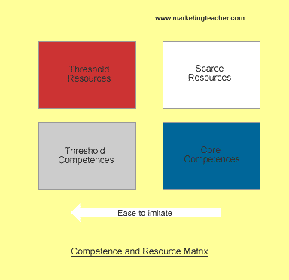
For example, Microsoft has expertise in many IT-based innovations and technologies. Customers perceive many benefits in relation to Microsoft's products. For a variety of reasons including unique skills, it is difficult for competitors to imitate Microsoft's core competences.

When trying to identify a core competence, it is often easy to mistake them for scarce or unique resources i.e. resources rather than skills or production technologies. Also often skills and production technologies do not amount to a core competence or resource because they do not comply with one or more of the three tests. They are the thresholds that the organization must achieve to remain competitive. Threshold competences and scarce resources may not provide access to a variety of markets, may not be so significant to customers and may be less difficult to imitate.
In summary there are core competences and scarce resources, and threshold competences and threshold resources.
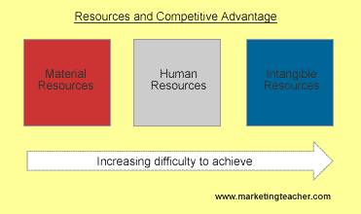

In order to be competitive an organization needs material resources such as premises, a factory or offices - depending on the nature of business of course. Material resources tend to be the most straightforward to achieve. Then an organization needs to achieve the right balance between Human Resources, training and recruitment. This state is more difficult to achieve. Intangible resources, including core competences are the most difficult and challenging to achieve. This is depicted in the diagram above. In fact they drive competitive advantage.

Cliff Bowman Strategy Clock:
The 'Strategy Clock' is based upon the work of Cliff Bowman It's another suitable way to analyze a company's competitive position in comparison to the offerings of competitors. As with Porter's Generic Strategies, Bowman considers competitive advantage in relation to cost advantage or differentiation advantage. There a six core strategic options:
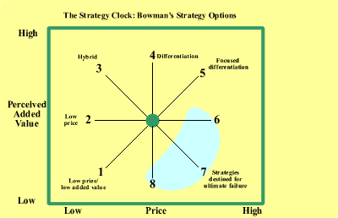

- Option one - low price/low added value.
Likely to be segment specific
- Option two - low price.
Risk of price war and low margins/need to be a 'cost leader'
- Option three - Hybrid.
Low cost base and reinvestment in low price and differentiation
- Option four - Differentiation.
(a) Without a price premium:
Perceived added value by user, yielding market share benefits
(b) With a price premium:

Perceived added value sufficient to bear price premium
- Option five - focused differentiation.
Perceived added value to a 'particular segment' warranting a premium price
- Option six - increased price/standard.
Higher margins if competitors do not value follow/risk of losing market share.
- Option seven - increased price/low values.
Only feasible in a monopoly situation
- Option eight - low value/standard price.
Loss of market share

Product
In marketing, a product is anything that can be offered to a market that might satisfy a want or need. It is of two types: Tangible (physical) or Intangible (non-physical). Since services have been at the forefront of all modern marketing strategies, some intangibility has become essential part of marketing offers. It is therefore the complete bundle of benefits or satisfactions that buyers perceive they will obtain if they purchase the product.

Levels of a Product:
For many a product is simply the tangible, physical entity that they may be buying or selling. You buy a new car and that's the product - simple! Or maybe not. When you buy a car, is the product more complex than you first thought? In order to actively explore the nature of a product further, lets consider it as three different products - the CORE product, the ACTUAL product, and finally the AUGMENTED product.

These are known as the 'Three Levels of a Product.' So what is the difference between the three products, or more precisely 'levels?'
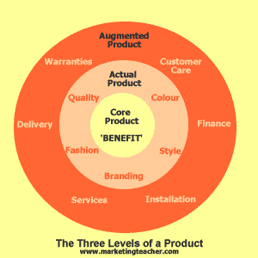

The CORE product is NOT the tangible, physical product. You can't touch it. That's because the core product is the BENEFIT of the product that makes it valuable to you. So with the car example, the benefit is convenience i.e. the ease at which you can go where you like, when you want to. Another core benefit is speed since you can travel around relatively quickly.

The ACTUAL product is the tangible, physical product. You can get some use out of it. Again with the car example, it is the vehicle that you test drive, buy and then collect.

The AUGMENTED product is the non-physical part of the product. It usually consists of lots of added value, for which you may or may not pay a premium. So when you buy a car, part of the augmented product would be the warranty, the customer service support offered by the car's manufacture, and any after-sales service.

New Product Development:
The goal of new product development is to address more of the market, to grow the market (new users and applications), and to win more when you compete for customers.
Steps in product development:
- New product strategy:
New product strategy relies on exhaustive analysis of the company itself (internal) and the marketplace at large (external).
- Idea generation & Screening
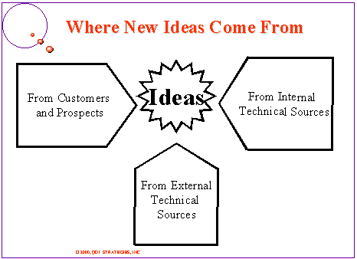
Idea Generation:
Ideas for new products can be obtained from customers (employing user innovation), the company's R&D department, competitors, focus groups, employees, salespeople, corporate spy’s, trade shows, or through a policy of Open Innovation. Ethnographic discovery methods (searching for user patterns and habits) may also be used to get an insight into new product lines or product features.
Idea Screening:
The object is to eliminate unsound concepts prior to devoting resources to them.
The screeners must ask at least three questions:
- Will the customer in the target market benefit from the product?
- Is it technically feasible to manufacture the product?
- Will the product be profitable when manufactured and delivered to the customer at the target price?
- Concept Development and Testing
Develop the marketing and engineering details
Who is the target market and who is the decision maker in the purchasing process?
What product features must the product incorporate?
What benefits will the product provide?
How will consumers react to the product?
How will the product be produced most cost effectively?
- Business Analysis
Estimate likely selling price based upon competition and customer feedback
Estimate sales volume based upon size of market
Estimate profitability and breakeven point
- Beta Testing and Market Testing
Produce a physical prototype or mock-up
Test the product in typical usage situations
Conduct focus group customer interviews or introduce at trade show
Make adjustments where necessary
Produce an initial run of the product and sell it in a test market area to determine customer acceptance
- Technical Implementation or Product development
New program initiation
Resource estimation
Requirement publication
Engineering operations planning
Department scheduling
Supplier collaboration
Resource plan publication
Program review and monitoring
Contingencies - what-if planning
- Commercialization (often considered post-NPD)
Launch the product
Produce and place advertisements and other promotions
Fill the distribution pipeline with product
Critical path analysis is most useful at this stage

SWOT:
It is a profile relates to various internal and external environment of the organization. Strength, weaknesses, Opportunities and threats are the main framework where it works.
Internal Environment:
Today’s strength is tomorrow’s weakness and for all organizations these are the two internal factor derived from internal environment takes maximum efforts to build and control.
Strengths:
- Superiority in the marketplace
- Staff expertise, loyalty and commitment
- Reputation and quality
- Capital efficiency
Weaknesses:
- Lack of marketing references
- Poor customer care
- Quality
External Environment:
Opportunities:
- New market
- New technology
- Infrastructural development
Threats:
- Competitive activity
- Customers interest
- Government policy change
- Suppliers references
SWOT results:
- Building on strengths
- Overcoming weaknesses
- Capitalizing on opportunities
- Preparing for threats
SWOT of organizations:
Internal
- Corporate level
- Marketing level
- Tactical level
External
Factor | Opportunity | Threats
Fall in population growth | Nuclear family | Decline in sales volume of children products
Lowering retirement age | Demand for leisure activities | Less disposable income
Fall in exchange rate of home currency | Cheaper overseas market | Expensive imported materials
Tax lowered in trading | Increase in sales volume | Expensive distribution
Trade alliances | New market | New competition
Environmental policy (awareness) | Demand for green product | Cost hike for environment friendly objects

Political and Legal audit on Marketing Mix:
Product:
- Rules related to packaging (Fresh, disposable, reusable)
- Material used in manufacturing
- Law can open new market (Helmet, Seat belt etc)
Price:
- Taxation
- Level of excise duty
- Exchange rates
- Price transparency law (Financial institutions)
Promotion:
- Rules related Advertisement
- Regulated sales promotion
- Mailing information
Place:
- Trade off day
- License and registration
- Health and safety
Economic and demographic factors:
- Economic Forecast
- Economic trend
- Disposable income
- Employment
- Segment size and location
- Economic growth and inflation
- Credit availability
Socio cultural factors:
- Education level
- Life style
- Values
- Behavior
Technical Factor:
- Product and its production process
Competitive challenge:
To play and have the advantages of competition it is necessary to know all aspects of competition which starts from the competitor itself.
Know your competitor:
- Product range
- Services offered
- Targeted sector
- Market positioning
- Market share
- Promotion
- Campaigns time, (Period, duration etc)
- Distribution methods
- Pricing
- Management style
- Intention or objectives
What businesses probably already know their competitors?
- Overall sales and profits
- Sales and profits by market
- Sales by main brand
- Cost structure
- Market shares (revenues and volumes)
- Organization structure
- Distribution system
- Identity / profile of senior management
- Advertising strategy and spending
- Customer / consumer profile & attitudes
- Customer retention levels
What businesses would really like to know about competitors?
- Sales and profits by product
- Relative costs
- Customer satisfaction and service levels
- Customer retention levels
- Distribution costs
- New product strategies
- Size and quality of customer databases
- Advertising effectiveness
- Future investment strategy
- Contractual terms with key suppliers
- Terms of strategic partnerships
Type of competitors:
- Laid back: Never respond
- Selective: Respond on some activities
- Tiger: Quick responder
- Stochastic: Respond only to those activities that are beneficial.
Competitor analysis:
Market structure or the Industry structure:
It is the classification of markets based on various characteristics such as nature of product, size of sellers and buyers, entry and exit regulations, price factor, etc.
Perfect competition or pure competition
Main Features:
- Large number of buyers and sellers, where both buyers and sellers are relatively small
- All sellers are selling homogeneous products
- There are no entry or exit regulations allowing the firms t enter or exit freely
- Each buyer and seller operates under conditions of certainty
- Price will be the lowest possible and uniform throughout the industry
Perfect monopoly or pure monopoly
Pure monopoly or monopoly is a scenario where there is only one firm produces and sells a particular commodity in the market.
Main Features:
- Large number of buyers but just one seller
- Homogeneous products by the firm
- Entry or exit regulations by law or by regulation
- Monopolists are price makers – highest possible price
- Monopoly is not a permanent phenomenon – the firm which is in monopoly now may not exist in monopoly tomorrow

Monopolistic Competition:
- Product differentiation by each firm
- Large number of buyers and many sellers
- Product differentiation may act as entry barrier
- Price is higher than perfectly competitive firm but lower than a monopolist
Duopoly:
- Usually Differentiated products
- Large number of buyers
- Only two sellers
- Entry barriers created by product differentiation or one of the two firms dominating the market
- High price
Oligopoly:
- Mostly differentiated products
- Large number of buyers and a few sellers
- Entry barriers due to product differentiation or a few firms dominating the market
- High price
Bilateral Monopoly
- Homogeneous products for the firm
- One buyer and one seller
- Entry and exit barriers are there
- Price is depending upon the bargaining power of the party (buyer or seller)

Nature of competition
The effort of two or more parties acting independently to secure the business of a third party by offering the most favorable terms.

There are three levels of economic or business related competition.

- The most narrow form is direct competition (also called category competition or brand competition), where products that perform the same function compete against each other. For example, a brand of pick-up trucks competes with several different brands of pick-up trucks. Sometimes two companies are rivals and one adds new products to their line so that each company distributes the same thing and they compete.

- The next form is substitute competition, where products that are close substitutes for one another compete. For example, butter competes with margarine, mayonnaise, and other various sauces and spreads.

- The broadest form of competition is typically called budget competition. Included in this category is anything that the consumer might want to spend their available money on. For example, a family that has $20,000 available may choose to spend it on many different items, which can all be seen as competing with each other for the family's available money.

Market share and trend
Branding
It is a strategy that is used by marketers. Pickton and Broderick (2001) describe branding as Strategy to differentiate products and companies, and to build economic value for both the consumer and the brand owner. Brand occupies space in the perception of the consumer, and is what results from the totality of what the consumer takes into consideration before making a purchase decision

So branding is a strategy, and brand is what has meaning to the consumer.
There are some other terms used in branding. Brand Equity is the addition of the brand's attributes including reputation, symbols, associations and names. Then the financial expression of the elements of brand equity is called Brand Value.
There are a number of interpretations of the term brand they are summarized as follows:
- A brand is simply a logo e.g. McDonald's Golden Arches.
- A brand is a legal instrument, existing in a similar way to a patent or copyright.
- A brand is a company e.g. Coca-Cola.
- A brand is shorthand - not as straightforward. Here a brand that is perceived as having benefits in the mind of the consumer is recognized and acts as a shortcut to circumvent large chunks of information. So when searching for a product or service in less familiar surroundings you will conduct an information search. A recognized brand will help you reach a decision more conveniently.
- A brand is a risk reducer. The brand reassures you when in unfamiliar territory.
- A brand is positioning. It is situated in relation to other brands in the mind of the consumer as better, worse, quicker, slower, etc.
- A brand is a personality, beyond function e.g. Apple's iPod versus just any MP3 player.
- A brand is a cluster of values e.g. Google is reliable, ethical, invaluable, innovative and so on.
- A brand is a vision. Here managers aspire to see a brand with a cluster of values. In this context vision is similar to goal or mission.
- A brand is added value, where the consumer sees value in a brand over and above its competition e.g. Audi over Volkswagen, and Volkswagen over Skoda - despite similarities.
- A brand is an identity that includes all sorts of components; depending on the brand e.g. Body Shop International encapsulates ethics, environmentalism and political beliefs.
- A brand is an image where the consumer perceives a brand as representing a particular reality e.g. Stella Artois Reassuring Expensive.
- A brand is a relationship where the consumer reflects upon him or herself through the experience of consuming a product or service.
SEGMENT: To get a product or service to the right person or company, a marketer would firstly segment the market, then target a single segment or series of segments, and finally position within the segment(s). .
Segmentation is essentially the identification of subsets of buyers within a market who share similar needs and who demonstrate similar buyer behavior. The world is made up from billions of buyers with their own sets of needs and behavior. Segmentation aims to match groups of purchasers with the same set of needs and buyer behavior. Such a group is known as a 'segment'. Think of you r market as an orange, with a series of connected but distinctive segments, each with their own profile.

Segmentation is a form of critical evaluation rather than a prescribed process or system, and hence no two markets are defined and segmented in the same way. However there are a number of underpinning criteria that assist us with segmentation:
- Is the segment viable? Can we make a profit from it?
- Is the segment accessible? How easy is it for us to get into the segment?
- Is the segment measurable? Can we obtain realistic data to consider its potential?
The are many ways that a segment can be considered. For example, the auto market could be segmented by: driver age, engine size, model type, cost, and so on. However the more general bases include:
- by geography - such as where in the world was the product bought.
- by psychographics - such as lifestyle or beliefs.
- by socio-cultural factors - such as class.
- by demography - such as age, sex, and so on.
A company will evaluate each segment based upon potential business success. Opportunities will depend upon factors such as: the potential growth of the segment the state of competitive rivalry within the segment how much profit the segment will deliver how big the segment is how the segment fits with the current direction of the company and its vision.

Targeting is the second stage of the SEGMENT "Target" POSITION (STP) process. After the market has been separated into its segments, the marketer will select a segment or series of segments and 'target' it/them. Resources and effort will be targeted at the
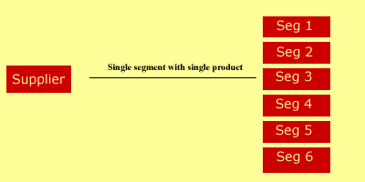
The first is the single segment with a single product. In other word, the marketer targets a single product offering at a single segment in a market with many segments. For example, British Airway's Concorde is a high value product aimed specifically at business people and tourists willing to pay more for speed.
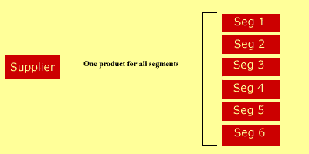
Secondly the marketer could ignore the differences in the segments, and choose to aim a single product at all segments i.e. the whole market. This is typical in 'mass marketing' or where differentiation is less important than cost. An example of this is the approach taken by budget airlines such as Go/
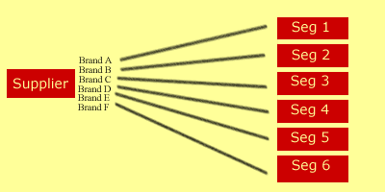
Finally there is a multi-segment approach. Here a marketer will target a variety of different segments with a series of differentiated products. This is typical in the motor industry. Here there are a variety of products such as diesel, four-wheel-drive, sports saloons, and so on.

Positioning is undoubtedly one of the simplest and most useful tools to marketers. After segmenting a market and then targeting a consumer, you would proceed to position a product within that market.
As perception differs from person to person, so do the results of the positioning map e.g. what you perceive as quality, value for money, etc, is different to my perception. However, there will be similarities.

Positioning Map:
Products or services are 'mapped' together on a 'positioning map'. This allows them to be compared and contrasted in relation to each other. This is the main strength of this tool. Marketers decide upon a competitive position which enables them to distinguish their own products from the offerings of their competition (hence the term positioning strategy).
Take a look at the basic positioning map template below

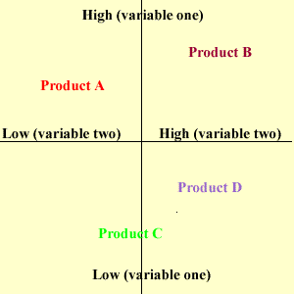
The marketer would draw out the map and decide upon a label for each axis. They could be price (variable one) and quality (variable two), or Comfort (variable one) and price (variable two). The individual products are then mapped out next to each other Any gaps could be regarded as possible areas for new products.
The term 'positioning' refers to the consumer's perception of a product or service in relation to its competitors. You need to ask yourself, what is the position of the product in the mind of the consumer?
Trout and Ries suggest a six-step question framework for successful positioning:
1. What position do you currently own?
2. What position do you want to own?
3. Whom you have to defeat to own the position you want.
4. Do you have the resources to do it?
5. Can you persist until you get there?
6. Are your tactics supporting the positioning objective you set?

Look at the example below using the auto market.
Product: Ferrari, BMW, Proton, Mercury Cougar, Hyundai, Daewoo.
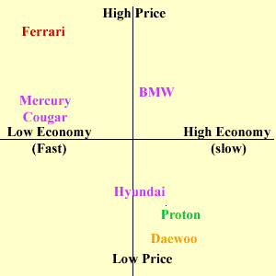

Positioning Map for Cars.
The seven products are plotted upon the positioning map. It can be concluded that products tend to bunch in the high price/low economy(fast) sector and also in the low price/high economy sector. There is an opportunity in the low price/ low economy (fast) sector. Maybe Hyundai or Daewoo could consider introducing a low cost sport saloon. However, remember that it is all down to the perception of the individual.
Unit 5

Marketing information system
A marketing information system (MIS) is intended to bring together disparate items of data into information. An MIS also provides methods for interpreting the information the MIS provides.
Moreover, as Kotler's definition says, "A marketing information system is a continuing and interacting structure of people, equipment and procedures to gather, sort, analyse, evaluate, and distribute pertinent, timely and accurate information for use by marketing decision makers to improve their marketing planning, implementation, and control".

Components of a marketing information system
Following Figure illustrates the major components of an MIS, the environmental factors monitored by the system and the types of marketing decision which the MIS seeks to underpin.
The marketing information systems and its subsystems
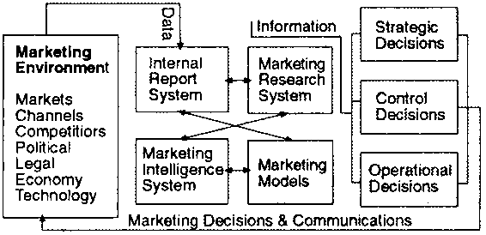
The explanation of this model of an MIS begins with a description of each of its four main constituent parts: the internal reporting systems, marketing research system, marketing intelligence system and marketing models.
Internal reporting systems: All enterprises which have been in operation for any period of time have a wealth of information. Information is usually categorised according to its nature so that there are, for example, financial, production, manpower, marketing, stockholding and logistical data. Often the entrepreneur, or various personnel working in the functional departments holding these pieces of data do not see how it could help decision makers in other functional areas. Similarly, decision makers can fail to appreciate how information from other functional areas might help them.
The internal records that are of immediate value to marketing decisions are: orders received, stockholdings and sales invoices. These are but a few of the internal records that can be used by marketing managers, but even this small set of records are capable of generating a great deal of information. Below, is a list of some of the information that can be derived from sales invoices:
· Product type, size and pack type by territory
· Product type, size and pack type by type of account
· Product type, size and pack type by industry
· Product type, size and pack type by customer
· Average value and/or volume of sale by territory
· Average value and/or volume of sale by type of account
· Average value and/or volume of sale by industry
· Average value and/or volume of sale by sales person
By comparing orders received with invoices an enterprise can establish the extent to which it is providing an acceptable level of customer service. In the same way, comparing stockholding records with orders received helps an enterprise ascertain whether its stocks are in line with current demand patterns.
Marketing research systems: Marketing research is a proactive search for information. That is, the enterprise which commissions these studies does so to solve a perceived marketing problem. In many cases, data is collected in a purposeful way to address a well-defined problem (or a problem which can be defined and solved within the course of the study). The other form of marketing research centres not around a specific marketing problem but is an attempt to continuously monitor the marketing environment. These monitoring or tracking exercises are continuous marketing research studies, often involving panels of farmers, consumers or distributors from which the same data is collected at regular intervals. Whilst the ad hoc study and continuous marketing research differs in the orientation, yet they are both proactive.
Marketing intelligence systems: A marketing intelligence system is a set of procedures and data sources used by marketing managers to sift information from the environment that they can use in their decision making. This scanning of the economic and business environment can be undertaken in a variety of ways, including:
Unfocused scanning | The manager, by virtue of what he/she reads, hears and watches exposes him/herself to information that may prove useful. Whilst the behaviour is unfocused and the manager has no specific purpose in mind, it is not unintentional
Semi-focused scanning | Again, the manager is not in search of particular pieces of information that he/she is actively searching but does narrow the range of media that is scanned. For instance, the manager may focus more on economic and business publications, broadcasts etc. and pay less attention to political, scientific or technological media.
Informal search | This describes the situation where a fairly limited and unstructured attempt is made to obtain information for a specific purpose. For example, the marketing manager of a firm considering entering the business of importing frozen fish from a neighbouring country may make informal inquiries as to prices and demand levels of frozen and fresh fish. There would be little structure to this search with the manager making inquiries with traders he/she happens to encounter as well as with other ad hoc contacts in ministries, international aid agencies, with trade associations, importers/exporters etc.
Formal search | This is a purposeful search after information in some systematic way. The information will be required to address a specific issue. Whilst this sort of activity may seem to share the characteristics of marketing research it is carried out by the manager him/herself rather than a professional researcher. Moreover, the scope of the search is likely to be narrow in scope and far less intensive than marketing research
Marketing intelligence is the province of entrepreneurs and senior managers within a business. It involves them in scanning newspaper trade magazines, business journals and reports, economic forecasts and other media. In addition it involves management in talking to producers, suppliers and customers, as well as to competitors.
Some enterprises will approach marketing intelligence gathering in a more deliberate fashion and will train its sales force, after-sales personnel and district/area managers to take benefits of competitors' actions, customer complaints and requests and distributor problems.
Marketing models: Within the MIS there has to be the means of interpreting information in order to give direction to decision. These models may be computerised or may not. Typical tools are:
· Time series sales modes
· Brand switching models
· Linear programming
· Elasticity models (price, incomes, demand, supply, etc.)
· Regression and correlation models
· Analysis of Variance (ANOVA) models
· Sensitivity analysis
· Discounted cash flow
· Spreadsheet 'what if models
These and similar mathematical, statistical, econometric and financial models are the analytical subsystem of the MIS. A relatively modest investment in a desktop computer is enough to allow an enterprise to automate the analysis of its data. Some of the models used are stochastic, i.e. those containing a probabilistic element whereas others are deterministic models where chance plays no part. Brand switching models are stochastic since these express brand choices in probabilities whereas linear programming is deterministic in that the relationships between variables are expressed in exact mathematical terms.
Marketing information System with Intelligence base (MkIS):
A Market Information System (MkIS) is one that systematically gathers and processes critical business information, transforming it into actionable management intelligence for marketing decisions.

Note the following points:

- Market intelligence is not just about market information, but the whole gamut of external environment information needed to support key strategic decisions - about products, prices, investment priorities, entering joint ventures etc.

- The system is not purely a computer-based system. It is a total system that incorporates human processes for interpreting and processing information into intelligence.

- The processes must be systematic, since only regular monitoring of key external parameters and integration of internal information will give a viable long-term intelligence base.

Benefits of an MkIS

Market and customer orientation - implementing an MkIS will encourage people throughout the organisation to focus externally.

Identification of new opportunities One company in a component industry identified a new trend before the 'expert' industry analysts.

Early warning of competitor moves - through good intelligence, One chemical company thwarted the siting of a competitor's manufacturing plant in one of their most profitable sales territories.

Minimizing investment risk - ongoing intelligence and analysis is more likely to temper unbridled enthusiasm to follow the bandwagon into those "mustn't miss the window of opportunity" markets

Better customer interaction - An insurance company downloads into their salespeople's portables up to date profiles, order history and relevant 'news bites', for the clients they are about to visit.

Better market selection & positioning - good understanding of customer needs and competitor positioning will help a company better carve out its own unique niche

Quicker, more efficient and cost-effective information - establishment of a system will make information more quickly and easily accessible.

Key Elements of an MkIS

Information:

A continuous flow of information is the lifeblood of a good market intelligence system - information about new technologies, markets, customers, the economic and regulatory environment etc. Both formal (routine reporting, factual) and informal information (gossip, opinions) must be tapped.

Information Management Processes:
With many professionals having external information delivered to their desktops, from online services such as Reuters or MAID, and increasingly from the Internet is easy to believe that users have all the information they need on tap. However, this is raw information and will need transforming into intelligence. Before that, however, this information must be classified, stored and made accessible - applying good practice principles of Information Resources Management (IRM).

Intelligence Development Processes:
A good intelligence system is more than information. It is a recurring cycle of linking the needs of decision makers to the processes of turning the information into actionable intelligence.

This requires human interpretation, communicating and sharing of information and perspectives between internal and external experts.

Computer Systems:
A comprehensive MkIS will combine many of the features of decision support systems, online databases and library systems. It is therefore likely to include many of the following:

For gathering information: CD-ROMs, online data-base access, data feeds, email, Internet access, filters, intelligent agents etc.

For storage and retrieval:Database/document management facilities, text retrieval, search engines, intelligent agents

For processing and analysis: modelling and visualisation software, groupware, group decision support systems (GDSS)

An Organizational Focus:
Although many professionals do much of their own information gathering and analysis, there still needs to be a clear focal point of MkIS responsibility. This may be a named individual or a small group who have the distinctive skills needed. Its role is to ensure a cohesive approach and effective interdepartmental co-ordination.

Developing an MkIS:
MkIS in most organisations evolves through several phases:

- Ad-Hoc. Individuals collect their own information. This phase culminates when management recognises the need to focus resources.

- Establishment of a specialist unit.

- Introduction of computer based solutions.

- Evolution into a full global electronic network.

- Recognition of information as a corporate asset with appropriate information resource management (IRM) policies and procedures.

- When appropriate, treating the resultant intelligence as a tradable commodity, to be shared with partners or sold externally.

Typical Applications:

- Strategic Analysis & Scenario Planning
- Environment Forecasting
- Acquisition targets
- Location of new plants
- Supplier evaluation
- Marketing Planning
- Industry analysis
- Competitor analysis
- New product introductions
- Product portfolio
- Pricing
- Sales & Marketing
- Sales cycle management (targeting etc)
- Database marketing
- Sales forecasting
- Promotion campaign assessment

Key factors:

1. Define the Customers.
Always a good place to start! For MkIS there are usually three distinct groups of customers who will need different solutions:
Field Personnel e.g. sales and service - their needs are immediate and specific: "I want the price of product X for competitor Y ... and I want it yesterday!"
Marketers and planners - more strategic but focused; market and product trends to develop marketing plans and adjust the mix - pricing, packaging promotion etc.
Board level management - strategic and broad: general industry and market developments that affect investment and other strategic decisions.

2. Understand Needs
A common starting point is an information audit a detailed analysis of information entities - their origins, uses, and formats. However, we would advocate a less onerous and more focused approach - the study of your customers' work and decisions, using structured interviews (taped if possible), focus groups etc.

3. Map Needs against Decisions & Sources
This will list information originators and users, sources required and decision supported. It will also identify high pay-off opportunities, for example where certain information has multiple uses.

4. Implement a Sourcing Strategy
The source/needs map from step 3 will point to clusters of information needs that can give economies in purchasing. For example, purchasing a networked CD-ROM may be more cost-effective than doing multiple ad-hoc online searches.

5. Define Information Policies & Standards
Steps 1-4 will reveal, often to many people for the first time, the sheer wealth of information that is available. This step therefore involves classification standards, ownership, life-cycle management standards and agreed 'protocols and procedures' between owners and users.

6. Select a Pilot Project.
This is to create a 'quick win' to demonstrate the power of an MkIS. Select a key decision process that involves people across several departments. Pricing can be a good one. It is something that needs to be reviewed regularly and has direct bottom line impact - a 1% price change flows straight to the bottom line and can equate to more than a 10% change in sales. The careful selection of a pilot cannot be overestimated. Pick the wrong one, and it be difficult to regain credibility.

7. Select & Adapt Appropriate Technology
With the selected pilot project acting as a focal point, now is the time to start detailed consideration of the computer solution. The choices are bewildering, and are proliferating daily. Therefore, selecting the right solution may need the involvement (or even the approval) of your MIS department - but make sure they are well-tuned into end-user computing styles (as opposed to the "we'll give users access to the Internet over my dead body" brigade - exact words recently relayed to me by an MIS manager).

8. Nurture the Intelligence Processes
This requires encouraging interaction across departmental boundaries and sub-cultures. Therefore, the creation of events and forums to encourage this interchange is often a useful starting point. Advanced MkIS users extend their systems access to business partners and external experts as part of this process.

9. Focus Dissemination
Intelligence on the shelf - or buried in a computer - is of little use to anyone. It needs to reach those in decision making situations. This can be in the form of regular dissemination, an alerting service or responding to an ad-hoc requests to the intelligence base. Many MkIS departments issue weekly or monthly bulletins of key developments. These should be short and focused. They give company relevant and specific information that no external newsletter, with its generic coverage, can provide.

10. Market the Capability
Good MkIS managers create two way interaction with their clients. Use all the techniques of marketing to reach your internal audience and consider carefully the incentives you can offer to encourage the regular inflow of useful information. After all the best intelligence is already probably lying somewhere within your own organisation. It comes from contacts made between employees and the outside world - marketing people at exhibitions, business managers at professional meetings, and perhaps, most important of all - salespeople on customer visits etc.

Market research for business planning
Market research is discovering what people want, need, or believe. It can also involve discovering how they act. Once that research is complete it can be used to determine how to market your specific product. Whenever possible, try to reduce risks at the earliest possible stage. For example you could carry out market research early on and not wait until you are almost ready to enter the market. If early market research reveals that your business idea has real potential, you can use this information in planning the build-up of your business.
For starting up a business there are a few things should be found out through market research in order to know if your business is feasible. These are things like:
- Market information
Market information is making known the prices of the different commodities in the market, the supply and the demand. Information about the markets can be obtained in several different varieties and formats. The most basic form of market information is the best quotation and last sale data, including the number of shares, with respect to a particular security at a given time.
Examples of market information questions are:

- Who are the customers?
- Where are they located and how can they be contacted?
- What quantity and quality do they want?
- What is the best time to sell?
- What is the long-term or historical price data over a number of years?
- What is the expected production in the country?
- Is there more demand for one product or another?
- Market segmentation
Market segmentation is the division of the market or population into subgroups with similar motivations. Widely used bases for segmenting include geographic differences, personality differences, demographic differences, use of product differences, and psychographic differences.
- Market trends
The market size is more difficult to estimate if you are starting with something completely new. In this case, you will have to derive the figures from the number of potential customers or customer segments.
But besides information about the target market you also need information about your competitor, your customers, products etc. A few techniques are:
- Customer analysis
- Competitor analysis
- Risk analysis
- Product research
- Advertising research

Perform market research
The steps involved in the market research process. The market research process has 4 basic steps. These steps include:
- Defining the research problem
- Establishing the research design
- Collecting and analyzing data
- Formulate findings

1. Defining the research problem
The step defining the research problem has two major dimensions: (1) formulating the problem and (2) establishing research objectives.
Defining the problem is the single most important step in the market research process. With the problem or opportunity defined, the next step is to set objectives for your market research operations. Research objectives, related to and determined by the problem formulation, are set so that when achieved they provide the necessary information to solve the problem.
A good way of setting research objectives is to ask, “What information is needed in order to solve the problem?" The problem description, the research question, sub questions and the research objectives are part of an overall document problem description. After describing and formulating the problem and the objectives, the next step is to prepare a detailed and realistic time frame to complete all steps of the market research process.

2. Selecting and establishing research design
The step selecting and establishing research design consists of 3 main steps: (1) select the research design, (2) identify information types and sources and (3) determine and design research instrument.

Select the research design
There are three types of research design:
- Exploratory research design -
- Descriptive research
- Causal research
Exploratory research: is defined as collecting information in an unstructured and informal way. For example if the owners of a new restaurant often eat out at competitor’s restaurants in order to gather information about menu selections, prices and service quality.
Descriptive research: refers to a set of methods and procedures that describe marketing variables. Descriptive studies portray these variables by answering who, what, why and how questions. These types of research studies may describe such things as consumers’ attitudes, intentions, and behaviors, or the number of competitors and their strategies.
Causal research: design is conducted by controlling various factors to determine which factor is causing the problem. It allows you to isolate causes and effects. By changing one factor, say price you can monitor its effects on a key consequence such as sales.

Identify information types and sources
There are two types of information available to a market researcher: primary data and secondary data.
Primary data is original information gathered for a specific purpose. Secondary data refers to information that already exists somewhere and has been collected for some other purpose. Both types of research have a number of activities and methods of conducting associated with them. Secondary research is usually faster and less expensive to obtain than primary research.
Information source
Secondary data help identify the problem; better define problem; develop an approach to problem; formulate an appropriate research design; answer certain research questions and test some research hypotheses; Interpret primary data more insightfully.

3. Determining and design research instrument
After determining which type(s) of information are needed, the methods of accessing data must be determined. There are several different methods of collecting data. These methods include
- Telephone surveys,
- Mail surveys,
- Personal interviews
- Group surveys.
The actual design of the research instrument, the data collection form that is used to ask and record the information is critical to the success of the project. There are two basic methods to collect information: by asking questions or by observing.
The most common research instrument is the questionnaire. There are two types of forms: structured and unstructured.
Structured questionnaires list close-end questions. These include multiple choice questions which offer respondents the ability to answer "yes" or "no" or choose from a list of several answer choices.
Close-end questions also include scales refer to questions that ask respondents to rank their answers at a particular point on a scale. Unstructured questionnaires have open-ended questions. Respondents can answer in their own words.

Collecting and analyzing data
Data collection is usually done by students. They are employed by field data collection companies to collect primary data. A choice has to be made between collecting the data yourself or hiring an external office who are specialized in interviews.
Data analysis is needed to give the raw data any meaning.
The first step in analyzing the data is cleaning the data. This is the process of checking the raw data to verify that the data has been correctly entered into the files from the data collection form. After that the data have to be coded. This is the process of assigning all response categories a numerical value. For example males = 1, females = 2. After that the data can be tabulated, which refers to the actual counting of the number of observations that fall in to each possible response category.
Data can also be collected on a smaller scale to obtain more qualitative data. One frequently used form of qualitative data collection is the focus group. Focus Groups are generally comprised of a small selection of the target audience. The participants are then queried and the discussions are guided by a moderator. The group is often recorded and/or viewed by the marketing team or others via a two-way mirror or closed circuit system.

Marketing research
Marketing Research is the search for and retrieval of existing, discovery or creation of new information or knowledge for a specific purpose. Research has many categories, from medical research to literary research. 'Marketing research is a form of business research. and Business-to-Business (B2B) Marketing Research, or Business Marketing Research, previously known as Industrial Marketing Research.
B2B Marketing Research investigates the markets for products sold by one business to another, rather than to consumers.
Consumer Marketing Research is a form of applied sociology which concentrates on understanding the behaviors, whims and preferences, of consumers in a market-based economy.
In addition to marketing research, other forms of business research include:
- Market research is broader in scope and examines all aspects of a business environment. It asks questions about competitors, market structure, government regulations, economic trends, technological advances, and numerous other factors that make up the business environment. Sometimes the term refers more particularly to the financial analysis of companies, industries, or sectors. In this case, financial analysts usually carry out the research and provide the results to investment advisors and potential investors.
- Product research - This looks at what products can be produced with available technology, and what new product innovations near-future technology can develop.
- Advertising research - This attempt to assess the likely impact of an advertising campaign in advance, and also measure the success of a recent campaign.

Types of marketing research
Marketing research techniques come in many forms, including:
- test marketing - a small-scale product launch used to determine the likely acceptance of the product when it is introduced into a wider market
- concept testing - to test the acceptance of a concept by target consumers
- Mystery shopping - An employee or representative of the market research firm anonymously contacts a salesperson and indicates he or she is shopping for a product. The shopper then records the entire experience. This method is often used for quality control or for researching competitors' products.
- store audit - to measure the sales of a product or product line at a statistically selected store sample in order to determine market share, or to determine whether a retail store provides adequate service
- demand estimation - to determine the approximate level of demand for the product
- Commercial eye tracking research - examine advertisements, package designs, websites, etc by analyzing visual behavior of the consumer
- Sales forecasting - to determine the expected level of sales given the level of demand. With respect to other factors like Advertising expenditure, sales promotion etc.
- customer satisfaction studies - exit interviews or surveys that determine a customer's level of satisfaction with the quality of the transaction
- distribution channel audits - to assess distributors’ and retailers’ attitudes toward a product, brand, or company
- price elasticity testing - to determine how sensitive customers are to price changes
- segmentation research - to determine the demographic, psychographic, and behavioral characteristics of potential buyers
- consumer decision process research - to determine what motivates people to buy and what decision-making process they use
- Positioning research - how does the target market see the brand relative to competitors? - What does the brand stand for?
- brand name testing - what do consumers feel about the names of the products?
- brand equity research - how favorably do consumers view the brand?
- Advertising and promotion research - how effective are ads - do potential customers recall the ad, understand the message, and does the ad influence consumer purchasing behaviour?
- Internet Strategic Intelligence - searching for customer opinions in the Internet: chats, forums, web pages, blogs... where people express freely about their experiences with products, becoming strong "opinion formers"
- Marketing Effectiveness and analytics - Building models and measuring results to determine the effectiveness of individual marketing activities
All of these forms of marketing research can be classified as either problem-identification research or as problem-solving research.
A company collects primary research by gathering original data. Secondary research is conducted on data published previously and usually by someone else. Secondary research costs far less than primary research, but seldom comes in a form that exactly meets the needs of the researcher.

Marketing research methods
Methodologically, marketing research uses the following types of research designs:
A-BASED ON QUESTIONING:
- Qualitative marketing research - generally used for probing purposes - small number of respondents - not generalize to the whole population - statistical significance and confidence not calculated - examples include focus groups, in-depth interviews, and projective techniques
- Quantitative marketing research - generally used to draw conclusions - tests a specific hypothesis - uses random sampling techniques so as to infer from the sample to the population - involves a large number of respondents - examples include surveys and questionnaires
B-BASED ON OBSERVATIONS:
- Ethnographic studies -, by nature qualitative, the researcher observes social phenomena in their natural setting - observations can occur cross-sectional (observations made at one time) or longitudinally (observations occur over several time-periods) - examples include product-use analysis and computer cookie traces
- Experimental techniques -by nature quantitative, the researcher creates a quasi-artificial environment to try to control spurious factors, then manipulates at least one of the variables - examples include purchase laboratories and test markets
Researchers often use more than one research design. They may start with secondary research to get background information, and then conduct a focus group (qualitative research design) to explore the issues. Finally they might do a full nation-wide survey (quantitative research design) in order to devise specific recommendations for the client.

Business to business market research
Business to business (b2b) research is inevitably more complicated than consumer research. The researchers need to know what type of multi-faceted approach will answer the objectives, since seldom is it possible to find the answers using just one method.
There are four key factors that make b2b market research special and different to consumer markets:
- The decision making unit is far more complex in b2b markets than in consumer markets
- B2b products and their applications are more complex than consumer products
- B2b marketers address a much smaller number of customers who are very much larger in their consumption of products than is the case in consumer markets
- Personal relationships are of critical importance in b2b markets.
Consumer behavior is the study of how people buy, what they buy, when they buy and why they buy.

Market Segment:
Market segmentation is the process in marketing of dividing a market into distinct subsets (segments) that behave in the same way or have similar needs.

The requirements for successful segmentation are:
- homogeneity within the segment
- heterogeneity between segments
- segments are measurable and identifiable
- segments are accessible and actionable
- segment is large enough to be profitable

Segment DAMAS:

D Differential: it must respond differently to a different marketing mix
A Actionable: you must have a product for this segment to be accured
M Measurable: size and purchasing power can be measured
A Accessible: it must be possible to reach it efficiently
S Substantial: the segment has to be large and profitable enough

The variables used for segmentation:
- Geographic variables
- Region of the world or country, East, West, South, North, Central, coastal, hilly, etc.
- Country size/country size: Metropolitan Cities, small cities, towns.
- Density of Area Urban, Semi-urban, Rural.
- Climate Hot, Cold, Humid, Rainy.
- Demographic variables
  - age
  - gender Male and Female
  - sexual orientation
  - family size
  - family life cycle
  - Education Primary, High School, Secondary, College, Universities.
  - income
  - occupation
  - education
  - socioeconomic status
  - religion
  - nationality/race
  - language
- Psychographic variables
- personality
- life style
- value
- attitude
- Behavioral variables
- benefit sought
- product usage rate
- brand loyalty
- product end use
- readiness-to-buy stage
- decision making unit
Depth segmentation: When numerous variables are combined to give an in-depth understanding of a segment.
Buyer profile: When enough information is combined to create a clear picture of a typical member of a segment.
*Cluster Analysis to determine the profile

The Customer Life Cycle (CLC)
CLC focuses upon the creation of and delivery of lifetime value to the customer i.e. looks at the products or services that customers NEED throughout their lives. It is marketing orientated rather than product orientated, and embodies the marketing concept. Essentially, CLC is a summary of the key stages in a customer's relationship with an organization.

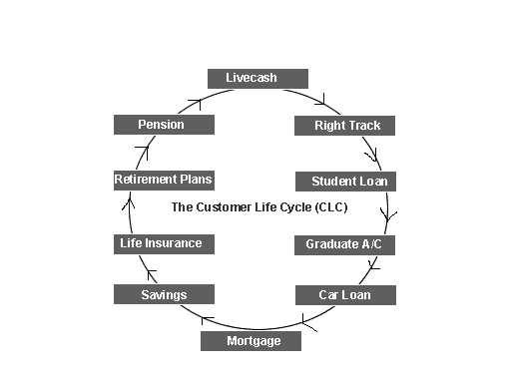

Let's consider an example from the Banking sector. HSBC has a number of products that it aims at its customers throughout their lifetime relationship with the company. Here we apply a CLC. You can start young when you want to save money. 11-15 year olds are targeted with the Live cash Account, and 16-17 year olds with the Right Track Account. Then when (or if) you begin College or University there are Student Loans, and when you qualify there are Recent Graduate Accounts.

When you begin work there are many types of current and savings account, and you may wish to buy property, and so take out a mortgage. You could take out a car loan, to buy a vehicle to get you to work. It would also be advisable to take out a pension.

Another important point is that a lifetime CLC is made up many shorter CLC's. So, for example, Volkswagen Cars retains a customer for many years and one can predict the products that meet a customers needs throughout his or her family lifetime. However the purchase of each car, will in itself be a CLC with many Customer Touch Points. The consumer may need a bigger vehicle as his or her family expands - so they visit VW's website and register.

The customer reviews models and books a test-drive with her or his local dealer. He or she decides to buy the car and arranges finance. The car is then delivered from the factory, and returns every year for its annual service. Then after three years, the customer decides to trade in his or her car, and the cycle begins again. The longer-term life cycle is simply the shorter-term life cycles viewed consecutively.

Bases of Segmentation:
There are two basic target audiences as:
  - Internal
Status: Doctor, Engineer, Teacher
Job: Secretary, Accountant, Cleaners
Department: Marketing, HRM, Purchase
Location: North, Sites, Factory,
  - External
    - Industrial External Market
Organization: Location, Wealth
Trade: Builders, Bakers
Profession: Dentist, teacher
Function: Marketing, Accounting
Purchasing Pattern: Value, Quantity
    - Consumer External Market
Demographic: Gender, Age
Psychographic: Social, Culture
Psychological: Motivation, Attitude
Criteria:
- Identifiable
- Recognizable
- Substantial
- Profitable
- Accessible
- Measurable
- Reliable / Stable
- Sustainable
Buyer decision process:
Buyer decision processes are the decision making processes undertaken by consumers in regard to a potential market transaction before, during, and after the purchase of a product or service.

In general there are three ways of analyzing consumer buying decisions. They are:
Economic models - These models are largely quantitative and are based on the assumptions of rationality and near perfect knowledge. The consumer is seen to maximize their utility. Game theory can also be used in some circumstances.
Psychological models - These models concentrate on psychological and cognitive processes such as motivation and need reduction. They are qualitative rather than quantitative and build on sociological factors like cultural influences and family influences.
Consumer behavior models - These are practical models used by marketers. They typically blend both economic and psychological models.

A general model of the buyer decision process consists of the following steps:
- Want recognition
- Search of information on products that could satisfy the needs of the buyer;
- Alternative selection;
- Decision-making on buying the product;
- Actual Purchase
- Post-purchase behavior
Stages of the Consumer Buying Process
Six Stages to the Consumer Buying Decision Process (For complex decisions). Actual purchasing is only one stage of the process. Not all decision processes lead to a purchase. All consumer decisions do not always include all 6 stages, determined by the degree of complexity...discussed next.
The 6 stages are:
- Problem Recognition awareness of need)--difference between the desired state and the actual condition. Deficit in assortment of products. Hunger--Food. Hunger stimulates your need to eat.
Can be stimulated by the marketer through product information--did not know you were deficient? I.E., see a commercial for a new pair of shoes, stimulates your recognition that you need a new pair of shoes.
- Information search--
  - Internal search, memory.
  - External search if you need more information. Friends and relatives (word of mouth). Marketer dominated sources; comparison shopping; public sources etc.
Hungry, want to go out and eat, evoked set is
- Maldivian food
- Chinese food
- Indian food

- Evaluation of Alternatives--need to establish criteria for evaluation, features the buyer wants or does not want. Rank/weight alternatives or resume search. May decide that you want to eat something spicy, Indian gets highest rank etc.
If not satisfied with your choice then returns to the search phase. Can you think of another restaurant? Look in the yellow pages etc. Information from different sources may be treated differently. Marketers try to influence by "framing" alternatives.
- Purchase decision--Choose buying alternative, includes product, package, store, method of purchase etc.
- Purchase--May differ from decision, time lapse between 4 & 5, product availability.
- Post-Purchase Evaluation--outcome: Satisfaction or Dissatisfaction. Cognitive Dissonance, have you made the right decision. This can be reduced by warranties, after sales communication etc.
After eating an Indian meal, may think that really you wanted a Chinese meal instead.

Family Life Cycle:
Individuals and families tend to go through a “life cycle.” The simple life cycle goes from:
Bachelor Stage:
- Young Single not at home with family
- Low Income but high discretionary income
- Decision influence by peer, References
- Few financial burden
- Fashion and opinion leader
- Recreation oriented
- Buy – Basic household, car, games, holidays
Newly married couple:
- Young no children
- Financially better off
- High income and High commitment
- Buy: Cars, Durables, Holidays, Insurances
Full Nest 1:
- Children under six
- Low income High debt
- High house hold purchase
- Low savings
- Dominated by children needs
- Buy: Necessities, Children purchases
Full nest -2:
- Last born over six
- Improved income
- Low debt
- Dominated by children needs
- Buy: Child oriented
Full Nest -3
- Older couple with dependent children
- Better financial position
- Both Parent on job
- Health & education domination
- Buy: Education, Holidays, Unnecessary gadgets
Empty Nest -1
- Older couple
- No children at home
- High income
- Low expense
- Interest on own improvement
- Buy: Holidays, Luxurious items, Renovations
Empty Nest-2
- Older couple
- No children at home
- Single income
- Concern on savings and pension
- Medical care
- Buy: Medicines and health related
Solitary Survivor-1
- Widow or widower
- Still working
- Low income
- Adjusted living
- Buy: Health and hobby
Solitary Survivor-2
- Widow or widower
- Not working
- Low income
- Poor health
- Dependent
- Buy: Health

Family Decision Making
Individual members of families often serve different roles in decisions that ultimately draw on shared family resources.
Some individuals are information gatherers/holders, who seek out information about products of relevance. These individuals often have a great deal of power because they may selectively pass on information that favors their chosen alternatives. Influencers do not ultimately have the power decide between alternatives, but they may make their wishes known by asking for specific products or causing embarrassing situations if their demands are not met. The decision maker(s) have the power to determine issues such as:

- Whether to buy;
- Which product to buy (pick-up or passenger car?);
- Which brand to buy;
- Where to buy It
- When to buy.

Note, however, that the role of the decision maker is separate from that of the purchaser. From the point of view of the marketer, this introduces some problems since the purchaser can be targeted by point-of-purchase (POP) marketing efforts that cannot be aimed at the decision maker. Also note that the distinction between the purchaser and decision maker may be somewhat blurred:
- The decision maker may specify what kind of product to buy, but not which brand;
- The purchaser may have to make a substitution if the desired brand is not in stock;
- The purchaser may disregard instructions (by error or deliberately).
It should be noted that family decisions are often subject to a great deal of conflict. The reality is that few families are wealthy enough to avoid a strong tension between demands on the family’s resources.
Conflicting pressures are especially likely in families with children and/or when only one spouse works outside the home.
Culture:
Culture is part of the external influences that impact the consumer. That is, culture represents influences that are imposed on the consumer by other individuals.
Dominant Family Purchase

PRODUCT | DOMINANT DECISION  MAKER | TYPICAL DECISION
Women’s casual clothing | Wife | Price, style
Vacations | Both | Whether to go, where
Men’s casual clothing | Husband | Type, price, style
Life insurance | Husband | Company, coverage
Homeowner’s insurance | Husband | Company, coverage
Household appliances | Wife | Style, brand, price

Types of buyer behaviour:
- Complex buyer behaviour e.g. Intel Pentium Processor
- Dissonance-reducing behaviour (brand reduces after-sales discomfort)
- Habitual buying behaviour e.g. salt - little difference
- variety seeking behaviour - significant brand differences e.g. soap powder

Types of Consumer Purchase Decisions

Minor New Purchases – these purchases represent something new to a consumer but in the customer’s mind is not a very important purchase in terms of need, money or other reason (e.g., status within a group).

Minor Re-Purchases – these are the most routine of all purchases and often the consumer returns to purchase the same product without giving much thought to other product options (i.e., consumer is brand loyalty).

Major New Purchases – these purchases are the most difficult of all purchases because these are important to the consumer but the consumer has little or no previous experience making the purchase AND is important. This type of decision often (but not always) requires the consumer to engage in an extensive decision-making process.

Major Re-Purchase - these purchase decisions are also important to the customer but the customer feels more confident in making the decision since they have experienced purchasing the product in the past.

