N E W S L E T T E R

Volume I Number 3 SUMMER ISSUE 2000 June 2000

Summer Regional on July 29th with Staten Island Yankees

©By Steve Nadel

For the second consecutive year, the NYC Casey Stengel Chapter will hold a summer regional. This year we will hold it in Staten Island, NY.
Those who will attend will be treated to a game between the Yankees Class A Penn League team and the Braves Class A Penn League team, the Jamestown Jammers.
Tentative Schedule of Events:
4 PM Picnic Area—Meeting
5 PM Picnic Area—Food Included
6 PM Go to seats for BP and the Game
7 PM The Game

In this Issue

Summer Regional p.1 Editorial p.2
Minor Leagues
by Frank Priegue p.3
Mets Matters p.4
Yankee Clippings p.4
All-Time Beans
by Frank Vaccaro p.5
Member Profile: Mike Caragliano p.6
NY vs. Philadelphia 8/25/1888
by John J. O’Malley p.7
Fielding Statistics
by Joe Wayman p.8
Little League Mom
by Roberta Newman p.9
Baseball & Ethics p.10
Ode to Casey Stengel
by Ev Parker p.11

Name that Newsletter—Send in your suggestion for the name of the Casey Stengel Chapter Newsletter.
See page 11-12 for details

The entire cost will be $20 for each person. If you want to skip the meeting and want to sit with the SABR group, the ticket is $9.
If you want to attend, make checks payable to: NYCSABR
Mail checks to:
SABR NYC Regional
C/O Philip Goldberg
43-57 Union Street #2B
Flushing, NY 11355
You must include a Self-Addressed Stamped Envelope.
There will be no admission to the picnic area without purchasing a game ticket. Partial payments will be returned.
If you are interested in sharing research in an oral presentation form, contact Burt Blum at (718) 891-8396. We currently have two spots open, so contact Burt ASAP.
This is the 19th Casey Stengel chapter meeting. The gatherings were started by Gary Kelleher in 1984. For the Summer 2001 meeting, we’ll try the Flushing Library tied in with a Mets game.
If you have any questions, contact me, Steve Nadel, by e-mail at Gongee@worldnet.att.net or call me at (718) 409-4527.
I hope to see you there.

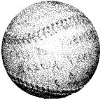

John O’Malley to Give Tour

John J. O’Malley will give a tour of the Moravian Cemetery on Staten Island as part of the June 29th regional evens before the game. He will include a short talk on Jim Murtrie and the early Metropolitans and giants, as well.
Anyone interested in this tour can find out more information by e-mailing ebegley2@juno.com or calling (212) 477-8809.

More from John O’Malley on page 7

Editorial

©By Burt Bloom

Hey there baseball fans! Can you believe that we are approaching the All-Star game? Is the season nearly half over? Are you surprised how some of the clubs playing in their new “digs” are under-performing? Do not ask the Houston Astros about new Enron Field. At least the hitters may like it, but not the pitchers. With pitching being in such short supply right now in the major leagues, any team that has three (even two) decent to good starting pitchers has a better than even chance of winning a spot in the playoffs. Current philosophy seems to be that if a team can get into their opponent’s bullpen by the fifth or sixth inning, they have the advantage. Is that a fair deduction? What do you think?

Speaking of thinking about the game, what do you think about interleague play? I think it is a gimmick. It is an admission that owners cannot market the game well enough so they have to resort to trickery and fool with the schedule. Perhaps I am in the minority, but I would much rather see the Mets play the Braves more often than seeing the Flushing Faithful play the Devil Rays. Yankee fans would rather see them play their traditional rivals than see the Bronx Bombers play the Phillies at Veterans Stadium. Can you see Boss George screaming about playing these lousy NL teams should Paul O’Neill rip up his legs on the turf at the Vet? Sure, Mets-Yankees is exciting, but whatever happened to the sanctity of the World Series? It all flew out the window when the owners had to figure out another way to pack stadiums and make a buck. Just remember one thing, my fellow fans. For every Yankee-Mets interleague game for which tickets get gobbled up. The usual 17,000 or so are not exactly elbowing their way in somewhere else. Does Montreal or Minnesota come to mind?

Now here is another subject on which I have strong feelings—baseball fights. Did you catch that fight earlier in this wild 2000 campaign between Chicago and Detroit? For a moment, I thought I was watching the Blackhawks play the Red Wings (Only joshing. WE all know hockey is a great sport, and I love it). However, something drastic needs to be done when grown men feel the need to settle disputes with violence. I know all the talk that they have to support one another, blah blah blah. Think of the image this sends to children. Every punch is plastered all over the television. Inevitably, whenever there is a “basebrawl,” those “highlights” get shown first, rather than the game action. I remember one prominent New York sportscaster used to show hockey fights between a couple of goons and parade it off as a spectacle. Well, it is not. No matter how you slice it, a fight is still a fight. These people have to set a better example. The problem is none of the major team sports has the stomach nor the will to legislate fighting out of their respective games. I guess what I object to the most is that every one in baseball joins in the fun when a player chargers the mound. At least in hockey, they have largely stopped the bench-clearing brawls. One player squares off against another until one goes down to the ice. Then, the linesmen separate them. Why is it that hockey is the only team sport where officials break up fights? In any event, here is my idea:

Suppose instead of a field littered with bodies, that players were forced to stand up for themselves. Let’s say a pitcher coughs up home runs to consecutive batters and then he plunks the next guy. Well, can this guy make it any more obvious? Discretion has to be taken away from the umpires. Throw that pitcher and the manager out immediately. Bud Selig has to mandate this. However, say Albert Belle is the next hitter, and he gets nailed in the backside. He would have to lay down his bat, and then he could go after the pitcher. That is right. One on one. Pitcher versus batter. No one else can join in. Do you think that pitcher would be as inclined to throw at a batter knowing that some slugging, hulking freight train of a batter is charging after him at full speed. Mind you, too may batters lean out over the plate and almost invite being struck. Jeff Bagwell of the Houston Astros has been hit numerous times in his career. I have yet to see him initiate a fight. He understands the risks involved.

Too many players today whine when a pitcher pitches them inside and backs them off of the plate. On the other hand, look at the advantage American League pitchers have. They have no fear at all because they know they won’t come up to bat, and their teammates will be there to protect them. The great Pedro Martinez has been seen to let a ball sip out of his hands. He’ll think twice about “accidentally” letting a fastball get away knowing he may have to defend himself. I am not condoning violence in any way. Willie Mays never ran after Bob Gibson. He know if Gibby surrendered a homer, he might be eating a dirt sandwich. But baseball is the only game that permits non-participants on the playing field (coaches, managers), Why? It is a tradition. Fighting is also a tradition which needs to be halted. Immediately. Now. There is no reason for it. Let’s get rid of it.

That is my opinion. What do you think? I took the time and trouble to write my beliefs. You can do the same.

Society for American Baseball Research
Casey Stengel Chapter Newsletter

Editors
Evelyn Begley
Burt Bloom
Roberta Newman

Art Director
Roberta Newman

The Minor Leagues

©By Frank Priegue

One of the biggest differences between the major leagues and the minor leagues is the travel. Big league ball players have equipment managers to pack and move their equipment for them receive sixty dollars a day in meal money, and travel by chartered jet.
Minor leaguers carry their own bags and move the equipment themselves, receive anywhere from twelve to twenty-five dollars a day in meal money and, with the exception of the International League, the Pacific Coast League, and the Texas League, travel by bus.
One of the first things every minor league ballplayer learns is that the bus rides are not fun, just long and monotonous. The constant travel is just another part of the job, like hitting and fielding, and, for most of them, the biggest adjustment they will make is living their lives out of a suitcase for three months a year.
When a team leaves for a road trip, many players try to arrive early, in hopes of getting their own seat so they don’t have to share with another player—it does not always work. With about forty-four to forty-six seats for twenty-five to thirty people, about half of them will have to share a seat. Having your own seat on the bus is a sign of status, usually determined by seniority.

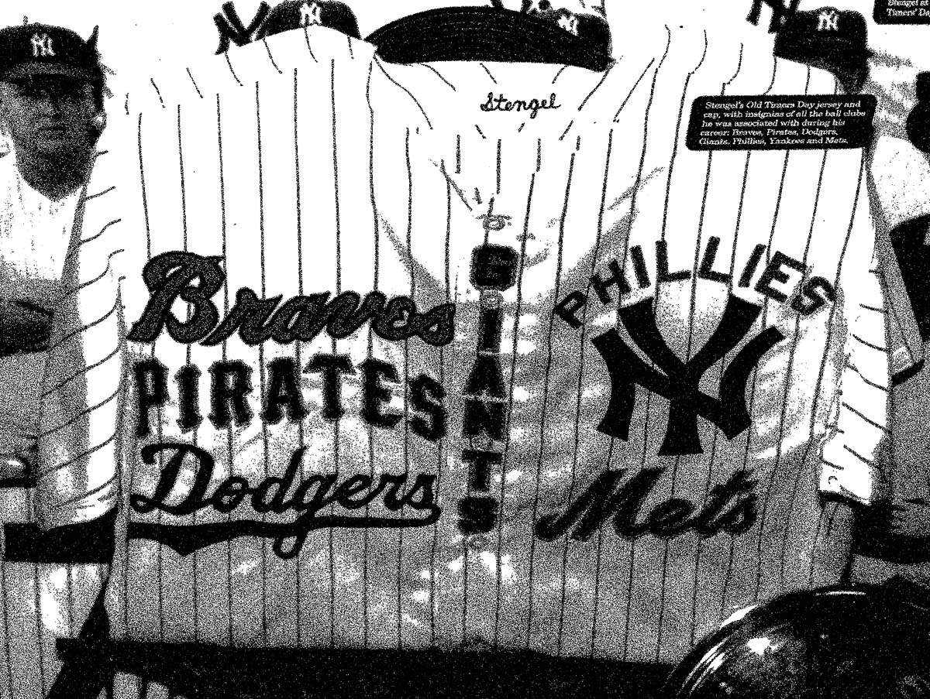

Players with Major League, Triple A, and Double A experience have priority—the rookies have to double up. In the old days, when the busses had overhead racks, smaller players would climb up to get some sleep. With no overhead racks, some players will bring inflatable rafts and sleep in the aisles.
A major challenge for minor leaguers is stretching their meager meal money into three meals—the task becomes more difficult. When they arrive at the visiting clubhouse, they have to pay the clubhouse attendant, the clubbie, dues. A Double A ballplayer receives twenty dollars a day and is required to pay between three and five dollars a day.
Not all clubhouses are created equal, but in most, the players will find peanut butter and jelly and some watermelon and cantaloupe, and either Kool Aid or Gatorade to drink. Away from the clubhouse, fast food is the main source of their diets. Although in recent years, players have been traveling with blenders and taking along meal replacement systems like Met-Rx.
After three or four days in a city, the cycle continues. After the game, they again pack up their equipment, load the bus, and they are off to another city. It does not matter if there is a rain delay or the team had to play fourteen innings in ninety-five degree heat.
Arriving in a different town at different hours of the night is part of the routine. Players will arrive tired and may have ha sub-par game the next day. The more successful players are those who learn to overcome this. But they all must have the proper mindset. Tomorrow there is another game to play.

Frank Priegue is a freelance photographer and writer, currently working on a book on the Double A Eastern League. Check out his website: www.twostesaway@erol.com

Mets Matters

©By Ross Adell

On April 20, Melvin Mora smacked his first career regular season home run against the Milwaukee Brewers. You may recall that Mora blasted a home run in the second game of last year’s National League Championship Series in the fifth inning against Atlanta’s Kevin Millwood, giving the Mets a short-lived 2-0 lead. The Braves went on to score four runs in the bottom of the sixth and won the game 4-3.
The significant part about Mora’s first regular season round-tripper was that it was a game –ending home run. As of this date, May 27, 2999, the Mets have hit a total of 90 regular season game-ending homers since the franchise began in 1962, and only three times it resulted in the batter’s first major league home run.
The first time it occurred was on September 24, 1976, when Billy Baldwin (no relation to the famous acting family) came up as a pinch hitter for relief pitcher Sip Lockwood in the ninth inning and took Joe Coleman “deep”
for a 4-3 Met victory over the Chicago Cubs. The next year, on June 21, 1977,(six days after the Seaver trade) Steve Henderson went “downtown” on Atlanta’s Don Collings with two runners on base in the 11th inning, giving the Mets a 502 win. Mora’s first regular season homer was a solo shot with one out in the 10th inning and was hit against Curtis Leskanic and gave NY a 5-4 win.
Incidentally three players share the lead in Met career game-ending homers: Chris Jones, Cleon Jones, and Kevin McReynolds. Each of these players has clouted four game-enders while playing for the Mets.
The Mets have hit two game-ending home runs in post-season play. On October11, 1986, Lenny Dykstra hit a two-run homer off Houston’s Dave Smith in the ninth inning of Game Three of the NLCS, giving the Mets a 6-5 win and a two games to one lead. Todd Pratt hit a solo shot in the 10th inning off Arizona’s Matt Mantei last October9th to give the Mets a 4-3 win and clinch the National League Division Series, three games to one. It was the fourth time a post-season series ended on a home run. Bill Mazeroski and Joe Carter did it in a World Series and Chris Chambliss did it in a Championship Series. Ironically, neither Dykstra nor Pratt have hit a regular season game-ending homer.

Career Regular Season Game-Ending Home Runs by Current Mets (as of 5/27/2000)

Robin Ventura—5
Mike Piazza—4(1)
Todd Zeile—3
Jon Nunnally—2
Derek Bell—1
Melvin Mora—1 (1)

Note on Mets Matters:
Number in parenthesis indicates game-ending home runs as a Met.

Yankee Clippings

©By Al Blumkin

The Yankees have a 28-19 record as of May 29 and are ½ game behind the Boston Red Sox in the American League East.
They have this record despite their low standing sin key offensive categories such as runs scored and on-base percentage. Derek Jeter and Chuck Knoblauch, who are normally the keys to the offense, have been hurt fairly frequently.
The Yankees compiled a 3-7 record during Jeter’s recent stint on the disabled list. They have received good offensive production from Bernie Williams, Paul O’Neill, and Jorge Posada. Tino Martinez has been mediocre, while Ricky Ledee and Scott Brosius have been awful.
The pitching staff has held its own. In these days of 10-9 games, they have been better than average. The middle relief corps of Jeff Nelson, Mike Stanton, Ramiro Mendoza, and Jason Grimsley has been outstanding. Mariano Rivera has been shaky.
However, the team needs better production for Roger Clemens (despite last Sunday), David Cone, and Orlando Hernandez, if they are to dominate the AL East.
They should have more than enough to qualify for post-season play.
The only other legitimate contenders at this point seem to be Boston, Cleveland, Chicago (the surprise team so far), and whoever survives in the AL West.

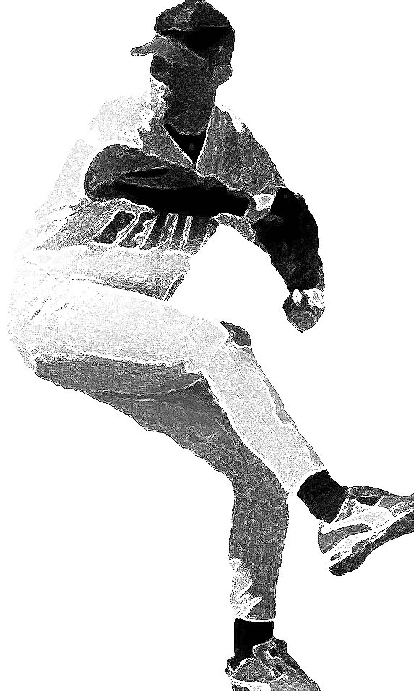

All-Time Beans
©By Frank Vaccaro

May 30, 2000. The April 22 bean-brawl between Chicago and Detroit had everyone guessing if this is the year the bean-ball takes over and ruins the sport. Here we go again. The bean-ball predates major league baseball itself, but the bean-brawl doesn’t.
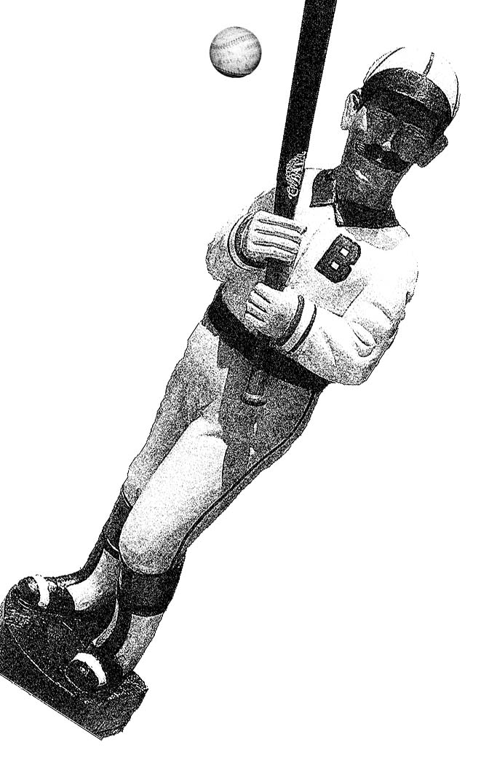
The first big bean-brawl came in Detroit on Friday the 13th, June 1924. Reliever Bert Cole had given up four runs and the lead to New York (the two teams had been tied for first place the day before), and in the bottom of the inning, his Tiger teammates laid the abuse on thick. Manager Ty Cobb called him a “quitter” and sent the demoralized pitcher out to pitch the ninth. Three straight times, Cole tried nailing the leadoff batter, Babe Ruth, before Ruth fouled out. Then, Bob Meusal batted with catcher Johnny Bassett screaming for Cole to bean him. Cole hit him square on the back and the dugouts emptied. A thousand fans slid onto the field from the grandstand, and Detroit had to forfeit.
Prior to that game, bean-ball incidents played second fiddle to spikings, personal abuse, and even rule book wrangling as a reason to have a riot. The hit-by-pitch rule itself did not entitle a batter to a base before 1885. (The rule was actually adopted by the AA in 1884 but not enforced effectively by the umpires.) Before then, a pitcher could hit a batter three or four times in one at bat. Many pitchers beaned a batter during a threat with the bases loaded. Then, after a ten-minute delay, the shaken batter would have to stand in again to finish the at-bat (see Philadelphia at Columbus, September 13, 1883). The ball was softer and pitchers probably did not throw ninety miles an hour yet, so injuries from beanings are hard to find in baseball’s early days.
The hit-by-pitch rule as it stands today was put in place to speed up games. The first players to suffer serious career-ending beanings were Bill McGunnigle in 1885 and Bob Allen in 1894, his wife fainting in the grandstand. Hugh Jennings is reported to have had a skull fracture in 1897 from a Rusie pitch in June 28, but he stayed in the game for a while and only missed three days.
A list of beaning after that gets to sound like the Old Testament. Coakley beaned Bresnahan, who called for a priest as he fell. Mays beaned Chapman. Hadley beaned Cochrane. Feller beaned Lieber—with a curve ball! Melton beaned Lieber. Bowman beaned Medwich six days after Brooklyn paid $132,000 for him. Then Lee McPhail, the Dodger vice-president, ran on the field and challenged the St. Louis Cardinals to a fight while Medwick was being carried off. The Medwick beaning gave rise to the practical introduction of the batting helmet—to protect a team’s investment—and was McPhail’s third innovation. His other two? —Organ music and night games.
No review of beanings is complete without mention of Yankee coach Don Zimmer’s two beanings—the first by James Kirk in the minors that put a tantalum plate in his head, and the other three years later in 1956 by Hal Jeffcoat. Tony Conigliaro’s beaning in 1967 by grease baller Jack Hamilton came while he was wearing a helmet and has been etched into memory by the horrific June 22, 1970 cover of Sports Illustrated.
The worst Yankee “hit-by-pitch” occurred in the grapefruit league, March 26, 1920 to Chick Fewster, who could not talk for a month after having his scull fractured by the Dodgers’ Fred Pfeffer.
The worst for the Mets broke Rusty Staub’s hand, June 13, 1972, by George Stone, after the team had put together a 25-7 start and a six game lead.
Helmets have made serious injury by a bean-ball rare. Nobody knows that better than Ron Cey, who took a Goose Gossage fastball on the left temple in the 1981 World Series. Slow motion replays of the beaning made may fans sick, by Cey paled the next game. Brawls lead to worse injuries than a hit-by-pitch, so what to make of the argument that today’s athlete is protective of his million dollar body?
This April 30th Roberto Alomar took an off-speed pitch from Pedro Martinez on the thigh in a bean-ball tit-for-tat and was ready to charge the mound. Frank Robinson, hit by pitcher 198 times in his career, handed down the MLB’s seventeenth bean-ball-related suspension of the year to Pedro. Could you see the twinkle in his eye at the press conference? He remembers the day when “Drysdale hits Robinson on the third attempt,” was not a headline, but a drone sentence buried in the game report.

Thanks to Ross Adell for his contributions.

Note: The sidebar on page 4 of the February, 2000 newsletter, “The Latest Dates…Both New York Teams in First Place,” Frank Vaccaro notes, was only valid to July 31st, the day on which it was submitted. The Mets were tied for first place as late as August 22, on which they dropped to second place.

Updated list as of opening day, 2000:
August 22, 1999
August 11, 1981
July 28, 1988
May 15, 1986
May 14, 1976.

Member Profile:
Michael Caragliano

Born: Bronx, NY 3/6/72
Occupation: Radio Engineer, WABC (I run the board in the studio for Yankee broadcasts)
Favorite teams: Yankees, Mets

First ball game:

Saturday, September 29, 1984, at Yankee Stadium, the next-to-last day of the season. Tigers- 11, Yanks- 3. After four years of bugging my dad (he hates any sport where you can't eat what you catch), I finally went to a major league game when my eighth grade class got free tickets. One of my friend's dad was a police lieutenant, so he got us 200 tickets in the upper deck. Ron Guidry took the loss to fall to 10-11, his first ever losing season in the majors. Dave Winfield had two hits to move in front of Don Mattingly for the batting title lead (Mattingly would get three hits the next day to take the title.)

I played little league for three years, so, of course, the sheer size of the Stadium blew away anything I'd ever seen before. But, of course, the thing I remember most about that game was my brother stepping on the mustard packet that came with his hot dog, and managing to splatter it all over the back of the white sweater of a woman three rows in front of us (Jackson Pollock would have been proud of it.)

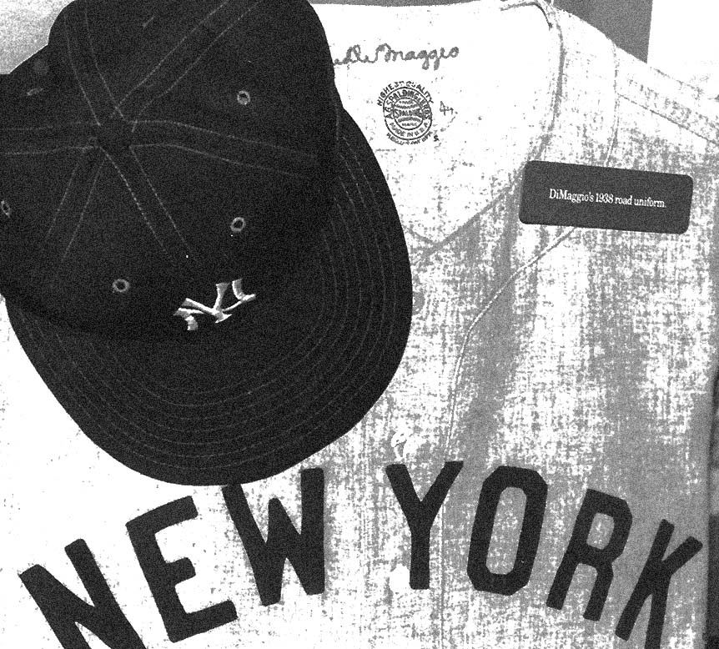

Favorite game attended:

Until SABR 29 took the top honors, there probably was no real favorite game I have attended. I've been to a few games won on last-swing homers (by Kevin Elster and Wade Boggs, no less). I've been to tight pitching duels (Steve Trachsel vs. Bill Pulsipher on July 3, 1995- what were you thinking hanging a slider to Rey Sanchez?). I've seen a couple of things no one thought they'd ever seen before of since (Rafael Belliard's second career homer passed right over my head in the left-field corner at Shea. Nobody in the park could even grasp the significance of the moment until it hit us as he rounded second, and 20,000 people let out that collective gasp of realization only a baseball crowd can make.) But mostly, I have a memory of each game- who I was with, where we were sitting, some great defensive play that dazzled us. Little things. I still have the ticket stubs to just about every game, by the way.

Why I like baseball:

The running gag I have is that I sold my soul to baseball when I was nine. I started following the game in 1981. I guess it always amazed me, to see a guy throw a ball at twice the speed of a moving car at another guy, while that other guy is standing there with a stick in his hands, waiting to send that ball 400 feet in the opposite direction.

Why I collect baseball cards:

For the Money!!! No, seriously, I got started with that in the fourth grade. A friend of mine had a bunch of last year's cards that he didn't want, so he gave them to me. I loved the photography- what was going through a player's mind as he stood there for his picture? After a while, it became a game- guess the park in the background, memorize the stats, and so on. Of course, my mom didn't like to play this game. I'm amazed she still hasn't killed me for every time we would go to Nino's Deli for a quart of milk, and she'd have to hear the inevitable, "Can I get another pack of cards?"

.

New York versus Philadelphia:
August 25, 1888
©By John J. O’Malley
The New York-Philadelphia game of August 25 was the second match-up between veteran pitchers Tim Keefe and Charlie Buffinton in 1888.
Two days earlier in Philadelphia, the Phillies, behind Buffinton, defeated the Giants and Keefe 3 to 2.
Philadelphia, although it was the home club, took the option of batting first.
Andrews opened the game with a single, but was eliminated as a base-runner when Fogarty fouled out to Giant catcher Ewing, who threw to Connor at first in time to double him up. Keefe then struck out Bastian to retire the side.
In the second for Philadelphia, Wood and Farrar each flied out while Clements struck out.
New York had three singles in the first, but failed to score. Ewing singled into left field. Richardson then struck out and Ewing was tagged out trying to steal second. Tiernan singled, went to second on a wild pitch and reached third on Ward’s single. Ward stole second, but Connor struck out to end the inning.
In the second, with one out, Whitney singled. He failed to advance, however, as Slattery struck out, and Keefe forced him at second.
In Philadelphia’s third, with one out, Irwin singled to left field and reached second on Buffinton’s grounder to Connor. A passed ball advanced Irwin to third. Andrews walked, then started for second. Ewing threw to Ward, who fired the ball back to him, with Irwin trying to score of a passed ball. Umpire Valentine at first ruled Irwin out, claiming Fogarty, in the batter’s box, had blocked Ewing’s play. Irwin objected, and Valentine reversed himself, ordering Irwin back to third and Andrews to first. Andrews then stole second followed by a walk to Fogarty. With the bases loaded, Irwin tried to score on a ball which at first eluded Ewing. Ewing recovered in time to trap Irwin between third and home. Third baseman Whitney made the out to retire the side.
For New York in the third, with two out, Tiernan homered over the right field wall to give New York a 1-0 lead. Ward hit to Irwin to close the inning.
Philadelphia had two hits and a base-on-balls in the fourth, but once again failed to score. With the bases loaded and two out, Irwin flew out to Giant third baseman Whitney.
The Giants were quickly disposed of in their half of the fourth. Connor walked, but O’Rourke hit into a double play. Whitney hit to Irwin at short to end the inning.
Buffinton, Andrews, and Fogarty went out in order in the fifth.
New York took a 5-0 lead in the bottom of the fifth. With one out, Keefe reached first, as Irwin dropped his towering fly ball. Keefe went to third on Ewing’s single and scored on Richardson’s double. Tiernan followed with a triple, scoring Ewing and Richardson/ Tiernan scored on Ward’s infield out. Connor struck out to end the inning.
Bastian., first up in the sixth, doubled, but was left stranded as Wood, Farrar,. And Clements went out in order.
In the bottom of the sixth, with one out Whitney doubled, but failed to advance as Slattery and Keefe were retired.
Mulvey, Irwin, and Buffinton went out in order in the top of the seven.
For the Giants, Ewing tripled. Richardson followed with a single, but Ewing was held at third base. Tiernan, who had previously singled, homered and tripled, doubled, scoring Ewing. Richardson scored on Ward’s infield out. Connor and O’Rourke were retired to close the inning with New York having a 7-0 lead.
Andrews, Fogarty. And Bastian went out 1-2-3 in the top of the eighth.
In the Giant’s turn at bat, Whitney singled, but was forced at second by Slattery. Keefe filed out to Wood, and Ewing forced Slattery out at second.
In Philadelphia’s last at bar, Wood singled, but was thrown out trying for second. Farrar fled out to Connor at first, and Clements struck out for the third time in the game.
For Keefe, it was the 30th win of the year giving him a total of six consecutive 30 victory seasons. He would win five more games in the year to raise his total for 1883-1888 to 222: 41-37-32-42-35-35. His lifetime total of 342 victories ranks eighth in major league history. In the 75-year history of the New York Giants, only Christy Mathewson would compile a more brilliant pitching record.
The Giant squad of 1888 boasted six future Hall-of-Famers: Tim Keefe, Mickey Welch, Buck Ewing, Roger Connor, John Ward, and Jim O’Rourke. Only Welch was absent from the August 25 lineup.
Two of the Phillies players should be mentioned. Charlie Buffinton in his 11 year pitching career would amass 233-152 lifetime won-loss totals, with seven 20-victory seasons. It includes a spectacular 48-16 record in 1884. In that year, he fanned 417 batters, sixth highest in major league history. Amazingly, he is still missing from the Hall of Fame. First baseman Sid Farrar is remembered not in his own right, but for his daughter, Geraldine, who would win world renown as a singer on the operatic stage.
Box Score p.8

Tim Keefe, 1888, courtesy Library of Congress
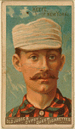
In Defense of
a Fielding Saves Statistic
©By Joe Wayman

Fielding saves? Why not, there is a rule recognizing pitching saves!
Now, let’s legitimize important fielding plays, too. An important fielding play is one that contributes to a team’s win. A fielding save play.
Exceptional, not always important, fielding plays were mentioned in the early (19th century) press baseball game highlights. All too often, today’s game descriptions omit comments on such plays—its about hitting a quotes we read.
The limited number of fielding record columns deters measuring, realistically, fielding worth. There appears to be no valuable counting stat proposal on the horizon.
Bill James has helped with his fielding range statistic. His fielding range formula (TC+G) has a weakness, the games are appearances. To be fair, use the number of innings played to determine the games (IP+9). Games based on IP account for fielding defensive changes and injury removals.
I developed and compiled two fielding counting, counting stats—the charging to a player’s record those unearned runs ant those that lost games for which he is responsible.
Every player’s unearned run was recorded over a seven year span, 1983-89. The 1983 record appeared in the Baseball Bulletin, summer 1984, and the balance in Grandstand Baseball Annual (GBA) editions. Unearned runs that directly lost games also were recorded over the seven years and totaled 13.3 % of the total defeats.
A few years ago, when the fielding saves stat began to gain favor, I thought it rated a rule book inclusion. When TB game highlights show fielders going over the fence to rob batters of a home run with a man or two on base, and two out, bottom of the ninth, his team ahead by one run, the drama and importance of this area reminds me of it again. There won’t necessarily be a game-saving play for each game, however.
Although there can be two game-saving plays (my proposed max.) in a game, they save but one game. When two game-saving plays occur, in record fairness, they should count .5 of a game. Thus, like pitchers, there can be no more than one save per game. I favor a fielding saves statistic. A player plus a club feat.

NOTE —— Joe Wayman is the editor and publisher of GBA (Grandstand Baseball Annual) and this article is from the 1998 GBA (p.5-6). For more information on GBA, write to Joe Wayman at P.O.Box 4203, Downey, CA 90241-1203.

[below: John J. O’Malley continued from page 7]

PHILADELPHIA

AB R H PO A E

Andrews, cf 3 0 1 0 0 0
Fogarty, rf 3 0 0 2 0 0
Bastian, 2b 4 0 2 2 2 0
Wood, lf 4 0 1 2 0 0
Farrar, 1b 4 0 1 8 0 0
Clements, c 4 0 0 6 1 1
Mulvey, 3b 2 0 0 1 1 1
Irwin, ss 3 0 1 3 7 1
Buffinton, p 3 0 0 0 4 0

TOTALS 30 0 6 24 15 3

NEW YORK

Ewing, c 4 2 3 7 4 0
Richardson, 2b 4 2 2 1 1 0
Tiernan, rf 4 2 4 3 0 0
Ward, ss 4 0 2 2 1 0
Connor, 1b 3 0 0 8 0 0
O’Rourke, lf 4 0 0 1 0 0
Whitney, 3b 4 0 3 2 1 0
Slattery, cf 4 0 0 3 0 0
Keefe, p 4 1 0 0 7 0

TOTALS 35 7 13 27 14 0

Earned runs NY 5
2 Base Hits Bastian, Richardson, Tiernan, and Whitney
3 Base Hits Ewing and Tiernan
Home Runs Tiernan
Double Plays Irwin and Farrar, Ewing and Connor
1st Base on Balls Andrews, Fogarty, Mulvey, and Connor
1st Base on Errors NY 1
Struck Out Andrews, Fogarty, Bastian, Clements (3), Irwin, Slattery, Richardson, and Connor (2)
Passed Balls Ewing 1
Wild Pitch Buffington 1
Stolen Bases Ward 1; Andrews, 1
Time of Game 2 hours.
Umpire Valentine

1 2 3 4 5 6 7 8 9

PHILADELPHIA 0 0 0 0 0 0 0 0 0 0
NEW YORK 0 0 1 0 4 0 2 0 X 7

Confessions of A Little League Mom

©By Roberta Newman

During the last two election cycles, a new phrase has entered our vocabulary, soccer mom. Politicians across the country court these mythical suburban women, who spend their mythical lives transporting their 2.3 children and friends to and from mythical suburban soccer fields. But while soccer moms represent what is generally perceived to be what is right with America, Little League moms, and dads—especially dads— have a bad rap.
Soccer moms smile broadly and proudly while little Johnny kicks one wide of the goal. It doesn’t matter, competition builds character. Little League moms yell profanities when Johnny misses a routine fly ball.
Soccer moms take Johnny and his smiling, fresh faced friends for ice cream. When faced with members of the opposing team, it’s cones for everyone. Little League moms send Johnny to his room for striking-out.
Soccer moms are always pleasant. Little League moms are downright mean.
Perhaps deservedly so, Little League moms, Little League parents, are seen as being difficult and contentious-- often far less mature than the Little Leaguers, themselves. When my own children were toddlers, I would stroll down Shore Road, past the diamonds, and see the worst humankind has to offer. If this was parenting in the late ’90’s, I wanted none of it. I swore up and down that my children would never be subjected to such indignities.
But then, something happened. My rather un-athletic son expressed a burning desire to play baseball. Who was I to prevent him from becoming an American Boy? After some research and a good deal of soul searching, my husband and I enrolled our budding ball player in the Prospect Park 78th Precinct Youth League, part of a non-traveling, teaching league
He was terrible. The experience was wonderful. Never has a group of parents defied stereotypes. Sure they were competitive. But first and foremost, they, like I, wanted the kids to have fun. And they wanted to have fun. Having fun may mean yelling at the odd umpire, but it never means berating the children. This is not to say that the kids were not criticized by the coaches for sloppy play, but criticism was always constructive. The only thing that was not tolerated was bad sportsmanship, from the boys AND from the parents. And amazingly, they won—Regularly.
Three years later, I am pleased to say that the boys are still together, still winning, and we are all still having a blast. As winter enters its darkest depths, I can honestly say that I look forward to those spring afternoons in the park—not always certain which child is at bat, what inning it is, or what the score is, but knowing for certain that it is there is no place I’d rather be. And I’m pleased to announce that my son has finally come out of his slump. After three seasons, he has finally gotten his first base hit.
Take that, soccer moms. 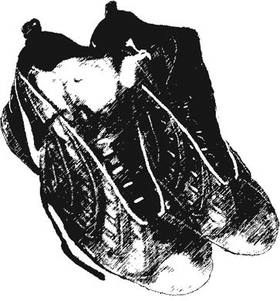

Baseball and Ethics
Jerry O’Connor fascinated the audience of the Philadelphia Regional with his questions about baseball ethics and would like anyone interested enough to fill out this survey to send it to him: Jerry O’Connor, 116 Baylor Avenue, Hillsdale, NJ, 07642.
He will send a copy of the results to anyone requesting it and thanks to all who take the time to respond to the questions below. Circle either Yes or No. Thank you.
1. When teams travel, should all players stay at the same facility? Y N

2. Should players be held accountable for off-the-field conduct? Y N

3. Should revenue-sharing be adopted to subsidize lower tier teams? Y N

4. Should bean ball pitch be legalized? Y N

5. Should bean ball pitch be tolerated? Y N

6. Should the penalty for intentional hit batter fine be suspension from rotations?Y N

7. If so, how many rotations? 1 2 3 4 5

8. Will re-distributing teams help to equalize tier issues? Y N

9. Should all umps call from the same side of the plate? Y N

10. Should a DH be adopted for both leagues? Y N

11. Should Pete Rose be re-instated? Y N

12. Should owners/managers be banned if convicted of a felony? Y N

13. Should the same ball be used in both leagues? Y N

14. If there is one change you would like to see, what is it? Y N

An Ode to Casey Stengel

©By Ev Parker

LIGHTS! CAMERA! ACTION!
NYC SABR on CABLE-TV
Mark your calendar for the October 2000 debut of Baseball Plus.
Want to be on TV? Contact ebegley2@juno.com

It’s been many a year

And many a crown

Since our pinstriped lads
Were in “Bucco Town.”

Sure they’ve got Friend
Vernon Law and Roy Face
But what they lack’s
A “Perfesser” named “Case”

New York, 1960

Note: Casey Stengel was fired by the New York Yankees after the 1960 World Series. His heavily favored team lost to the Pittsburgh Pirates in seven games on a Bill Mazeroski home run. Two years later, Casey was hired as the manager of the brand new 1962 Mets. Many still say that being fired by the Yankees was far less a punishment than being hired by the hapless Mets, where Casey coined the classic “Can’t anyone here play this game?”

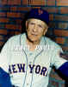

Photo from the George Brace Collection

Courtesy of Mary Brace
http://www.bracephoto.com/about.html

The cost of printing and mailing this newsletter has led to a dwindling of chapter funds, necessitating a $3 per year for 3 issues subscription rate. Your $3 will guarantee you the remaining newsletter for later this year, as well as the 3 newsletters we hope to produce next year.
Anyone contributing to the production of the newsletter (submitting features or fillers, collating, labeling, stamping, etc. the newsletter) will have the fee waived so please do make a contribution —— this is YOUR newsletter.
Thank you – Evelyn Begley

SEND WITH $3 CHECK PAYABLE TO: NYC SABR
To: Ross Adell, 141-10 28th Avenue, Flushing, NY 11354

YOUR NAME

ADDRESS

NAME THAT NEWSLETTER: The Windup? The Lineup? —any suggestions? We are currently soliciting suggestions for a name for this publication. Why not use this opportunity to express your creativity.

YOUR SUGGESTION

