VOLUME II NUMBER 1 SUMMER ISSUE 2001 JUNE 2001
Join Us for a Night At the Ballpark As Baseball Returns To Brooklyn!!

Summer Regional, 2001

©By Phil Goldberg
We are pleased to be a part of the historic first season of Brooklyn baseball since 1957 as we have our first ever get together at the brand new home of the Cyclones. The festivities will kick off at 3.30 PM with an exclusive tour of the ballpark followed by guest speakers from the club, and then watch the Cyclones battle the Hudson Valley Renegades at 6PM!
The price does not include parking or food.

If you wish to do a 15 minute presentation, please contact Philip at bike21@att.net or 718 353 4171 .

Our thanks to Marty Haber (son of SABR founder Bill Haber) for his help in making this the most memorable Chapter meeting ever!

For driving and subway directions please visit
http:// brooklyncyclones.net

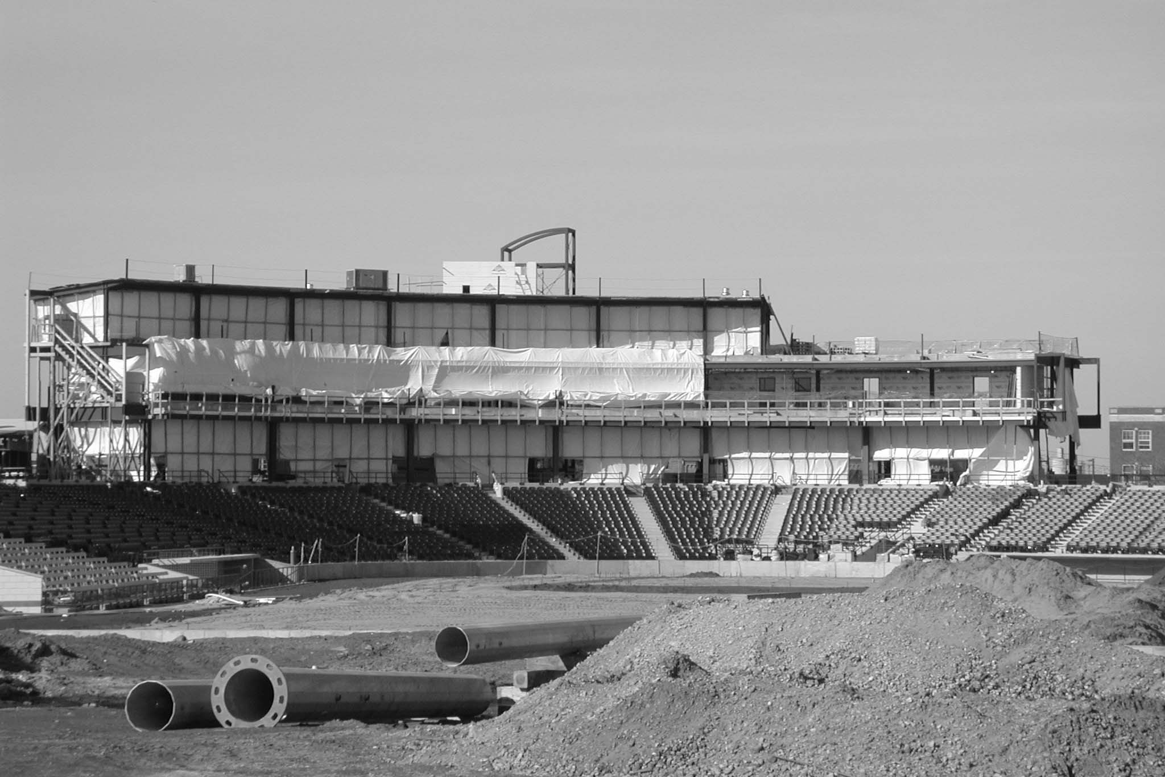
Photo by Ed Grupsmith

Date -- Saturday August 25, 2000 at 3.30 PM

Place --Keyspan Park, Home of the Brooklyn Cyclones
1904 Surf Ave . Brooklyn NY 11224

Cost--$10 payable to:

SABR Casey Stengel Chapter with a self-addressed stamped envelope. Send Checks to:

Philip Goldberg

43 57 Union St Apt 2B

Flushing NY 11355

IN THIS ISSUE:

P. 2-3… Jake Daubert in Poetry and Prose by Vic. Debs

P.4…Westchester News by John Vorperian

P.5…Web Meeting Summary & Goals

P.6…The 1939 New York Yankees by Paul Tarr

P.8… Yankee Clippings by Al Blumkin

P.8 … Met Matters by Ross Adell

p. 9… Tim O’Keefe’s 300th Victory by John J. O’Malley

P.11…Here’s the Pitch by Roberta Newman

Throughout : Ballpark Photos by Ed Grupsmith

Thank You to Sam Bernstein

Sam Bernstein, a Middle School Social Worker at Theodore Roosevelt Middle School in Elizabeth, NJ, recently wrote this after forming a junior chapter of SABR, mostly of 5th and 6th graders:

This effort to get students in my school into SABR activities came out of a need to build self-esteem in these children. The more they feel connected to their heritage and heroes, the better they feel about themselves. The catalyst was a BRSP posting about a SABR member whose son had completed a research project on Negro League baseball and requested presentation time at the SABR national. I did not know that SABR had helped two other school chapters get started until I read postings from Rodney Johnson about the Education Committee. (I get the deadball committee postings because that is where my research interest lies). Anything that the NYC chapter can do to help my group or get other groups like this going should only be seen as a win-win situation: The students win and SABR builds a base of enthusiasts.

Sam has earned my admiration for taking the first step in making a difference to our youth, and in having a positive impact not just on the students but on our SABR activities as well: Because SABR requires any student chapter to be affiliated with a regional chapter, perhaps the Goose Goslin Chapter of NJ will now be revived.
Upstate, in Clinton, NY, Richard Hunt put together a regular Central NY chapter because he, too, formed a HS chapter initially. Wouldn’t it be amazing if these 2 “youth” chapters began corresponding with each other and researched baseball projects together? Geographical boundaries vanish via the ‘Net….
The National History Day awards were celebrated this year (May 5) in Cooperstown; no one from our chapter responded to the request by Rodney Johnson (posted to our eNewsletter and elsewhere) for someone in NYC SABR to give out free SABR publications to the participating students. A bit disappointing, that.
However, no need for discouragement as long as people like Richard Berlin are in our chapter ---- Richard is the Director of the Harlem RBI program in NYC, and another inspirational leader we can thank for being a role model, not just to “the kids”, but to members who are inclined to contribute to a better future but just don’t have the time or resources to do so (yet).
Anyone wishing to help (in any way, even with ideas) can contact Sam (BernstSa@Elizabeth.K12.NJ.US)
and Richard (rberlin@harlemrbi.org). THANKS!

YOU COULD LOOK IT UP

Society for American Baseball Research

Casey Stengel Chapter

Editors: Evelyn Begley, Roberta Newman

Art Director: Roberta Newman

Ode to a Gentleman
©By Vic Debs
Hall of Fame favorites can be controversial, or, perhaps, some worthy player has been overlooked; this opinion from author Victor Debs takes the form of a poem here and a research-based article on page 3.

Slickest of fielders donning first-base mitts,
Skilled with the stick, possessing baserunning wits.
Thus was Gentleman Jake Daubert regarded by those
Who battled against him or shared a team pose.
With title "Captain" was this onetime cave-toiler honored
By two champeen clubs that otherwise wouldn't be bothered.
One of many distinctions Ol' Jake would ultimately gather;
Even more had he believed Brooklyn alderman does matter.
Writers labeled this first sacker, "Better than the rest."
Opposing managers admitted their envy when pressed.
"Chase is Jake's only rival," all would rightfully scream,
"In proficiency with the leather, but not self-esteem."
Back-to-back batting champ could this Schulykill native claim,
As can nine 20th century NLers, four in the Hall of Fame.
Third MVP conqueror was this senior circuit son
(Then called Chalmers Award, for the auto prize won.)
A still-standing record does Gentleman Jake hold
For most careers sacs. Admittedly, not bold.
Indicative, though, of his one-for-all philosophy:
"No glory in bunting, but it helps the team, you see."
And what of the art abandoned by players today
Who react to the coach's sign with fret and dismay,
Or regard shortenin' up as an insult or threat
To a long-term deal or the free agent market?
Ol' Timers knew the value of laying one down,
And practiced for hours in every ballpark and town.
Adept tacticians of a craft no one made jest;
And Jake was their mentor, the best of the best.
Even longer is Gentleman Jake's hardball desire
If uninterrupted by the call of that Ultimate Umpire.
Morning brings mourning in the City Queen
And fans stand mute in a Fall Classic scene.
A place in the hallowed Hall Jake does deserve,
A cause his son George for years fought with verve.
Now I shall pick up the banner dropped by his son
And continue the fight for the gentlemanly one.

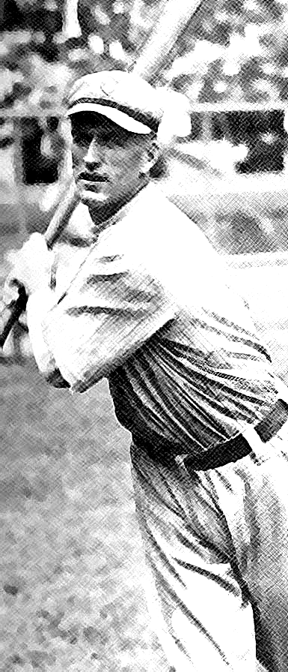Gentleman Jake
Belongs in the Hall

©By Vic Debs

Forget about Pete Rose. The exclusion of Jake Daubert from the Hall of Fame is a greater injustice. Jake who? That's a likely response you'd get from the average baseball fan, even many SABRites (not Caseyites, of course!). Considering his numerous and significant accomplishments, Daubert may be one of the game's best kept secrets.
Born in Shamokin, Pennsylvania in 1884, young Jake moved with his parents and older brothers, Calvin and Irwin, to Llewelyn around 1890. His father, Jacob, worked in the anthracite-rich Blackwood Mines while wife Sarah cared for the children. At age 11, Jake joined his father and brothers in the mines, working part-time as a breaker boy by removing pieces of slate from slow-moving streams of ore. Jake's mother died the following year, and soon afterwards he quit school for full-time mine work.
While helping the family meet expenses, Jake honed his baseball skills by playing amateur ball on weekends in Llewelyn and neighboring towns. By his teen years, the southpaw hurler was good enough to play semi-pro ball. While pitching for Lykens, Jake developed a bad arm. It was a fortuitous injury. His successful shift to first base helped land positions on various minor league clubs. By the spring of 1910, he was the starting first sacker for the Dodgers. Jake would remain a regular in the big leagues for 15 years, and play at no other position but first.
And how impressive his achievements in those 15 seasons! Six-straight years batting over .300 (1911-1916). League leader in hitting in consecutive seasons (1913-1914). Lifetime .303 mark despite playing most of his career during the Dead-Ball Era. A 22-game hitting streak in 1922. While not an outstanding homerun hitter (who was in those days), Jake led the league in triples twice.
Playing at a time when low-scoring games was the norm rather than exception, Daubert displayed a greater proficiency in the art of bunting than any other National Leaguer. So what, you say? Remember, unlike today all major leaguers of that period were expected to bunt successfully on a regular basis, so Daubert's being the best is noteworthy. His 392 career sacrifice bunts remains a senior circuit record (talk about your unbreakable records!) .His four sac bunts in the nightcap of an August doubleheader of 1914 is still good for a share of a major-league record for one game, and combined with the two he had in the opener that day makes him sole possessor of the
twin bill record, one of the longest-standing hitting marks in baseball history!
JAKE DAUBERT
The third NL MVP winner in history (called Chalmers Award in 1913), Daubert's greatest value may have been his fielding prowess. No contemporary big league first baseman was any better (he collected 21 putouts in a 1910 game, one shy of the still-standing record), and only the notorious Hal Chase matched him in ability, if not in integrity. Sportswriter F. C. Lane compared the gifted glovemen in a 1914 article in Baseball Magazine. "We have no criticisms to make of Chase, but even before the popularity of the once great Highlander star began to wane, we were privileged to select Jake Daubert as the greatest first baseman on the diamond… While his fielding may lack something of that finesse, or glitter, for which Chase was famous, The Brooklyn Captain is undoubtedly one of the most brilliant first baseman the game has ever known."
Yes, Brooklyn Captain. And he was still The Captain when the Dodgers won the flag in 1916. Still The Captain when, following his trade to the Reds in 1919, his club grabbed the pennant, then defeated the Black Sox in that infamous Series. He was a team leader off the field, giving advice to teammates as unofficial player rep, and even got the best of frugal Charlie Ebbets in most negotiations. Jake even ran for Brooklyn alderman once, and would have won had he taken seriously the campaign.
Daubert's career accomplishments could have been even greater had he not died following an appendicitis operation in October of 1924. He actually missed much of that season not from the appendix ailment but from a beaning he suffered in midseason, which may have been a contributing cause of his death. (The doctor stated as much on the death certificate).
I spoke with Jake's 93-year-old son a couple of years ago for the purpose of gathering research for a Jake Daubert biography. At that time, George Daubert mentioned he was writing to each member of the Hall of Fame's Veterans Committee asking that they consider Jake for induction. I shall soon begin doing the same. For anyone interested in "joining the cause," send a note to "Victor Debs, Jr., P.O. Box 131800, Staten Island, New York 10313. Or e-mail at tkmlty7@aol.com.

Jake Daubert's champion is author Vic Debs, who graciously agreed to appear at the Union Square Barnes and Noble on Saturday, June 9th, at 5:30 pm for a discussion of two of his books:
Still Standing After All These Years,
as well as Missed It By That Much.

Westchester Meetings; Continuing Success

Ken Matinale, who co-founded the very successful Westchester meetings more than a year ago with John Pardon and Frank Jazzo, has gone to the great southwest (we miss him!) but has left a thriving and active group meetings format each month in Westchester. John Vorperian has stepped up to the plate and is continuing the successful meetings.
If you have not attended one of these gatherings, you might ask yourself, “What have I been missing?”
January 4- Frank Jazzo has booked two old time players: Jack Randall - Bronxville; Dodgers 1944 spring training, & Sal Yvars - Giants catcher from 1947 - 1953 and Cards 1953 - 1954.
Yvars broke the news that the Wall Street Journal would publish a story that the 1951 Giants cheated by stealing signs. That story appeared on January 31, 2001. Randall spoke about his movement through the minor leagues, finally making it to the majors and not playing because of injury.
We got a scoop on the Jan. 31 Wall Street Journal back on Jan. 4 when Sal Yvars told us the story and that it would appear in he WSJ.
February 1 -- Ed Randell told Frank Jazzo that the Metro Channel telecast of some of our January meeting .
Sam Korn spoke about the 1938 season.
Joe Giulia shared his all-time "Yankees in Heaven".
Eric Weiss administered a trivia quiz.
March 1 -- Mark Alvarez, Director of Publications for the Society of American Baseball Research, was the special guest. He pointed out that he is neither an employee nor a board member, working as a contractor since 1993. He was very enthusiastic in encouraging members to contact him directly. His order of preference: phone, letter, e-mail.
John Vorperian gave his review of two sports history books published by Total/SPORTS ILLUSTRATED.
April 5--Doug Lyons discussed his latest book: Over 1,286 Incredible Baseball Facts, Finds, Flukes, and More! He also administered a brutal trivia quiz. Doug Pappas discussed forfeits since 1901.
May 3-- Red Sox Fan Handbook compiled by Leigh Grossman "..whether you're a longtime Red Sox fan or have just discovered the particular brand of stoic suffering that defines the Red Sox nation, this is an essential reference book...brings the reader up to speed on everything he/she needs to know about New England's fav. team...book includes material on more than 330 players, quotes, the Fenway experience, internet sites."

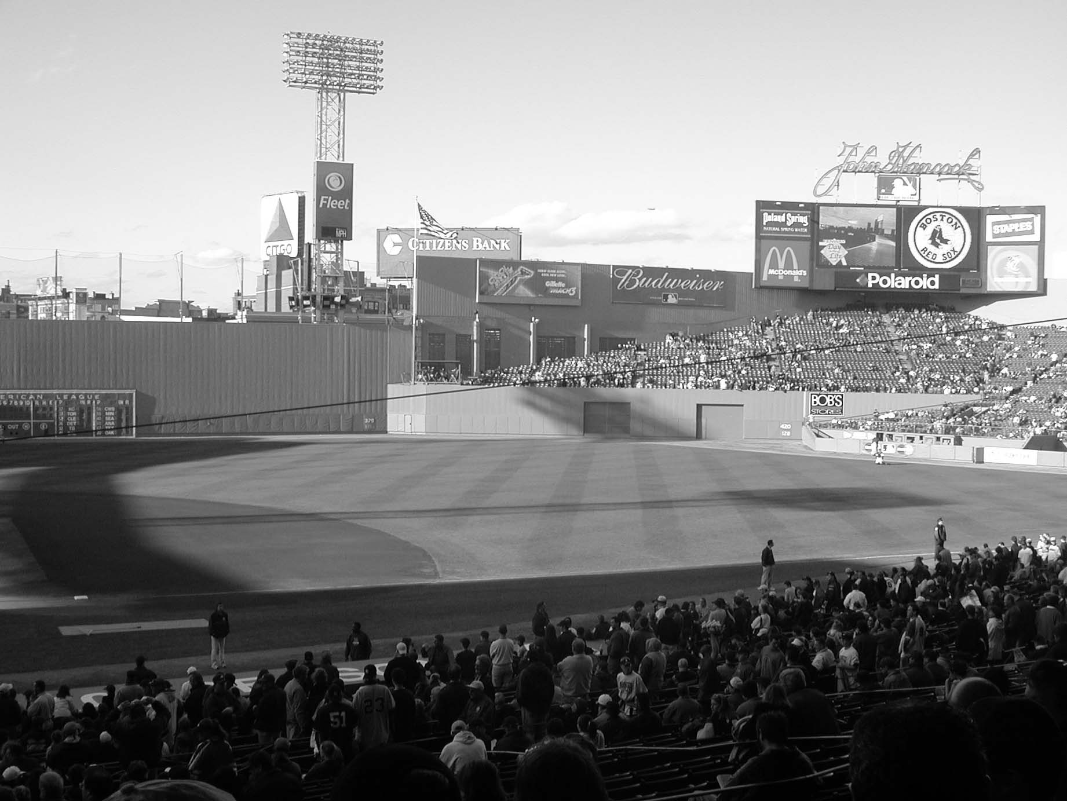
The Green Monster
Photo by Ed Grupsmith

Monthly meetings start at 7:00 PM.
Usual Meeting place: Greenburgh Town Hall, Greenburgh, NY
100A (Knollwood Rd.) & 119 (Tarrytown Rd.) across from Staples Exit 4 off Interstate 287 Parking in back near entrance.

Contact persons:
Frank Jazzo 914-949-2971 e-mail: fsjazz2001@yahoo.com
John Vorperian (jmv3@westchestergov.com)
John Pardon 914-737-1265

New York Challenges: Q & A
No New Yorker would EVER claim to know New York Baseball inside and out but here are 4 Questions that you MIGHT have the Anwers for, all taken from previous eNewsletters. Feel free to contact the “poster” via postal mail.

PHIL SIENKO: Attention Yankee fans! Who was he?
About that postseason Yanks-Seattle series in 1995, I remember a player in 1995 coming out of retirement and being placed on the roster; but being that he didn't play, he didn't go into the books, and on the seasonal roster, which I checked, his name wasn't on it (if it was it would have jumped off the page at me!).
So the answer CAN'T actually be looked up, someone would just have to know the answer. I checked two editions of the Daily News which I have copies of, one being the morning after the Yankees' 15-inning win, and there was no mention of the player who didn't play. Know his name? Please email STEELWHLS1@AOL.COM
Call to Cooperstown
Interested in attending SABR's 30th Anniversary held at the HOF on Sat. Aug. 11th? Contact Evelyn Begley at ebegley2@juno.com (or 212-477-8809) for information

NYC SABR Remains on Cable TV
Every Monday night at 7:30 on (Manhattan's Time Warner) Channel 56 and (RCN's) Channel 108, our SABR show called, BASEBALL PLUS, airs weekly through 9/10/01. Does anyone want to see another NYC SABR show on TV in the fall? It’s free for us. If so, please send suggestions and ideas for content to Evelyn Begley at ebegley2@uno.com or call 212-477-8809

New York, New York: Calling Our Chapter Experts
George W. Case III, SABR Executive Director Gegrje@aol.com asks, “ Are members able to answer specific questions, to be called upon as "experts"?…I’d like to have a SABR membership brochure included in the "media guide” and link SABR to various BB publications.” If you will avail yourself as someone knowledgeable in any given field of BB interest, please contact me NOW

In Appreciation of Mike Schacht

Many New Yorkers remember the late Mike Schacht as someone special. Mike was the editor of FAN Magazine, and a sports artist, whose player portraits or silhouettes often appeared in SABR publications. One tribute, by Gene "Two Finger" Carney (carneya6@BORG.COM) suggests that" those not familiar with his work might visit www.dreamfire.com/schacht/. My own tribute to Mike will be in Notes from the Shadows of Cooperstown #232, at The Baseball Archive web site (www.baseball1.com)"

Another tribute, in NYC, commemorated Mike as a valued friend and writer. Chris Jennison spoke with eloquence:
"We all remember Mike for his wonderful paintings, sculptures, and designs. I also remember what a good writer he was, and as I reflected on Mike as a good writer, I thought of the last two sentences of E.B. White's CHARLOTTE'S WEB, in which Mr. White speaks of Charlotte's soul and spirit: 'It isn't often that someone comes along who is a true friend and a good writer. Charlotte was both.' And so was Mike."

XXX
Weaving a Web
Steve Nadel (gongee@worldnet.att.net) led a productive WebMeeting (3/24) attended by 8 people: chapter webmaster Steve, Sue Rosner, Charlie O’Reilly, Evelyn Begley, Frank Priegue, Roberta Newman, Phil Goldberg, and Al Blumkin.
The talk was focussed on Design and Content. We would like a NYC SABR history written by our members for the page, and we'd like chapter articles, so we appreciate input for ideas on chapter website content.
Our website is http://sabrnyc.freeyellow.com
PLEASE DO HELP by offering feedback; we need your ideas! Highlights of the meeting are below:

Design Discussion
Front Page seems to be the software that all involved will be using. Consistency is imperative for us.
The background color remains the same and needs to be consistent with the entire website. Roberta suggested we do without background wallpapering. Everyone agreed.
Steve spoke about the layout in frames and Sue strongly recommended eliminating the "ticker" which could be a distraction.
Charlie said that some domain servers have a shrinking banner that is a lot less annoying.
The possibility of another server was discussed; Frank volunteered to check out additional sources including free hosting provided there are no banner ads. Charlie verified that Domain Name costs about $70 for 2 years.
Phil wondered if we should investigate the idea of getting money by linking up with 1-800-Flowers or one of the other income-generating businesses like Amazon.
The design of the Home page will have the menu on the left side with the "Liberty" logo above the Menu. The links below "Liberty" can have miniature "Liberty logos" as "clickables" that bring the reader back to the Home page.

Content Discussion
The (left side) Menu will list links to:
Chapter Newsletter (Roberta will use full page layout, without columns).
Yankees "contributor"
Mets "contributor"
Minor League teams (S.I., Brooklyn, PLUS another team in our geographic proximity, on a rotating basis)
Member websites
GREAT BB sites
Obits & Tributes
Chapter History
Trivia
Additional links (MLB, NYY, NYM, ESPN, SABR, etc.)
Hall of Fame
Guest Column
SABR e-Group: a place to exchange views and ideas.
Update on Chapter Activities
Contact us!
Subscribe to our (free) emaiList
Regional Recaps
Archives
We will include at the bottom in smaller print: "last update was on ___________"
The Menu will probably be subdivided so that links to MLB, Yanks, Mets, etc. are accessible while navigating, though unlisted by us as Direct Menu Links.
Chapter History can possibly be linked to Obits & Tributes (as well as Archives). IF we need to combine any Menu Links, then perhaps a link in the Menu called "BB Columns" can go to our Yankee writer, Met writer, Minor League writer, Guest column, etc. Let's discuss this, okay?

New York Baseball Trivia
By Eric Weiss

1. Name the only team to play in the post-season with a losing regular reason record.

2. Name the winning pitchers in the following famous World Series Seventh Games:
a. 1960 Yankees - Pirates
b. 1979 Orioles - Pirates
c. 1997 Marlins - Indians

3. What 4 players had a 3-home run game in post-season play?

4. No Met has ever won the MVP award. Can you name the 8 players who played for the Mets and won MVP awards for other teams?

5. In the interest of balance, name the 10 players who played for the Yankees and won an MVP award for another team.

6. Who made the last out in 2 of Sandy Koufax's 4 no hitters?

7. Who was the last player to score 150 or more runs in a single season?

8. In 1996, one team set a record for having its pitchers strike out the most batters, another set a record for having its batters strike out the most times. Both records still stand, name the teams.

9. Who was the last Yankee to lead the AL in strikeouts?

10. Name the only 2 players to win a MVP award, throw a no-hitter, and win a World Series MVP award.

11.Who was the last Met to league the NL in runs scored?

12. What Hall of Famer hit the most triples in post-season play?
Answers on page 10

Eric Weiss (DWEISS0690@aol.com) won the very tough trivia quiz (by Elliott Hines and Al Blumkin) presented during our Feb.17, 2001 regional meeting. More than 140 people attended the event, many of whom took the trivia contest, forcing Eric to face some rough competition ---Congratulations, Eric!

The Hot Stove League:Raking the Embers of Baseball’s Golden Age by Lee Allen (Total/Sports Illustrated)
Trade $12.95 (Review by John Vorperian)

John Vorperian’s book review, which he wrote before Opening Day, still applies for anyone who can’t get enough baseball even during the season …especially just before and after the All-Star Break!
‘Tis the season of Grapefruit and Cactus Leagues. Now, all baseball fans hold great hope and tidings for their favorite nine. Come in from winter’s cold and settle down with Lee Allen’s THE HOT STOVE LEAGUE.
First published in 1955, HOT STOVE should be in your sports library for perusing at this time of year. Allen’s collection of true baseball stories will forcefully empower you for upcoming SABR meetings. Additionally, if you need a pill to ready yourself for opening day this manuscript fits to a tee.
Baseball is timeless. The ball’s juiced. There’s too many homeruns. Sunbelt cities steal away other town’s squads. Clubs look for that special ethnic player to draw new fame. It’s all here. It’s as fresh as today and as it was penned ------ nearly half-century ago.
Lee Allen was a weekly columnist for The Sporting News and Historian at the Baseball Hall of Fame.
The Greatest Team
of the 20th Century –
a Vote for the
1939 New York Yankees

©By Paul Tarr

On April 25, 1999 25 experts selected by Baseball America chose the greatest teams of the 20th century. In order, they were as follows:

- 1927 New York Yankees
- 1998 New York Yankees
- 1975 Cincinnati Reds
- 1906 Chicago Cubs
- 1961 New York Yankees
- 1970 Baltimore Orioles
- 1954 Cleveland Indians
- 1929 Philadelphia Athletics
- 1953 Brooklyn Dodgers
- 1986 New York Mets

The 1939 New York Yankees, my selection for the greatest team, was not on this list. Why not?
I suspect it is because my criteria for selection are different than those used by the 25 experts.

What are the criteria I used to select the greatest team?

The first and most important criterion for the greatest team is winning, in a dominating way, both in its own league and versus the other league. In my opinion there are three benchmarks the greatest team must exceed:

- Win 70+ percent of its games in its own league.
- Win at least a comparable percentage or a greater percentage of its road games than its overall percentage.
- Win 80+ percent of its World Series games.

My second benchmark deserves some explanation.

In their book “The Hidden Game of Baseball”, John Thorn and Pete Palmer explained the importance of winning on the road. “With so many factors going into a team’s winning percentage, its runs scored and allowed, its home runs, etc., it may be useful to think of the road record as the best index of ability, pure and portable.”
Later in the book they wrote “The team that plays well on the road is, virtually by definition, the team that has the best overall talent.”

Using these winning percentage criteria, following is a listing of the 9 teams with overall winning percentages over 70%.

Total Road W. S.
Team Pct. Pct. Pct. Year
Pittsburgh NL .741 .691 None 1902
Chicago NL .763 .800 .333 1906
Chicago NL .704 .671 1.000 1907
Pittsburgh NL .724 .720 .571 1909
New York AL .714 .679 1.000 1927
Philadelphia AL . 704 .610 .429 1931

New York AL .702 .730 1.000 1939
Cleveland AL .721 .675 1.000 1954
New York AL .704 .642 1.000 1998

The 1939 New York Yankees was the only team that met or exceeded all three benchmarks.

My second criterion is for a team to score, on average, 2+ runs per game more than its opponents. This translates into a difference of over 300 runs scored more than runs allowed in a 154 game schedule.
Because of the differences in the total number of games played during the 20th century, from a low of 107 league average in 1981, the year of the 1st major baseball strike, to the present 162 game schedule, after expansion, runs scored and runs allowed are expressed as runs per game.
Bill James, in his book, “The Bill James Historical Baseball Abstract”, outlined his Pythagorean Theorem. The theorem suggests that a team’s winning percentage was directly related to a team’s runs scored divided by the team’s runs scored + the opponent’s runs scored. All of the runs scored data are squared.
This means that the difference between runs scored and runs allowed is the major driving force underlying a team’s winning percentage. The team with the greatest difference in runs, both in total and on the road, was the 1939 New York Yankees as can be seen below.

Total Road
Runs per Game 6.36 7.80*
Opponents Runs per Game 3.66 3.93
Runs per Game Difference 2.70* 3.87*

*20th Century Major League Record

The difference in total runs was 411, also a record for the 20th century. No other team broke the 400 run difference barrier.
Importantly, the total run difference was driven by the team’s road record.

My third criterion is that the team be dominant offensively. For a team, offensive dominance is reflected in runs scored. The way I measure dominance is to compare the team’s run’s scored to the average level for the league.

Total Road
Runs per Game/Team 6.36 7.80*
Runs per Game/League 5.21 5.32
Runs per Game/Difference 1.15 2.48*

*20th Century Major League Record

The 1939 New York Yankees led their league in Runs per Game Difference. They set a 20th century road record for both Team Runs per Game and Runs per Game Difference.

My fourth criterion is that the team be dominant in its pitching. For a team, pitching dominance is reflected in fewest runs allowed to the opposition. I again compare the team’s runs allowed to the average level in the league.

Total Road
Opponents Runs per Game/Team 3.66 3.93
Opponents Runs per Game/League 5.21 5.09
Opponents Runs per Game/Difference -1.55* -1.16

*20th Century Major League Record

The 1939 New York Yankees Total Opponent’s Runs per Game Difference was larger than any other team in the 20th century. However, in this instance it was not their road record that was the primary driver of the total difference.

My fifth and final criterion is that the team be dominant in its fielding. While fielding percentage is not the best indicator of an individual player’s fielding ability, it is more meaningful for a team. At this writing I only had the records for Total Fielding Percentage.

Total
Fielding Percentage/Team .978
Fielding Percentage/League .969
Fielding Percentage/Difference+.009

The 1939 New York Yankees not only led the American League by 9 percentage points in fielding percentage, they finished 6 percentage points above the second best team.

In summary, the 1939 New York Yankees dominated their league in winning percentage, offensively, in pitching, and in fielding to an extent no other team ever has in the 20th century. Most of this dominance resulted from their record-breaking performance on the road. Under these circumstances how can any other team be selected as the greatest in the 20th century?
The team that has been generally selected as the greatest team in the 20th century has been the 1927 New York Yankees. I believe the reasons have to do with the dominant performances of its stars: Babe Ruth and Lou Gehrig. This was the team of “Murderer’s Row”. Stars on a team make headlines and their overwhelming performance highlights the team’s status among both the fans and the sportswriters. Don’t get me wrong. This was a great team, the 2nd best team of the 20th century, but not the best. The major reason is that their wins at home, not their road record, was primarily responsible for their overall success. The same was true for the 1998 New York Yankees.

The 1939 New York Yankees have been occasionally selected as the 20th century’s greatest team. However, it has been relatively rare. There are probably 2 major reasons that the team has not earned the reputation of other selections, particularly the 1927 New York Yankees:

- The first is that, with the exception of Joe DiMaggio, the team had no outstanding offensive stars. The team’s players did not dominate the individual league leading statistics.
- The second may be the more important. This was the saddest year in New York Yankee history. Lou Gehrig’s 2130 game playing streak came to an end because of his contracting the horrible disease, which was named after him. How could you select the greatest team of the 20th century in the year when Lou Gehrig was forced to retire from the team?

Despite these qualifications, the record seems clear. No other team has such an overall team dominance, driven by its road record.
Which was the greatest team of the 20th century? My vote goes to the 1939 New York Yankees.

References

1. Bailey, James. "Baseball America's 20th Century Celebration - Greatest Teams".(Durham, N.C.: All-American Baseball News, April 25, 1999).

2. James, B., John Dewan, Neil Munro, Don Zminda, et al. "STATS All-time Baseball Sourcebook".(Skokie, Ill.: STATS Publishing, 1998).

3. James, B. "The Bill James Historical Baseball Abstract" (New York, N.Y.: Villard Books, 1988).

4. Neyer, R. and Eddie Epstein. "Baseball Dynasties". (New York, N.Y.: W. W. Norton & Company, 2000).

5.Thorn,J. and Pete Palmer. "The Hidden Game of Baseball". (Garden City, N.Y.: Doubleday & Company, Inc., 1984).

6. Thorn, J. and Palmer, P., Eds. "Total Baseball" (New York, N.Y.: Warner Books, 1989).

- www.usatoday.com/sports/baseball, 3/8/99.

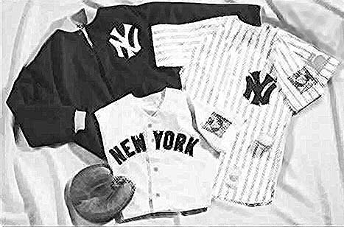

Yankee Clippings

©By Al Blumkin

As of Monday, May 14th, the Yankees are 22-16 and are 1/2 game behind their archrival Boston Red Sox. They are 15-1 against teams under.500 and 7-15 against teams over .500. They have shown surprising strengths and weaknesses.
They have received surprisingly good offensive production from Tino Martinez and Scott Brosius who are both in their last contract years.
Alfonso Soriano has been a spark even though he has only one walk. Derek Jeter, Paul O'Neill, and Chuck Knoblauch have been their usual selves.
David Justice and Jorge Posada have been erratic. Bernie Williams has been unproductive due his father's illness and passing. He has missed considerable time due to his family situation.
The interior defense has been erratic. Jeter is making more errors and misplays than expected. This may be due to residual effects from his hamstring problems. Soriano has his defensive problems, also. Runners have been taking liberties on Jorge Posada's arm. Chuck Knoblauch, who is new to his position, has had some bad moments in left field.
However, the biggest problem seems to be pitching. Andy Pettite and Mike Mussina are currently the only reliable starters. Roger Clemens seems to alternate good games and bad games. Orlando Hernandez has been awful as have the various fifth starters. This has put enormous pressure on the bullpen. Brian Boehringer seems to be inheriting the Jeff Nelson role. Ramiro Mendoza and Mike Stanton have been excellent. Mariano Rivera is having his problems due to overuse and the fact that opposing batters are getting used to him. The New York Times pointed out last year that he loses effectiveness after 15 pitches.
Fortunately, they are in a division where no one will run away. Right now Manny Ramirez is carrying the Red Sox offensively, with Nomar Garciaparra on the DL until the All-Star game. Pedro Martinez is his usual overwhelming self. Toronto is erratic and Baltimore is awful. Tampa Bay is probably the worst team in the American League and the
Yankees haven't played them yet. There are enough sub-.500 teams to keep the Yankees in contention this year.

Note: Due to the unbalanced schedule, the Yankees will not play Minnesota or Kansas City again this season.

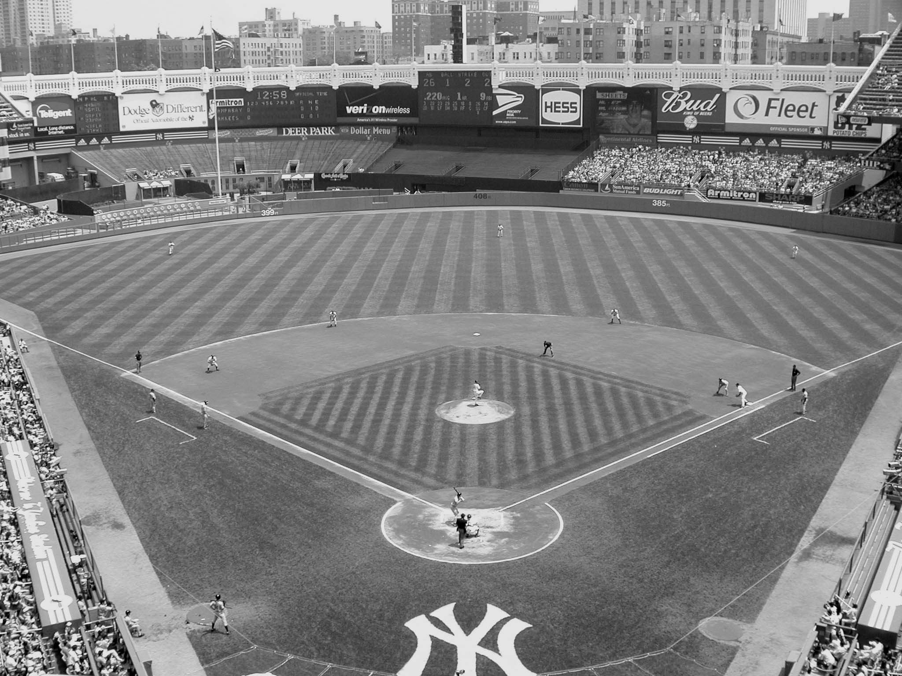
Photo by Ed Grupsmith

Mets Matters

©By Ross Adell

At this point in time, Monday May 14, 2001, The Mets after a rough road trip (1-6), find themselves in last place in the National League East. They are 14-23, 8 1/2 games behind the division leading Philadelphia Phillies. The following chart is a listing of how the Mets have fared after 37 games from the best record to the worst record:

Mets Record After 37 Games 1962-2001

Record # Times Years
27-10 1 1972
26-11 2 1986, 1988
23-14 1 1985
22-15 1 1971
21-16 5 1976, 1989, 1991, 1992, 1999
20-17 3 1973, 1982, 1984
19-18 6 1970, 1975, 1994, 1997, 1998, 2000
18-19 2 1969, 1990
17-20 4 1968, 1974, 1981(2nd Half), 1987
16-21 3 1963, 1978, 1980
15-22 4 1966, 1983, 1995, 1996
14-23 4 1965, 1967, 1977, 2001
13-24 1 1979
12-25 3 1962, 1981(1st Half), 1993
11-26 1 1964

On May 1, 2001, Robin Ventura smacked his 15th career grand slam. He leads all active players in that department. It was also his fifth career grand slam as a Met. This ties him with Howard Johnson, Kevin McReynolds and the late John Milner for most career grand slams by a Met.

Here is a listing of "Rocking Robin's" Met Grand Slams:
Date Inning Pitcher Team Site
5/20/99 (1G) 1 Jim Abbott Mil Shea
5/20/99(2G) 4 Horacio Estrada Mil Shea
8/15/99 5 Livan Hernandez SF SF
4/18/00 4 Jaime Navarro Mil Shea
5/1/01 7 Jay Powell Hou Shea

Mike Piazza leads the Mets with 10 home runs as of May 14, 2001. There have been two games this season in which he has hit two home runs giving him a total of 25 multi- home run games for his career: April 9 versus the Braves in the home opener and April 26 at Miller Park in Milwaukee.

Here is a breakdown of Piazza's home runs with men on base:
0 MOB: 4
1 MOB: 4
2 MOB: 2
3 MOB: 0

Tim Keefe’s 300th Victory

THE BOX SCORE

NEW YORK AB R H PO A E
Gore cf 4 3 3 1 0 0
Ewing c 4 3 2 5 3 0
Connor 1b 3 0 1 12 1 0
O’Rourke rf 5 0 1 0 1 0

D. Richardson 2b 4 1 1 5 6 0

Slattery lf 5 0 2 3 0 0
Shannon ss 5 1 2 0 1 1
Hatfield 3b 5 1 2 0 0 0
Keefe p 5 0 0 1 0 0
40 9 14 27 12 1

BOSTON AB R H PO A E
Brown cf 5 0 1 3 0 0
H. Richardson lf 5 0 1 4 0 0
Stovey rf 4 1 1 1 0 1
Nash 3b 3 1 0 3 1 0
Brouthers 1b 3 0 0 4 1 0
Murphy c 4 1 1 4 2 1
Irwin ss 3 1 1 2 3 1
Quinn 2b 4 0 2 6 2 0
Madden p 1 0 0 0 0 0
Gumbert p 3 0 1 0 0 1
35 4 8 27 9 4

Inning 1 2 3 4 5 6 7 8 9

NY 3 0 1 0 1 3 0 0 1 9
BOS 0 0 0 0 1 3 0 0 0 4

Earned runs: NY 4, Boston 1
2 base hits: Gore (2), Hatfield, Irwin
3 base hits: Shannon, Gumbert
Double plays: Quinn and Brouthers
1st base on balls: Gore (1), Ewing (1), Connor (2), D. Richardson (1), Nash (1), Brouthers (1), Irwin (1)
1st base on errors: New York (2), Boston (1)
Struck out: Keefe (2), Brown (2), H. Richardson (1), Nash (2), Brouthers (1), Murphy (1)
Wild pitch: Keefe (1)
Stolen bases: D. Richardson, Shannon, Stovey, Nash
Time of game: 2 hours and 6 minutes
Umpires: Gunning and Mathews
Attendance: 1,533

©By John J. O’Malley

The scorching heat of June 4, 1890 helped limit attendance at Brotherhood Park to a mere 1,533 diehard fans to witness the clash between the New York and Boston nines of the fledgling Players League. General dissatisfaction with the reserve clause and salary limitations led most major leaguers to create a new league.
The New York lineup on June 4 included eight veterans of the champion New York Giants of 1889. Shannon at shortstop, who had spent the previous season with Louisville of the American Association, was the only excerption. New York, although it was the home club, took the option of batting first.
In the top of the first, Gore led off with a base on balls. Ewing followed with a single. Connor’s bid for a homer was foiled by a brilliant catch by Hardy Richardson. Gore scored on the out while Ewing reached second. O’Rourke flied out to Stovey as Ewing took third. Richardson walked, stole second and with Ewing scored on Slattery’s single.
New York added a run in the third on Ewing. Ewing’s single, an error by Murphy and hits by Connor and O’Rourke. Madden, who started for Boston, was relieved after pitching the first three innings by Gumbert. New York ran the score up to 5-0 in the top of the fifth on Gore’s hit, a walk to Connor and Danny Richardson’s single.
In the bottom of the fifth, Boston scored on Irwin’s double and Gumbert’s triple. New York added three runs in the top of the sixth on doubles by Hatfield and Gore, Ewing’s base on balls and an error by Gumbert.
In the bottom of the sixth, Stovey singled, followed by a walk to Nash. Stovey then stole third. Brouthers sacrificed followed by an error by Shannon, a wild pitch by Keefe and Quinn’s single to give Boston three additional runs.
New York ended the scoring in the ninth on Shannon’s triple and Hatfield’s single.
Final score: New York 9, Boston 4.
For Tim Keefe, 9 years, 9 months and 29 days after his pitching debut on August 6, 1880, it was the 300th victory of his career. That milestone was previously reached only by Jim Galvin, pitching for Buffalo and Pittsburgh nines.
The New York Herald exulted “with Keefe in the box and Ewing behind the bat, the New Yorks of Brotherhood Park are more than a match for any club that plays baseball.”

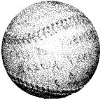

Did You Know?
It seems that every time we go to the ballpark--any ballpark-- we hear blaring from the loud speaker the same pattern of eleven beats, some long, some short, often followed by “Let’s Go!” Did you ever wonder what the significance of this pattern might be?
It’s Morse Code for Best Wishes!!!!—R.N.

Summary of the Casey Stengel Chapter Winter Regional, February 17, 2001

By Evelyn Begley

Joe Christopher (Pirates 1959-61, Mets 1962-65, Red Sox 1966) entertained more than 140 attendees of the NYC regional on Saturday, Feb.17 in the Flushing Library with his theories on hitting, numerology, art, physics, and other topics, then signed autographs on the many photos he freely provided for all there, including the fascinated library staff and security which let the SABR meeting continue for 30 minutes past closing time!

Author Rory Costello (Baseball in the Virgin Islands), who arranged Joe's appearance, surprised him with a phone call by Julio Navarro (Angels 1962-64, Tigers 1964-66, Braves 1970) and the 2 players chatted, to the delight of SABR members, in Spanish and English, with the call ending after Joe congratulated Julio about son Jaime. Joe and Julio were high school teammates.

Among the day's highlights were rare video clips of "Baseball Players in Films" by renowned movies-and-baseball author Rob Edelman, and a video by George Case III featuring his father, outfielder George Case, Jr. (Senators 1937-1945 & 1947, and Indians 1946), as well as the Authors Panel of Sam Korn, Steve Krevisky, Doug Lyons, George Robinson, Andrew Schiff, and Dan Schlossberg.

George Robinson (On a Clear Day, They Could See Seventh Place) amused the audience with his "worst baseball teams of all time", Doug Lyons (Curveballs and Screwballs) regaled the crowd with tales of his unique quest for quiz questions, Sam Korn (The Ticket) revealed a Cooperstown connection of a winning ticket that saved survivors of a concentration camp.

Steve Krevisky (Left Field Baseball Book, 1991 & 1992) emphasized the need to explore lesser-known aspects of baseball like minor league triple crown winners, Dan Schlossberg (The Baseball Catalog) shared his humorous insights and behind-the-scenes stories of players like Feller, Spahn, & Marichal, and Andrew Schiff (Henry Chadwick) spoke of Chadwick's influence (box scores, writing) on the game.

Al Blumkin presented on "The Forgotten Aces: Vic Raschi, Allie Reynolds, and Eddie Lopat of the 1949-53 Yankees"; Ross Adell remembered "My First Day at Shea".

Joe Dorinson gave an impassioned "Defense of di Maggio"; Roberta Newman incorporated slides of vintage commercialism into her research on "Baseball and Advertising"; and Frank Priegue gave a slide show of his experiences at minor league games.

The Mets’ minor league Brooklyn Cyclones team was represented by Marty Haber, the son of SABR co-founder Bill Haber. Tom Knight did his usual expert job as Master of Ceremonies. After 7+ hours of a baseball-filled day, Eric Weiss won the baseball videotape prize for being #1 in the trivia quiz by Elliot Hines, and John Docke won the second-prize BB video.

The last 4 years of the NYC regional are available on videotape for SABR members to view; they have been sent to Len Levin's Lending Library.

GROUP TOUR OF YANKEES AT REST

Frank Jazzo (fsjazz2001@yahoo.com, 914-949-2971) is planning a (free) tour of Kensico Cemetery (Valhalla), and perhaps of Gate of Heaven Cemetery (depending on response)
Kensico has Lou Gehrig, Edward Grant Barrow, Col. Jacob Ruppert, Paddy Chayevsky, Danny Kaye, Tommy Dorsey, Ayn Rand, Florenz Ziegfeld, and others, and GOH has Babe Ruth, Billy Martin, Mayor Jimmy Walker, Jimmy Cagney, Fred Allen, and others.

GROUP TOUR OF YANKEE STADIUM

Anyone interested in taking a tour of Yankee Stadium tour? Tour guide Tony Morante, a SABR member, can be e-mailed at tmorante@yankees.com, and there are 2 types of tours, the basic ($10) one (dugout, press box, clubhouse, scoreboard operations, Monument Park, Yankee history) and the newer one (Basic, plus film and Suites).

Answers to Trivia Quiz

1-1981 Kansas City Royals
2-a. Harvey Haddix, b.Grant Jackson, c.Jay Powell
3-BabeRuth,ReggieJackson,GeorgeBrett,Bob Robertson
4-Foster,Torre,Boyer,Mays,Berra,Kent,Hernandez,Mitchell
5-Jensen,Vance,Canseco,Peckinpaugh,Konstanty,Shantz,Reggie Jackson, R.Henderson, Clemens, Baylor
6-Harvey Kuenn
7-Jeff Bagwell
8-Braves, Tigers
9-Al Downing, 1964
10-Koufax, Gibson
11-Howard Johnson, 1989
12-George Brett, 5, including two off Ron Guidry

GIANT REQUEST FROM JAY ROBERTS:

I've been working on several projects related to the New York Giants on my website, The Giants Journal http://members.aol.com/Jaybird926/giants.com You can also find it at sabr.org through the links and member web sites.

Everything will be linked up with the headline - 50th Anniversary of the Shot Heard Round the World, e.g., an article summarizing the '51 season, a close up look at the '51 Giants, a bibliography, a synopsis of the 9th-inning rally, a recap of the World Series, Information on celebration events, and Trivia. It's been real fun researching this.

Does anyone know of any events that I can add? Is the NY Giants Historical Society planning anything? Thanks for any info in this special year! Jaybird926@AOL.COM

Here’s the Pitch
©By Roberta Newman

In recent years, one of the most common complaints of baseball fans, SABR members and the uninitiated, alike, is the way in which the plethora of new professional ballparks are named. Stadiums with names like The Ballpark at Arlington and Oriole Park at Camden Yards are few and far between. Instead, most new venues sport corporate monikers. PacBell and Miller Parks and Safeco Field represent the norm. The new retro-ballparks may harken back to older, simpler times, but what about those names? Sure, professional baseball is, and always has been, a business, but must we be reminded every time we spend an afternoon or evening at a game?

The practice of naming ballparks after corporate entities is far from new. In fact, it goes way back to 1925, when ad man Albert Lasker sold his share of the Chicago Cubs to William Wrigley. Lasker suggested that Wrigley change the name of his team’s ballpark from Cubs Park to Wrigley Field, not as monument to Wrigley’s ego, but because it would help Wrigley sell more gum.

It has been argued that there is a difference between naming a ballpark after the owner’s company and selling the naming rights. Nevertheless, the desired result is the same. Whether it is paid for or free, naming a ballpark to increase corporate name recognition is a form of advertising. Thus, it’s nice to know that some things never change. If ivy-bedecked Wrigley Field is a traditional ballpark, then Safeco, PacBell, Miller, and the like, are traditional ballpark names.

GUEST LECTURER WANTED
Elizabeth Lucas (elucas@valleyhealth.com, 201-291 6218), coordinator of programs (senior club) through The Valley Hospital in Ridgewood, NJ, is putting together a program this July or August on the history of BB, and needs someone local who could lecture (1/2 to 1 hour) to a group of her members (30-70 people). They usually meet during the day (with occasional evening seminars).

JOHN PASTIER (johnpastier@EMAIL.MSN.COM), former New Yorker, posed this question:

"In New York, we had a position called official catcher, which meant that some poor kid got to do all the backcatching for both sides and never get to bat.
“ I remember it more as a stickball phenomenon than one of hardball or softball. Does that still happen nowadays?"

ANNUAL ‘POP’ LLOYD WEEKEND

Michael Everett (Meveret@aol.com) is coordinating the 9th Annual "Pop" Lloyd Weekend Celebration Aug. 24-26 in Atlantic City, NJ, which honors those who played Negro League baseball.

Events include a commemoration of Negro League veterans of the 1951 Giants and Dodgers – Willie Mays, Monte Irvin and Don Newcombe, Emilio Navarro 1929 New York Cuban and Member of the Puerto Rican Baseball Hall of Fame, presentation of the Max Manning Scholarship, a historical monologue by Byron Motley, and much more.

Hall of Fame “Terms” of BB

TOM SHIEBER says, "Folks - The National Baseball Hall of Fame and Museum would like your help with a concept for part of an upcoming exhibit. We wish to show that baseball terminology is part of the American vernacular.
People use baseball terms in conversation and probably don't even realize it. Terms such as "ballpark figure," "he's off base," "touch base," "right off the bat," "pinch hit," "bush league," "strike out," etc. are all used in everyday speech without actually being used to refer to baseball.

“We would like to track down specific instances of such baseball terms as found in movies, television programs, or other visual media. The key is that the person or persons uttering the terms must not be using them in a baseball context.

“For instance, in Woody Allen's "Annie Hall" there's a line as follows: "Hey, kid, he tells me you're really good. Well, lemme explain a little bit o' how I work. You know, you can tell RIGHT OFF THE BAT that I don't look like a funny guy when I come -- you know, like some o' the guys that come out."

"Note that the phrase (in ALL CAPS) is unquestionably from baseball, but it is not used in a baseball context.

“That's what we're looking for. Movies, television shows, even a nightly news show in which the anchor uses such a term ..... all would fit the bill. Please note that we need specific instances (what program, when was it aired, where in the movie, etc.) as we plan to track down the appropriate clips. In other words, vague remembrances don't really help. Thanks so much for your help." --- Tom Shieber (tshieber@BASEBALLHALLOFFAME.ORG)

Baseball Book Authors Talks at Barnes & Noble (Union Square) in Its 3rd Year Now….

Many a Saturday evening is shared by "Caseyites" at the Union Square Barnes & Noble (33 East 17th St.), where the NYC chapter of SABR hosts a Baseball Book Reading Group beginning at 5:30 pm, usually on the 2nd Saturday.

We try to have an occasional non-author as well because that was how the group began 3 years ago and we want to remember our beginnings. Members wishing to discuss baseball books/topics may contact ebegley2@juno.com (or 212-477-8809). The schedule is updated at www.sabr.org and at http://sabrnyc.freeyellow.com. It’s free and fun!

UPCOMING SCHEDULE

July 21 --- Marty Appel, author of Now Pitching for the Yankees: Spinning The News for Mickey, Billy and George

Aug.18 --- Cliff Blau, Mike Frank, and John Vorperian will discuss The Hot Stove League (by Lee Allen), Baseball:100 years of the Modern Era (by The Sporting News), and How to Do Baseball Research (by SABR)

Sept. 8 --- Tom Keegan, co-author (with Elden Auker) of Sleeper Cars and Flannel Uniforms: A Lifetime Of Memories From Striking Out The Babe ToTeeing It Up With the President.

