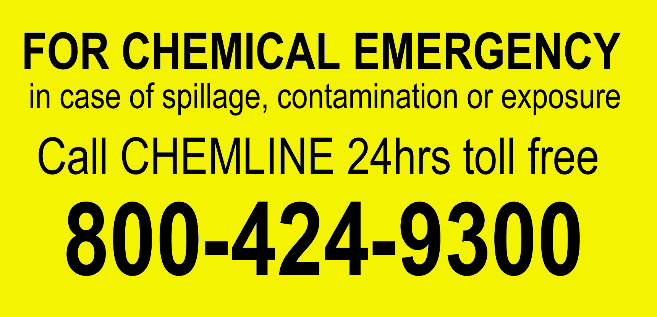

sclair
sclair
POLYETHYLENE
4 47 74
4 47 74
DOCX 44774
DOCX 44774
C A N A D A
POLYETHYLENE
POLYETHYLENE
POLYETHYLENE
C A N A D A
D O C X
D O C X

