Capacitor Identification Codes

There are no international agreements in place to standardise capacitor identification. Most plastic film types (Figure1) have printed values and are normally in microfarads or if the symbol is n, nanofarads. Working voltage is easily identified. Tolerances are upper case letters: M = 20%, K = 10%, J = 5%, H = 2.5% and F = ± 1pF.

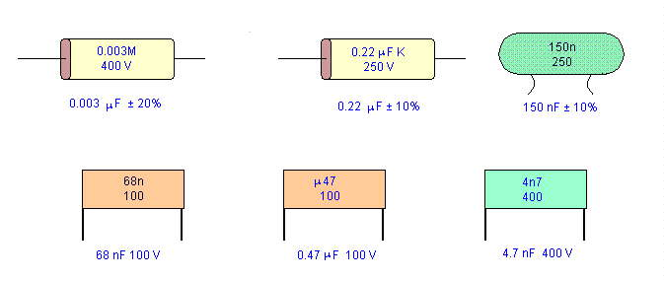
Figure 1
A more difficult scheme is shown in Figure 2 with examples. The unit is picofarads and the third number is a multiplier. A capacitor coded 474K63 means 47 × 10000 pF which is equivalent to 470000 pF or 0.47 microfarads. K indicates 10% tolerance. 50, 63 and 100 are working volts.
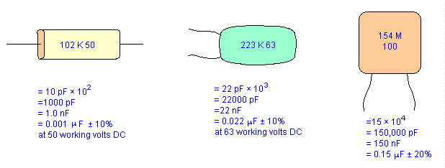
Figure 2
Ceramic disk capacitors have many marking schemes. Capacitance, tolerance, working voltage and temperature coefficient may be found. See Figure 3. Capacitance values are given as number without any identification as to units. (uF, nF, pF) Whole numbers usually indicate pF and decimal numbers such as 0.1 or 0.47 are microfarads. Odd looking numbers such as 473 is the previously explained system and means 47 nF. | 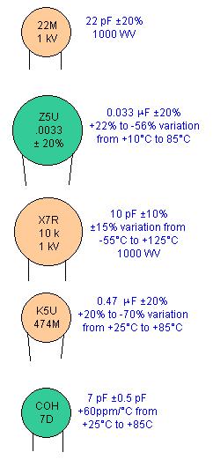  Figure 3

Figure 4 shows some other miscelaneous schemes. | 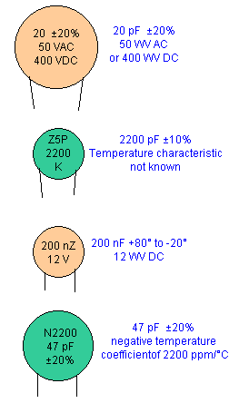  Figure 4

