*** Please Give To Mrs. ***
*** Furman By June 2 . ***

BOY SCOUT
TROOP 267
LOGO APPAREL

All items include embroidered left chest logo

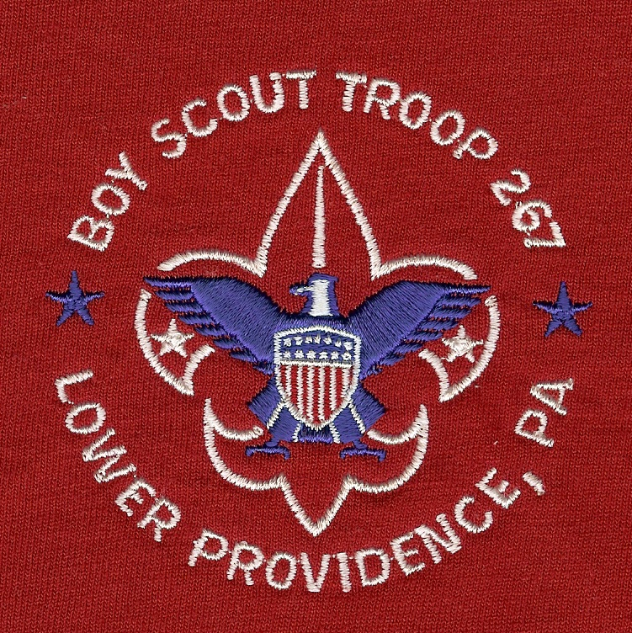

POLO SHIRT, 100% cotton by Outer Banks
 | S (34-36) | M (38-40) | L (42-44) | XL (46-48) | XXL (50-52) | Total
 | $18 | $18 | $18 | $18 | $21 | Qty. | $
Red

CREWNECK SWEATSHIRT, heavyweight 50% cotton/50% poly by Jerzees
 | S (34-36) | M (38-40) | L (42-44) | XL (46-48) | XXL (50-52) | Total
 | $16 | $16 | $16 | $16 | $18 | Qty. | $
Red

HOODED PULLOVER SWEATSHIRT, heavyweight 50% cotton/50% poly by Jerzees
 | S (34-36) | M (38-40) | L (42-44) | XL (46-48) | XXL (50-52) | Total
 | $21.00 | $22 | $22 | $22 | $25 | Qty. | $
Red

Silk Screened T Shirt
 | S (34-36) | M (38-40) | L (42-44) | XL (46-48) | XXL (50-52) | Total
 | $6.00 | $6.00 | $6.00 | $6.00 | $6.00 | Qty. | $
Red

Name: ________________________________ GRAND TOTAL: $ ______

Phone Number (Work):____________________ # of Items:____________

Phone Number (Home):____________________ $ Enclosed:___________
* * * * * * * * * * * * * * * * * * * * * * * * * * * * * * * * * * * * * * * * * * *
Logo clothing prepared by
SUNRISE Promotions, Inc.
5107 Brandywine Drive, Eagleville, PA 19403
P 610.630.4286
F 610.630.5660
www.sunrisepromo.com
E-mail: sales@sunrisepromo.com

Full Service Promotional Products Specialists
Embroidered and Screen-printed Corporate/Team Apparel, Executive Gifts, Incentives,
Awards, Employee Recognition Giveaways

