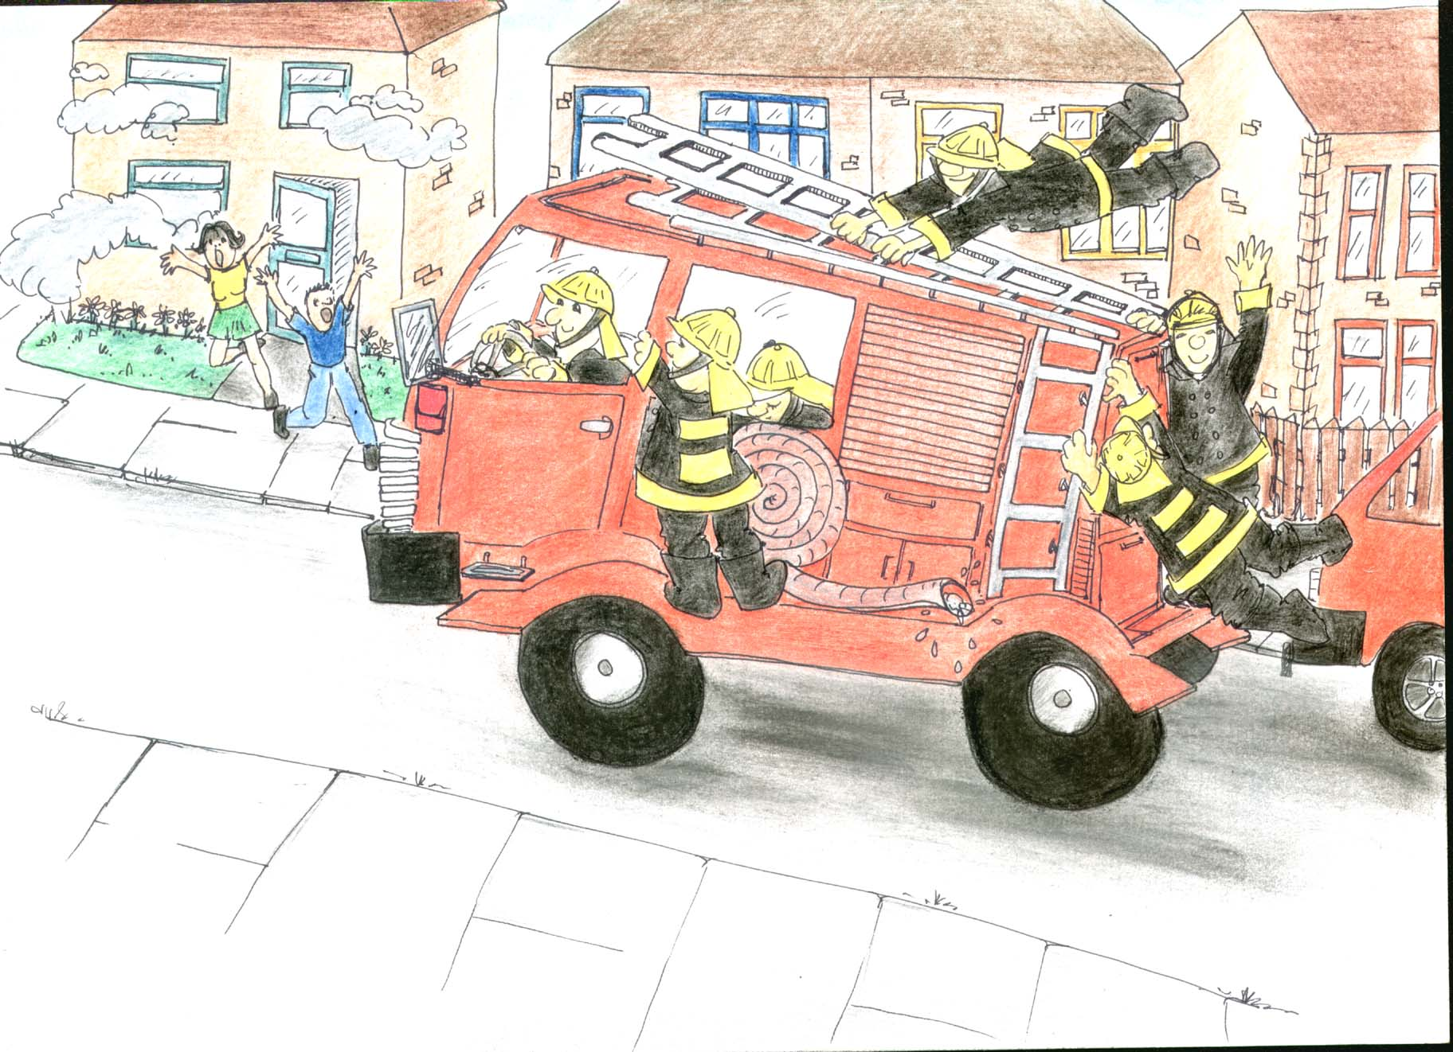
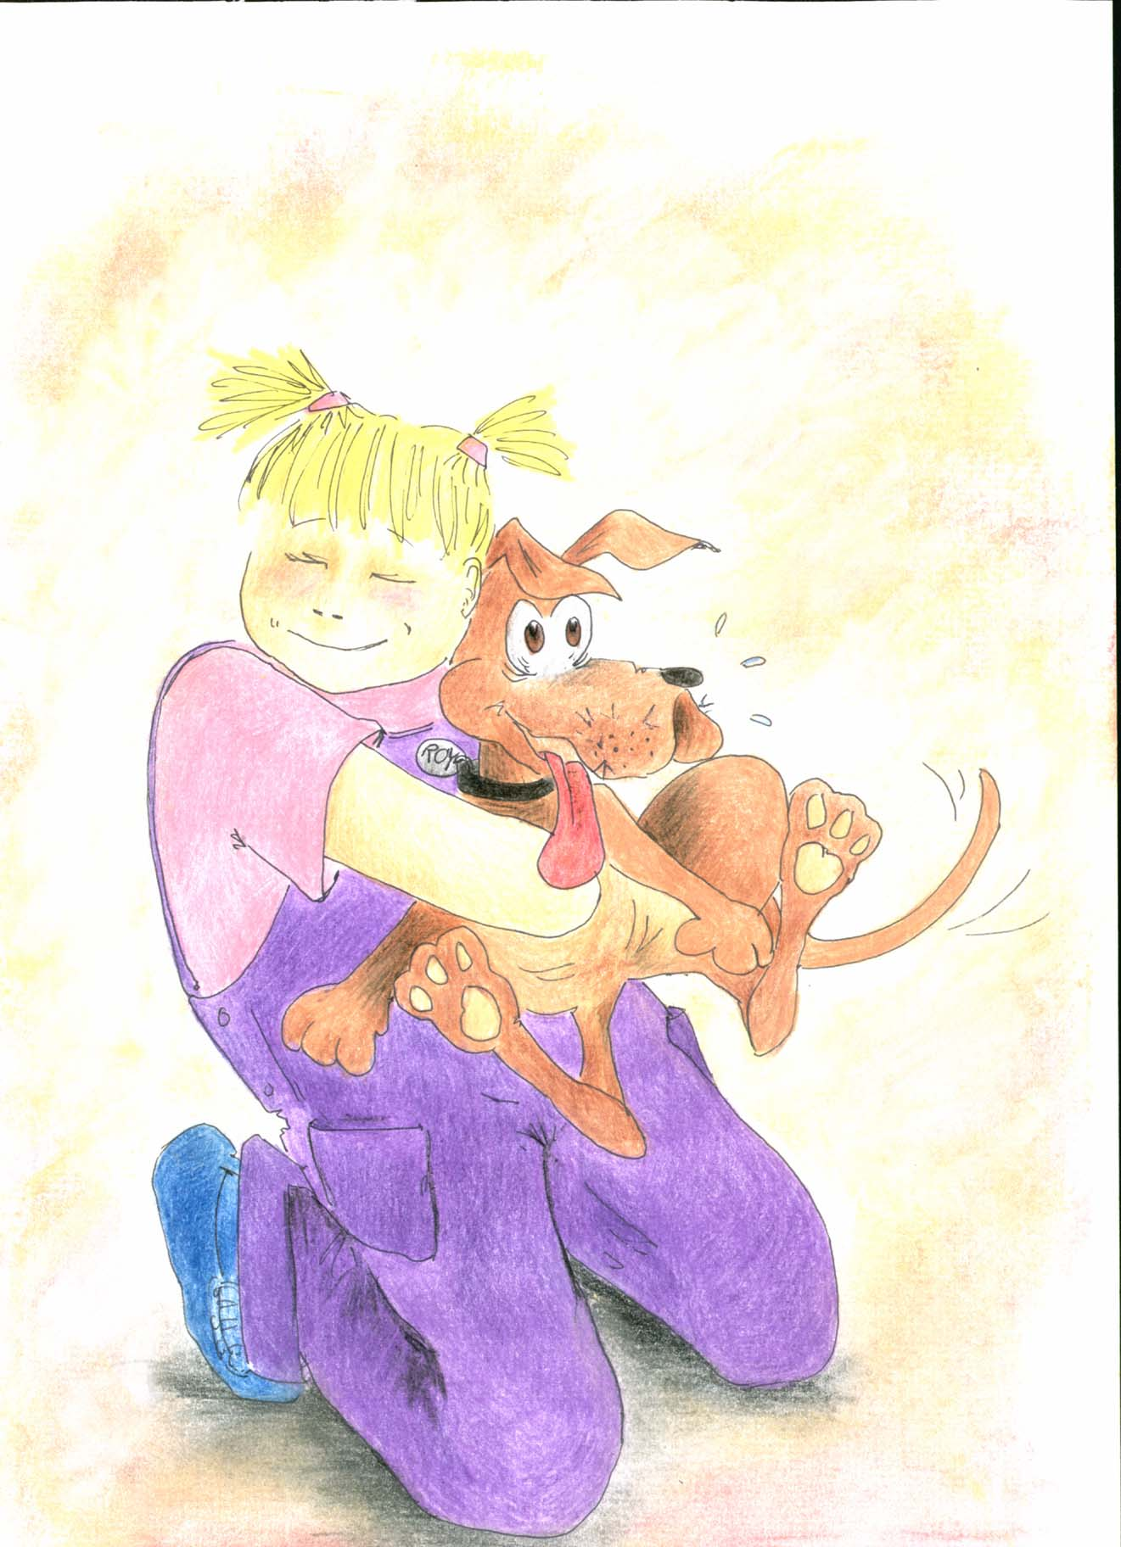
Sounds I Can Hear…
In a Car
by Jennifer LB Leese
http://www.geocities.com/ladyjiraff
r | b | q | a | z | p | l | s | w | s | x | d | e | o | g | u | m | d | o | g
s | u | a | m | h | y | o | o | f | c | a | r | r | v | n | a | w | a | i | k
x | s | m | d | j | m | b | u | c | p | f | a | r | f | c | h | h | o | o | a
g | u | c | b | z | a | s | n | s | m | o | o | e | g | e | r | o | n | v | r
s | j | h | u | l | l | n | d | e | u | s | o | p | e | s | w | o | o | s | h
a | j | d | b | c | e | e | s | a | h | l | t | a | h | f | t | s | n | c | t
p | o | u | n | d | o | e | r | g | t | w | i | r | l | o | s | h | r | m | r
m | t | r | h | q | z | u | i | c | c | x | y | r | m | c | e | i | x | y | u
y | u | e | g | e | s | m | k | c | i | t | m | t | r | e | t | k | c | l | c
a | k | g | e | n | t | r | s | o | w | y | t | o | a | c | b | x | i | w | k
b | g | i | i | v | a | d | w | m | u | m | b | l | e | h | y | d | k | s | b
c | q | e | b | b | q | a | i | t | n | x | y | l | t | o | p | l | e | s | s
s | g | h | j | i | l | b | r | u | m | b | l | e | a | s | d | r | e | k | v

car rumble sounds tick
mumble twirl brumble bark
whoo swoosh thump pound
kiss squeeze bus truck
Compliments of Hagerstown, Maryland author Jennifer LB Leese

Sounds I Can Hear…In a Car is one book in a series coming out in 2003 by this author. It is an interactive electronic book with sounds & animation!
Visit her author webpage for more information and find out what else this Maryland author writes.
It's Only Ink! www.geocities.com/ladyjiraff
Wanna writer her: JenniferLBLeese@msn.com

