Student Learning Setback Due
to Improper Use of Technology

Teacher: Mr. Difederico
Course: DCC OAO
Period: 3
Date Due: April 9, 2001
Student: Eric Cheng
# of pages: 26
Table of Contents

Title Page i
Table of Contents 1
Abstract 2
Introduction 3
Legal Notice 3
Background 4-13
• Circle of Learning Model 4-10
• Technology in Society 11
• Technological Influence on the Development Stages 12-13
Support Arguments 14-18
• Consequences of Technology in Early Development (Lectures) 14-15
• The Loss of Experience (Concurrent Learning) 15-16
• The Loss of Group Dynamics (Collaborative Learning) 16-17
• One Way Communication (Self-Study) 17-18
Discussion 19-22
• Loss of fundamentals and no discernment of fact or fiction 19-21
• Loss of effective group communication 21-22
• Student digression 22
Further Reading 23
Conclusion 23
References 24-25
Backing Page 26
Abstract

This research report proves focuses on the root cause of the setback in the human learning curve. In the present day society, technology plays a vital role as astounding results in all sectors of science confirm. But in the excitement of new discoveries and advancements, are the fundamentals of learning being lost? Using the Circle of Learning Model (posted by members of the AXIA Multimedia Corporation), we will discuss the why the learning curve sags as a result of immediate human dependence on machines. The current human learning trend leans towards a method of self-study. Guidance does not have a place in this system and many students (especially elementary students) no longer have the ability to discern the truth. Is learning being hindered by the catalyst? The discussion section of this research analysis will delve into the other factors that affect the lessening human learning curve. The conclusion challenges students of this day and age to consider themselves informed and responsible for final implementation of technology to aid in maximizing the learning curve.

Introduction

In the past 50 years, the influence of technology on the education system has had an undeniable impact on students regardless of the level of study. Indeed computer technology has proven to be perhaps the most resourceful tool in furthering education. Nevertheless, the use of technology in the education system also seems to be the major setback in the human learning curve. “Student Learning Setback Due to Improper Use of Technology” bases its arguments primarily upon the Circle of Learning Model. Using this Model of learning, a logical explanation for the setback in learning will be generated through research studies. The learning curve is definitely being diminished as a direct result of the improper use of modern technology.

Legal Notice

You will notice that this research paper is based upon the Circle of Learning Model put out by Arizona State University, Tempe AZ. This report was copyrighted in 1997 by the EDUCATION POLICY ANALYSIS ARCHIVES. Permission to use the contents of this article have been graciously granted from the EDUCATION POLICY ANALYSIS ARCHIVES provided no reproduction of its contents are sold.

Circle of Learning Model Presentation

In order to understand the role technology plays in education, we must first consider the learning process. Through extensive research, I have come across many learning models. In this section I have combined personal observations with a synopsis of "The Circle of Learning: Individual and Group Processes" by Ernest Chang (MD PhD) and Don Simpson (PhD) of AXIA Multimedia Corporation. Published by Arizona State University, Tempe AZ 85287-2411. This paper can be found in volume 5 #7; dated February 25, 1997; ISSN 1068-2341 in the Education Policy Analysis Archives. Or simply at http://olam.ed.asu.edu/epaa/v5n7/. These “learning strategy” specialists have produced a comprehensive report. Please take the time to study the next section with care as you will benefit much from this model of learning. Note: all diagrams are taken from "The Circle of Learning: Individual and Group Processes" by Ernest Chang and Don Simpson; EPAA, 1997.

The Circle of Learning Model is set on the x and y coordinate axis. The x-axis represents the learning activities (whether solo or in groups). Learning in this dimension requires extensive interaction with others. The y-axis characterizes the process orientation (whether the lesson focus is directed at a group or individual). Learning in this dimension involves a sequence of activities directed towards a specific goal. Below is a graphical illustration.

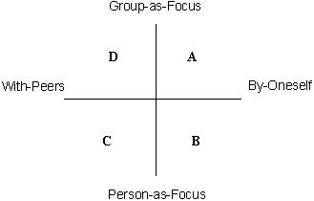
Each quadrant represents a distinct learning category. These are as follows: A) Lectures; B) Self-Study; C) Concurrent Learning; and D) Collaborative Learning. These four components of the learning cycle are commonly used in many learning other models.

Lectures refer to talks that motivate and inspire audience members to reflect and perform logical analysis in order to learn. Self-Study simply implies study by oneself regardless of the medium (ie. textbook, media, etc). Concurrent learning involves interaction with group members to accomplish individual objectives while collaborative learning centres on group work to achieve a common learning goal.

These four categories combine to form the four quadrants which make up the core structure of this learning model. The next diagram will clarify.

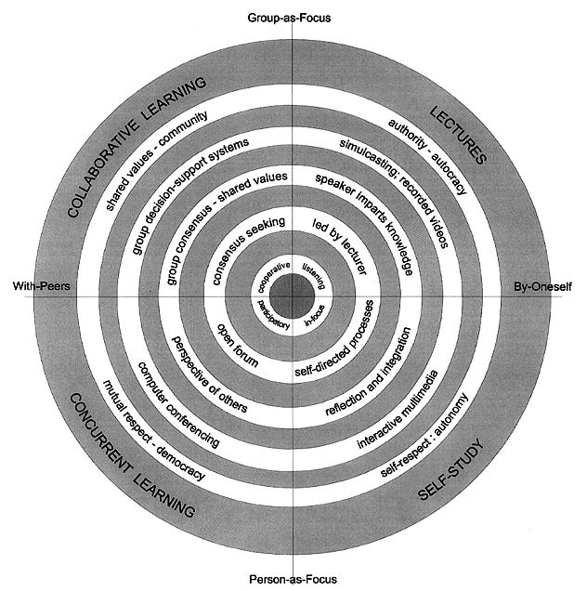
The five individual attributes of the learning model are as follows:
- interpersonal dimension;
- learning environment;
- knowledge content;
- technology support; and
- sociological dimensions.
Each of these components perform a vital role in the learning cycle.

Category  | Lectures | Self – Study | Concurrent Learning | Collaborative Learning
 Attributes
Interpersonal Dimension | - Listening | - focused on own thoughts | - participartory | - cooperative
Learning Environment | - constrained to cognitive tempo of the lecturer | - self-directed internal and external processes | - open forum for competing priorities and values | - consensus seeking based on common goals
Knowledge Content | - speaker imparts knowledge to the recipient | - self-directed reflective integration of subject | - generate own knowledge in perspective of others | - group consensus based on shared values
Technology Support | - simulcasting  - videos | - interactive multimedia | - computer conferences | - GDSS (Group decisions support systems)
Sociological Dimensions | - authority | - self-respect | - mutual respect | - shared values

From the above data table, it is possible to relate the different characteristics of the specific learning styles to their respective category. Using the knowledge of the Circle of Learning, it is possible to categorize certain learning styles. Please refer to the following list for examples.
Classroom Session
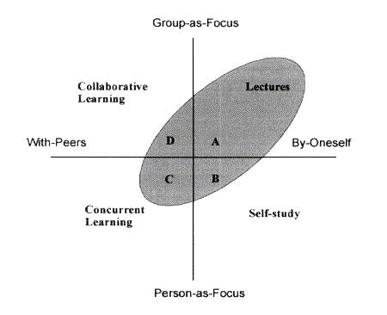

Cooperative Learning in the Classroom
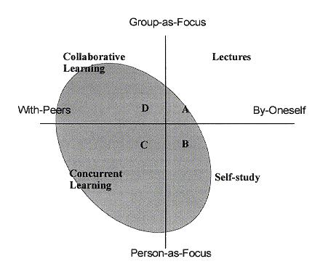

Informal Discussion Session

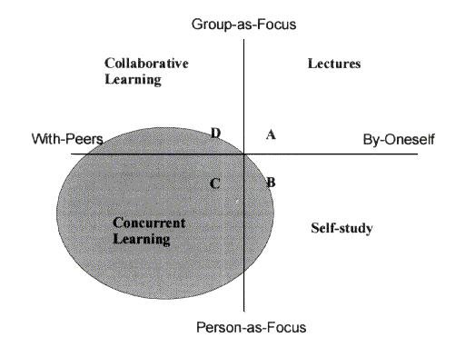

Conference

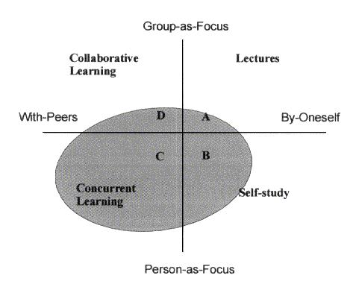

Business Meeting
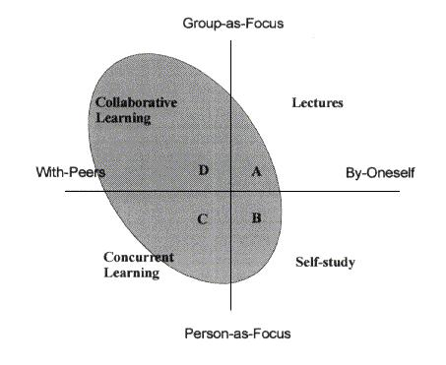

It is clearly evident that with the Circle of Learning Theory, it is possible to categorize different learning opportunities. This will be discussed with further research. With this in mind, we will now venture into the current role of technology in the average school student.

Technology in Society

Everywhere you look, the presence of technology at work is prevalent. From the moment you wake up and switch on that light to the moment you switch it off at night, your life revolves around technology. (Not to mention, if you have a security system, technology works while you sleep. Even that is only what you experience first hand)

In the last 50 years the technological boom has had an undeniable impact on the changes in society. Since the invention of the television, media has emerged. It has, does, and will continue to manipulate society. From the TV, media has expanded to the movie theatres, video games, and now schools through advertisement. The media technology affects you whether you realize it or not. Over the same period of time, many other convenient inventions have been produced. Edison single-handedly pumped out over 1000 inventions. From watches to microwaves and fluorescent light to cars, modern technology has indeed been an effective and efficient solution to our once time consuming activities.

Computer technology has indeed rose to aid in our society. Processing information takes a faction of the time as does obtaining specific files. Organizations run much more effectively with automated computers to hold a strict standard. Even the school bells are automated. Are the lives of students governed by a chip that rings a school bell?

Whether you appreciate it or not, technology is in your face!

Technological Influence on Development Stages

In order to understand the technological influence of technology of students, we look at segments in the development cycle as suggested by Austrian Rudolf Steiner. Based on his concepts of the development of children and teenagers, students undergo seven-year stages from birth. During the first stage of development, students should be educated "exclusively upon contact with the physical environment, imitation, imagined fantasy, and rhythm", comments Valdemar W. Setzer and Lowell Monke on Steiner's theory. However, with the influence of technology, children in their first stage of life already lack their much needed contact with the environment. Rather, their lives dwindle away in front of a screen watching television and playing computer and/or video games; ironically, quite contradictory to the physical environment. Imitation, sure that is evident in their lives. Countless newspaper articles report of increased violence over the last 50 years. When technology makes violence readily available in theatres, video games, and on TV, this is inevitable. Make the connection. Kids grow up through the first stage deprived of their exclusive need of an environmental experience. Let us proceed to the next seven-year stage of life.

In the second stage, children are now students around 7-14 years in age. Steiner suggests that students begin to concentrate on individualizing feelings. They subconsciously seek a beautiful world during this time period. It is interesting to note that nothing should be rigid – students should be encouraged to bring out their uniqueness. Nevertheless, it is quite evident that this stage of reinforcing individuality is being destroyed by the exploitation of technology through media. As I walk downtown, I see little kids dressed as their favourite social figure whether it be in athletics, music, movies, etc. Technology has made it possible to broadcast anything anywhere. From an ever-changing worldview, the technological industry continues to thrive at the expense of students seeking a beautiful world.

As the third stage of life takes place, individual thoughts, and points of view are established. Students begin to look for the true world. They are on a quest for truth. It is finally in this stage that many do realize the strength of technology and learn to harness this powerful tool society has exploited in many ways. Since this paper focuses on the learning in students, only the first three stages of Steiner's theory will be taken into consideration.

This marks the end of the background section in which much of the research report will refer and reflect upon.

Consequences of Technology in Early Development (Lectures)

"Society's dependence on technology has hindered the ability for creativity and use of brains."
– survey response

As mentioned in the above section, students in the present society are being bombarded with information from all different directions. This experience of information overload can be related to the Lectures quadrant in the Circle of Learning Model. This section of the learning strong depends on the lecturer. A strong speaker will be able to convince his audience to conform and retain his words. A perfect example of how technology is used to influence our knowledge is through media. Although not much, when media is combined with technology to create a mass message is very effective. Without a doubt media works at a personal level manipulating the way you think, act, and your overall perspective. Just take a look next time you are walking down the street. By the way someone dresses, you can tell what has influenced them most. Whether it is their favourite move star, music group, or athletic activity, it is usually quite evident.

Lectures have a characteristic of being authoritative. It is spoken as truth and whether you choose to accept is up your choice. Especially with mass media, students must be able to discern and explore issues critically and thoroughly before making a decision. This is simply because computers function on "1"s and "0"s. The computer has no mind, it cannot discern truth and lie. "It [computers] generates data without understanding. It does not accept responsibility for the future. It is an automaton." When using computers as a method for lecture learning, students must be very careful "to develop those inner qualities, such as insight, creativity, and good judgement, which education at its best has always sought to inspire".

The Loss of Experience (Concurrent Learning)

Concurrent learning provides the student with an opportunity to experience things first hand in the company of peers. This is a key element in the development process as it involves physical contact with the environment. Although computer technology would seem to be the cheap more efficient approach in encountering this vital stage in life the opposite is true. In reality, students encounter the unexpected as they journey into the unknown. Although this type of learning is not limited solely to self-study, rather, it may apply to either concurrent learning or collaborative learning as many experiences involve a strategy of survival. It is also a versatile activity that can be conducted for groups or individuals. Nevertheless, it gives students a flexible first-hand experience allowing them to select their educational sites of interest. Students are then given the opportunity make connections and associations with their personal experiences in reality. However, "if education software even attempt to deal with these crucial concepts, the limits of the media may make the presentation inflexible, superficial, and inadequate." Though these personal experiences, students are given the opportunity to have an appreciation for the world in which they live. By sharing among themselves in the group, they will be able to learn concurrently with one another.
Computer virtual reality tours also have the possibility of misrepresentation in certain areas. Since all input is subject to the designer of the program. You will see only what the user wishes you to see. Certain elements may be edited to create an optimal presentation often misrepresenting the truth. Unlike the experience in reality, this method of computer-based learning is firmly grounded in the self-study quadrant of our Circle of Learning Model. Another drawback to the computer-oriented learning would be loss of time in mastering other skills that are easily acquired in young children (ie. foreign languages and musical instruments). Since live experiences involve all five sensory organs of your body, the student obtains a complete feel for living through experience. For example, sky diving. Although fascinating to watch on TV, if you were actually pushed out from a plane a couple hundred feet up, I'm sure you would have a lot more to talk about when you land. In addition, the issue of uncertainty comes with real life experiences, in which obscure events may occur. These obscure, out of the ordinary events are the most effective lessons as experiences remain with them for a lifetime. In summary, live experiences in concurrent learning cannot be compromised in order to save a trip to the zoo. You just never know what you'll encounter.

The Loss of Group Dynamics (Collaborative Learning)

A key quadrant in the Circle of Learning Model is collaborative learning. Collaborative learning focuses on synergy, where the group works together with a common purpose to achieve a better result than individually possible. With the boom in technology, computers in the educational system become more prevalent. From research on various Peel elementary schools, it was noted that the newly erected elementary schools come equipped with at least one computer lab and multiple computer stations in various parts of the school. An estimated ratio of 1 computer to every 8 students was calculated. This is extremely high for an elementary school. This was confirmed in further research when I found that the Peel Board of Education is currently planning to establish a program to support elementary schools in using technology to support the school program. As more computer-oriented activities are being designed, one must consider the quadrant of the Circle of Learning Model that is being substituted. It seems that the education system sacrifices collaborative learning for a higher level of self-study. Personally I believe this is ridiculous because the school system lacks in collaborative learning. Not only is collaborative learning extremely effective, but it teaches students to work with one another developing social skills in the process. As much of the work achieved in the real world is done through teamwork, social skills are an essential attribute in society. Furthermore, in the recent push to implement technology in classrooms, "some teachers, however, are beginning to question the contribution of computers to education, at least the kindergarten through eight grade".

One-Way Communication (Self-Study)

The quadrant of Self-study is essentially a method of learning where the student is hammered with information and forced to believe it with no questions asked. This seems to be a horrible method study, but can be used effectively to reinforce prior knowledge. For example, many teachers encourage students to take advantage of this method of learning after the fundamental lesson has been taught in the classroom. This will ensure that the student has had an opportunity to learn the material and ask necessary questions. The self-study will be done as homework to reinforce principles from the lesson taught. Self-study also creates more associations and connections for the student to refer to when required on evaluations and real life. This approach to study has proven to work extremely well in the past when students were required to learn the basics. Although great for drills, this technique seems to pose discrepancies when combined with computer technology. It is seen that "in choosing the computer we are not simply making a choice based on one tool being better for a job than another. The computer caries some pretty hefty psychological and cultural baggage along with it. Employing it without concern may result in some important educational values being unintentionally left behind." Indeed, this is prevalent in the dependence of students on computers.

As discussed early in the previous section, modern technology has provided solutions to our once time consuming activities. But essential survival skills are lost in the process of transition. "Technology allows for laziness. [It] let's people work faster and more efficient." comments a surveyed student. Yes, technology can edit an article in a fraction of the time, but it does not always prove to be reliable. Also in a recent survey I conducted, I found that senior high school students had a divided opinion about human dependence on technology. Over 80% of the students said they are very dependent on technology. This is not a surprise as I received responses with multiple grammatical and spelling mistakes. One student writes, "very dependent these dayz - my assignments are collaborated via email the night before they're due". Another writes, "extremely dependant". Simple spelling and grammatical errors are unnoticed as a result of our total faith and reliance on computers. However, as stated previously, technology has limitations within itself. It goes only as far as the creator. In this case, while grammar and spell may pick up some errors, semantics cannot be analyzed. Since our minds have been so engraved in the boundaries placed by technology, we fail to notice theses subtleties. Although technology does provide many useful tools in self-study, they should not be exploited and students must learn to use them with discretion if he/she chooses to use them.

Discussion

As seen from the previous arguments, it is evident that technology has not been effectively implemented to continue along the maximum learning curve. The improper use of technology in the present society is in fact diminishing the full potential of the human learning curve.

Indeed, there are many other factors that affect the decline in the human learning curve. With the drastic increase in high-speed technology, (ie. video, computer, internet, etc.) constant usage promotes the present instantaneous culture. As a natural adaptation, a limited attention span develops in students. And despite teacher efforts, this hinders their learning in the classroom. Even with the use of computers, students have the desire to accomplish tasks within a shorter amount of time. This is also evident in today’s society as computers become more dependent on the mouse. Many keyboard applications have changed and are almost totally mouse driven. Reason? – it is faster. We are in an instantaneous society, if it can be done faster, why not go along with it? Today, students can access databases, internet, play games, etc all without touching the keyboard – it is all in one or two buttons of a mobile mouse. However, there is an opportunity cost to this instantaneous culture that has been overlooked by many. As a result for instant answers, students blindly learn only shortcuts to find solutions. For example, if a student was asked to find the sin of angle 108000. Most turn to their calculators in hopes that the right answer will magically appear. The problem is not that they are using technology, but the reason for using technology. They use technology, because it has proven to be reliable. However, technology is only as reliable as the user makes it. If there is an input error then the answer will not be correct.
In my recent survey, students were asked to add ½ + 5/6 + 11/12 + 19/20 + 29/30 + 41/42 + 55/56 + 71/72 + 89/90 + 9/10. Of the total surveyed senior students, none opted to even attempt the problem without the aid of a calculator. However, the surprising results came in the number of incorrect responses. More that one third of the answers were incorrect. These educated senior students had absolutely no idea of how to even estimate a projected answer. Students take the power of technology as the whole truth and nothing but the truth. This is dangerous as their dependence on technology overrules a bit of common sense. Because of the need for instant answers, students no longer possess the basic skills. Again, another disturbing survey statistic shows that approximately 20% of senior students who have all taken senior math courses cannot apply the basic concepts of BEDMAS. The question was (4 + 6) x (198 – 93 – 95). When a calculator was not used, more than 15% of students did not obtain the correct answer. When a calculator was used, 100% of the surveyed senior students all obtained the correct response. This shows that students do not even understand the basic functions of their calculator much less other complex functions. Since calculators are permitted on many tests, students no longer need to understand the fundamentals of mathematics. Similarly, in all areas of education, students no longer need to understand the fundamentals to understand how to apply their knowledge. This is indeed very dangerous as incorrect interpretations and results cannot be identified in their preliminary stages. This is precisely the reason for documentation error and flawed engineering designs. Graduate students do not know the basics and cannot differentiate a right and wrong result. A prime example is NASA’s probe that crashed into Mars. If people did some mental calculations they would have realized that not only did the distance not match, but that the time would be way off. It is because numbers were big and people would rather trust technology blindly. Similarly in the English, grammar is no longer taught. This is because we live in an instantaneous society where people believe that everything can come naturally. So students are expected to naturally speak properly through osmosis. However, many English teachers would argue that the evolution of the English language has gotten out of hand. For example, consider the word “wicked”. The internet is another key implication as many sites provide false information. Since young students are so reliable on technology, they do not have the ability to discern between fact or fiction. This uncertainty often urges them to look for the most instant solution – to blindly take the internet source as truth. Evidently technology has taken a toll on the fundamentals in all branches of education. It has uprooted all the rudiments of knowledge. As surfaces in inaccurate accounts of the truth. Society is set back trying to solve problems rooted in the basics that no one can interpret.

Another key factor in diminished learning is communication. Although briefly discussed in the collaborative learning section, we will take a closer look at it now. As mentioned in the Learning Model presentation the need for GDSS (Group Decision Support Systems) is vital. Group work encourages a broader range of the idea flow from various working backgrounds. However, the core to effective group work lies in communication. It has been proven time and time again that words play an extremely minor role in the communication process.

In “Developing Healthy Communication Skills”, it is proven that effective communication is based heavily on behavioural and tonal components rather than just the words. With the use of technology in schools and the workplace (Instant messaging systems, ICQ, messenger), verbal communication has been minimized. While it seems to be working efficiently, it does not encourage and build up essential Group Decision Support Systems. Communication becomes something very impersonal and hence, the true ideas and thoughts of an individual on a project or assignment cannot be properly expressed solely through a typed message. As effective communication breaks down, the chance for good group dynamics is lost. Information is pasted, but the group has no way of working together to accomplish a specific goal with maximum efficiency without knowing each of their team member as a person rather than by an employee tag number. Communication is an integral portion of the maximum learning curve that must not be overlooked.

Technology causes student to digress from their academic goals. A prime example of this is games. Simple, subtle games lure students to essentially “waste” their time. From violent battle games to the harmless solitaire, minesweeper, football keep-ups, etc, games of this calibre all contain absolutely no educational value; rather, an opportunity for students to pass on an excellent concurrent learning opportunity. Instead of using the time to study and seek for help from the teacher, students take the opportunity to procrastinate. Again the focus of the study points to the Self-Study quadrant.

Further Reading

If you are interested in finding out more about how technology should be implemented in the education system, you are encouraged to read the following article listed. It is a very informative study supported by the State of Sao Paulo Research Foundation. Although lenthy, many key issues surface that this report cannot discuss due to length restrictions.
Valdemar W. Setzer and Lowell Monke. "Challenging the Applications: An Alternative View2 on Why, When and How Computers Should Be Used in Education" University of Sao Paulo, Brazil.

Conclusion

From the evidence, it is quite clear that technology pushes learning to be achieved mainly in self-study. Please note that the learning categories discussed in this paper are in no way mutually exclusive of one another. Each of these learning categories work together to synthesize the optimal learning potential in students. Students must beware of the technological potential and use it intelligently in their learning experience. They must strive for the areas lacking in the current education system due to technology. Namely – group decision support systems, quality lectures, and open forum discussions. By making a conscious effort to include a well-balanced learning environment, students will learn to harness the power of technology and bring the learning curve to its maximum potential once again.

Reference

• Books:

Bannon LJ. 1995. Issues in computer supported collaborative learning. In C. O'Malley, editor, Computer Supported Collaborative Learning, volume 128 of NATO ASI Series, Series F, Computer and Systems Sciences. Springer Verlag,

Berlin. Carley K. 1992. Organizational learning and personnel turnover. Organization Science 3(1):20-46. Dillon JT. 1988. Questioning and teaching: A manual of practice. Teachers College Press: New York. Fjuk A. 1995. Towards an analytical framework for CSC distance learning. In J. L. Schnase and E. L.

Cunnius, editors, Proceedings of CSCL '95: The First International Conference on Computer Support for Collaborative Learning. Lawrence.

Graesser AC, Person NK. 1994. Question asking during tutoring. American Educational Research Journal 31(1):104-137. Spring, 1994.

Johnson DW, Johnson RT, Smith KA. 1991. Active learning: cooperation in the college classroom. Interaction Book Company, Edina, Minnesota.

Johnson DW, Johnson RT. 1991. Cooperative learning: increasing college faculty instructional productivity. ASHE-ERIC Higher Education Report No. 4. George

Konferenzen Rudolf Steiner mit den Lehren der Freien Waldorfschule in Stuttgart 1919-1924, Vol. 1. Private edition: Stuttgart, (translation unknown)

Vetter R. 1995. Videoconferencing on the internet. Computer 28(1):77-79. January 1995.

• Internet Sites:

http://www.meadia-awareness.ca/eng/news/news/peel2.htm
News: April 21, 97 – Peel Board moves ahead with ads on screen savers

http://library.northernlight.com/FB20010307730000114.html
Canada Newswire: Grade 10 literacy tests results incredible – Why?

http://www.osopinion.com/Opinions/TomNadeau/Tom Nadeau34.html
The Trouble with Technology

http://www.peel.edu.on.ca/facts/d-use.htm
Peel District School Board – Get the Facts. Published by the Peel District School Board

http://wwwpublic.iastate.edu/~lmonke/online_doc.html
"Computers in Education: The Web and the Plow" - Lowell, Monke
"Forgetting Ourselves in the Age of Automatons" - Steve Talbott

http://www.realworld.org/
Learning in the Real World
725 Main St. Suite 232
Woodland, California 95695-3406
Phone: 530-661-7240 Fax: 530-661-9242

• Articles (Magazines, Journals, Newspapers) :

Mendels, Pamela "Technology Critic Takes on Computers in Schools" New York Times, April 5, 2000

Postman, N. "The End of Education" Knopf, NY 1995.

Postnam, N. "The Disappearance of Childhood" Delacorte Press, NY 1982.

Sava, Samuel G. "Maybe Computers Aren't Schools' Salvation" The New York Times, September 6, 1997.

Valdemar W. Setzer and Lowell Monke. "Challenging the Applications: An Alternative View2 on Why, When and How Computers Should Be Used in Education" University of Sao Paulo, Brazil.

Konferenzen Rudolf Steiner mit den Lehren der Freien Waldorfschule in Stuttgart 1919-1924, Vol. 1. Private edition: Stuttgart, (translation unknown)
Valdemar W. Setzer and Lowell Monke. "Challenging the Applications: An Alternative View2 on Why, When and How Computers Should Be Used in Education" University of S. Paulo, Brazil.
Talbott, Steve. "Forgetting Ourselves in the Age of Automatons" http://www.public.iastate.edu/~lmonke/online_doc.html 1996.
Monke, Lowell. "Computers in Education: The Web and the Plow" http://222.public.iastate.edu/~lmonke/online_doc.html 1996.
Learning in the Real World: http://www.realworld.org/
Peel District School Board – Get the Facts: http://www.peel.edu.on.ca/facts/d-use.htm
Sava, Samuel G. "Maybe Computers Aren't Schools' Salvation" The New York Times, September 6, 1997.
Monke, Lowell. "Computers in Education: The Web and the Plow" http://222.public.iastate.edu/~lmonke/online_doc.html 1996.
Upon closer inspection, one would realize the addition problem can be rewritten as ½ + (½ + 1/3) + (2/3 + ¼) + (3/4 + 1/5) + (4/5 + 1/6) + (5/6 + 1/7) + (6/7 + 1/8) + (7/8 + 1/9) + (8/9 + 1/10) + 9/10. Regrouping would generate 1 + 1 + 1 + 1 + 1 + 1 + 1 + 1 + 1 = 9 ◻
Tyndale Seminary: Counselling handout “Developing Healthy Communication Skills”

