Mr. Tippetts
Physical Education

Badminton

Background

History:
The origins of badminton are clouded in history; it isn’t certain where it started. One theory is that it may have originated in China in the 5th century B.C. with the game TI Jian Zi. This game involves kicking a shuttlecock, a little like hacky-sack.
The origins of modern badminton started in India with a game called Poona. English military officers in India started to play it and it became very popular with them. These officers brought the game back to England. In the 1870’s the Duke of Beaufort introduced the game to a number of socialites at his estate called Badminton. These socialites started to call the game badminton after the estate and the name stuck.
By 1895 the Badminton Association of England became the official governing body and established the first standard set of rules. In 1899 the first All-England Badminton Championships for men were held. In 1900 women had their championships.
The first American Club was formed in New York in 1878. In the 1930’s it was a popular activity for movie stars. The American governing body is the United States Badminton Association (USBA). The International Badminton Federation (IBF) was organized in 1934.
In the United States badminton has the reputation for being and dainty outdoor picnic sport. In reality it is an indoor sport played by over 30 million people worldwide (250,000 – 500,000 in the U.S.). Badminton became a full medal sport at the 1992 Barcelona Olympic Games after 20 years as a demonstration sport. Badminton is played at the high school, college, and club levels. There is also a professional circuit with several million dollars in prize money (not enough to make a living). The U.S. Open had a purse of over $35,000 in 1992.

Statistical Facts

- Top players string a three-ounce racket at 25 pounds per square inch.
- Top players can smash the bird at 200+ mph.
- It is a highly aerobic sport where players run about a mile per game.
- Speed, endurance and reflexes are rewarded over strength alone.
- Two players can play a match in 45 minutes.
- It can be played throughout your life.

Tennis vs. Badminton

This is a statistical comparison of the 1985 All-England Tennis Championship match and the 1985 World Badminton Championship match.

 | Tennis | Badminton
Time | 3 hrs. 18 min. | 1 hr. 16 min
Ball/bird in play | 18 min. | 37 min.
Match intensity (play/time) | 9% | 48%
Rallies | 299 | 146
Shots | 1004 | 1972
Shots per rally | 3.4 | 3.5
Distance covered | 2 miles | 4 miles
- Badminton players ran 4 miles in half the time tennis players ran two miles.

Badminton can be played as a singles game, men’s and women’s doubles and mixed doubles (1 man and 1 women on a team).

Rules

The Court:

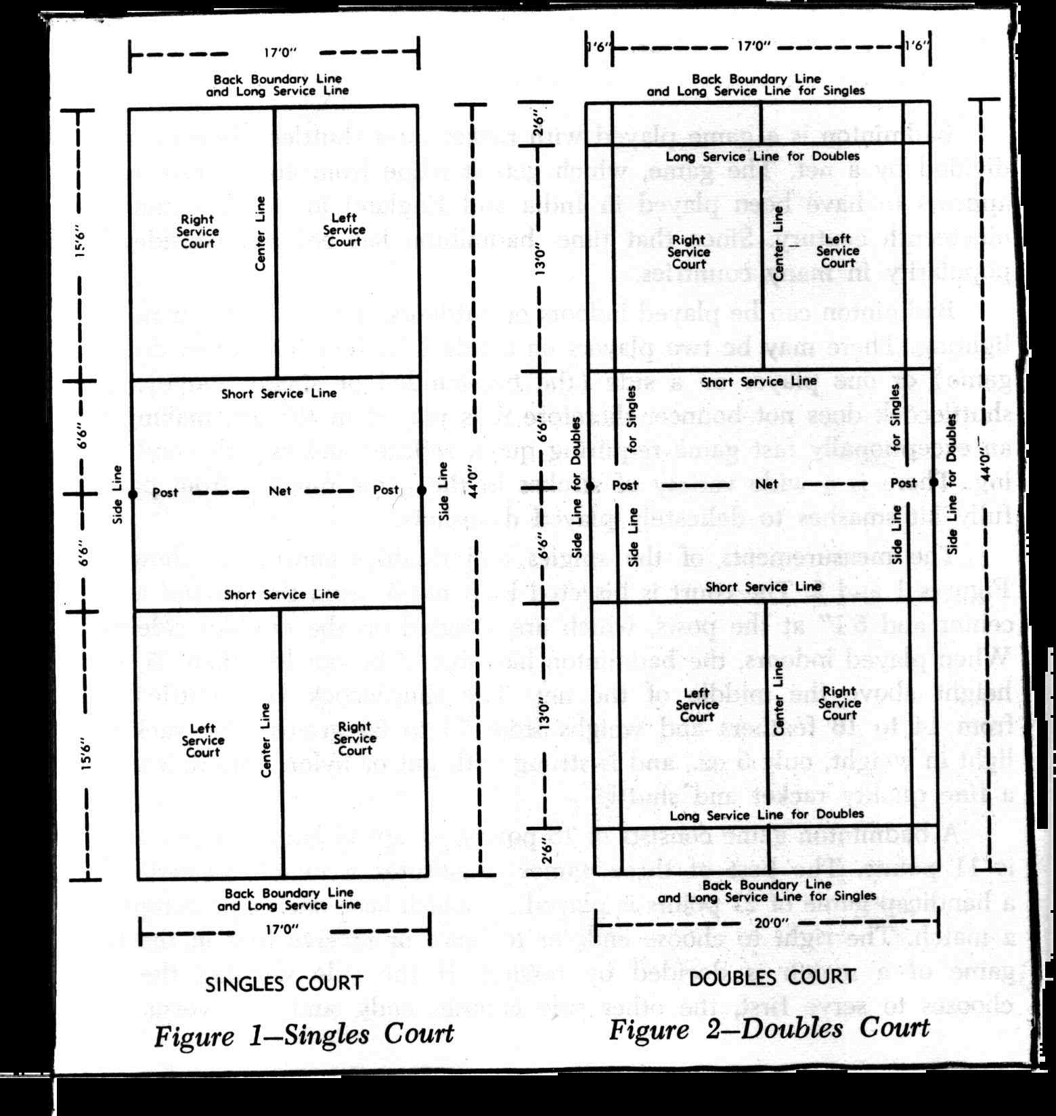

Lines are considered good or in if the bird lands on them.

Starting the Game:
To determine who starts the game the players hit a shuttle up in the air and let it hit the ground. The team or player it points to gets the choice of side, serve, or receive.

Game/Match:
All games except women’s singles are played to 15 points. Women’s singles games are played to 11 points.
A match is 3 games, whomever wins 2 out of 3 games wins the match.
In class we will play one game to 21 points.

Scoring:
You can only score when you or your team is serving. Points are scored when the receiving team fails to return the bird successfully (they commit a fault).

Serving:

Doubles: an Inning --- When both teams have served.
a Hand --- a players turn at serving.

- Both players on a team get a hand at serving each inning except at the start of the game. At the start of the game the team that serves first only gets one hand at serving in the first inning.
- A player serves until their team commits a fault then it is their partners turn (hand) or the other teams.
- When it becomes a team’s turn to serve they always start from the right service court and alternates service court each serve.
- If a player starts the game serving or receiving first then they will always be in the right service court if their score is 0 or even. They will be in the left service court if their score is odd. It is just the opposite for their partner.
- If the serving team serves out of rotation or from the wrong service court and it is caught before the next serve then the serve is taken over (it is a let). If it is not caught before the next serve then the new rotation stands.
- The doubles service court is short and wide (see the diagram of the court).

Singles:
- In singles the players serve from the right service court if their score is 0 or even and they serve from the left if the serve is odd.
- The singles service court is long and narrow.

General Service Rules:
- The serve is served diagonally, from right service court to right service court or from left service court to left service court.
- Serves must land within the service court.
- Both feet of the server and the receiver must be in contact with the ground until the bird is hit.
- Contact with the bird must be made below the waist.
- Contact with the bird must be made with the racket below the wrist.
- Once the racket starts forward that is the start of the serve and it must continue in one continuous forward motion.
- If the bird hits the net and lands in the correct service court then it is a good serve. If it does not land in the service court then it is a fault and the server looses the serve.
- You must wait until the receiver is ready before you serve. The receiver cannot delay the game; they should be ready in 30 seconds.

Faults: (An error that ends a rally and results in a loss of point or loss of serve.)

- Any violation of the service rules.
- The bird is hit into the net.
- The bird does not go over the net.
- The bird hits an obstruction outside the court.
- The bird hits a player or their clothes.
- The bird is hit while still on the opponent’s side of the net. If a player hits the bird on their side of the net and follows through over the net it is okay.
- A player touches the net with their racket or body.
- If a player steps into the opponent’s court.
- If a player deliberately distracts an opponent as they are about to hit the bird.
- If the bird is caught on the racket and slung.
- If the bird is hit twice by a player or a player and their partner before it crosses the net.

Lets: Takeovers
- An accidental disruption of the game.
- The bird goes over the net but gets stuck in the net.
- The server serves before the receiver is ready.
- The head of the bird separates from the body.
- The bird hits an obstruction hanging over the court (determined by the courts ground rules).

Strategies:

Doubles: Hits are generally low and fast. Drives, attacking clears and smashes are the most used shots. Players should try to work the alleys unless the opponents are side-by-side. Try not to hit across the middle of the court.

Up and Back formation: In this formation the server stays at the net and their partner stays in the back court. The person at the net takes everything hit near the net and the back person takes all the rest. The weakness with this formation is that it is difficult to cover the alleys and the back person has a lot of area to cover. The strength of this is that it is an attacking formation and you discourage your opponent from dropping the bird.

Side-By-Side formation: In this formation the partners play at mid court each in their own service court. The weakness of this formation is that the opponent can drive a player back and the drop on them moving them back and forth and totally ignore the other player. There is also often confusion about who gets the bird hit down the middle. The strength is that the alleys are easily covered. This is a defensive formation because both players are back from the net in a better position to return a smash.

Rotation formation: In this formation the player move around the court like a compass needle with one player staying to the opposite side of the court from their partner. Whichever player can get the bird gets it and the other player moves to cover the open court. The weakness of this formation is that it is confusing and sometimes both players go for the bird leaving a large open court area. The strength of this formation is that it allows for open areas of the court to be covered and it keeps one player from having to cover most of the court. It also allows easy shifting from offense to defense and back.

