Soccer (Football) Puzzle

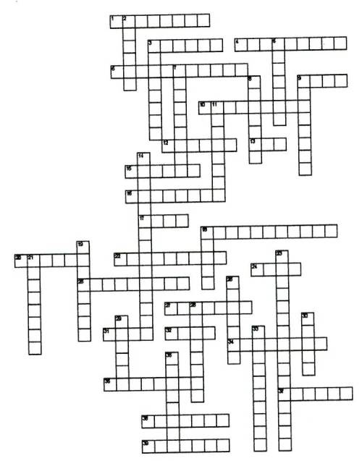
Across
1. How a throw-in must be performed.
3. These people played a soccer styled game called Harpaston.
4. The length of time in minutes for each half of a professional soccer game.
6. The part of the field a goalie may use their hands.
9. What must maintain contact with the ground on a throw-in?
10. The team with the ball is the ______ team.
12. The center _________ has a ten yard radius.
13. the number of periods in a game.
15. The forward who usually kicks off.
16. An offensive and defensive position.
17. To stop and control the ball with a part of your body.
18. This divides the field in half.
20. A __________ kick is awarded to the attacking team when a defender knocks
the ball out of play over the goal line.
22. Moving the ball down the field using soft kicks.
24. The type of kick used by a goalie in which the ball is kicked after it is
dropped but before it hits the ground.
25. All free kicks are this type of kick.
27. A free kick used to start a game and half.
31. In 1-on-1 defense, a defender must _______ an attacking player.
32. The type of defense in which a defender is responsible for a section of
the field
34. Kicking the ball at the goal.
36. What most of the world calls soccer.
37. The number of players per team.
38. An offensive only position.
39. Striking the ball with your head.

Down
2. Striking the ball with a part of the body with the purpose to redirect the
ball.
3. This is taken by the defending team when the attacking team kicks the ball
out of play over the goal line.
5. How is the ball put back into play after going over the touchline.
7. What the sideline is called.
8. A violation of the rules.
9. This is awarded to a team when the opponents commit a foul.
11. A defensive only position.
14. Where a penalty kick must be taken from.
18. You may not use your __________ in soccer.
19. How is a game restarted when it is not clear which team knocked the ball
out of play.
21. The attacking player is __________ when there are not two defenders
between them and the goal at the time the ball is passed forward.
23. This is awarded for technical fouls and a goal cannot be scored directly
from it.
26. The team trying to keep the other team from scoring.
28. A successful trap stops the ball and __________ it.
29. A precursor to soccer played in Italy.
30. The outside forwards.
33. The only player allowed to use their hands.
35. Where a goal kick must be taken from.

