Mr. Tippetts
Physical Education
Soccer
Soccer Rules and Information

I. What is Soccer?

A. Sport played between 2 teams
1. 11 players per team
2. Two 30 min. halves (45 min halves for college and professional)
3. Purpose: Score more points by moving the ball into opponents goal using your feet and head.
a. hands and arms may not be used.
b. hands and arms are only used for throw-ins and by the goalie.
4. Uniforms: Simple - Jersey, shorts, knee-length socks, shoes, shinguards (optional)
* goalies wear different colored clothes so they are easily identified.

II. Who invented the Game of Soccer?

The game of soccer has been thought to have originated from a Greek game called harpaston or from an Italian game called
calzio. Both games were forerunners of the game of soccer (football) that was played in England during the middle ages.
During this time the game of soccer was very much a part of English life. The big game of the season was always played on
Shrove Tuesday. Over the years this game was played by the peasants, but gradually grew in popularity. In 1863 soccer
became an official school game, complete with rules and regulations.

The first college game of soccer was played in the United States on November 6, 1869. Today soccer is played in most
schools, colleges, and communities. The popularity of soccer is growing because of soccer’s fast action and low investment
costs. The United States Soccer Federation (USSF) governs play within the United States, while the United States Youth
Soccer Association (USYSA) governs youth soccer for those 19 and younger.

III. Why Play Soccer?

A. One of the worlds most popular sports (called football in most of the word).
1. Simple
2. Inexpensive
3. Enjoyed by boys and girls regardless of size and age.
4. It can be played leisurely at a slow pace as in recreational soccer, or at a fast and intense pace in
professional or World Cup competition.
5. Fitness
a. strength
b. endurance
c. agility
d. eye-foot and eye-hand coordination
6. It develops skills such as quick decision making and judgment, tactics and strategy.
7. It also develops social skills such as, cooperation, emotional control, trust, concentration, respect,
and perseverance.

IV. Class Safety Rules:
1. Follow instructions of the teacher.
2. Wear appropriate attire.
3. Do not chew gum, eat, or drink during class.
4. Check the soccer field for holes and make sure it is clear of litter and dangerous objects like rocks
glass.
5. Report potentially dangerous circumstances to the teacher.
6. Pay attention to what you are doing.
7. Do not begin play until all players on the field are ready and the teacher tells you to.
8. Do not run onto another soccer field to retrieve your ball until it is safe to do so.
9. Follow soccer rules regarding fouls and misconduct.
10. Stop game play/practice at the end of the period when the whistle is blown.
11. Carry all equipment in at the end of the period: do not throw or kick it in.
12. No heading, slide tackling, no shots on goal above the shoulders.

V. The Field:
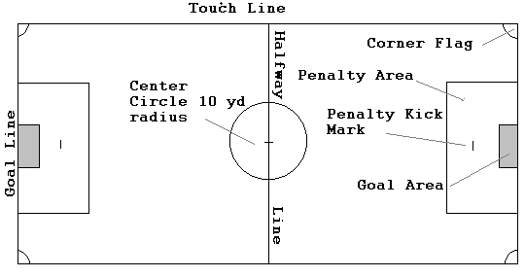

VI: Positions:
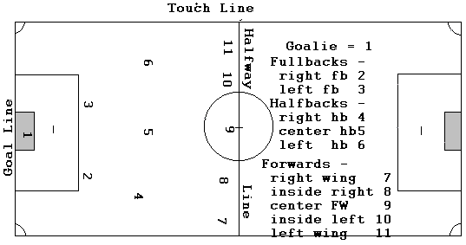
A. Forwards
1. Offensive players
2. 5 players
B. Halfbacks
1. Offensive and defensive players
2. Cover the entire field
3. Help forwards and fullbacks
4. 2 - 3 players
C. Fullbacks
1. Defensive players
2. 2 - 3 players
D. Goal Keeper (Goalie)
1. Defense
2. Only player allowed to use their hands.
3. 1 player

VII. Soccer Terms:

Attacking team - The team having possession of the ball.

Corner kick - a place kick made by the attacking team from the corner arc. This
occurs when the defending team sends the ball over the goal line or
over the goal. Another player must play the ball before the kicker
touches it again. A goal may be scored from the kick itself.
Defensive team - the team that does not have possession of the ball.
Dribbling - A method of advancing the ball by using soft taps with the inside and
outside of feet to control and propel the ball along the ground.
Drop ball - The way the game is restarted when the referee is not sure who last touched
the ball before itwent out of bounds or on restart, if the referee stops the game
due to injury. The referee holds the ball between two opposing players and
drops it: neither player may touch it until it reaches the ground.
Foul - A rule infraction which results in a free kick. Examples of fouls
include tripping, pushing, holding, shoving, and kicking an opponent,
and unsportsmanlike conduct.
Free kick - A place kick which puts the ball into play from a designated spot for an
infraction of the rules. The kick is awarded to a team when the
opposing team is penalized. Opponents must be 10 yards
from the ball and cannot interfere with the kick. There are two types of free
kicks, an indirect free kick and a direct free kick .
Indirect free kick - a free kick that cannot score a goal until another player has touched the
ball. It is awarded when a minor technical infraction has occurred.
Direct free kick - a free kick awarded as a result of an intentional personal foul such as kicking,
tripping, pushing, hands, or holding, taken from the point of the infraction. A goal
can be scored directly from this kick.
Goal Kick - A free kick made by the defending team when the ball goes out of
bounds across the goal line and was last touched by a member of the
attacking team. All opposing players must be outside the penalty area
when a goal kick is made. Another player must touch the ball before
the kicker can play it again. The kick is taken from the goal area closest to where it
went out.
Goalkeeper - A player who guards the goal. Unlike any other players, the
goalkeeper (goalie) can touch or throw the ball provided s/he is in the
penalty area.
Heading - To hit the ball with the head. The player must jump to meet the ball
with a stiff neck and back straight. Contact with the ball is on the
forehead between the eyebrows and the goal line.
Heading should only be done when the ball is above the head!
Kick-off - An indirect free kick used to put the ball into play from the center
circle at the beginning of the game, beginning of a new period, and after a goal has been scored.
Mark or Marking - To guard or guarding a player.
Off sides - When an attacking player does not have two defending players between themselves
and the goal when the ball is passed.
Penalty kick - a direct free kick awarded to the attacking team when the defense commits a foul
within the penalty area. All players stand outside the penalty area
except the player taking the penalty kick and the goalkeeper defending
the goal. The goalie must stand on the goal line and cannot move their feet until the
ball is kicked.
Place Kick - A kick taken when the ball is stationary on the ground and the kicker taking several
steps to approach the ball.
Punting - A kick used only by the goalkeeper. The ball is dropped from the
hands and is kicked by the foot before it hits the ground. The punt
must be kicked within the penalty area.
Throw-in - This occurs when the ball goes out of bounds over the touchline. The
ball is thrown in from the point where it went of bounds by the
opposite team. The throw-in is a two-hand overhead pass with both
feet in contact with the ground. The ball must be played by another
player before the thrower may touch it again.
Shooting - The act of kicking or heading the ball towards the goal with the intent
of scoring.
Trapping - The act of stopping the ball with a part of your body. You may use
your upper trunk, hips, thighs, shins, or feet to trap the ball. The
hands or arms may not be used.
Volley - A kick or strike of the ball performed before the ball hits the ground.

VIII. Rules of the Game:

A. Start of the Game
- Referee tosses a coin to determine choice of kick-off or end of field.
- A kick-off is a place kick taken from the center of the field.
2. The center forward takes a place kick from the center of the field
a. The ball must be stationary
b. All players must be on their half of field.
c. Defensive players must be outside the center circle (10 yard radius) until the ball is kicked and
travels at least 27 inches.
d. The kicker may not touch the ball again until another player touches it.
** If they do the other team is awarded an indirect free kick.
e. Once the ball is kicked the forwards from both teams should move across the halfway line onto their opponents
side of the field.
f. Goals may not be scored directly off of the kick off.

B. Method of Scoring.
A goal is scored when the entire ball passes behind the goal line within the goal posts and cross bar.

C. Fouls and Misconduct
1. The following are fouls that will result in a direct free kick.
a. kicking or trying to kick an opponent, tripping an opponent, throwing or trying to throw an
opponent, jumping an opponent, violently or dangerously charging an opponent, charging an
opponent from behind, striking or trying to strike an opponent, holding an opponent, pushing
an opponent. Handling the ball (carrying, striking, or propelling the ball with the hands or
arms) with the exception of the goalie within the penalty area.
b. If a member of the defense commits any of the above infractions within their teams penalty
area, a penalty kick is awarded to the attacking team
c. During the penalty kick all players except the kicker and goalie must be outside the penalty area
at least 10 yards from the penalty kick mark. The goalie cannot move until the ball has been
kicked.
2. An indirect free kick is awarded for the following technical offenses:
** playing a ball a second time on the kick-off, throw-in, corner-kick, goal-kick, using offensive
language or being unsportsmanlike, persistently violating the rules, constantly arguing the
referees decisions.

IX. Skills

A. Kicks

1. Inside of the Foot Kick: The inside of the foot is used to dribble (advance the ball), pass the ball to a teammate and
to shoot the ball (kick it towards the goal). When performing this kick the striking foot is brought forward with the
dorsi flexed (front of the foot lifted up) and the foot rotated outwards so the inside of the foot is perpendicular (at a
right angle) to the plant foot (support foot). (See the diagram.) The ball is then struck with the inside of the foot and
the foot swings through the ball to complete the follow through. Since the inside of the foot has the largest flat surface
area to make contact with the ball it allows for the greatest amount of ball control.

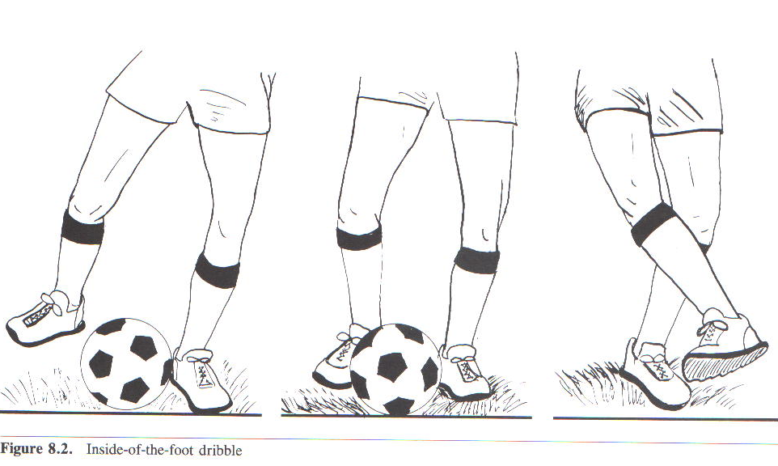

2. Outside of the Foot Kick: This kick is also used for dribbling and passing. It takes a little more agility and practice
to execute this kick properly but it does allow for you to deceive a defender and more effectively change directions
while dribbling the ball. The kicker must dorsi flex the ankle and rotate the foot inwards, towards the other foot, to
position it to strike the ball. After striking the ball the foot continues through the ball and out towards the side to
complete the follow through. (See the diagram.)
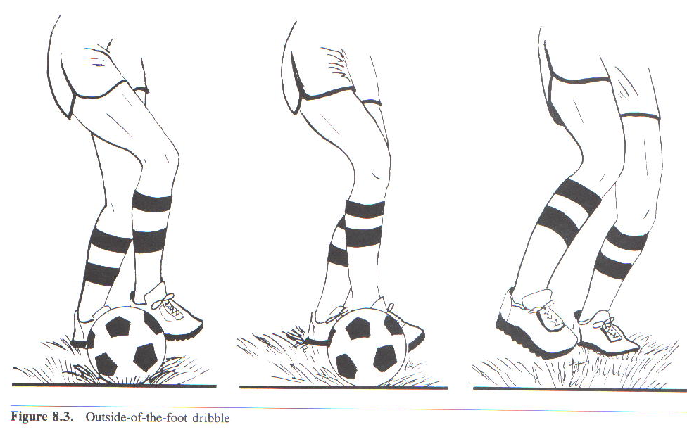

3. Instep Kick: This kick is a more powerful kick that is used for passing and taking shots on goal. In this kick the
ball is struck with the top of the instep of the foot (top of the foot). The kicker should approach the ball at about a
45 degree angle to the direction they want the ball to go. The plant foot is placed at the side and slightly behind the
ball. The striking foots ankle is plantar flexed (toes pointed down) and contact is made with the instep of the foot.
The toes should go under the ball (do not kick directly with the toes). The striking foot/leg should continue through
the ball in a sweeping motion across the body. This kick allows the ball to be lifted in the air rather easily or kept on
the ground, depending on the position of the plant foot. You can also kick the ball gently or forcefully. This kick is
more difficult to control than the inside of the foot kick due to the rounded nature of the instep.

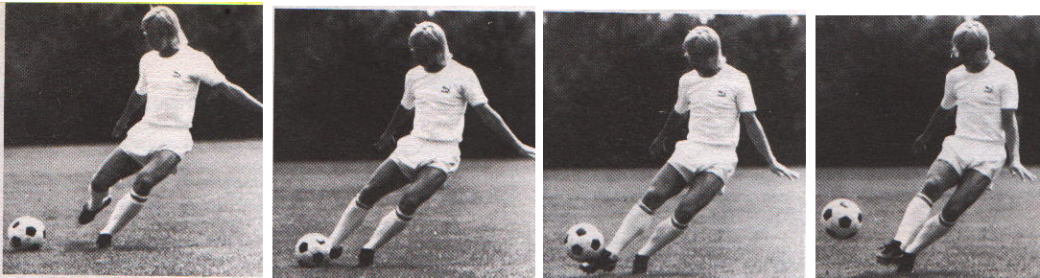

4. Punt: The punt is used to kick the ball far and clear it away from the goal. Only the goalkeeper may punt the ball.
For this kick the ball is held between abdomen and chest high with the arms extended in front of the body. The
kicker should take about three steps, starting with his/her plant foot (non-kicking foot), then drop the ball as they are
swinging their kicking leg through to kick the ball. The kicking leg will start behind the kicker with the knee flexed,
then it is swung down and under the body, as it goes through its motion the knee will extend until it is fully extended
at the point of contact with the ball. The ankle should be plantar flexed so that the toes are pointed forward not
up. Contact should be made on the instep of the foot. The leg should continue straight up through the ball. Do not
toss the ball up, doing so will throw off the timing of the kick. Make sure you release the ball and let it drop
from your hands in front of you.

- Note: For all kicks the follow through is necessary to maintain accuracy and power.

B. Trapping: Trapping is the skill of stopping the ball with parts of your body in order to gain control of the ball in order to
dribble, pass or shoot. You van basically use any part of your body to trap the ball except your hands and arms.

1. Sole of the foot trap: This trap is used when the ball is rolling smoothly toward the trapper. The player should get in
front of the ball. Just before the ball reaches the player they lift their foot and flex the ankle upwards (dorsi flex).
They then stop the ball with the sole (bottom) of the foot. Do not try to step on top of the ball. Once contact is made
the player should withdraw the foot to decrease the force of the ball and prevent it from bouncing back. (See the
diagram.)

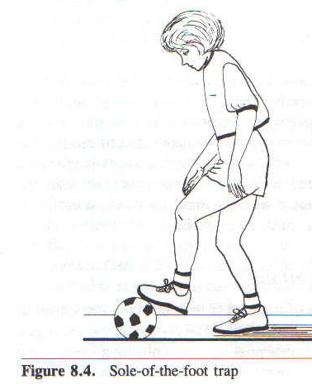

2. Inside of the foot trap: The player should move into the path of the ball. The player then moves their outside foot
toward the ball with a slightly flexed knee. The ankle is turned so the toes are pointed out. Once contact is made the
foot/leg is pulled back and the ball is stopped, by cradling it between the inside of the foot and the ground. This type
of trap places the player into good position to pass laterally or to dribble.

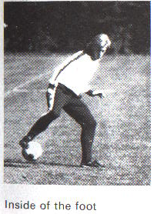

3. Thigh Trap: For this trap the thigh is raised toward the ball coming down off the fly. The knee is also flexed.
When the ball contacts the thigh the player should extend the hip (this lowers the thigh) to deaden the ball and allow
the player to gain control. Since the ball is coming down from a high point towards the ground this type of trap
allows the player to be aggressive and charge the ball.

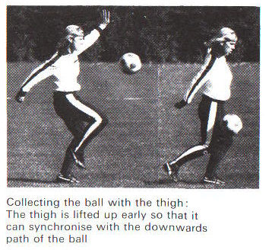

4. Chest Trap: This trap is used to a ball coming at the player high up in the air. Facing directly at the ball the player
should thrust out their chest towards the ball. This is accomplished by arching the back and bringing the arms back
behind you. Allow the ball to make contact with the top of the chest and as it makes contact, pull the chest back
away from the ball to deaden the force of the ball. The player should straighten out their back and bring their arms
forward to achieve this. Some players (especially females) may want to cross their arm across their chests to help
protect themselves. This is legal as long as all parts of their arms remain in contact with their body.

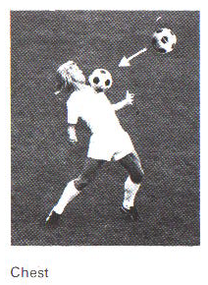

C. Throw-ins: This is used to restart play after the ball has gone out of bounds across the touchline. It is a two handed
overhead Throw. The player must throw it with both hands on the ball, over the head and with both feet in contact with
the ground at the time the ball is released. There are two versions of the throw-in, standing and running.

1. Standing throw-in: The player is stationary outside of the touchline. The player holds the ball over and behind their
head with their elbows bent. Their knees should also be should also be flexed (bent) and their back arched
(hyper-extended). The player then swings their arms forward and extends their elbows. The player should also
extend their knees and back and push off with their feet to add power to the throw. As the ball comes over the head
the player should release the ball at the appropriate time depending on how far they are throwing the ball. The feet
must be in contact with the ground until the ball has left their hands.

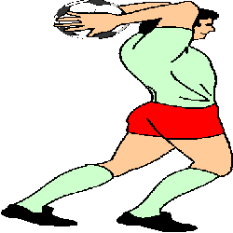

2. Running Throw-in: The player runs towards the touch line and brings the ball up, over and behind their head as in
the standing throw-in. Their back should be arched and knees bent. When they get ready to throw the should plant
their lead foot and extend their arms and knees and bring their trunk forward, releasing the ball at the appropriate
point. The thrower should be sure to drag the toe of their training foot to ensure it remains in contact with the
ground. The running throw-in will give the thrower extra force behind the throw.

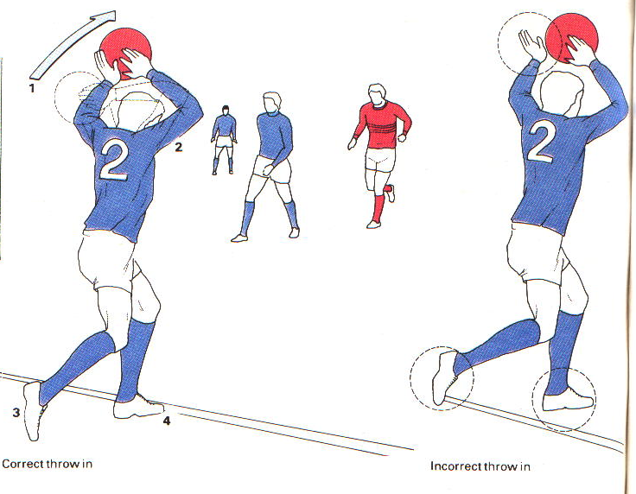

D. Goal Keeping: The primary job of the goal keeper (goalie) is to prevent the ball from crossing the goal line between the
goalposts. Goalies must have quick reflexes, jumping ability, be able to kick accurately and have good judgment. A
secondary responsibility of the goalie is to initiate (start) an offensive attack on the opponents goal, once they have kept
the other team from scoring.
1. Goalie Tactics: To achieve these objectives, goalies have special privileges that other players do not have. Goalies
can use their hands, they can punt the ball, drop kick the ball, catch and throw the ball. They can only make use of
the these tactics if they are inside the penalty area.

Once the goalie stops the ball they can initiate an offensive attack by making accurate kicks or throws to their
teammates. Long kicks just to clear the ball out of their end of the field are often ineffective because they usually
result in the ball being kick right back by the opponents.

2. Goalie Stance and Positioning: Goalies should stand with their feet shoulder-width apart and knees flexed. They
should be slightly bent at the waist with their weight on the balls of their feet. The goalies elbows should be flexed
and next to the body with their palms forward and their fingers pointed up. This will put them into position to react
rapidly to a shot on goal.

Goalies must also move to position themselves between the ball ant the goal so that the shooting angle is reduced
Thus giving the opponent less of a target to hit. If the ball is directly in front of the goal there is a larger target and
the goalie must move farther away from the goal to cut down the angle. The farther to the side of the goal the ball is,
the less of an angle there is to shoot at the goal so there is a smaller target. As a result of there being a smaller target
the goalie doesn’t have to move away from the goal as far if at all.

X. Defensive Strategies: There are two traditional types of defenses used in soccer, the 1-on-1 and the zone defense. Quite
often teams usually use a combination of these two defenses. The 1-on-1 is used when the ball is on the defending teams half
of the field. The zone defense is used when the ball is on the attacking teams half of the field.

A. 1-on-1: Each defensive player is assigned to mark (guard) a particular opposing attacker. The usual pattern is to have the
side halfbacks mark the opposing outside wings (forwards). The center halfback marks the opposing center forward and
the fullbacks mark the opposing inside forwards. If an attacker gets past their marker another defender must leave their
mark to help until the other player can get back into position.

B. Zone: The zone defense requires each defender to be responsible for a certain area of the field and they mark any player
who enters that zone. It is effective against forwards who often change positions, but it is weak if attackers cluster in one
zone. Usually the field is divided into five zones using imaginary lines and each defensive player is responsible for one
zone. The 3 halfbacks take the three center zones and the two fullbacks take the two outside zones.

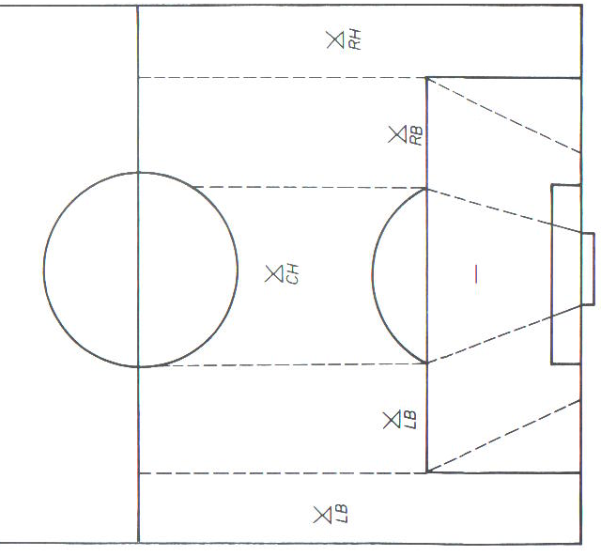

XI. Offensive Strategies:

A. Team Strategies: These strategies will make an offensive team more successful.
- Use the entire width of the field to force the defense to spread out and give attackers more room to move.
- If two defenders are near you, look for your teammate they have left free and pass to them.
- Use short passes most of the time because long passes allow more chance for interception.
- Occasionally use long diagonal passes to change the attack from one wing to the other. This may cause the defenders to get out of position.
- Backfield players should take throw-ins and free kicks outside the penalty area so the forwards may move ahead and prepare to receive a pass.
- Be alert and ready to shift from offense to defense.
- Stay away from teammates with the ball so one defender can’t easily mark two attackers.
- Pass rather than dribble (it is faster) unless you want to draw a defender with you.
- Pass ahead of teammates who are moving.
- Never pass in front of your own goal.
- Always try to center the ball when approaching your opponents’ goal.
- Move to the ball when it is passed to you don’t wait for it.

