Nattaset Somsri 481075009

Homework LAB 2 Communication System

1.When I first run the program , get constant graph

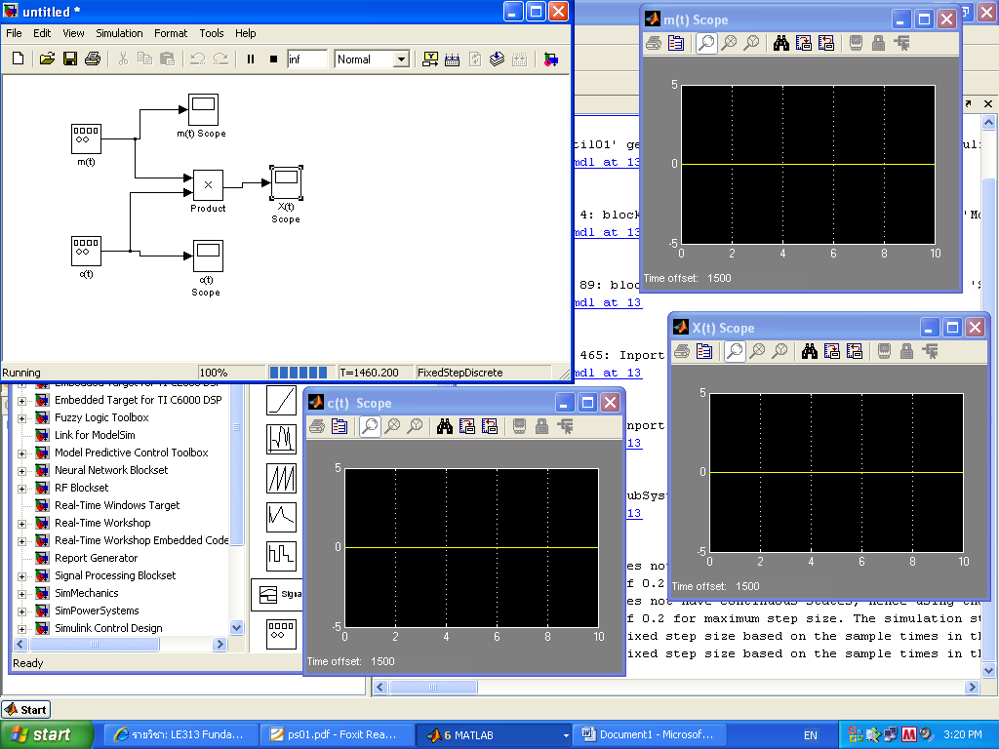

2.When I put the Spectrum Analyzer

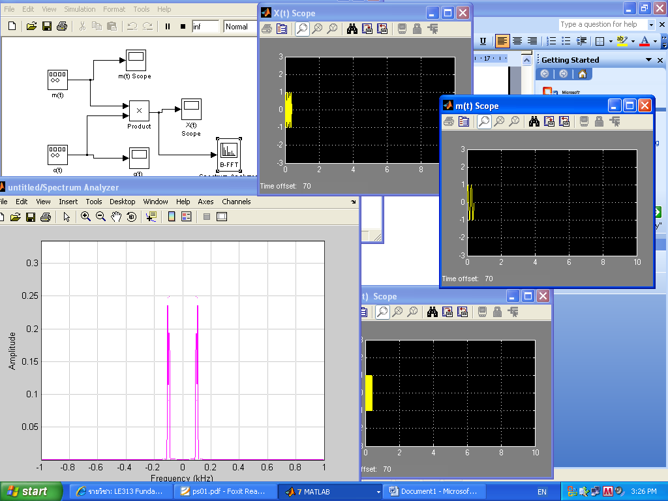

3. When I add To File to save the data to the file untitled.mat as the default value

