Metal oxide layer having oxygen deficit tilting structure
Abstract
To obtain metal oxide layer having a reactiveness to electromagnetic wave whose wave length is longer than that of ultraviolet rays, for example, visible radiation or the like. A metal oxide layer is a layer of a stable metal oxide, for example, TiO, ZnO, WO, SnO, ZrO or the like obtained by melting and adhering metal powder for forming a layer of titanium (Ti), zinc (Zn), wolfram (W), stannum (Sn) and zirconium (Zr) or the like on a surface of a product to be treated comprising of a metal, ceramics or a mixture of them by injecting the metal powder with high speed by dint of using a compressed air and has oxygen deficit tilting structure wherein bonding quantity of oxygen is decreased as goes from the surface to the inside gradually.

What is claimed is:
1. A layer formed by shot peening and having an oxygen deficit tilting structure comprising metal oxide formed on a surface to be treated; and precious metal is supported in said layer.
2. A layer formed by shot peening and having an oxygen deficit tilting structure comprising metal oxide formed on a surface of a product comprising of metal, ceramics or a mixture thereof; and precious metal is supported in said layer.
3. A layer having oxygen deficit tilting structure according to claim 1 wherein metal ions are implanted in said layer.
4. A layer having oxygen deficit tilting structure according to claim 2 wherein metal ions are implanted in said layer.

12) Patent Application: | (11) CA 2348343
(54) BOOT SHAPE RETAINER AND SUSPENDING DEVICE THEREFOR
(54) EMBAUCHOIR POUR BOTTES ET ACCESSOIRE POUR LE SUSPENDRE
Representative Drawing:
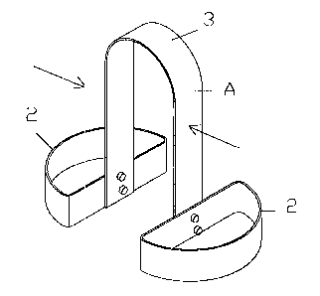
ABSTRACT:
A boot retainer can store boots without losing the shape. The retainer includes inner pads capable of moving to conform to the interior surface at two or more points of the boot of different sizes, and also includes a hook for suspending the retainer together with the boot
CLAIMS:
1. A boot shape retainer comprising: inner pads (2) movable to conform to a boot at two or more points around the interior circumference of the boot; and a hook (3) connected to the inner pads and adapted to be engaged for a suspending device.
2. The boot shape retainer according to claim 1, wherein said inner pads (2) are interconnected by spring means to be movable under or against the bias of the spring means.
3. The boot shape retainer according to claim 1, wherein said inner pads (2) are pivotally supported to opposite ends of a link (2A).
4. The boot shape retainer according to claim 3, wherein said link (2A) comprises a pair of sub-links which are pivotally interconnected.
5. A combination of a boot shape retainer as recited in any of claims 1 to 4 and a suspending device, said suspending device including a movable stand (7) for engaging with said hook (3) for suspending the boot shape retainer (A).
6. The combination according to claim 5, wherein said suspending device includes a hanger (52) adapted to be secured on a furniture such as a locker and a shoe cupboard and to be engaged with said hook
(3) for suspending the boot shape retainer.

Patent number: | US2007039840
Publication date: | 2007-02-22
Inventor: | MU DER LIANG (US); KIM LISA LYNN (US)
Applicant:
Classification:
- international: | B65D5/46; B65D81/28; B65D85/18; B65D5/46; B65D81/28; B65D85/18;
- european: | B65D85/18S; B65D5/38; B65D5/42V; B65D5/46A2; B65D81/20F1; B65D81/28
Application number: | US20050161810 20050817
Priority number(s): | US20050161810 20050817

Abstract of US2007039840
A multi-functional shoe storage box comprises a substantially transparent outer container defined by a bottom plate and first to fourth side plates, the first and second side plates facing each other, the third side plate facing the bottom plate, an opposing side of the fourth side plate being a side opening. A substantially transparent inner container defined by a bottom plate and first to fourth side plates, an opposing side of the inner container bottom plate being a top opening, the inner container first and second plates facing each other, the inner container third and fourth plates facing each other, whereby the inner container is slid through the side opening in and out of the outer container. A substantially transparent side tab extends from the outer container bottom plate and adjacent to the side opening, the side tab having a hole. |  | 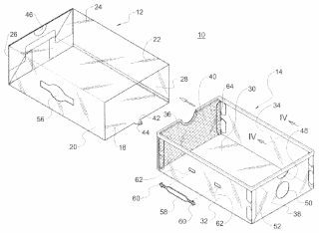

Patent number: | US2006278592
Publication date: | 2006-12-14
Inventor: | ZIPETO KENNETH M (US); ZIPETO JENNIFER S (US)
Applicant:
Classification:
- international: | A47G29/00; A47G29/00;
- european: | A47B49/00
Application number: | US20050147673 20050608
Priority number(s): | US20050147673 20050608
Abstract of US2006278592
A rotary shoe storage device includes a base member and a pivot extending outwardly from and attached to the base member. A shelf for supporting shoes has an inclined surface and a hub connected to and extending outwardly from the shelf. The hub is provided with an aperture for engaging the pivot thus enabling pivoting of the shelf about the base member. The hub is further provided with a plurality of surface slots for receiving partitions which divide the shelf into adjustable compartments to accommodate various shoe sizes. The shelf is provided with a peripheral flange to generally confine the shoes within each compartment. The device can be placed beneath a conventional bed or mounted to an underside of the bed. The shelf can be provided with a clamp for mounting to a vertically disposed shaft of a rotary shoe rack. |  |  | 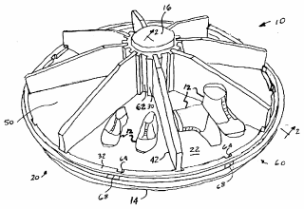

Title: Washing device and its operation controlling method
Application Number: | 200510016058 | Application Date: | 2005.11.14
Publication Number: | 1966803 | Publication Date: | 2007.05.23
Approval Pub. Date: |  | Granted Pub. Date:
International Classifi-cation: | D06F23/02;D06F58/10;D06F58/28
Applicant(s) Name: | LG Electronics (Tianjin) Electric Appliances Co., Ltd.
Address:
Inventor(s) Name: | Kim Jeung-choo;Lee Deuk-hee;Choe Seong-bong;An Byeong-hwan;Chao Heung-myong
Attorney & Agent: | panghua xin
Abstract
It is about a washing device and its operation and control. It comprises a roller washing machine, on the top of which sets a reservation sector for all kinds of clothes or dried goods, a warm air supply channel to guide the flow of warm air, at least two dry heaters on the warm air supply channel for heating the air inside, a wind supply fan forcing the warm wind out inside the warm air supply channel, a cupboard dryer to dry the reserved goods, and a control sector setting on the roller washing machine or the cupboard dryer to control the running of the roller washing machine and the cupboard dryer. It can wash and dry and be able to utilize over two dry heaters to selectively control the output power, with proper power selection to avoid unnecessary loss of electric power.

Title: Composite drying machine with hot blast feeding shelf
Application Number: | 200510016062 | Application Date: | 2005.11.14
Publication Number: | 1966833 | Publication Date: | 2007.05.23
Approval Pub. Date: |  | Granted Pub. Date:
International Classifi-cation: | D06F58/10;D06F58/20;D06F25/00
Applicant(s) Name: | LG Electronics (Tianjin) Electric Appliances Co., Ltd.
Address:
Inventor(s) Name: | Kim Jeung-choo;Lee Deuk-hee;Choe Seong-bong;An Byeong-hwan;Chao Heung-myong
Attorney & Agent: | madun fang
Abstract
A composite dryer with warm air supply rack comprises a roller dryer, a cupboard dryer on the roller dryer, a warm air intake on the cupboard dryer, a detachable rack inside the cupboard dryer with the function of placing articles to be washed and guiding the warm air through the channel to the articles to be washed. It can keep internal circulation of the air inside of the roller and cupboard dryers. Condensing the high humidity air exhaust from the roller and cupboard dryer with the air condenser, it can eliminate air from air by providing convenient drying for washed articles. With inside warm air supply rack or the convex rack, it can provide even and through drying for the articles to be washed with shortened time.

Patent number:
  US2006231602
  Publication date: | 2006-10-19
  Inventor: | MU DER LIANG (US); KIM LISA LYNN (US)
  Applicant:
  Classification:
  - international: | B65D43/00; B65D43/00;
  - european: | B65D5/30B1; B65D5/38; B65D5/42D; B65D5/42V; B65D5/46A2; B65D5/66D2E
  Application number: | US20050907772 20050414
  Priority number(s): | US20050907772 20050414
  View INPADOC patent family
  View forward citations
Report a data error here
Abstract of US2006231602
A multi-functional shoe storage box comprising an outer container defined by a bottom plate and first to third side plates, the first and second side plates facing each other, the third side plate completing the outer container with a fourth side being a slide opening. A cover has a top plate hingedly extending from the second side plate with a wing plate extending from the top plate so that when the cover is hingedly closed the wing plate becomes overlapped onto the first side plate. An inner container with its first and second plates facing each other, the inner third and fourth plates facing each other, whereby the inner container is slid through the slide opening in and out of the outer container. A side tab extending outwardly from the outer container bottom plate has a hole. |  | 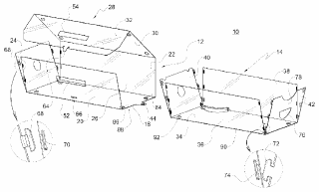

Title: Hinge for mounting in an opening
Application Number: | 200580003237 | Application Date: | 2005.01.26
Publication Number: | 1914395 | Publication Date: | 2007.02.14
Approval Pub. Date: |  | Granted Pub. Date:
International Classifi-cation: | E05D5/02;E05D7/12
Applicant(s) Name: | Ramsauer Dieter
Address:
Inventor(s) Name: | Ramsauer Dieter
Attorney & Agent: | zhong qiang fan weimin
Abstract
The invention relates to a hinge(บานพับ) (10) comprising at least one hinge element (16) that can be mounted in an opening (12) in a thin wall (14), such as a sheet metal cupboard door. Said hinge comprises a head part (28), such as a flange(ช่อง) or a hinge leaf, covering the edge (24) of the opening (12) of the thin wall (14) on the (outer) side (26) thereof, a body part (30) that extends from the head part (28) and can be inserted through the opening (12) in the thin wall (14), and a holding part (34) that is carried by the body part (30), supported on the other (rear) side (32) of the thin wall (14), and separated from the body part. Said holding part (34) consists of holding elements (36) that project from the body part (30) towards the outer surface thereof in a flexible manner, and the free end of said holding elements has an inclined surface (38) for supporting the body part (30) on the edge (40) of the opening (12) in such a way that there is no play.

Title: Method for processing refuse in kitchen cupboard into biological feed
Application Number: | 03132556 | Application Date: | 2003.08.08
Publication Number: | 1579199 | Publication Date: | 2005.02.16
Approval Pub. Date: | 2007.06.06 | Granted Pub. Date: | 2007.06.06
International Classifi-cation: | A23K1/10
Applicant(s) Name: | Ding Zhiyong
Address:
Inventor(s) Name: | Xia Haihua;Wei Guosheng;Zhang Xuefang
Attorney & Agent: | zu yuqing
Abstract
The invention provides a method of biologically making restaurant and kitchen rubbishes into feed, including: solid-liquid separation and oil-water separation. The oil separated out is made into fatty acid calcium particles by emulsifying and hydrogenating. The water separated out is added to feed saccharomycetes to obtain a saccharomycetes-containing solution. The solid separated out is sterilized at high pressure and then mixes with the solution to ferment into the feed. The method is special, the process is novel, and the final product is economic and practical. It converts the restaurant and kitchen rubbishes to the feed that has high-added value fatty acid calcium and high protein. The whole course does not discharge any pollutant and has no secondary pollution. The feed obtained contains various physiological active substances, helpful for the domestic animals and fowls to digest and assimilate the feed, thus increasing the utilization rate of the feed.

Title: Adjusting arm driving device for cabinet door plate
Application Number: | 200580004324 | Application Date: | 2005.01.24
Publication Number: | 1918352 | Publication Date: | 2007.02.21
Approval Pub. Date: |  | Granted Pub. Date:
International Classifi-cation: | E05F5/00;E05F1/10;E05D15/46
Applicant(s) Name: | Blum GmbH Julius
Address:
Inventor(s) Name: | Hollenstein Helmut
Attorney & Agent: | zhang zhaodong
Abstract
The invention relates to an actuating-arm drive (1) for cupboard doors (4). Said drive comprises an actuating arm (2) that is hinged to a door (4) and is subjected to the action of a spring (11). The actuating arm (2) can be tilted over a pivoting area that is delimited by two end positions. The actuating-arm drive (1) is equipped with at least one damper (18) that damps the tilting motion of the actuating arm before the latter (2) reaches the two end positions.

(21)Application number : | 04-228704 | (71)Applicant : | MISAWA HOMES CO LTD
(22)Date of filing : | 27.08.1992 | (72)Inventor : | IMOTO HIBIKI

(54) RECEIVING BODY OF UNIT BUILDING
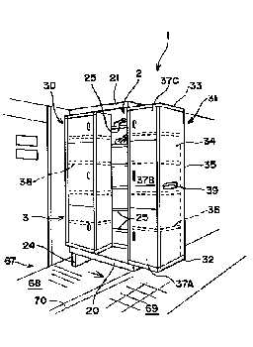
(57)Abstract:
PURPOSE: To effectively utilize a dead space in a unit building and receive many objects to be received while saving the space.
CONSTITUTION: A boot cupboard 1 as a receiving body is arranged in the vicinity of a clearance part as a dead space generated at assembling a plurality of building units, and it is constituted of a first receiving part 2 in which many objects to be received are received, and a second part 3 which is provided in front of the first receiving part 2, slided in lateral direction against the first receiving 2 part so as to open or close it, and receives many objects to be received. Because the clearance part is provided with the first receiving part 2 and further the second receiving part 3, many footgears such as shoes can be received even in a saved space.

21)Application number : | 06-237530 | (71)Applicant : | SEKISUI CHEM CO LTD
(22)Date of filing : | 30.09.1994 | (72)Inventor : | ONO SATOMI

(54) PORCH CABINET
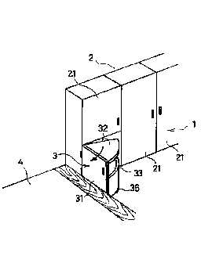
(57)Abstract:
PURPOSE: To enable even an aged person and invalid to wear easily shoes and prepare a chair without any hindrance by providing the chair in a cabinet body to be drawn out so that they can sit on the chair drawn out of the cabinet body and wear shoes.
CONSTITUTION: A porch cabinet 1 consisting of boot cupboards is composed of a cabinet body 2 and chair part 3. The cabinet body 2 has a door 21 mounted rotatably to the front face and a multistage shelves providing in the inside to receive a plurality of footwears, while the chair part 3 is mounted on the front surface rotatably with a door 31 and, as the door 31 is opened, a chair 32 mounted to the door 31 appears. Also, the chair part 3 is provided on the lower surface with casters 35 and formed below as a receptacle 33 to house shoe polish and shoe brush. Thus, when one goes out, one opens the door 21 to take out footwears and opens the door 31 to take out the chair 32. Then, one can sit down on the chair 32 to wear shoes.

(21)Application number : | 06-051762 | (71)Applicant : | OCHIAI YOSHIKI
(22)Date of filing : | 23.03.1994 | (72)Inventor : | OCHIAI YOSHIKI

(54) EXPANSIBLE TOP RAIL
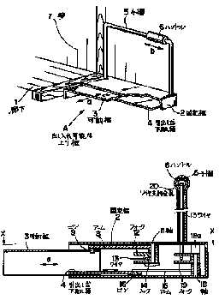
(57)Abstract:
PURPOSE: To make it possible to utilize the narrow front door efficiently by providing a movable rail capable of being taken in and out to a fixed rail having a hollow inside, providing a boot cupboard in the movable rail, and driving the movable rail with a handle.
CONSTITUTION: A fixed rail connected to a passage 1 is hollow, a movable rail 3 capable of being taken in and out in the direction of the arrow (a) is provided thereinto and, at the same time, the inside of the movable rail 3 is used for a boot cupboard 4. A turning arm is also provided to the inside of the fixed rail 2, the arm is connected to a handle 6 through a wire, and the movable rail 3 can be taken in and out by moving the handle 6 in the direction of the arrow (a). The front door space used for taking off clogs and shoes is efficiently utilized. According to the constitution, the narrow front door can be broad used.

