  Visit your local library  to discover more poetry  New York Public Library  Brooklyn Public Library  Queens Public Library | 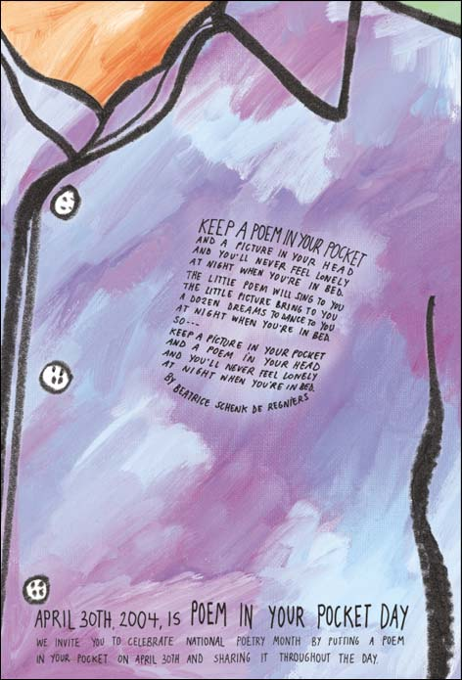

Brought to you by: | 
Thank You For Filling Out This Form
Shown below is your submission to NYC.gov on
Thursday, April 29, 2004 at 20:04:34
This form resides at http://www.nyc.gov/html/mail/html/mailnypd.html

Name of Fields | Data
Message Type: | Request for Information
Topic: | Other
Contact Info: | Yes
M/M: | Ms
First Name: | Eileen
Middle Name: | M.
Last Name: | Smith
Suffix: | M.Arch.
Company: | SOLAR DEVELOPMENT COOPERATIVE
Street Address: | 3535 East Coast Highway
Address Number: | 216
City: | Corona del Mar
State: | CA
Postal Code: | 92625
Country: | United States
Work Phone #: | 949-862-5826
Extension: | 1
Email Address: | JOURNEY2004MEDIA2@yahoo.com
Message: | Previously contacted NYPD about Journey by Horseback for Peace & Photovoltaics [www.geocities.com/JOURNEYHORSEPEACEBIPV2004] originally scheduled August 15th to September 11, 2003. NYPD offered mounted police escort from Manhattan Ferry to Ground Zero for dedication of 11 districts of Manhattan as Charter Neighborhood Energy Watch Solution Groups or N.E.W.S. Groups with blackout rescheduled: Began 4|11|04 with arrival at Ground Zero on 4th of July 2004

