AZMAR

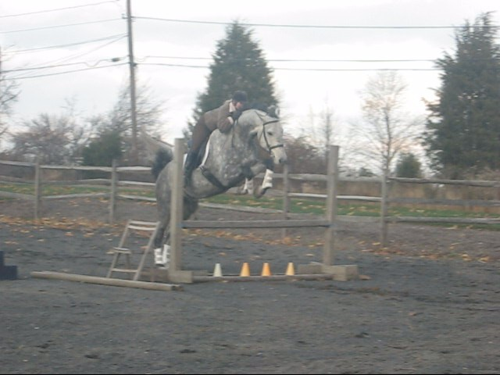
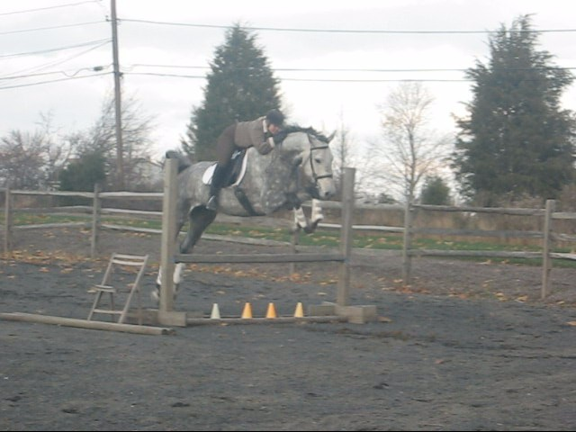
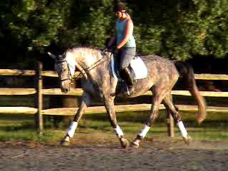

17.2 hands, 5-year-old Grey Hanoverian gelding

  - Uncomplicated with a superior temperament; great work ethic and always tries his hardest to please; has a “puppy dog” personality.

  - Azmar is balanced with three super gaits. Very big, yet soft canter-easy to sit. Brought along carefully and correctly on the flat and started over fences. Shows great hunter potential!

  - Cross ties, baths, clips, and is an excellent companion for any horse in turn out. Large, solid hooves– the farrier loves his feet!

  - Foaled May 22, 2003 (imprint trained at birth)

  - Sire: Akatschi-American Hanoverian Society approved, 17hh
Dam: Matera (Maronjo)-AHS Main Stud Book, 16.2hh

Azmar will be a perfect match for the amateur or junior who wants to really enjoy their horse while still being competitive in the show ring. Azmar has an outstanding disposition and will make his mark in the hunter or jumper arena. He is a “gentle giant” ready to be taken to the next level!

Price-$35,000 (subject to change)
Located in Bucks County, PA

Contact Tanya Forsyth at:
Email: ellwood155@yahoo.com
Phone: 610-357-9888

