Google opens online video store
By Alfred Hermida
Technology editor, BBC News website in Las Vegas
Google is to start selling video online, offering a way for people to search for and buy TV shows and more through its site.
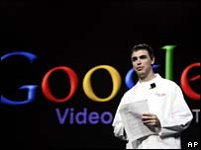
Google is now offering premium video content for the first time
The web giant's co-founder Larry Page announced the service at the Consumer Electronics Show (CES) in Las Vegas.
US network CBS is making shows like CSI and Star Trek available to buy online.
Google is the latest company to explore the idea of selling video on the net following Apple, who led the way with its iTunes online store.

