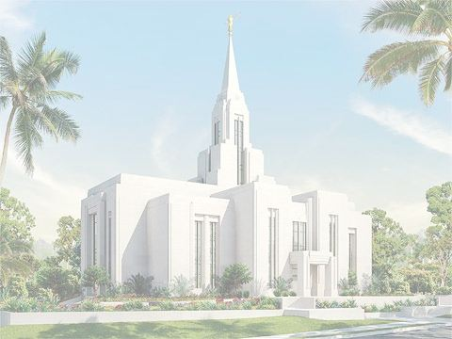
ANOINTING THE SICK:
A few drops of consecrated oil are poured upon the head of the person being anointed. And Elder lays his hands upon the person’s head, calls him/her by name and in substance says: “_______ (name), in the name of Jesus Christ and by the authority of the Holy Priesthood I lay my hands upon your head and anoint you with this oil which has been consecrated, in the name of Jesus Christ. Amen.”

SEALING THE ANOINTING
Two or more Elders lay their hands upon the head of the person, who has been anointed and the one speaking says in substance: “_______ (name), in the name of Jesus Christ and by the authority of the Holy Priesthood we seal this anointing which ahs just taken place.” A blessing may be added as the Spirit Dictates.

DEDICATING GRAVES
The Elder offering the prayer may begin: “our Father in Heaven, by the authority of the Holy Priesthood, we surround this open grave and dedicate and consecrate this spot of earth as the final resting place for the body of ________ (name). (If deemed appropriate we pray that this spot on earth be a hollowed place to which the kindred may come, and that at the time of resurrection the body may again come forth reunited with the spirit.” Continue with comforting thoughts as the spirit dictates.

FATHER’S AND OTHER BLESSINGS
The Elder places his hands upon the person’s head and in substance says: “_______ (name), in the name of Jesus Christ and by the authority of the Holy Priesthood I lay my hands upon your head and give you a father’s (or whatever title is appropriate) blessing.” A blessing is then pronounced as the spirit dictates.

BLESSING OF THE BREAD
“O God, the Eternal Father, we ask thee in the name of thy Son, Jesus Christ, to bless and sanctify this bread to the souls of all those who partake of it, that they may eat in remembrance of the body of thy Son, and witness unto thee, O God, the Eternal Father, that they are willing to take upon them the name of thy Son, and always remember him and keep his commandments which he has given them; that they may always have his Spirit to be with them. Amen”

BLESSING OF THE WATER
“O God, the Eternal Father, we ask thee in the name of thy Son, Jesus Christ, to bless and sanctify this [water] to the souls of all those who drink of it, that they may do it in remembrance of the blood of thy Son, which was shed for them; that they may witness unto thee, O God, the Eternal Father, that they do always remember him, that they may have his Spirit to be with them. Amen”

CONFERRING AND ORDAING OF THE AARONIC PRIESTHOOD
The Elder or Priest lays his hands upon the person’s head and in substance says: “_______ (name), by the authority of the Holy Priesthood I/we lay my/our hands upon your head (for Deacons or first ordination only) and confer the Aaronic Priesthood upon you and ordain you to the office of a Deacon (or Teacher or Priest) in The Church of Jesus Christ of Latter-day Saints,

SUGGESTIONS FOR BLESSINGS AND ORIDNANCES
While using this card keep in mind no definite language is established except blessing of the sacrament, baptism and confirmation. (“Elder” is used to denote any Melchizedek Priesthood holder.)

NAMING AND BLESSING CHILDREN
The child is taken in the arms of the Elders and the Elder who is voice may begin in substance: “Our Father in Heaven, in the name of Jesus Christ and by the authority of the Holy Priesthood we present before Thee this infant to give him/her a name and a blessing. We give him/her a name of ___________.” A blessing may be added as the Spirit Dictates.

BAPTIZING
The officiating Elder or Priest should hold securely in his left hand the hands of the person being baptized. Raising his right hand and arm to the square and calling the person by name says, “_______ (name), having been commissioned of Jesus Christ, I baptized you in the name of the Father, and of the Son, and of the Holy Ghost. Amen.” The right hand is then placed on the back of the candidate’s head. He or she is then completely immersed and assisted in “coming up out of the water”.

CONFIRMING
After being baptized, the Elder lays his hands upon the candidate’s head and says: “_______ (name), in the name of Jesus Christ and by the authority of the Holy Priesthood, we lay our hands upon your Head and confirm you a member of The Church of Jesus Christ of Latter-day Saints and say unto you ‘Receive the Holy Ghost’.” A blessing may be added as the Spirit Dictates.

and bestow upon you all the rights, powers, and authority pertaining to this office and calling in the Aaronic Priesthood, in the name of Jesus Christ. Amen.” A blessing may be added as the Spirit Dictates.

ORDAINING TO THE MELCHIZEDEK PRIESTHOOD AND ORDAINING
The Elder lays his hands upon the person’s head and in substance says: “_______ (name), by the authority of the Holy Priesthood I/we lay my/our hands upon your head (first ordination to the Melchizedek Priesthood) and confer upon you the Melchizedek Priesthood and ordain you to the office of an Elder (or High Priest) ) in The Church of Jesus Christ of Latter-day Saints, and bestow upon you all the rights, powers, and authority pertaining to this office and calling in the Melchizedek Priesthood, in the name of Jesus Christ. Amen.” A blessing may be added as the Spirit Dictates

CONSECRATING OIL
The Elder holds the container of the Olive Oil, with cap removed, and consecrates it with words such as: “Father in Heaven by the authority of the Holy Priesthood I/we consecrate, dedicate and set apart this oil for anointing and blessing of the sick, in. the name of Jesus Christ. Amen” care should be taken to consecrate the oil, not the container.

