Super Conductors
About Superconductivity
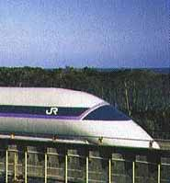
How would you like to board a Maglev train and then speed off to your destination at more than 300 miles per hour? The magnets that levitate these trains are an application of superconductivity.
Japanese Maglev train prototype (photo courtesy of Railway Technical Research Institute, Maglev Systems Development Dept.)

Metals are good conductors of electric current. That is, they have very low electrical resistance, but this resistance is not zero. A voltage difference is still required to generate the current in the metal, and the metal heats up while the current is flowing.
The electrical resistance of an object depends on its temperature and declines slowly as the temperature falls. Early in the last century, however, a Dutch physicist discovered that a sample of mercury, when cooled below a certain temperature close to absolute zero, loses all electrical resistance. When the mercury is in this state, an electric current flows indefinitely, even in the absence of any applied voltage. This effect is called "superconductivity." The table lists the everyday metals that exhibit superconductivity and the temperature below which electrical resistance disappears. These elements require cooling by liquid helium to become superconductors. Such materials are called "low-temperature superconductors."
Much later, in the 1980s, physicists discovered ceramic compounds that exhibit superconductivity at temperatures as high as -145º Celsius. This temperature is high enough that the materials need be cooled only with liquid nitrogen, which is far less expensive to do than with liquid helium.

  0 K = -273º C = -460º F
  element | transition temp. (K)
  aluminum | 1.2
  zinc | 0.9
  tin | 3.7
  mercury | 4.2
  lead | 7.2

Applications of Superconductivity
The early superconductors were chunks of metal. A breakthrough came in the 1960s with the development of a superconducting wire, an alloy of niobium and titanium. With this wire, engineers could wind electromagnet coils. These superconducting coils permit the construction of extremely powerful electromagnets. As with many engineering advances, there are tradeoffs:
cost saving: Since the magnet is operated with the wire at superconducting temperatures, the resistance of the coils is zero and no energy is lost to heating the coils. For superconducting magnets, a small power supply is sufficient to initiate the flow of current.
cost increase: Since the coils must be maintained at a low temperature, an expensive liquid helium refrigeration system is required.
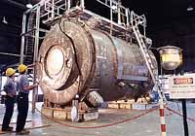
200-ton superconducting magnet built at Argonne National Laboratory as part of a project to investigate power generation from fusion (see Plasma Power in Physics in Action Archives); photo by Dan Giroux, courtesy of Argonne National Laboratory

Superconducting Magnet Application: Maglev Train
A future application is the Maglev train, now under development in Japan. To minimize friction, powerful onboard superconducting magnets support this train above the tracks. The prototype train shown in the photo reached a speed of 411 km/hr (256 mi/hr).

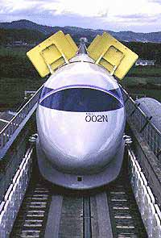
Japanese Maglev prototype MLU0002N with aerodynamic brakes deployed; photo courtesy of Railway Technical Research Institute Maglev Systems Development Department.
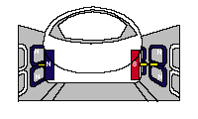
Running alongside the track are walls (see photo) with a continuous series of vertical coils of wire mounted inside. The wire in these coils is not a superconductor. As the train passes each coil, the motion of the superconducting magnet on the train induces a current in these coils, making them electromagnets. The electromagnets on the train and outside produce forces that levitate the train and keep it centered above the track. In addition, a wave of electric current sweeps down these outside coils and propels the train forward (see drawings).
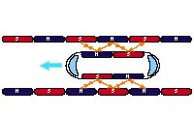
Drawings of Maglev train showing magnets both on-board and built into sidewalls; drawings courtesy of Railway Technical Research Institute Maglev Systems Development Department

Superconducting Magnet Applications: MRI scanners
MRI (Magnetic Resonance Image) scans produce detailed images of soft tissues.
The superconducting magnet coils produce a large and uniform magnetic field inside the patient's body. Note the large size of the scanner, which contains the liquid helium refrigeration system. .
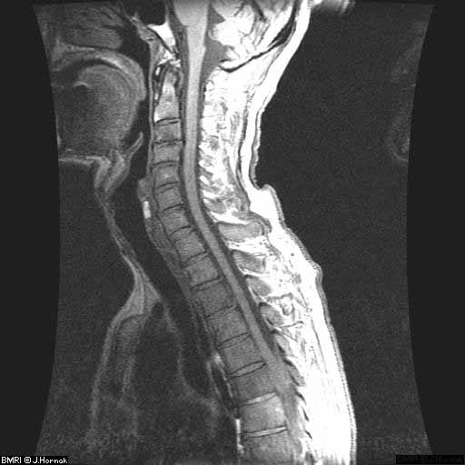  MRI of lower human spine (image used with permission, J.P. Hornak, The Basics of MRI) | 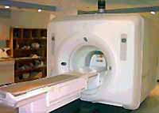  MRI imager (© 2000, Joseph Hornak, The Basics of MRI )

Superconducting Magnet Applications: Particle Accelerators
One important application of superconducting electromagnets is within an area of fundamental physics research-the study of the elementary particles. In collider-style particle accelerators, magnets steer charged particles along counter-circulating paths so the particles can smash into each other at high energy. Modern colliding accelerators are now built using superconducting magnets because the high energies needed by researchers are not attainable without the high magnetic fields created by these magnets. Because superconductors do not have electrical resistance, accelerators built with superconducting magnets are also much less costly to operate. In fact, modern colliders could not be built or operated using conventional (non-superconducting) magnets. Now under construction, the Large Hadron Collider at CERN in Switzerland has a circumference of 27 km (about 16 miles) and requires 8,000 superconducting magnets and 700,000 liters of liquid helium.
Model of a superconducting magnet for the particle accelerator now under construction at CERN. (photo courtesy of CERN)

The Promise of Superconductivity
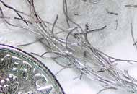
Imagine walking into a hardware store to look for wire and the clerk asks if you'd like "regular or superconducting." This ultimate promise of superconductivity-a practical material with no resistance at room temperature-may never be fulfilled, but researchers are hoping to develop a superconductor that will revolutionize our everyday world.
Magnesium diboride wires as they appear after removal from the tantalum tube and part of a U.S. dime for scale.
Photo courtesy of Paul Canfield and the U.S. Department of Energy's Ames Laboratory.

There are two main issues in superconductivity that must be dealt with in order to develop practical technology. First, the material must be abundant and easily manufactured. The so-called "low-temperature superconductors" are primarily niobium compounds- not an abundant substance. The ceramic, high- temperature superconductors are complex mixtures of yttrium, barium, carbon, and oxygen and are difficult to make into wire. Second, the material must exhibit superconductivity at a high enough temperature to limit the cost of cooling the material to its transition temperature. The low-temperature niobium compounds require large amounts of costly liquid helium to maintain superconductivity, but the high-temperature ceramics only require less expensive liquid nitrogen.
In January 2001 a team of Japanese physicists provided an adrenaline shot to superconductor research by announcing that they had observed superconductivity in an abundant magnesium-boron compound, MgB2. While the transition temperature, 40K, of the magnesium diboride is still lower than that of high- temperature ceramic compounds, it is much higher than ever observed in an intermetallic compound and requires only half as much liquid helium. Researchers have already begun to develop techniques for creating magnesium diboride wires, and have shown that the crystal structure of the compound allows it to carry far more electrical current than ceramic superconductors.
Given the fast progress already made with developing this new superconductor, researchers are optimistic that they will be able to tweak the chemical structure to raise the transition temperature to within the reach of liquid nitrogen. But even if this proves impossible, magnesium diboride already promises to surpass the niobium compounds as the low-temperature superconductor of choice.

Matters of State
About the Bose-Einstein Condensate—A New State of Matter
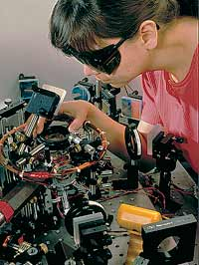
Physicist Deborah Jin of the National Institute for Standards and Technology (NIST) aligning an infrared laser in apparatus designed to create a Bose-Einstein Condensate of rubidium atoms (©Geoffrey Wheeler)
Inexpensive tabletop setup to observe sonoluminescence. The coiled wires lead to transducers that excite the sound waves in the water-filled flask. (photo courtesy of Andrew Steer)
We know about solids, liquids, gases, and plasmas —these are the well-known states of matter. But now there’s another, called the Bose-Einstein condensate (BEC), and it’s been predicted for a long time. In 1924, Albert Einstein built upon work of Satyendra Bose to predict that ultracold atoms could form a new state of matter, with all the atoms overlapping.
What does it mean to say that atoms overlap? The coins in a stack of pennies don’t overlap, and neither do the gas molecules in the air we breathe. As a gas becomes colder and colder, quantum mechanics tells us that the wavelike behavior of the atoms becomes more and more important. At the lowest temperatures—within a few hundred billionths of absolute zero—the probability waves of the atoms in a gas can overlap and create, in effect, one super-atom. In this state, it hardly even makes sense to talk about individual atoms because they all behave as one collective object. This is much like the output of a laser, since all the light is the same wavelength (same color) and the waves are all in step and you can’t tell one light particle (a photon) from another. In recent developments, BECs are being used to create atom lasers, the equivalent of a laser made of light.
Research
In the 1990s, many research groups pushed small samples of gas to lower and lower temperatures with laser cooling and trapping. Then magnetic fields confine the cold gas while the most energetic atoms are allowed to evaporate away, cooling the sample further—just like the way that water evaporating on the skin cools the body. The image shows the velocities of trapped atoms as they enter the BEC state. The sharper the peak, the greater the number of atoms in the BEC.
In making the first BEC in 1995, a team led by Carl Wieman, of the University of Colorado at Boulder, and Eric Cornell, of the National Institute of Standards and Technology, trapped about 2,000 rubidium atoms in a space about 20 microns in diameter (20 x 10⁻⁶ m, or about one-tenth the thickness of a human hair). A few months later, a team led by Wolfgang Ketterle at MIT achieved a BEC with half a million sodium atoms. These three physicists shared the Nobel Prize in Physics 2001.

Magneto-0ptic Trap at MIT (photo couGravity Waves)
About gravity waves
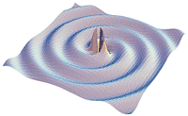
Artist’s drawing of gravitational waves emitted by a rotating system of two massive, tightly bound stars (image courtesy of Caltech/LIGO)
In our everyday world, we observe all sorts of waves, including sound waves, water waves, and radio waves. But what about gravity waves?
In the antenna of a radio station, electrons surge back and forth and produce electromagnetic waves. Suppose a very massive body like a star moved back and forth. Would it produce gravity waves?
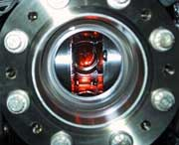
It may seem far-fetched to think of a star moving like this, but in fact many of the stars we see are members of binary star systems—two stars that circle around each other in a dance of mutual gravitational attraction. If the stars are massive and close together, the stars swing around each other pulled by enormous forces. Einstein, in 1915, predicted that such a system would emit gravity waves, which would move at the speed of light, but he suspected that the radiation would be too feeble to be detected. The drawing shows a representation of these waves.
If two such stars did give off gravitational radiation, their mechanical energy would decrease, they would draw closer together, and their rate of mutual rotation would increase. So if physicists could measure the period of a binary system very precisely, they could look for evidence of gravitational radiation.
The physicists who found the evidence, Russell Hulse and Joseph Taylor, were studying pulsars—neutron stars that spin rapidly and emits sharp pulses of radio energy with extraordinary regularity. They found a pulsar whose rate of pulsing oscillated, first speeding up and then slowing down. Careful analysis showed that this variation was a Doppler shift, and that the pulsar was alternately moving towards and away from Earth as it and an unseen companion star orbited each other. The two objects rotate around each other about every eight hours, at a separation of from one to five solar radii. Since they are so close together, the gravitational forces between them are extraordinarily strong.
Painstaking, long-term measurements of the pulse arrival times revealed that the rate of rotation of the system was increasing, and in just the way that Einstein predicted 63 years before. In 1993, Hulse and Taylor were awarded the Nobel Prize in physics for this work. They had identified a source of gravitational waves. The next step would be to build a detector to observe these waves directly.
Research
Gravitational waves are hard to detect. These waves are actually faint ripples in space-time, the four-dimensional world that Einstein created in his theories of special and general relativity. As a gravitational wave passes by, objects would change their length, but by only about one part in 1021, which for the distance from the sun to Earth is about one atomic diameter. This is an extremely small effect.
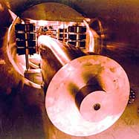
Niobium resonant mass detector at The University of Western Australia; the niobium cylinder weighs 1.5 tons; the detector is operated at liquid helium temperatures—five degrees above absolute zero. (photo courtesy of the Australian International Gravitational Research Center, The University of Western Australia)
Here are the three main categories of detectors:
RESONANT MASS DETECTORS: These consist of a large suspended metal cylinder, some tens of meters long, instrumented to detect small changes in length. (See photo.) Astrophysical theory predicts that a typical double star system with a pulsar would radiate gravitational waves at a frequency of about 1600 Hz. The length of the cylinder is chosen so the cylinder will resonate at this frequency, enabling the faint gravity wave to produce a detectable oscillation in the length of the cylinder.
A chief limitation on the sensitivity of the resonant detectors is their small size. A different type of detector utilizes laser beams reflected over long distances.
GROUND-BASED INTERFEROMETERS: To increase the magnitude of the oscillation to be measured, these detectors are interferometers with arms several kilometers long. A laser beam is split and travels several kilometers in perpendicular directions to suspended mirrors (see diagram). The reflected beams are combined and interfere, providing a pattern of light and dark that shows the relative phases of the two beams. The Laser Interferometer Gravity Wave Observatory (LIGO), with one detector in Washington and the other in Louisiana, is currently being constructed and tested. The two detectors will be operated together to reduce the chances that noise at one or the other would mimic a gravity wave. The photograph shows the Washington detector.
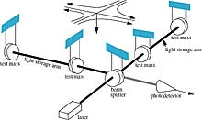
Drawing of the interferometer in the LIGO detector; the laser beam splits into two beams that pass down the long arms, reflect back, and then combine and interfere; if the length of one arm changes relative to the other, the phase of the combined light beams changes, changing the intensity at the detector. (images courtesy of Caltech/LIGO)

Land-based interferometers like LIGO are vulnerable to the effects of seismic noise, especially at low frequencies. This frequency dependence is important, because supermassive black holes and compact binary stars are expected to produce gravity waves at low frequencies, below 1 cycle per second (Hz). To avoid this noise, the interferometer can be flown in space on three well-separated satellites. Note that, since a gravity wave changes space itself, no matter is required between the mirrors.
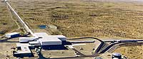
Ariel view of the LIGO Hanford Observatory; the long wings contain the interferometer beams. (photo by Gary White, courtesy of LIGO Laboratory)
SPACE-BASED INTERFEROMETERS: The Laser Interferometeric Space Antenna (LISA) system is located on three satellites about five million kilometers apart, in an orbit with a period of about a year. (See drawing.) LISA will be sensitive to gravity waves from .1 x 10-3 Hz to 1 Hz. It is scheduled for launch sometime near 2011.
Since gravity waves interact so little with matter, they would propagate virtually without change as they pass through interstellar space. Thus they are expected to provide a new window on the universe and a wealth of information very different from what we observe with electromagnetic radiation.
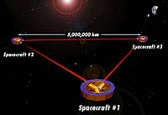
Drawing of the formation of three LISA satellites (image courtesy of NASA)
rtesy of the MIT BEC group)

Sensors and Accessories
Mag-03 three axis sensors
The Mag-03 range of three axis magnetic field sensors is based on the fluxgate principle. These sensors are very accurate, have a linear response and are extremely stable. They also have a flat frequency response with a bandwidth of d.c. to 3kHz. They are suitable for measuring magnetic fields from zero to more than ten times the value of the earth's field and provide a continuous analog output.
The Mag-03 sensors contain three orthogonal elements with integral electronics in a compact package. They require a supply of ±12 volts and produce an analog output of ±10 volts full scale for each axis. With a bandwidth of d.c. to 3kHz the units are suitable for a.c. and d.c. measurements. The magnetometers are available in cylindrical, square section or submersible packages and with full scale ranges from ±70 to ±1000µT. Versions are available with noise levels down to 4-6pTrms/sqrt Hz at 1Hz.
Mag-03PSU power supply
The Mag-03PSU power supply unit contains a rechargeable battery power supply for the sensor together with a filter for each output which can be configured as a low-pass or band-pass filter.
Mag-03DAM data acquisition module
The Mag-03DAM six channel data acquisition module with 24 bit resolution allows the data from two Mag-03 sensors to be stored on an IBM compatible PC. The unit, which features software control and filtering, is designed for recording changes in the earth's field with the highest resolution at low data rates.
DLM24Mag high-speed data acquisition system
The DLM24Mag high-speed multichannel data acquisition system with simultaneous sampling allows data to be recorded from up to four three-axis magnetic field sensors. A fibre-optic or RS232 interface can be selected depending on the number of channels and bandwidth required. Memory modules provide multiplexing for a larger number of sensors and allow remote data logging.
Mag-03SCU signal conditioning unit
The Mag-03SCU combines a power supply, signal conditioning filters and LED display for each of the three output channels. Each channel has an adjustable high and low pass filter with a variable gain and offset facility. This enables the response of the system to be set for individual requirements.
Mag-03CU calibration unit
The Mag-03CU calibration unit is a battery powered unit which provides a sinusoidal reference magnetic field for checking the calibration of Mag-03 sensors which have a cylindrical enclosure.

Applications
Medical physics
Magnetic Resonance Imaging (MRI) equipment used in medical physics requires the generation of stable magnetic fields and is therefore susceptible to interference from external fields which may result from radio frequency interference, lower frequency interference from electrically operated equipment, such as lifts within the same building, or electric trains at a considerable distance. It is standard practice to survey an area prior to installation of this sensitive equipment to record the variations in the magnetic field and select a site with the least disturbance.
Radio frequency interference can usually be sufficiently reduced by shielding but lower frequencies may be largely unaffected. A Mag-03 sensor can be used in conjunction with a Mag-03PSU power supply and a digital voltmeter to provide information on the d.c. and a.c. fields in three axes.
General physics
In some applications where low energy electrons or ions are used, such as in electron microscopes and photo electron spectrometers, low magnetic fields are required and the earth's field needs to be cancelled. This is often done using pairs of Helmholtz coils to oppose the vertical and horizontal components of the environmental field. In many applications a reduction to 10% of the earth's field is sufficient and this can be achieved by applying constant currents to the coils. The Mag-03 sensor, in conjunction with a Mag-03PSU and a digital voltmeter, can be used to monitor each of the three components of the field in turn while the appropriate coil currents are adjusted to achieve zero field. This technique is known as active shielding with open loop control.
The earth's magnetic field is subject to considerable variations during the course of a day and further variations will occur within a building due to its structure and to activities both inside and out. In order to achieve a very low or constant field it is necessary to apply a servo system to monitor the field continuously and vary the currents in the coils to counteract these field changes. This provides active shielding with closed loop control. A sensor from the Mag-03 range is suitable for this application as it provides simultaneous three axis monitoring with a good frequency response.
ELF measurements
The flat frequency response of the Mag-03 sensors over the range from d.c. to 3kHz allows measurements of the environmental ELF (10Hz to 3kHz) magnetic field to be made in three axes. Sources of magnetic fields which may be investigated include devices operating at power frequencies, which generate fields at the power frequency and its harmonics, and others which produce fields that are independent of the power frequency. Examples of the latter category include VDU terminals, electric trains (16.7Hz and 25Hz), mass transportation systems (0Hz to 3kHz depending on the characteristics of the variable speed drive) , commercial aircraft (400Hz), induction heaters (50Hz to 3kHz) and electric vehicles.
Power distribution
The Mag-03 range is used for the measurement of phase imbalances in transmission systems and earth leakage currents around power generation and distribution facilities.
Defence
The Mag-03 range of sensors, together with the Mag-03SCU signal conditioning unit or DLM24Mag data acquisition unit, can be used in magnetic ranges to measure the magnetic signature of vessels or vehicles. The Grad-03-12 is a three axis gradiometer for closed loop degaussing applications.
Earth's field measurements and magnetic surveys
The Mag-03 range of sensors, combined with the Mag-03DAM or DLM24Mag provides a high resolution system to measure the earth's magnetic field. It can be used as a base station during magnetic surveys, as a secondary system to monitor the performance of a magnetic observatory system or as a long baseline gradiometer. The Mag-03MS is used as a sensor for the airframe compensation system during airborne surveys.

A research needed for the Subject Sci 123

Submitted to:
Engr. Ma. Teresa A. Dizon

Submitted by:
Luisito T. Guanzon
BIT 1-L Computer

