Republic of the Philippines

Bulacan State Univesity

Institute of Computer Education
Malolos,Bulacan



Submitted to:
Mr. Alex Caparas

Professor

Submitted By:
Mahinay, Tristan Franz V
BIT II-L

Computer

Boolean Algebra
Introduction
The most obvious way to simplify Boolean expressions is to manipulate them in the same way as normal algebraic expressions are manipulated. With regards to logic relations in digital forms, a set of rules for symbolic manipulation is needed in order to solve for the unknowns.
A set of rules formulated by the English mathematician George Boole describe certain propositions whose outcome would be either true or false. With regard to digital logic, these rules are used to describe circuits whose state can be either, 1 (true) or 0 (false). In order to fully understand this, the relation between the AND gate, OR gate and NOT gate operations should be appreciated. A number of rules can be derived from these relations as Table 1 demonstrates.

Table 1: Boolean Postulates
- P1: X = 0 or X = 1
- P2: 0 . 0 = 0
- P3: 1 + 1 = 1
- P4: 0 + 0 = 0
- P5: 1 . 1 = 1
- P6: 1 . 0 = 0 . 1 = 0
- P7: 1 + 0 = 0 + 1 = 1
A Boolean algebra is a set with two binary operations, and , that are commutative, associative and each distributes over the other, plus a unary operation . Also required are identity elements and U for the binary operations that satisfy , , and for all elements A in the set.
One interpretation of Boolean algebra is the collection of subsets of a fixed set X. We take , , , and U to be set union, set intersection, complementation, the empty set and the set X respectively. Equality here means the usual equality of sets.
Another interpretation is the calculus of propositions in symbolic logic. Here we take , , , and U to be disjunction, conjunction, negation, a fixed contradiction and a fixed tautology respectively. In this setting equality means logical equivalence.
It is not surprising then that we find analogous properties and rules appearing in these two areas. For example, the axiom of the distributive properties says that for sets we have while is a familiar equivalence in logic.
From the axioms above one can prove DeMorgan's Laws (in some axiom sets this is included as an axiom). The following table contains just a few rules that hold in a Boolean algebra, written in both set and logic notation. Rows 3 and 4 are DeMorgan's Laws. Note that the two versions of these rules are identical in structure, differing only in the choice of symbols.
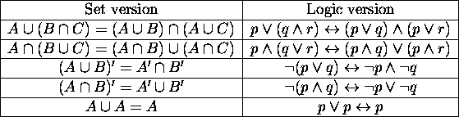

Laws of Boolean Algebra
Table 2 shows the basic Boolean laws. Note that every law has two expressions, (a) and (b). This is known as duality. These are obtained by changing every AND(.) to OR(+), every OR(+) to AND(.) and all 1's to 0's and vice-versa.
It has become conventional to drop the . (AND symbol) i.e. A.B is written as AB.
T1 : Commutative Law
(a) A + B = B + A
(b) A B = B A
T2 : Associate Law
(a) (A + B) + C = A + (B + C)
(b) (A B) C = A (B C)
T3 : Distributive Law
(a) A (B + C) = A B + A C
(b) A + (B C) = (A + B) (A + C)
T4 : Identity Law
(a) A + A = A
(b) A A = A
T5 :
(a)
(b)
T6 : Redundance Law
(a) A + A B = A
(b) A (A + B) = A
T7 :
(a) 0 + A = A
(b) 0 A = 0
T8 :
(a) 1 + A = 1
(b) 1 A = A
T9 :
(a)
(b)
T10 :
(a)
(b)

T11 : De Morgan's Theorem
(a)
(b)

Examples
Prove T10 : (a)
(1) Algebraically:
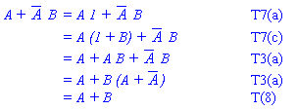
(2) Using the truth table:
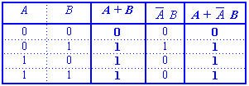
Using the laws given above, complicated expressions can be simplified.
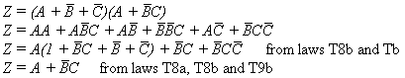
Problems
(a) Prove T10(b).
(b) Copy or print out the truth table below and use it to prove T11: (a) and (b).
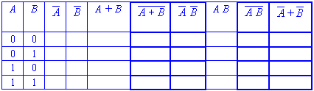

Answer to problems
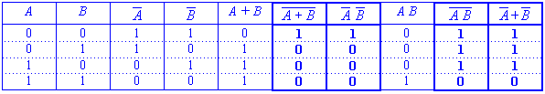

If we take the equations that are true in the the calculus of classes and replace the symbols using the following table
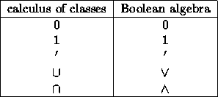

then we have the equations of Boolean algebra. Before 1900 Boolean algebra really meant the juggling of equations (and neg-equations) to reflect valid arguments.
In 1904 E.V. Huntington wrote a paper [1] in which he viewed Boolean algebras as algebraic structures satisfying the equations obtained from the calculus of classes. This viewpoint became dominant in the 1920's under the influence of M.H. Stone and A. Tarski. Stone was initially interested in Boolean algebras in order to gain insight into the structure of rings of functions which were being investigated in functional analysis. He wrote two massive papers, one on the equivalence of Boolean algebras and Boolean rings, and the other on the duality between Boolean algebras and Boolean spaces [= totally disconnected compact Hausdorff spaces]. Tarski studied Boolean algebras while working on the abstract notion of `closure under deductive consequence'. In the 1930's Stone proved that every Boolean algebra is isomorphic to a field of sets, and that the equations true of the two-element Boolean algebra are the same as the equations true of all Boolean algebras; and these equations were consequences of a small initial set of defining equations.
What has the modern subject of Boolean algebra got to do with propositional logic? Not very much. Boolean algebra became a deep and fascinating subject in its own right, with much more to offer than a convenient notation to analyze simple chains of reasoning. Nonetheless on the level of equivalence and equations the subjects of propositional logic, calculus of classes, and Boolean algebras are essentially the same, as illustrated by the following table:
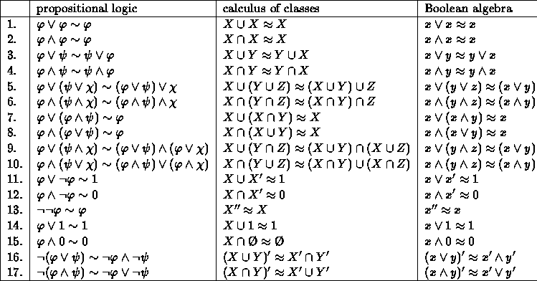
In the second half of the 1800's these identities were considered pretty exciting, and most of them were named after prominent logicians -- now only the two attributed to DeMorgan still have such a name attached.
One can take the identities in the third column as a set of axioms for Boolean algebra, but this set of axioms is somewhat redundant. Huntington was quite fascinated with the problem of finding sets of axioms for the Calculus of Classes. There is a variation of a set of axioms that he proposed (see [2]), due to Herbert Robbins in 1933, that only recently has been proved to also define Boolean algebras (see III.16 of LMCS), namely:

Since this problem was so difficult one can pose the fundamental question:
Given a finite set of identities in the language of Boolean algebras, is there an algorithm to determine if defines precisely the class of Boolean algebras?
Certainly one can determine if an identity is true in all Boolean algebras -- just check it out on the two-element Boolean algebra. So this reduces the question to:
Given a finite set of identities which are true of Boolean algebras, is there an algorithm to determine if defines precisely the class of Boolean algebras?
As mentioned in II.14.10 of LMCS, a similar question for propositional logic had been proved to be undecidable. The above question was answered in the negative by McNulty [3] and Murskii [4].

Logic Gates

Introduction

In digital systems the basic component of logic is the logic gate . An electrical circuit is made of different physical components (i.e. capacitors, transistors etc.) that cause various levels of voltage and current. When designing a digital system voltage levels are of prime importance. Using positive logic, a high voltage (other than zero or ground) is logic 1 and low voltage (zero or ground) is logic 0. Variables are used to describe the inputs and outputs of gates. A variable with an apostrophe (C') after it will be used to signify the inverse of the variable (C). Truth Tables are used to graphically describe the relationship between all the possible inputs and outputs. This Section will not deal with issues of Circuit Analysis such as Fan-Out, Noise margin, or Switching Times. These issues will be dealt with in the Digital Integrated Circuits and Electrical Circuits Sections.

Logic Gate Types
Here are the 6 basic logic gates.
The Buffer does not change the logic of the input. The output is the same as the input. If logic levels are attenuated a buffer is used to refresh the levels. It is only here for completeness. In discussions of logic it has no purpose. The NOT gate is a buffer with a circle either before or after the triangle. Here it is pictured after the triangle. It is an inverter. If the input is a logic 1 the output is a logic 0 and vise-a-versa. The circle is the inversion symbol. The AND gates output is 1 if and only if all its inputs are 1 otherwise the output is 0. The NAND (Not AND) gate is an AND gate with the output inverted. The OR gates output is 1 if any of the inputs are 1 and 0 otherwise. The NOR (Not OR) gate is an OR gate with the output inverted. The XOR (Exclusive OR) gates output is 1 if one and only one of the inputs is 1 otherwise the output is 0. The XNOR (Exclusive NOR) gate is an XOR gate with the output inverted. The following is a list of the gates with accompanying Truth Tables.

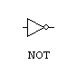
  A (input) | X (output)
  0 | 1
  1 | 0
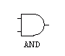
  A (input) | B (input) | X (output)
  0 | 0 | 0
  0 | 1 | 0
  1 | 0 | 0
  1 | 1 | 1
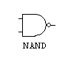
  A (input) | B (input) | X (output)
  0 | 0 | 1
  0 | 1 | 1
  1 | 0 | 1
  1 | 1 | 0
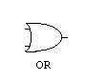
  A (input) | B (input) | X (output)
  0 | 0 | 0
  0 | 1 | 1
  1 | 0 | 1
  1 | 1 | 1
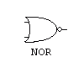
  A (input) | B (input) | X (output)
  0 | 0 | 1
  0 | 1 | 0
  1 | 0 | 0
  1 | 1 | 0
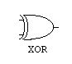
  A (input) | B (input) | X (input)
  0 | 0 | 0
  0 | 1 | 1
  1 | 0 | 1
  1 | 1 | 0
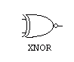
  A (input) | B (input) | X (input)
  0 | 0 | 1
  0 | 1 | 0
  1 | 0 | 0
  1 | 1 | 1
If both the input leads of a NOR or NAND gate are connected to the same input the gate inverts the logic. Because of this ability these gates are minimal sets, meaning that any logic function can be realized using only NAND or only NOR gates. This does not mean that it is the optimal design. It depends what parameters are the most important in the design (i.e. fewer packages, faster switching speed).

