Offensive clothing designs by :

SALE! Psycho Tank Top $22.95!!!

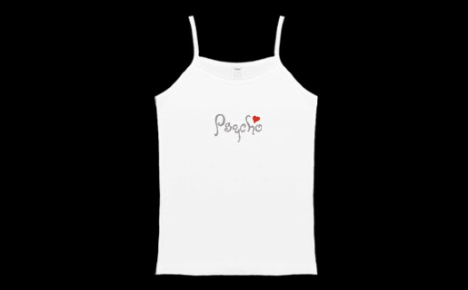
Order #: BKRPSYTNK

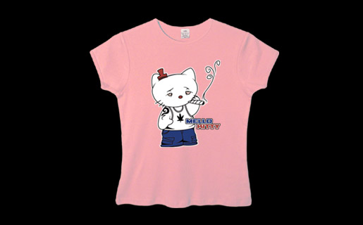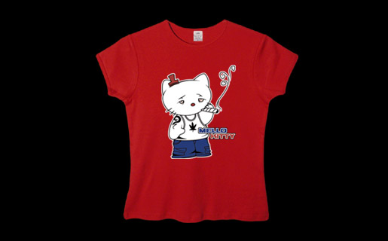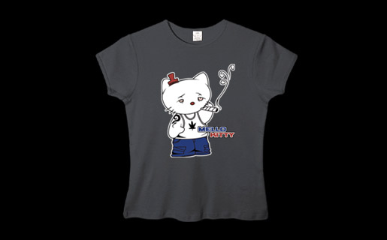

HelloKitty Baby T
PRICE: $ 24.95 / ORDER NUMBER : BKHK
Pink, Red, & Black (sizes S,M,L)
*SPECIFY COLOR AFTER ORDER NUMBER. FOR EXAMPLE: BKHKPINK

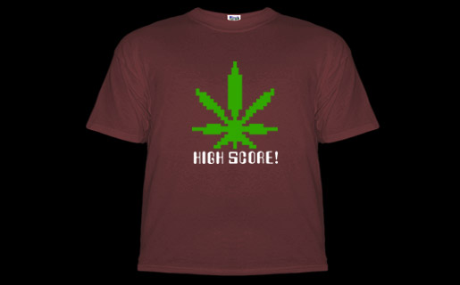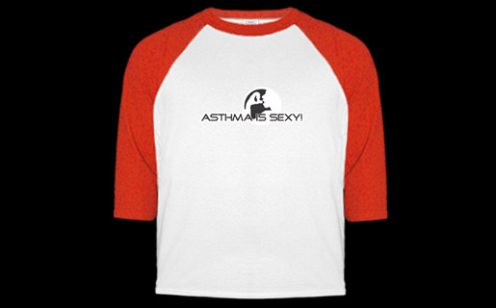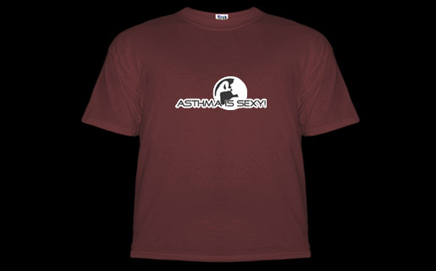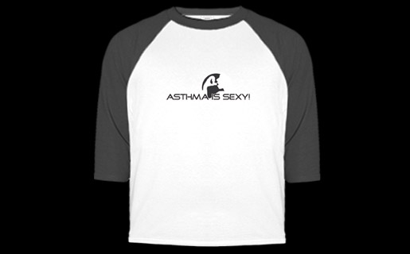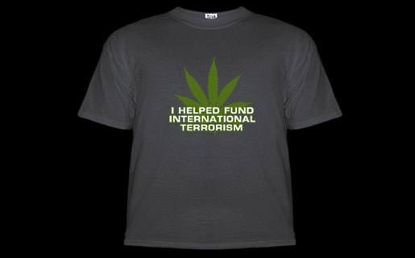

“Your Whore is My Little Princess”

Price: $22.95 Order# : BKRWHR71
Available in Men’s T sizes: M,L,XL,XXL
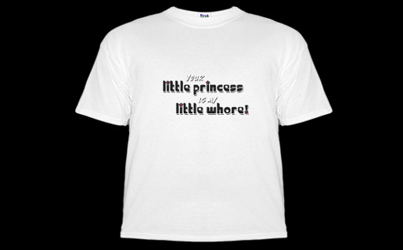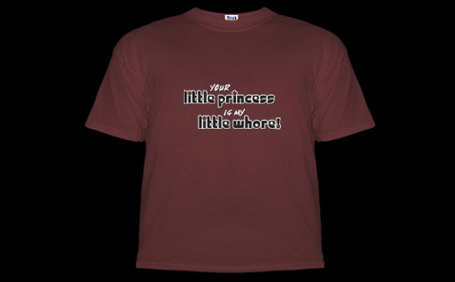

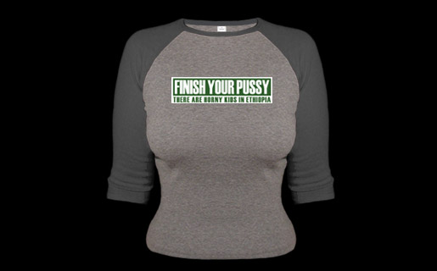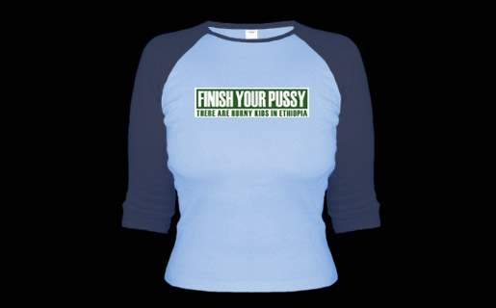
Women’s Jerseys

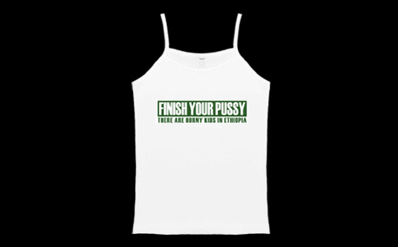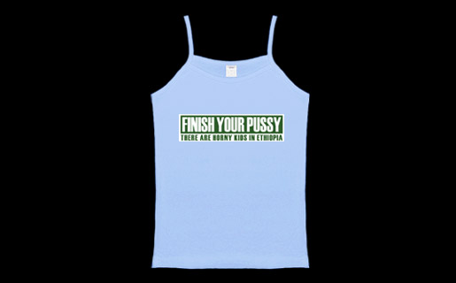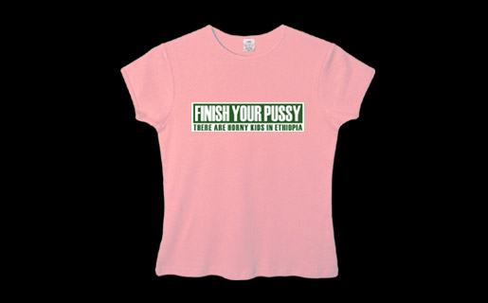
Women’s Tank Women’s Baby T

Finish your Pussy
Women’s Styles

Jersey ..Price: $29.99…. Order #:BKFYPJRSY
Baby T …. .Price: $24.95 …Order #:BKFYPBT
Tank Top… Price: $24.95 …Order #: BKFYPTK
*Women’s sizes S,M,L
Mens Styles
Slacker T Price: $23.95 Order #:BKFYP69
**SweatShirt Price: $29.99 Order #: BKFYP70

*Men’s sizes M,L,XL

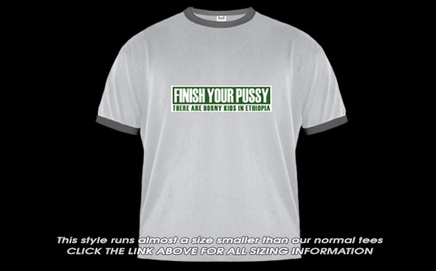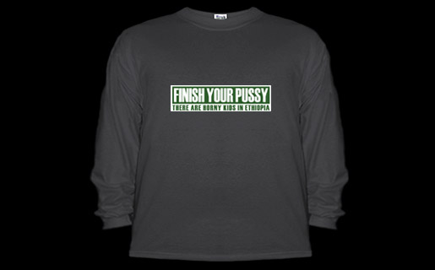

Men’s Slacker T Men’s SweatShirt

