Felipe’s Stain
Arsenic On TV:
:( Upon heating “arsenic gas” permeates the atmosphere):

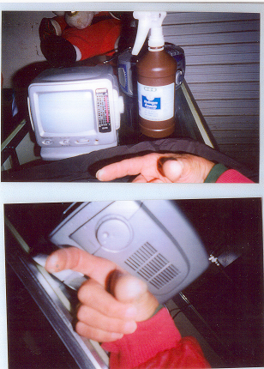

Arsenic reacts with hydrogen: (notice the white spots on fingers): (after turning the dial, and noticing the smell of fumigant, I sprayed hydrogen peroxide on my hands and the tell tail: (reaction of hydrogen and arsenic appeared) …This is because the stores “fumigate” :( once a week), and every item in that store is “covered with fumigant, and that fumigant contains “ARSENIC”) … Because arsenic is an element and cannot be broken down any further, nor can it be destroyed, there is then “ACUMULATION” :(year, after year, after year, after year, after year, after year, after year, after year, after year, after year, etc., etc., etc.,
An so, how do you get rid of it, ‘monstrous’, People have and do die from ‘Heart attack’ ‘Liver failure’
‘Kidney failure’ ‘Bone marrow failure’ ‘Blood failure’ ‘Lung failure’ ‘Skin cancer’ ‘Lung cancer’ ‘Cancerous tumors’ ‘Nerve damage’ ‘People become ‘blind’ ‘People do have birth deaths and defects’ etc., and this is were it’s coming from, “Fumigants” “Insecticides!” etc., along with “6.1” Health Hazards! And can not, CAN NOT LAWFULY CONTINUE. I invoke the law, and “sue, by “Direct
Verdict :(based on “common sense knowledge”): (common sense is what every one has as their own ability to use God’s consciousness): (their own innate ability to use ‘reason’ there then the court conceders it to be true and correct “conclusive” long before it reaches any higher court, as common sense
is what every good person has as there own knowledge: (There can be no argument, any argument is “contempt” :(punishable by fine ,and ,or imprisonment) …

Felipe A. G. Castañeda Sr.
Chemist
C 4635

