Arsenic

(Break through-time) :( the time it takes for a chemical to break trough a bearer
(Chronic Toxicity from “insecticides on products and food in stores)

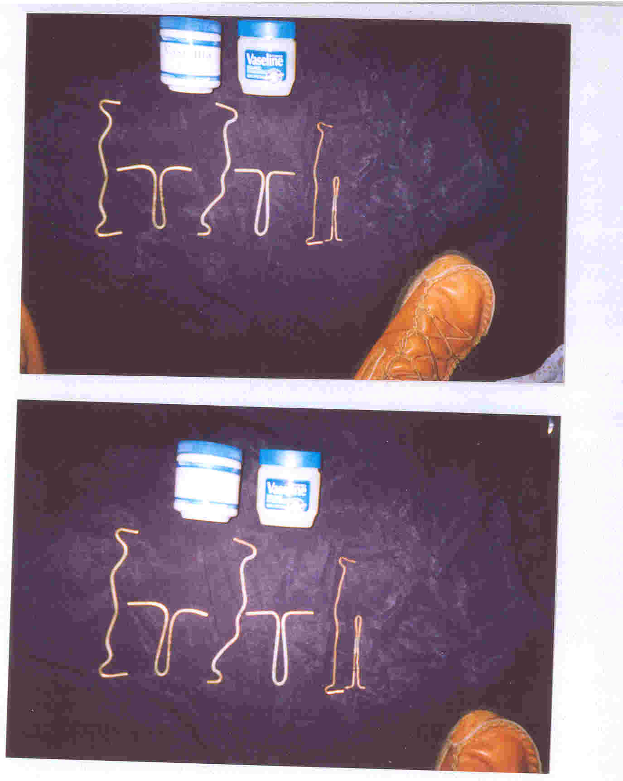
If you submerse a ‘brass’ or ‘copper’ rod in urine, and boil at a simmer, for “one-hour” and there appears black, and or, green :(Scheele’s green), spots or rings: (“That’s the cupric salt of ‘Arsenic’), again, if you spray the “cooper rod”) with Hydrogen peroxide: (Arsenic reacts with ‘carbon’ ‘oxygen, and ‘hydrogen’), and then wipe the rod dry, then submerse the rod in urine, and boil for one hour, the remaining molecules of hydrogen will react with the arsenic, and the rod will be covered with a “Green-molasses-like-substance: (Felipe’s Green): (originally the sample used to test for arsenic is submersed in “copper-sulfate”) … but a copper-rod with a bit of hydrogen works as well) … Felipe … Arsenic: (Chronic poisoning): Reference Range: (100-500-ug/L), (1.33-6.65-umo/L); Acute poison:(600-9300ug/L):[7.98-123.69-umo/L] : (Exposure to arsenic: (‘Polyneuropathy begins in the peripheral extremities and may progress in an ascending fashion to involve proximal arms and legs. Dysesthesisa begin in the lower extremities, with a severe painful burnilng sensation occurring in the soles of the feet … weakness and paralysis may involve the reparatory muscles, resulting in neuromuscular respiratory failure; Encephalopathy: (disease of the brain), associated with elevated arsenic levels slowly resolving over months to years: (encephalopathy may be permanent); Basophilic striping ; circulatory failure; Kidney failure; Liver failure; Heart failure Bone morrow failure; Skin changes :(hyperpignentation; melanosis, hyperkeratosis: (usually appears as “corn-like elevations), warts, and cancer of skin, lungs, lymph glands, bone marrow, also bladder, kidney, prostate, and liver cancer.) … Lesions usually appear “1” to “6” after the onset of illness. In most cases a diffuse brawny desquamation develops over the trunk and extremities that is dry, scaling, and nonpruriltic. Patchy hyper pigmentation - dark brown patches with scattered pale spots sometimes described as raindrops on a dusty road; freckles appearing were originally there were none – transudation of plasma; hypovolemia; Rice-water stools; Red cell hemolysis; Seizures; Leucopenia; Acute myelogenous leukemia; Anemia; Absolute neutropenia etc., Arsenic can cross the human placenta. Symptoms: (Tingling of nerves, and numbness, muscle pain with burning sensation; moments of paralysis; death comes eventually from heart failure bone marrow failure or infection. Arsenic found in keratin-rich tissues :(‘skin’ ‘hair’ and ‘nails’) … Arsenic inhibits various enzymes, e.g. :(pyruvate oxidase, transaminase, and “choline oxidase: (puts fat in liver). Exposure to arsenic and it’s, compounds should not exceed .02mg/m³ as elemental. As during an “8” hour day. There values are being studied and may be lowered.

