Arsenic Poisoning
Reynolds-Aldrich-Mees lines :

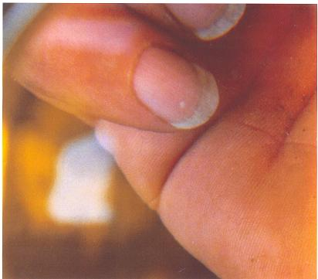

Reflects transient disruption of nail plate growth during acute poisoning. Leukonychia striata
Arsenicalis transverses takes approximately “5” to “6” weeks to appear over the lunulae after acute poisoning. Thinning of the hair and patchy or diffuse alopecia also are associated with arsenic poisoning. More than one type of skin cancer may occur in affected individuals:(Bowen’s desease; Squamous cell carcinomas; skin lesions will take several years to manifest the characteristic pigmented changes and hyperkeratosis, whereas skin cancer will not become evident for up to “40”
years. Brittle mails, the surface of which is marked by ‘transverse white bands are known as: (leukonychia striata arsenicalis transverses). Basal cell carcinomas; and “Combined forms” Hyperkeratosis and hyper pigmentation usually are present in patients with dermal malignancies. Arsenic is teratogenic, Also Skin, lungs, lymph glands, bone marrow, bladder, kidney, prostate and liver cancer. Peripheral vascular disease and associated gangrene (so called Blackfoot disease). Elevation of hepatic transaminases also has been noted in several reports.

CHRONIC AND LONG-TERM TOXICITY

The bone marrow, skin and peripheral nervous system may become involved after acute or chronic exposure.

Probably the most important diagnostic test is urinary arsenic measurement. …

