
Why choose Rapid Alarms?
Rapid Alarms have been working in the home and office safety since 1937. Now we have progressed as far as the latest manufactures. Back when the company first started, the company name was Heath’s Safety. We are now the leading company in the alarm system area. We believe that this is because of our very strongly established roots.

When were alarm systems invented?
Dogs were first portrayed as Alarms systems. Guard dogs were very efficient as alarms.

But the world of burglary is getting worse. Now we rely on machines to do the detection of trespassers. The newest machines are very accurate in stopping intruders.

Why buy an alarm system from Rapid Alarms?
When you buy alarm systems from us, we shall give you 3 extra movement sensors (each worth £15) absolutely free.
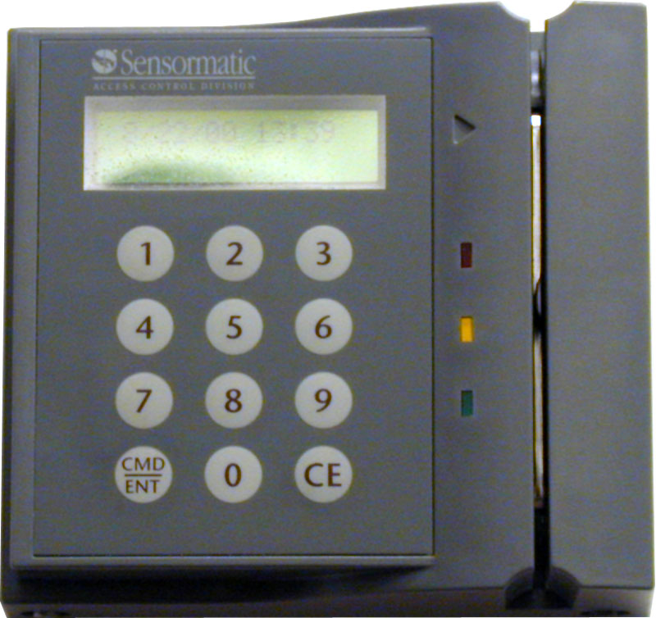
Also whatever system you decide on getting, you shall receive free installation and help from our, staff that are online for 24/7.

