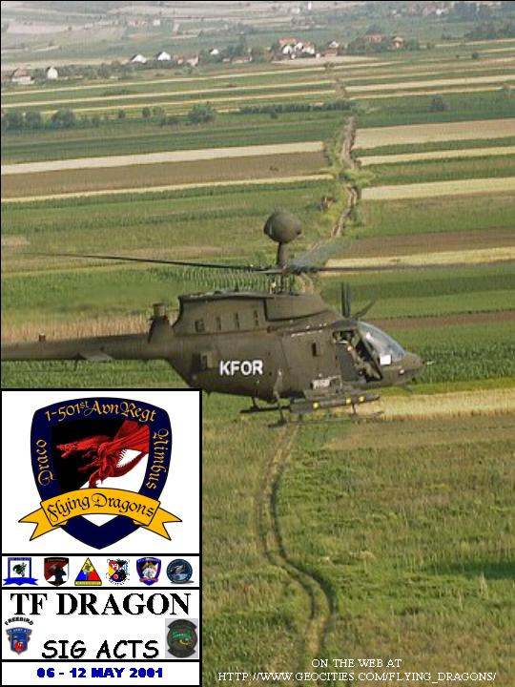

words go here

More text can go here as well

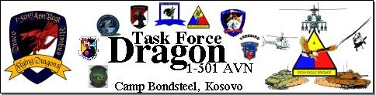


As this page is being written, the inbound trickle of 2-17 soldiers has turned into a flood. If ever there was a sign that our mission was nearing an end, this is it.
Well, this is it for most of us at least. This week B/1-501st was tasked by TFF to remain behind and assist 2-17CAV in providing security during the collapse of B sector in the GSZ. The additional seven aircraft and crews will dramatically increase the amount of reconnaissance assets available; while their months of experience will help show 2-17 what right looks like.
The rest of the TFD is concentrating on finishing up the mission strong, as well as preparing to redeploy to Buedingen and Hanau. The entire task force has moved into tents, and most of the companies have already cleaned and packed their MILVANS. Right seat rides are in full swing.

While it has been a long six months, the members of Task Force Dragon are proud of their accomplishments. While the situation in Kosovo remains a quagmire of different factions competing for power and revenge, KFOR continues to balance and deter these forces in order to provide a secure environment. Every member of Task Force Dragon is heading home, knowing that they accomplished all assigned missions and played their part in KFOR’s mission.

Task Force Dragon Signing Out….
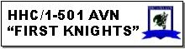
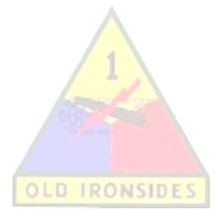

.

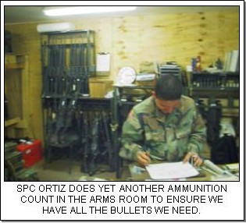
As we continue our standard mission support to the task force, this week is basically “Milvan Week”. We are emptying, cleaning, washing, and re-loading all milvans and ISU90s this week so we can finalize our load plans.
On Monday we had our final TF Dragon Board in Kosovo and on Tuesday we held a record PLDC PT test . SPC Watt excelled at the TF Falcon Board and missed first place by one half of a point.
We will continue Milvan load-up and inventory as we prepare to move into tents and welcome our 101st brothers to Kosovo. The TOA inventories will start on 16 May.
The next key events for re-deployment prep are ADVON arrival on the 15th, TOA Inventories, and ammunition collection. We remain mission-focused and flexibly ready for anything.

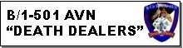

The Death Dealers flew close to 50 hours in support of the 13 TG this past week. Our focus was to provide surveillance to the Russian LCE while they emplaced signs for the relaxation of B sector. Our maintenance continues to lead the pack; our eyes are set on finishing the reporting period above 95%. Redeployment is near, but our pilots stay focused. Aviators and maintainers are busy cleaning and packing for our return to Central Region. Next week, the Dealers will be busy with reconnaissance and surveillance and redeployment operations.

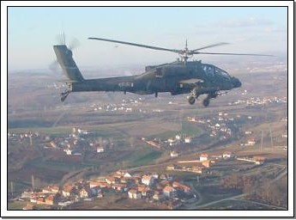

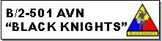

.

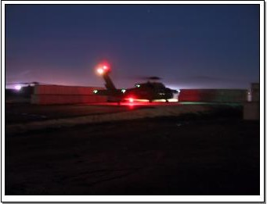
Black Knights conducted VIP support for GEN Meigs, LTG Riley, MG Lutz, the KFOR staff, as well as BG Quinlan and the Falcon staff. Re-supply and air movement missions continue is support of 1-325 INF. Preparations for the redeployment to central region continue.

In the final weeks of the KFOR2B rotation the Black Knights have begun right seat rides in preparation for the hand over to Task Force Sabre. The Black Knight’s remain mission focused and are ensuring a smooth transition with Task Force Sabre.

Black Knights continue to provide VIP transport, General Support, Limited Air Assault, and QRF Support to Task Force Falcon.

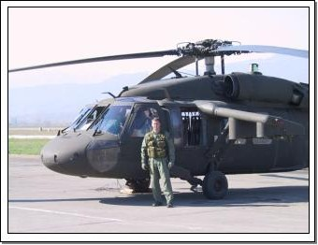

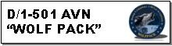

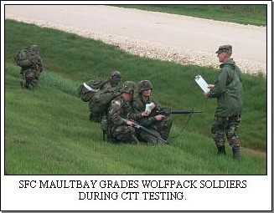

The optempo for the Wolfpack is picking up. This week, we had two DART missions on two consecutive days. The first, a UH-60 with main transmission chips, was handled by SSG Oliver and a crew of three. The second, an AH-64 with a ruptured hydraulic hose, was handled by a DART led by SSG McCarthy. Both were returned to Camp Bondsteel in under 3 hours without further maintenance requirements.
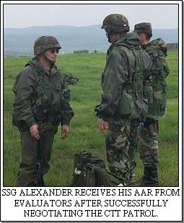
Another highlight this week was CTT testing. 1SG Ruiz put together a challenging, realistic scenario placing 8-9 soldiers in a squad with a mission to reach and secure a downed aircraft. Along the way, they received direct and indirect fire, treated casualties, and set up a platoon defense at the crash site. This innovative method brought some realism and excitement to an otherwise mundane exercise.
Our preparations for departure are continuing as well. We are preparing and repositioning our containers for loading. Our redeployment DARTs have been established, and all of them received overwater training in preparation for the trip across the Adriatic Sea.
Additionally, SFC Jindrich attended the Task Force Falcon SGT Morales Board. It is arguably the toughest board in USAREUR. Of all those who attempted to be inducted into the SGT Morales Club, only 3 were recommended to continue on to the next level - and SFC Jindrich was one of them! We’re all very proud of his hard work in preparation for this and wish him the best of luck next week at the next board.

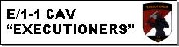

The TF 2-17 Advance Party arrived late last week and their presence has been a definite source of morale for the Troop. Before their departure, we completed Right Seat Rides on all of their pilots, and also flew multiple left seat rides. We employed their aviators first as part of a mixed crew, and then began employing them as complete crews in order to show them the subtleties of the KFOR mission in MNB-E. R/LSRs will continue as soon as they come back from port.
This week AXE Troop flew presence patrols in support of a curfew on the town of Vitina. The town has been the site of many recent ethnically motivated killings. Presence patrols continue to be an effective means of supporting the ground commander in providing a safe and secure environment.
AXE QRF launched soon after notification that KFOR ground soldiers were receiving fire. The shooting was actually directed towards a third party along the Macedonian border. AXE screened a portion of the boundary to ensure that none of the fighting elements crossed into Kosovo. The mission demonstrated AXE’s ability to react quickly and support ground forces
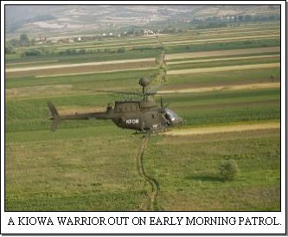
While focusing on missions, AXE Troop is also preparing for redeployment. We have also conducted a series of After Action Reviews to identify areas that the Task Force and Troop should improve or sustain. The Troop is busy conducting equipment inventories and packing its shipping containers.

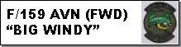

It’s another week here at Camp Able Sentry for the Big Windy Crew. Unfortunately I don’t have anything really cool to report. A lot of packing and shuttle runs have occurred throughout the week. The next issue will be far more exciting because the day after this deadline we will be recovering a damaged UH-60. It should provide us with some good pictures next week. More to follow!



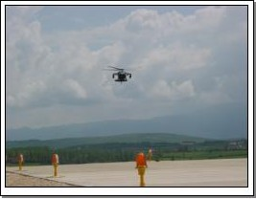

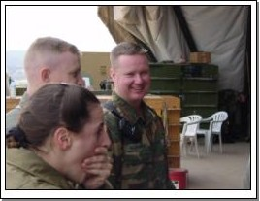
The 236th closed out another week in Kosovo true to form with a dedication to duty that is the embodiment of America’s helping hand in the region. Over the week DUSTOFF responded to three urgent calls delivering their patients safely to needed care in the least amount of time offered by any ambulance in the area. The 236th continued to provide round the clock MEDEVAC coverage for Kosovo, FYROM, and Albania as we began to integrate our Fort Campbell counterparts into the cockpit to exact a smooth transition and orientation for the 50th Medical Company (AA).
CPT Howard’s crew found themselves the magnet crew this week. On May 2nd, the crew composed of 1LT Neuenschwander (PI), SGT Alldaffer (CE), and SGT Lawrence (MO) launched late in the afternoon on a call from the Russian Aid station. They arrived to find a “cute little 12 year old girl with a possible appendicitis” according to SGT Lawrence, the crew’s flight medic. These calls were a common occurrence at the beginning of the deployment, and members of the 236th were almost relieved to know that things were still running according to schedule out there at the NITEX factory. They delivered the girl a few minutes later to the able care of the CSH (Combat Support Hospital). Later in the week, the crew was called again for an urgent patient transfer. On the night of May 8th, they mounted NVGs (Night Vision Goggles) and departed from the CSH at Bondsteel with an Albanian man in the back suffering from multiple injuries suffered in a car accident. The man was being transported to the British hospital in Pristina. Again, the DUSTOFF crew provided a necessary means of transport that cut an hour-long ride by ground ambulance to a fifteen-minute affair in the back of a Blackhawk. A nice little service we provide.
In the coming week, the 236th looks forward to moving into “tent
city” on the 12th, marking a significant step towards home. It will be a very busy week of packing, packaging, and shipping the various components of the MEDEVAC machine. It will be highlighted by the return of the 50th Med personnel arriving back from Bulgaria in their own aircraft again marking a ritual step towards home. The TOA (Transfer Of Authority) is scheduled for May 22nd, a day when 236th crewmembers can exhale a deep breath as we fly towards Italy and then home.






