Integration Testing – Graphical User Interface (GUI)

In this section, Classes Form, Question, Option, Converter and SurveyCreater were integrated. We tested the combination of the various components using White Box Testing techniques. Techniques used include Basis Path Testing and Loop Testing. The techniques were used to test on the procedural logic and structure of the program.
Class SurveyCreater contains the methods for the GUI and it was tested manually during the process.

13
5
6
7
8
1
2
3
4
9
10
11
12
13
Flow Chart And Flow Graph Of GUI:

Cyclomatic Complexity:

V(G) = Number of Regions
= 3

V(G) = Edges – Nodes + 2
= 14 – 13 + 2
= 3

Basis Set:

1, 2, 3, 4, 5, 6, 7, 8, 9, 10, 11, 12, 13

Test Cases And Results:

No | Test Cases | Test Results
1 | 1 question 2 options | Pass ( Test Results, Form Created)
2 | 1 question 3 options | Pass ( Test Results, Form Created)
3 | 1 question 5 options | Pass ( Test Results, Form Created)
4 | 1 question 9 options | Pass ( Test Results, Form Created)
5 | 1 question 10 options | Pass ( Test Results, Form Created)
6 | 2 questions 2 options | Pass ( Test Results, Form Created)
7 | 10 questions 2 options | Pass ( Test Results, Form Created)
8 | 19 questions 2 options | Pass ( Test Results, Form Created)
9 | 20 questions 2 options | Pass ( Test Results, Form Created)
10 | 21 questions 2 options | System hang

Please click here for Test Program

File Saving After Survey Created

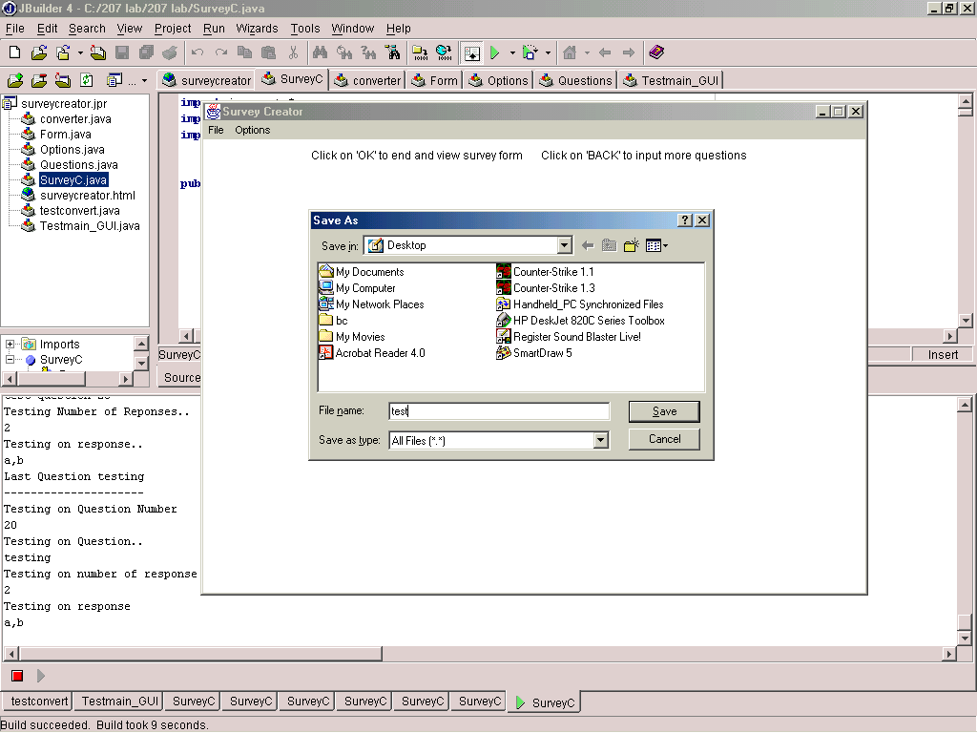

Integration Testing – Data Storage (SQL)

The Data Storage section consists of a server, Class Servlet and an Access table that acts as the database. In this section, testing was done to ensure that an Access table was created with the required fields. Testing was also done to ensure that the surveyee is able to send the survey form back to the server. At the server, Class Servlet was tested to see if information could be extracted successfully and passed to the database.

Test Procedure:

- Pass in parameters to create an Access table
- Check if fields have been generated correctly
- Fill in survey forms and click submit
- Check if results have been passed into the table

Test Results:

- Table was generated with the correct number of fields
- When survey is submitted, results were entered into database.

Please click here to view survey forms sent to server
Please click here to view table with results

Comments

Manual testing of GUI was successful.
The only problem encountered during testing was test case 10 where the system hanged when 21 questions with 2 options were entered. No error message was noted.
The HTML forms were created successfully.
All other tests were completed with positive results.

