Sandy Grabow, Show Secretary
PO Box 304
Crescent City, IL 60928

Buckeye Spring Classic
JUNE 13-14, 2009

Ashland County Fairgrounds, Ashland Ohio
Ashland Fairgrounds, Ashland,OH

ASPC/AMHR/ASPR Sanctioned Show  Tri-State Approved
Hackney Classes

JUDGES
Jean Brown
Debra Hamilton
Roger Daulton

STEWARD
Bud Stephenson

Show Secretary: Show Manager:
Sandy Grabow Robert Franks
PO Box 304 cell: (330) 464-6428
Crescent City, IL 60928 Fax; (603) 484-6428 Phone: (815) 644-6830 foxlanefarm@yahoo.com
Email: sandygrabow@yahoo.com

SPONSORSHIPS – Help Support Our Show!

$5.00 reg. class, $10.00 championship class, $15.00 grand championship/stake class
Your name will be announced as the sponsor preceding the class.

Name _______________________________________________________

Farm Name ___________________________________________________

CLASS NAME AND NUMBER YOU WISH TO SPONSOR

1 choice _______________________________________ class # ______

2 choice _______________________________________ class # ______

3 choice _______________________________________ class # ______

Buckeye Spring Classic
ASPC/AMHR/ASPR Sanctioned Show
Ashland Fairgrounds - June 13-14, 2009

Show will include Amateur, Youth and Open classes. Ribbons will be awarded for first through sixth places.
.

We will again be serving our Exhibitor’s Appreciation Supper Saturday evening during the evening performance classes. Join us for an evening of great ponies, companionship and food!

The show will start promptly at 8am on Saturday and Sunday, June 13 and 14.

Measurements will start at 7:00 am each day. All horses and ponies must be measured or have a current measurement card.

Entries must be received by Show Secretary by Saturday, May 30, 2009.

Horses will not be entered in classes until all requirements have been met. Entries must include:
✓ Completed entry form
✓ Copy of registration papers for each horse
✓ Copy of Amateur or Youth Card for all entries in Amateur or Youth classes
✓ Negative Coggins certificate for out-of-state horses/ponies
✓ Payment in full

Horses may be late entered for individual classes at the show. Late entries must be made by 7:30 am of day of class or at least 10 classes before desired class to enter is in ring. Late fees will be applied for all late classes entered.

Show management is asking that you be courteous of all exhibitors. Please have your horses ready at the gate when your class is called. If you know you’ll need extra time for a tack change after a class, please notify the Announcer, Ring Steward or Gate Person before the start of the class. We will be enforcing the 2-minute gate rule.

All dogs must be on a leash at all times. This is a Fairgrounds rule.

Remember, if you travel across the Ohio state line, you will need to have a 12-month negative Coggins certificate with you for each horse/pony you have onboard.

For additional information please contact Sandy Grabow, Show Secretary, or Robert Franks, Show Manager.

Stalls in barns will open at noon on Friday, June 12.
Ashland County Fairgrounds
2042 Claremont Avenue
Ashland, Ohio

Check out what’s available at the fairgrounds:

☑ Covered show arena!
☑ Large outdoor warm-up arena!
☑ Spacious wash racks located by each barn!
☑ Camping with water and electricity hookups!
☑ Exceptionally clean restrooms!
Map:
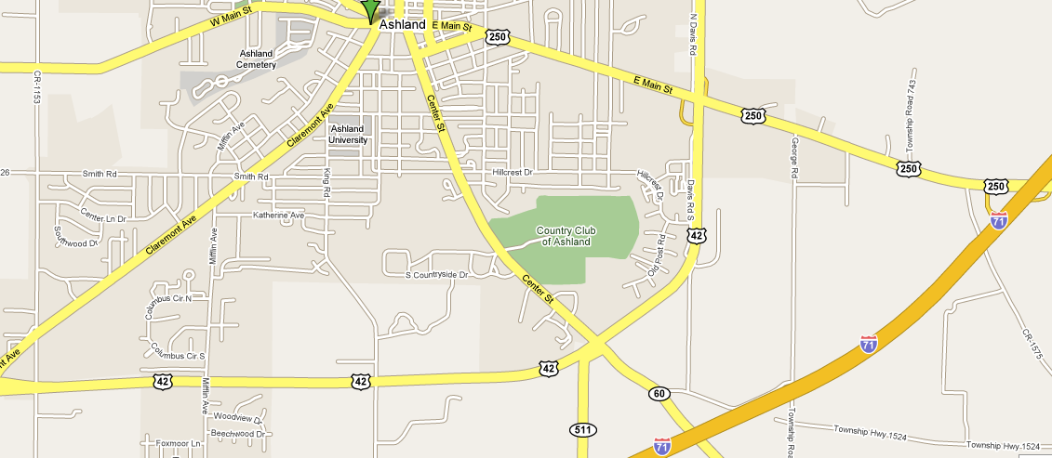
⬇
Fairgrounds

