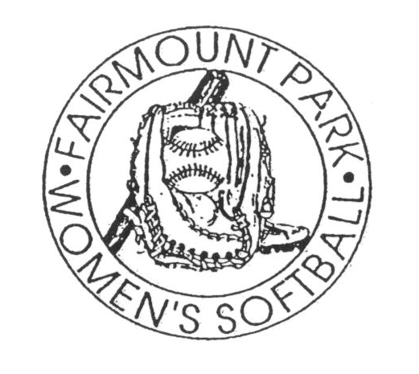
FAIRMOUNT PARK WOMEN’S SOFTBALL LEAGUE

ADVERTISING RATES FOR THE BASELINES

Full Page: $100.00 for 4 issues
$ 30.00 per issue

1/2 Page: $50.00 for 4 issues
$ 20.00 per issue

1/4 Page: $ 25.00 for 4 issues
$15.00 per issue

Business Card:
$ 20.00 for 4 issues
$ 5.00 per issue

ISSUE DATES

April 25th
May 23rd
June 27th
July 30th/August 1st

TO ADVERTISE IN THE BASELINES, PLEASE FILL OUT THE FORM BELOW. PLEASE MAKE CHECK OUT TO “FAIRMOUNT PARK WOMEN’S SOFTBALL LEAGUE”.

PLEASE HAVE COPY-READY ARTWORK ATTACHED. YOU MAY ALSO SEND A JPEG OR GIF FILE TO BELTOCHR@SSD.K12.PA.US

NAME:___________________________________________________ DATE:____________________

PHONE NUMBER:_________________________________E-MAIL ADDRESS:___________________

NUMBER OF ISSUES IN WHICH YOU’D LIKE TO RUN YOUR AD:___________________

SIZE OF AD: BUSINESS CARD ¼ PAGE ½ PAGE FULL PAGE

AMOUNT DUE:____________________________________________________________

