1. [L1] List the Four Conditions needed for deadlock?

A. _Mutual Exclusion: Each resource is assigned to exactly one prcess, or is available.
B. _Resource Holding: Processes currently holding resources granted earlier can request new resources. _____________________________
C. _No Preemption: Resources granted earlier cannot be forcibly taken away from a process. _____________________________
D. _ Circular Wait: There must be a circular chain of two or more processes, each of which is waiting for a resource held by the next member of the chain.

2. [L1] (True or False) Deadlock is more serious than indefinite postponement or starvation because it affects more than one job.

3. [L1] (Choose the one correct answer) The following diagram is an example of

- A graph that cannot be reduced

- A system in a deadlocked state

- A circular wait

- All of the above is the intended answer. However, it is NOT DEADLOCKED if you allow preemption. In either case, (a) and (c) are true. If (b) is true, then (d) is true.

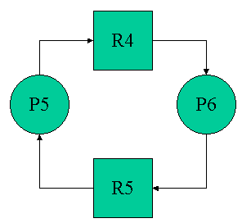

4. [L3] Four strategies for handling deadlocks are listed below. Choose two.

For each of your choices,
- Name a technique used to implement the strategy.
- Name the deadlock condition this technique is designed to break.

a. Prevention _Spooling: mutual exclusion; Snapshots: no preemption; Hierarchical Scheduling: circular wait; Interrupts: No preemption

b. Avoidance MUTEX: No preemption; Spooling: Mutual exclusion;

c. Detection Digraph Reduction: Circular wait

d. Recovery Victim Selection: No preemption

RACE is not a deadlock condition. It does have some strategies: Locking data base, semaphores.

5. [L3] The following table shows a system in a safe state. The system has a total of 12 tape drives. (Extra columns in the table are available for your use, but you are not required to use them.)

User # | Already Has | Max Need | Remaining Needs
1 | 1 | 4 | 3
2 | 4 | 6 | 2
3 | 5 | 7 | 2
 | 10 Total

Select which of the following would change it to an unsafe state.

- User 1 requests and is allocated 2 tape drives.

- User 2 requests and is allocated 2 tape drives.

- User 3 requests and is allocated 2 tape drives.

6. [L2] (Choose the one correct answer.) Which algorithm is designed to remove busy waiting in concurrent processing?

- Test and Set

- Wait and Signal

- First Come First Served

- Elevator Algorithm

7. [L2] (Fill in the blank.) What is essential to the mechanisms used to lock out a critical region for process synchronization?

A. Test to see the key is _Available_______________ .

B. If available, pick the key up and lock out the _other processes _____ .

C. Do this all in a single ___machine cycle____________________________ .

8. [L1] (Matching) Match the processor configuration with the figure.

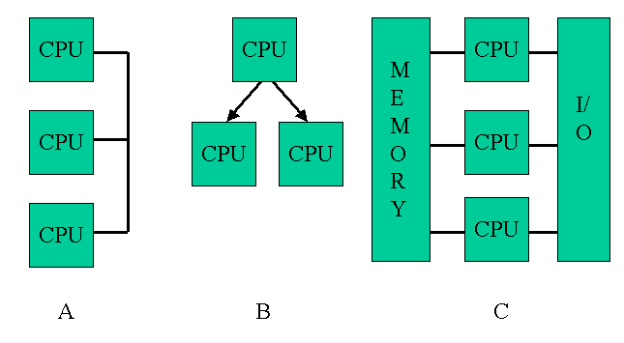

a. master/slave ___B_____

b. loosely coupled ___A_____

c. symmetric ___C_____

9. [L1] Give an example of a critical region and how it is important to two competing processes.
A critical region is a process or block of code which uses a resource, such that the process or code block must be completed as a unit before the resource is released for use by other processes.

Race problem: Critical Region is the time to complete an update on a file. Two processes can desire to make changes to the same file.
Intersection: Collision if mutual exclusion is not guaranteed.

10. [L1] What is the purpose of a semaphore? __Block access to a resource in use, signal availability when a resource is free. _____________________________________________________________________________

11. [L2] (Choose the correct answer.) What performs the actions that control the semaphore?

a. The operating system

b. The process

12. [L1] (Fill in the blank.) A mutex is a special semaphore. Its name means

___Mutual Exclusion________________ , which also describes the protection it gives to resources from competing processes.

13. [L2] Explain buffering as an operating system example of the "Producers and Consumers" classic problem.

___Process puts data into buffer. Target device (disk, printer) asynchronously removes data from buffer. ________________________________________________________________________

___________________________________________________________________________

14. [L3] (Circle the correct choice.) Which of the following code segments would the equation
A = B + C – 3 * D / (B + C)
be translated into if we used a concurrent language?

a. COBEGIN | b. COBEGIN | c. COBEGIN
T1 := B + C; | T1 := B + C; | T1 := B + C;
T2 := 3 * D; | T2 := 3 * D; | T2 := 3 * D / T1;
T3 := T1 / T2; | COEND; | COEND;
COEND; | A := T1 – T2 / T1 | A := T1 – T2
A := T1 – T3

15. [L2] (Choose ALL correct statements for operating systems.) Spooling

- Permits matching data streams between a slow speed I/O device and a high speed device.

- Avoids the problem of mutual exclusion by Converting a dedicated devices to a shared device.

- Allows I/O job scheduling since the spooling file can be examined for size and priority.

- Spools are round, blocks are square.

- Permits faster data transmission from one region of memory to another.

16. [L1] (Circle the correct choice.) What type of device is a print spooler?

a. Dedicated | b. Shared | c. Virtual

17. [L2] What is the purpose of I/O Channels in a sophisticated I/O subsystem?
a. Match speeds of a fast device with multiple slower devices: Buffer and retransmit.
b. Increase system reliability through cross connection.
An I/O subsystem handles the transmission of data to and from I/O devices once the decision is made to send data to a device. It is not to make a device available to more than one process. That is the function of spooling, which is a separate function. That is part of process management.

18. [L2] What is the purpose of a Channel Status Word?

__Identify if a clear path exists between memory and an Input/Output (I/O) device. One bit per link. _______________________________________________________________________

19. [L1] (Circle S or D) Specify which devices are sequential access storage media (S) or direct access storage devices (D) .

Device | Sequential (S) or Direct Access (D)
a. Printer | S D
b. Magnetic Tape | S D
c. Magnetic Disk | S D
d. CD-ROM | S D
e. Semiconductor Memory | S D

20. [L2] (Circle the correct answer.) Which one of the following choices are not an advantage of blocking?

- Fewer I/O operations are needed
- Less tape is wasted
- Overhead and software routines are needed

21. [L3] Given the following diagram indicating the disk arm scheduling

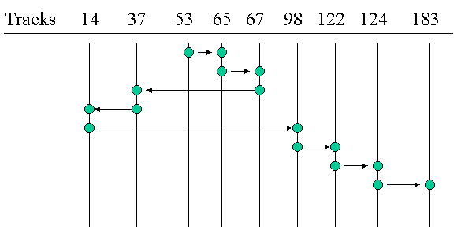
The arm starts at track 53. It moves to track 65 and stops on track 65. Look at the distance between track numbers. All requests arrived simultaneously. The vertical axis is the sequence that the scheduler decided. It is not necessarily the arrival sequence.
a. (Circle the correct choice.) What type of scheduling policy is being used?
(1) First Come First Served | (2) SCAN | (3) Shortest Seek Time First | (4) None of the other choices

b. (Circle the correct choice.) The total head movement covers how many tracks? How many tracks does the head have to move in order to service requests? Important since the dominant factor in time delay is the time required to move the head.
(1) 236 | (2) 208 | (3) 640 | (4) None of the other choices

c. (Circle the correct choice.) If a stream of requests clustered about track 14 occurs while servicing that track, then we have the possibility of which of the following for the requests following track 14 in the original list?

(1) deadlock
(2) race
(3) indefinite postponement
(4) immediate service

22. [L3] Why are buffers used? ___synchronize movement of data between devices of different speeds. ______________________________________________

____________________________________________________________________________

23. [L2] (True or False) Device management involves following basic functions

- ( T / F ) Tracking the status of each device.

- ( T / F ) Using present policies to determine which process will get a device and for how long.

- ( T / F ) Allocating the device.

- ( T / F ) Deallocating a device at the process level when an I/O command has been executed and the device is temporarily released.

- ( T / F ) Deallocating a device at the job level when the job is finished and the device is permanently released.

