Questions on course web site as of 10 April 2000, 1020 hrs
Updates will be posted periodically as questions are added and categorized.

An exam should give fairly even coverage of the subject matter.
An exam must establish mastery of basic knowledge.

About 70% of an exam should be terminology.
About 89% of an exam should be of Bloom Levels 1 and 2.

1. Knowledge: List, Identify, Outline, State, Draw, …
2.Comprehension: Explain, Describe, Interpret, Distinguish, …

About 6% of an exam should be of Bloom Levels 4 and 5.
3.Application: Apply, Calculate, Solve, …
4. Analysis: Classify, Derive, Explain, …

About 5% of an exam should be of Bloom Levels 5 and 6.
5. Synthesis: Formulate, Design, Create, …
6. Evaluation: Determine, Optimize, Evaluate, …

Key Terms:

Process synchronization
Deadly embrace
Deadlock
Starvation
Locking
Race
Spooling
Mutual exclusion
Resource holding
No preemption
Circular wait
Directed graphs
Prevention
Avoidance
Safe state
Unsafe state
Victim
Detection
Recovery

Parallel processingmultiprocessing
Master/ slave configuration
Loosely coupled configuration
Symmetric configuration
Process synchronization
Critical region
Test and set
Busy waiting
Wait and Signal
Semaphore
P
V
Mutex
Producers and consumers
Readers and writers
Concurrent processing
COBEGIN
COEND
Explicit parallelism
Implicit parallelism
Embedded computer systems
Ada
Concurrent programming

Dedicated device
Shared device
Virtual device
Sequential access media
Direct access storage devices (DASDs)
Magnetic tape
Interrecord gap (IRG)
Blocking
Transfer rate
Transport speed
Interblock gap (IBG)
Access time
Track
Sector
Cylinder
Optical disk drive
CD-ROM
Seek time
Search time
Transfer time
Latency time
Rotational delay time
I/O subsystem
I/O channel
Channel program
I/O control unit
Channel Status Word (CSW)
Polling
Interrupts
Direct memory access (DMA)
Buffers
I/O controller
I/O scheduler
I/O device handler
Seek strategy
First come first served (FCFS)
Shortest seek time first (SSTF)
SCAN
LOOK
Search strategy
Rotational ordering

1. Briefly explain a deadlock.
A system wide tangle of resource requests that begins when two or more jobs are put on hold, each waiting for a vital resource to become available. (Tamara Ann Carter)

2. What are virtual Devices?
A virtual device is a combination of the dedicated device and the shared device. For example, printers, which are dedicated devices are converted into sharable devices through a spooling program that reroutes all print requests to a disk. (Tamara Ann Carter)

1. (true or false) Resource Holding is processes currently holding resources granted earlier can request new resources. (Hyo Moon)

2. (true or false) No Preemption is resources previously granted cannot be forcibly taken away from a process. (Hyo Moon)

3. (Discuss) What are the conditions and strategies dealing with deadlocks. (Hyo Moon)

1. To have a job process through the safe state. The operating system must identify what conditions prior for job
completion.
a. smallest number remaining resources
b. number of available resources is equal or > than the number needed.
c. all of above
(James)

2. What are the 2 groups that divide the storage media?
a. direct acess storage device & sequential access media
b. sequential access media & magnetic tape
c. megnetic tape &random access storage device
(James)

1. What are the four strategies for handling deadlocks?

a. Prevention
b. Avoidance
c. Detection
d. Recovery
(Chuck Phillips)

2. What are the typical multiprocessing configurations?

a. master/slave
b. loosely coupled
c. symmetric
(Chuck Phillips)

1. What is the difference between a deadlock and starvation?

Deadlocks occur when resources needed by jobs to run to completion are held by other jobs which are waiting for some other resources.

Starvation is the result of conservative allocations where a single job is prevented from execution because it's kept waiting for resources that never become available.
(Cordelia Dugan)

2. What are the three categories of a system's peripheral devices?

Dedicated, shared and virtual.
(Cordelia Dugan)

1. Match the definitions with the questions
a. explicit parallelism
b. implicit parallelism

1. Programmer states which instructions can be executed in parallel.
2. Compiler automatically detects which instructions can be executed in parallel.

Answer 1.a. and 2.b.
(Michele O'Donnell)

2. Specify which devices are sequential access storage media (S) or direct access storage devices (D)

Printouts (S), Punch Cards (S), Paper Tape (S)
Magnetic Tape (S), Drum (D), Disk (D)
(Michele O'Donnell)

1. List the four conditions must be present simultaneously in a system for deadlock to occur.

- ______________________________________________
- ______________________________________________
- ______________________________________________
- ______________________________________________

(Flynn and McHoes)

2. The following system has a total of 12 tape drives allocated like this.
User # | Already Has | Max Need
1 | 8 | 10
2 | 3 | 5

Is this system in a safe state or an unsafe state? _______________________________

(Flynn and McHoes)

3. The following table shows a system in a safe state. The system has a total of 12 tape drives.
User # | Already Has | Max Need
1 | 1 | 4
2 | 4 | 6
3 | 5 | 7

Select which of the following would change it to an unsafe state.

- User 1 requests and is allocated 2 tape drives.
- User 2 requests and is allocated 2 tape drives.
- User 3 requests and is allocated 2 tape drives.

(Flynn and McHoes)

4. When two or more processes can access and modify the same data area so that the final result depends on which process finishes last, we have what kind of problem?

- Deadly embrace
- Deadlock
- Deadbolt
- Race

(Flynn and McHoes)

5. A hamburger stand where the cook places hamburgers in the “hamburger bin” and the bagger retrieves the hamburgers to satisfy incoming orders is an example of:

- Readers/writers problem
- Dining philosophers problem
- Producer/consumer problem
- None of the above

(Flynn and McHoes)

6. An airline reservation system where there are many inquiries but few reservations made is an example of

- Readers/writers problem
- Dining philosophers problem
- Producer/consumer problem
- None of the above

(Flynn and McHoes)

7. Counting semaphores are variables that

- Can take on the value of 0 and 1 only
- Can take on any integer value
- Are used to synchronize processes
- All of the above
- Both b and c

(Flynn and McHoes)

8. The following diagram, where P5 has been allocated resource R5 that is being requested by process P6 which has been allocated resource R4 that is being requested by process P5, is an example of

- A graph that cannot be reduced
- A system in a deadlocked state
- A circular wait
- All of the above
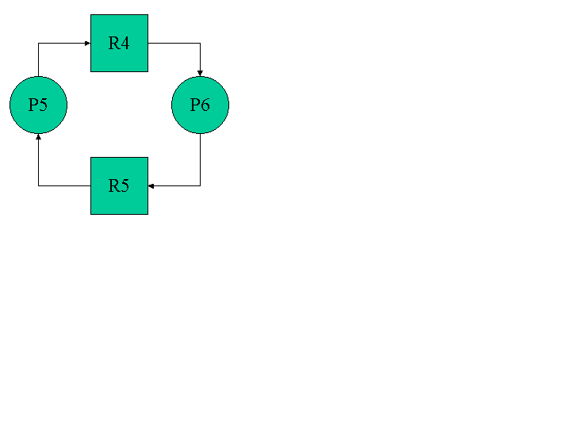
(Flynn and McHoes)

9. Which of the following code segments would the equation
A = B + C – 3 * D / (B + C)
be translated into if we used a concurrent language?

a. COBEGIN | b. COBEGIN | c. COBEGIN
T1 := B + C; | T1 := B + C; | T1 := B + C;
T2 := 3 * D; | T2 := 3 * D; | T2 := 3 * D / T1;
T3 := T1 / T2; | COEND; | COEND;
COEND; | A := T1 – T2 / T1 | A := T1 – T2
A := T1 – T3

(Flynn and McHoes)

10. Give at least three major differences between Master/Slave and Loosely Coupled multiprocessing configurations.
Master/ Slave | Loosely Coupled
Easiest to implement | Each processor has its own operating system
Only master may execute operating system | Mutual exclusion techniques are used to control access to global system information
Mutual exclusion for system tables is greatly simplified | Failure of a single processor is unlikely to be catastrophic
A failure in the master causes catastrophic system failure | Each processor controls its own resources
 | A process runs to completion on the processor to which it is assigned
 | Utilization can be poor. It is possible for some processors to remain idle while one processor executes a lengthy process.

(Flynn and McHoes)

11. A sequential access device, such as magnetic tape, has:
- No variance in access time for various records
- Compared to a direct access device, relatively small variance in access time for various records
- Compared to a direct access device, relatively large variance in access time for various records

(Flynn and McHoes)

12. To access a record in a movable head disk, the following information is needed:
- Cylinder number, sector number, record number
- Track number, record number
- Record number
- None of the above

(Flynn and McHoes)

13. A major purpose of blocking records is to:
- Position all records in a given file on the same section of a tape
- Decrease the number of times that the tape drive must stop and then start up again
- Store more records on one tape
- Increase the number of inter-record gaps
- Both b and c

(Flynn and McHoes)

14. To access a record in a fixed head disk, the following information is needed:
- Cylinder number, sector number, record number
- Track number, record number
- Record number
- None of the above

(Flynn and McHoes)

15. Multiple I/O paths to I/O devices have the following advantage(s):
- More flexibility in accessing a device
- More reliability in accessing a device
- Both a and b
- None of the above

(Flynn and McHoes)

16. Given the following diagram indicating the disk arm scheduling

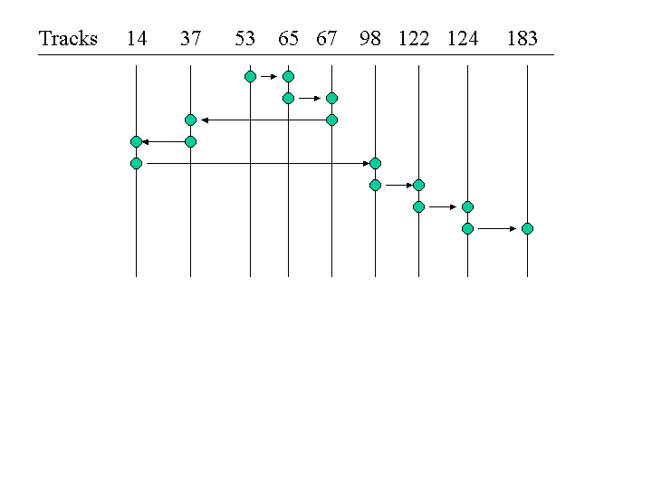

a. What type of scheduling policy is being used?
(1) FCFS | (2) SCAN | (3) SSTF | (4) None of the other choices

b. The total head movement covers how many tracks?
(1) 236 | (2) 208 | (3) 640 | (4) None of the other choices

c. If a stream of requests clustered about track 14 occurs while servicing that track, then we have the possibility of which of the following for the requests following track 14 in the original list?
(1) deadlock
(2) race
(3) indefinite postponement
(4) immediate service

(Flynn and McHoes)

17. A disk scheduling policy where the arm sweeps back and forth across the disk surface servicing all requests in its path, and changes direction only when there are no more requests to service in the current direction is called
- FCFS
- SSTF
- LOOK
- None of the above

(Flynn and McHoes)

18. A disk scheduling policy that services requests according to their proximity to the last request, that is, the next request services is the closest to the last request regardless of the direction in which the arm was moving is called
- FCFS
- SSTF
- SCAN
- None of the above

(Flynn and McHoes)

19. Rotational optimization is
- Useful under heavy loading conditions
- Useful in a disk when several requests for the same cylinder are present
- Used on a disk to schedule requests
- All of the above

(Flynn and McHoes)

20. Spooling
- Involves reading job streams from a slow speed input device into a high speed input device
- Involves reading more jobs into memory
- Involved writing records from memory to a high speed device before sending them to a slow speed output device
- Both a and c
- Both a and b

(Flynn and McHoes)

21 Given the following data:
(1) A magnetic disk with one movable head and four tracks numbered 0, 1, 2, 3
(2) Each track contains ten records numbered from 0 to 9
(3) It takes 10 ms for the disk to make one revolution
(4) The read/ write head takes 10 ms to move from one track to the next adjacent one
(5) It takes 1 ms to perform one read/ write
(6) A list of I/O requests (track, record): (0,1) (1,1) (1,3) (2,4) (2,6) (2,3) (3,5)
(7) The read/write head is positioned at track 0, record 0 (0,0) when the first track arrives.

Compute the following:
- The total amount of time that it will take to satisfy all the requests on a FCFS basis. Answer: 56 ms
- The amount of time that it will take to just read all the records. Answer: 7 ms

(Flynn and McHoes)

22. Given that a magnetic tape has a density of 1600 bytes/inch and that the inter-record gap is 0.5 inch, compute the percentage of tape utilization when the tape is filled with blocks of three hundred 80-character records. Answer: 24000 / (24000 + 800) = 97%

(Flynn and McHoes)

23. What specific information is needed to calculate the transfer rate for a magnetic tape storage device?
Answer:
(1) The speed at which the transport mechanism moves the tape (inches/second)
(2) The density used to write data (bytes/inch)

(Flynn and McHoes)

24. List three benefits of spooling.
Answer:
(1) Converts dedicated devices to shared devices
(2) Allows job scheduling since SPOOL file can be examined
(3) Faster I/O speeds since input/output takes place between disks and CPU

(Flynn and McHoes)

1. For Fixed-Head devices, assume the following:

Maximum access = 16.8ms + 0.00094ms/byte
Average access= 8.4ms + 0.00094ms/byte
Sequential access= depends on the length of the record
generally less than 1ms.
(known as the transfer rate)

a record contains 100 bytes
blocks containing 20 records

(1) Calculate access time to read ten records individually.

(2) Calculate access time to read one block of ten records.
(Myongsin Masek)

2. Which one of the following choices are not an advantage of blocking?
- Fewer I/O operations are needed
- Less tape is wasted
- Overhead and software routines are needed
(Myongsin Masek)

3. Which one is the greatest advantage of magnetic tape?
- sequential access
- random access
- compact storage capabilities
(Myongsin Masek)

4. Which algorithm is designed to remove busy waiting in concurrent processing?
- Test and Set
- Wait and Signal
- Symmetric configuration
- Loosely coupled configuration
(Myongsin Masek)

5. Whose job is it to synchronize the fast speed of the CPU with the slow speed of an I/O device?
- Control unit
- I/O device
- I/O channel
(Myongsin Masek)

1. If s is defined as a variable, the P operation is stated as:
P(s): If s > 0 then s: = s - 1
Which of the following is invalid:

a) fetch, test, decrement, and store sequence
b) test, fetch, decrement, and store sequence
c) fetch, increment, and store sequence
d) none of the above.

answer (b)
(Brian Shore)

2. True or False
A semaphore is an interger variable that's used as a flag?

answer: False - it is a nonnegative integer variable.
(Brian Shore)

1. Exlain how deadlocks can occur?
(Kamau Scott)

2. Explain A "Safe State"?
(Kamau Scott)

1. (ADVWIN 329 - 330. ) Using the state diagram on pg. 79 of our class text, discuss what must happen when you click on a program button in the task bar in Windows 95.
(Caldwell)

2. (ADVWIN 329 - 330. ) Use the state diagram on pg. 79 of our class text to discuss what must happen when multiple threads are used for the spreadsheet application to recalculate formulas while the user continues editing a spreadsheet.
(Caldwell)

3. (ADVWIN 329 - 330. ) Use the state diagram on pg. 79 of our class text to discuss what must happen when you use Control-Alt-Delete to kill a task in Windows 95.
(Caldwell)

1. (Object Linking and Embedding, ADVWIN 349 - 350, 354, 356 - 357) What is the difference between linking and embedding?
(Caldwell)

2. (Object Linking and Embedding, ADVWIN 349 - 350, 354, 356 - 357) What is a situation when linking is preferred rather than embedding?
(Caldwell)

3. (Object Linking and Embedding, ADVWIN 349 - 350, 354, 356 - 357) What is a situation when embedding is preferred rather than linking?
(Caldwell)

4. What happens if you change the location of the file that originated the object you linked to?
(Caldwell)

5. (Object Linking and Embedding, ADVWIN 349 - 350, 354, 356 - 357) If you are editing a document, how can you tell if an object in that document was linked to or embedded?
(Caldwell)

1. If you could put the file allocation table anywhere on a hard disk that you wanted to, where would you put it (them)?
(Caldwell)

2. If you could put the file allocation table anywhere on a floppy disk that you wanted to, where would you put it (them?)
(Caldwell)
3. What are the advantages and disadvantages of having two read/write arms on a disk drive?
(Caldwell)

4. For a specified application environment, choose an appropriate disk arm scheduling algorithm to maximize performance.
(Caldwell)

5. What are the four conditions required for a deadlock, and what do they mean?
[See the solution set for Chapter 5 problem 5a for definitions of these terms. These definitions were given in class lecture. The author gives examples on page 107, but does not provide definitions. The definitions in the text's glossary are workable, though less precise.]
- Mutual exclusion
- Resource holding
- No preemption
- Circular wait
(Caldwell)

6. Modeling Deadlocks. Refer to the digraphs by the process and resource numbers labeled in the digraph. Explain the meaning of the following digraphs. One (and only one) of the digraphs is ambiguous or meaningless. Identify which one.

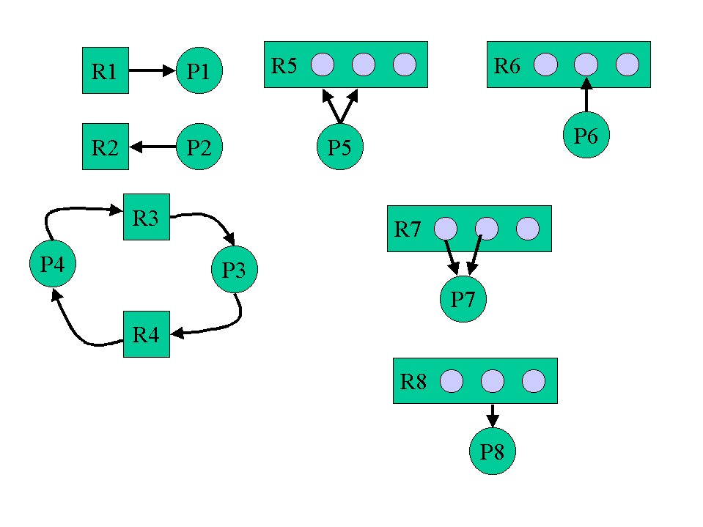
(Caldwell)

7. Give an example of how to solve the mutual exclusion problem with a printer.
(Caldwell)

8. Three definitions were given for "safe state". Pick one definition and compare it to the other two. Discuss why you might want to use one definition compared to the other, as it affects throughput and turnaround time.
(a) A system is in a safe state if has enough unallocated resources to satisfy the maximum requests of all active processes. (pg. 112, bottom)
(b) A system is in a safe state if it has enough unallocated resources to permit the process with the smallest number of remaining resources to run to completion. (pg. 113, bottom)
(c) A system is in a safe state if there exists a sequence of resource allocations that will permit all processes to eventually run to completion. (This definition was given in class.)
(Caldwell)

9. Be able to apply the Banker's Algorithm to determine how to satisfy a sequence of resource requests to permit all jobs in the system to run to completion.
(Caldwell)

10. Know and be able to apply the rules for decomposing a digraph to detect the presence of a deadlock.
(Caldwell)

11. Discuss how to select a victim to kill in order to break a deadlock.
- Job priority
- Closeness to completion
- Number of dependent jobs
(Caldwell)

12. Discuss possible actions to handle a deadlock.
- Kill all jobs.
- Kill all deadlocked jobs.
- Kill one deadlocked job at a time.
- Programmer responsibility: Do periodic snapshots to permit restarts from a known state.
(Caldwell)

13. What is a snapshot?
(Caldwell)

14. What are the differences between deadlock, race, and starvation? [The author uses the term "deadlock" in two ways. Restrict your definition of a deadlock as a condition satisfying all four of the conditions necessary to produce a deadlock.]
(Caldwell)

15. Discuss the difference between a Master/ Slave configuration (which the class text discusses) and a Client/ Server configuration (which was discussed in CIS110 and in our Windows 95 Advanced lab manual.)
(Caldwell)

16. Give an example of a critical region and how it is important to two competing processes.
(Caldwell)

17. Sequential access: Think "magnetic tape" as the model for understanding sequential access. Issues: Inter-record gap, blocking of records, tape density (bits per inch), 8 data tracks and 1 parity bit track, tape speed, time required to read a block or record.
(Caldwell)

18. Direct Access: Understand basic physical process of movement of arm and rotation of device.
(Caldwell)

19. Direct Access device access time:
- Seek time: arm movement.
- Rotational delay = latency time
- Data transfer time
(Caldwell)

20. Components of an I/O System
- I/O Channels
- I/O Control Units
- I/O Devices
(Caldwell)

21. Understand that the operating system, channels, control units, and I/O devices may have software or firmware that control the flow of data from one stage of transmission to another.
(Caldwell)

22. Understand that I/O channels and control units are sometimes given the ability to be cross-connected to increase overall system reliability.
(Caldwell)

23. Channel Status Word: Three bits: One bit each for Channel, Control Unit, and Device. Understand that the Channel Status Word is checked as a prerequisite for data transmission. What does this do?
(Caldwell)

24. Channel Status Word checking: Polling versus interrupt. Contrast the methods of checking. What affect does this have on the operating system as a whole, or a channel?
(Caldwell)

25. What is Direct Memory Access (DMA)?
(Caldwell)

26. What is a buffer? What is meant by "double buffering"? Why are buffers used?
(Caldwell)

27. Device Manager: What are the component managers?
- Traffic Controller
- Scheduler
- Device Handler
(Caldwell)

28. Seek Strategies: Elevator Algorithm.
(Caldwell)

1. Briefly discuss the conditions and strategies dealing with
deadlocks.

Conditions Strategies
a) Mutual Exclusion a) Prevent
b) Resource Holding b) Avoid
c) No preemption c) Detect
d) Circular Wait d) Recovery
(Jose Muniz)

2. The success of any multiprocessing system relies solely on the
programmers' instructions or explicit parallelism.
a) True
b) False
(Jose Muniz)

3. High level language ADA may contain program units that can be
classified as subprograms, packages, or tasks.
a) True
b) False
(Jose Muniz)

4. The success of I/O subsystems depends on the communications that
link the

__________, __________, and ____________.

a) Channels
b) Control units
c) Devices themselves
(Jose Muniz)

1.What are the Four Conditions needed for deadlock?
A.Mutual Exclusion
B.Resource Holding
C.No Preemption
D.Circular Wait
(Tom Hobgood)

2.What are the mechnisms used to lock out a critical Region in order to execute syncronization?
A.Test & Set
B.Wait & Signal
C.Semaphores
(Tom Hobgood)

3.What is essential to the mechnisms?
A.They must see the key is avaialble.
B.If available, pick the key up and lock out the critical region
C.Do this all in a single machine cycle.
(Tom Hobgood)

1. Describe the difference between a shared device and a virtual device. (Rudy Jones)
2. Describe and sketch the components of the I/O System. (Rudy Jones)

1. (True or False) Deadlock is more serious than indefinite postponement or starvation because it affects more than one job.
(Tangela Robinson)

2. (True or False) An operating system should be able to recognize a mutual exclusion, resource holding, no preemption, and circular wait.
(Tangela Robinson)

3. (True or False) A classic problem of producers and consumers is one in which one process produces some data that another process consumes later.
(Tangela Robinson)

4. (True or False) Device management involves four basic functions
- Tracking the status of each device
- Using present policies to determine which process will get a device and for how long
- Allocating the device
- Deallocating them at two levels: at the process level when an I/O command has been executed and the device is temporarily released, and at the job level when the job is finished and the device is permanently released.
(Tangela Robinson)

5. (True or False) Data is recorded serially on each track by the fixed read/write head positioned over it.

1. What are the three strategies operating systems use to deal with deadlocks?
Ans. (a) Prevent one of the four conditions from occuring; (b) Avoid the deadlock if it becomes probable; and (c) Detect the
deadlock when it occurs and recover from it gracefully.
(Charles McClain)

2. What factors should be considered to choose a victim when trying to recover from deadlock?
Ans. (a) The priority of the job under consideration; (b) CPU time used by job; and (c) The number of jobs that would be
affected if this job were selected as the victim.
(Charles McClain)

1. What is the "Producers and Consumers" classic problem?
One process produces some data that another process consumes later.
(William McNair)

2. What is starvation?
When a single job is prevented from execution because it is kept waiting for resources that never become available.
It is an extreme case of indefinite postponement.
(William McNair)

3. What is an I/O Channel?
A specialized programmable unit placed between the CPU and I/O Control Units to synchronize the fast speed of the CPU with the slow speed of the I/O device, and vice versa. I/O Channels control the transmission of data between control units and main memory.
(William McNair)

