Registering Files Types with the Registry

The Registry is a database program that stores user information such as options you set in My Computer, application program information, and information about the specific computer you are using. The Registry centralizes, then tracks all this information, including the data file extensions that an application program assigns to its data files, the icons that will represent a programs or and its data files, and other file-oriented information. The Registry keeps track of which data files belong to which program, so that when you double-click a document icon, Windows 95 checks the Registry so it know which program to open. Windows 95 will also place any opened registered data file on the Documents menu. The Registry bases its decision on the file extension (file type). When you install a program written for the Windows 95 interface, part of the installation process is the program informing the Registry what file extensions it plans to use for its data files.

The Registry, on a stand-alone computer, consists of two files: user.dat and system.dat. There is a special Windows program called the Registration Editor that allows a user to make changes directly to the Registry (user.dat, system.dat, and policy.pol). However, it is very dangerous to edit these files directly. If you edited the files incorrectly, Windows 95 could not boot. Fortunately, you can register file types (extensions) easily without ever having to touch these important system files directly.

You may ask yourself why you would want to assign an unregistered file extension to a data file you create, rather than letting the program assign the file extension. One reason is that you will be creating many data files. The challenge is creating data files is organizing and retrieving them quickly. If you use a program such as Word for Windows, Word will assign the file extension.doc to each data file created in Word so that every file you create in Word will have a different file name but the same extension (Kathy letter.doc, Mr., Jones letter.doc, Finance plan report.doc, or Business plan report.doc). In terms of retrieving and identifying files, it would be helpful if files about similar topics have something in common. You could choose to have all files that were letters have a .let extension so that now your file name would be Kathy.let and Mr. Jones.let. All reports could have a .rep file extension so that now your file names would be Finance plan.rep or Business plan.rep You create an organizational scheme that helps you manage files. When you open your document files to alter, review, or print them, you easily identify the kind of data in the files by extension you assigned. However, since you, not Word, assigned the file extension, Windows 95 will not know what application program to open nor will Windows 95 place any of these unregistered files types on the Documents menu. Word, in the installation process, registered.doc. It did not register .rep or .let. You may register (inform Windows 95 of your preferences) your own file extensions to the Registry so that Windows 95 knows that, for instance, in the example, it should not only open Word with any .doc extension, but it should also open Word with any file with the extensions of .let or .rep.

Activity⎯Registering File Types

Note: The listed settings are assumed for each chapter. If you are working on your own computer, the changes you made in the default settings should be retained from one work session to the next. However, if you are working in a computer lab, you may have to change your settings each time you log into the network. The settings are as follows:

My Computer

❑ Toolbar and status bar on (in the View menu).
❑ Large icons arranged by name (in the View menu).
❑ Browse folders by suing a single window that changes as you open each folder (View/Options/Folder tab).
❑ Hide files of these types is set (View/Options/View tab).
❑ Display the full MS-DOS path in the title bar is set (View/Options/View tab).
❑ Hide MS-DOS file extensions for file types that are registered is not set (View/Options/View tab).

1. Double-click My computer. Double-click the Drive A icon.

- Double-click Apr.99.
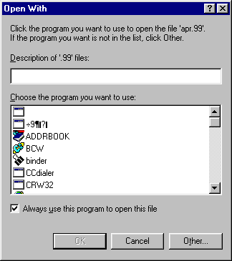

The file called Apr.99 does not have a registered file extension. Double-clicking a registered document icon will open the program that created that file. Since .99 is not registered, Windows 95 does not know what application program to open for a file with the extension of .99. Windows 95 then presents you with an Open With dialog box listing all programs installed on your computer system. The dialog box asks you what program you wish to use to open Apr.99. What it is really asking you to do is to register (assign) the file extension .99 with a program so that in the future Windows 95 will know what program to open for any file with a .99 extension. The registration of a file is based not on the file name but on the file extension. The dialog box has an empty text box called Description of ‘.99’ files: in which you can add descriptive information when registering a file type (extension). Thus, you can create file extensions that mean specific things to you and clearly reflect your work.

- In the Description text box, key in the following These are files for my Windows 95 class.
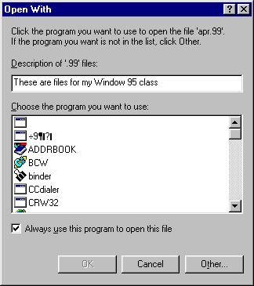

Whenever you see a file with a .99 extension, you will have a generalized description of this type of file.

- Scroll through the list box until you locate Notepad. Click Notepad.

Notepad is the program that you wish to use with the .99 files. There is a check box in this dialog box labeled Always use this program to open this file. When this setting is checked, the specified program is always used to open any files with the selected extension. If you select OK when this box is checked, you will register the file. In this case, whenever Windows 95 sees a .99 file extension, it will open Notepad. If there were no check mark, you would open this file with Notepad this time only. No check mark means no entry in the Registry.

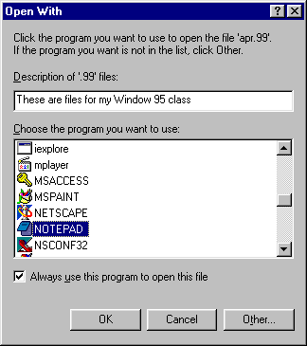

- Be sure Always use this program to open this file check box has a check mark. Click OK.

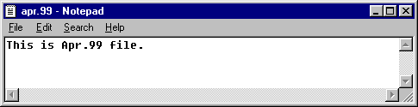
Notepad opened, with Apr.99 as the data file.

- Close Notepad.

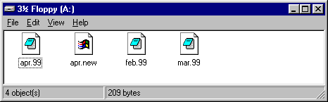

Notice that Apr.99 (and ALL files ending in .99) now has a user-registered document icon. Windows 95 knows that Notepad is the program to use to open any file with a .99 extension. When you double-click this icon, Windows 95 will open Notepad and display the Apr.99 document.

Notice that Apr.new still has a generic document icon. Windows 95 does not know what program to use to open this file. If you double-click this icon, Windows 95 will present you with the Open With dialog box.

Notice that Mar.txt has a program registered document icon. Windows 95 knows that Notepad is the program to use to open any file with a .txt extension. When you create a file in Notepad, Notepad automatically assigns the .txt file extension. When you double-click this icon, Windows 95 will open Notepad and display the Bye.txt document.

- Look at Feb.99.

Since you registered the .99 file extension with Notepad in Windows 95, all files with a .99 file extension are registered. You may double-click any of them, and Notepad will open along with a .99 data file.

- Double-click Feb.99.

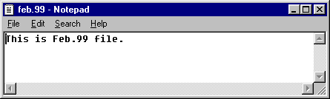
Since this is a registered file, Notepad opened it.

- Close Notepad. Find the Apr.99 icon.

- Right-click Apr.99.

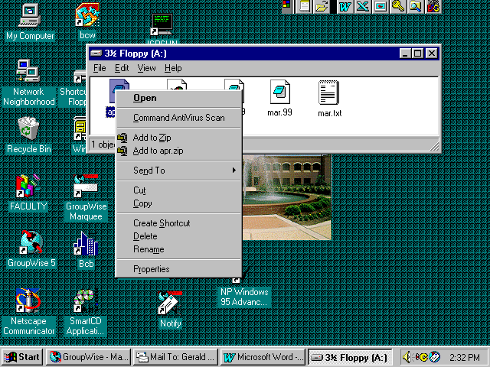
You have opened a shortcut menu that will help you manipulate the Apr.99 object. Each item on the menu describes an action you can take with the Apr.99 file; you can Open it, Copy it, or Delete it.

- Click outside the menu to close it. Right-click Apr.new.

Since Apr.new is not a registered file, Windows 95 does not know what program to use to open the file, so instead of Open, your menu choice is Open With.

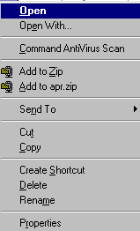
- Click outside the menu to close it. Click Apr.99. Hold the Shift key and right-click Apr.99.

When a file is registered, it will always open the program that it is registered to. Sometimes you may have different programs that use the same file extension for their data files. If a file extension is already registered to one program, it cannot be registered to another. For example, Word and WordPad both assign the file extension .doc to their data files; however, .doc is registered only to Word. Any file with a .doc extension would automatically open Word. Only by holding the Shift key when you right-click could you choose the Open With menu and select WordPad to open the file instead of Word.

- Click Properties.

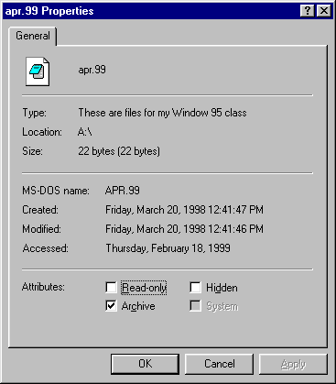
You opened the property sheet for Apr.99. Not only does the property sheet tell you the name of this file and when it was created, but also why it was created. The only indication that Notepad created this file is its document icon. If you wanted to be more descriptive in your file type, you could have written your description as Notepad files for my Windows 95 class. Then you would know which application program created these files.

- Click Cancel.

- Click the Start button. Point at Documents.

Now that you have registered the file extension, every registered file that you used is listed on the Documents menu. If you want, you can open any file on this list.
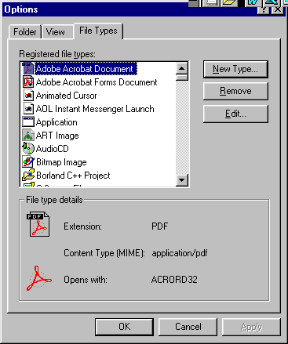
- Click outside the Start menu. In the A:\ window on the menu bar, click View. Click Options. Click the File Types tab.

You may add or remove file types at any time by selecting the property sheet under Options from the View menu.

- The list is alphabetically arranged. Scroll the list window until you locate These are my files for my Windows 95 class. Click that line to select it.

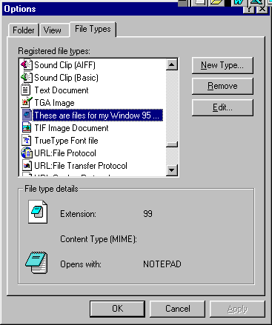

When you selected from the Registered file types list box, the information in File type details at the bottom of the dialog box told you what the file extension is (.99) and the application program that open it (Notepad). This is one way to identify which extensions are registered to which programs.

- Click the Remove command button.

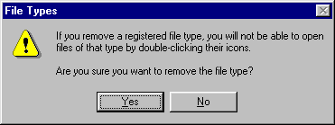
You see an information message box warning you that once you remove a registered file type, you will no longer be able to double-click to open it easily. You may still open it, but you will have to use the program approach with its many steps.

- Click Yes. Click Close.

- Hold the shift key and click the Close button for the 95book window.

You have returned to the desktop.

