Self-biased PLL based on the work of I.A. Young and J.G. Maneatis
A paper summary
Fuding Ge

- If a precise 50% duty cycle clock is required, a VCO runs at twice the desired frequency is used in the PLL then this twice-frequency signal is divided by 2 using D filp-flop.
- Divider: from the point view of deskew, it simply masks out the clock cycles, dose not introduce any additional delay in the feedback clock. This divider should be able work at the maximum VCO output frequency.
- The conventional delay elements (show following) are power supply sensitive.

- Low pass filter circuit schematic:

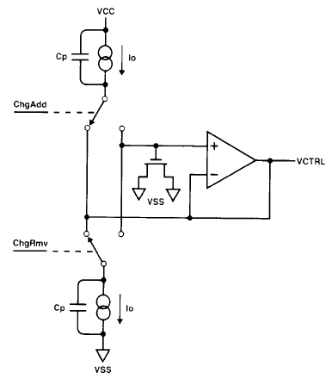

The unavoidable parasitic capacitance Cp will induce charge error, and this can be prevented by clamping each parasitic Cp with Vc whenever its current source is not charging the filter capacitor.

- Differential current-controlled delay element
The following figure shows the delay cell. It is based on a P-MOSFET source-coupled pair (N-MOSFET source coupled pair can also be used in the design) with voltage-controlled resistor (VCR) load element. By controlling signal R_{control} to VCR, the voltage swing is held constant and independent on power supply voltage. Then the delay is only dependent on I_{source} so that VCO frequency is directly proportional to I_{source}.

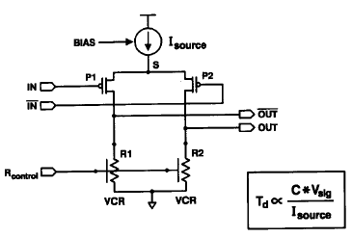
The following figure shows a N-MOSFET source coupled pair delay cell. The symmetric load acts as the VCR and V_{BP} is the control voltage R_{control}. Signal VBN is the bias voltage controls the I_{source}.
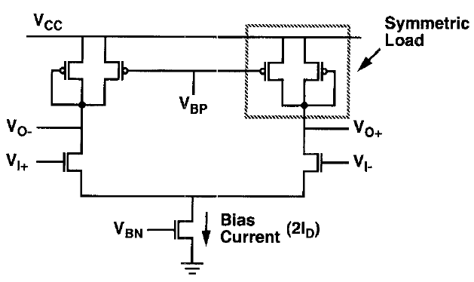

- VCO output amplifier
The output of VCO is not a rail-to-rail swing signal, a high gain, fully differential OTA is followed the VCO to get a 50% duty cycle and rail-to-rail swing signal. The OTA is shown below:
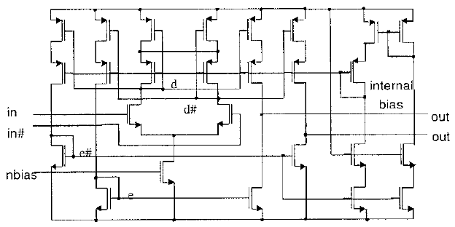

- V-I converter
Because the delay cell is current controlled and the VCO frequency is proportional to the bias current, we need a V-I converter to convert the control voltage Vc from the low-pass filter to a current whose value is proportional to Vc. The function block can be shown as following:

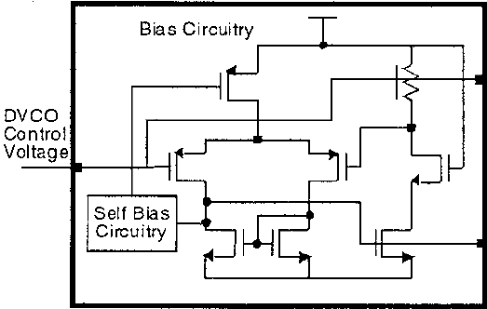
V_{BP}
V_{BN}

It can be implemented by the following schematic.
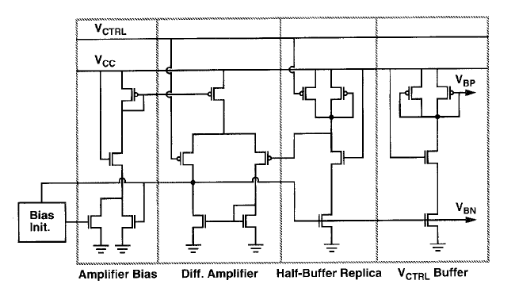

- Initial circuit:

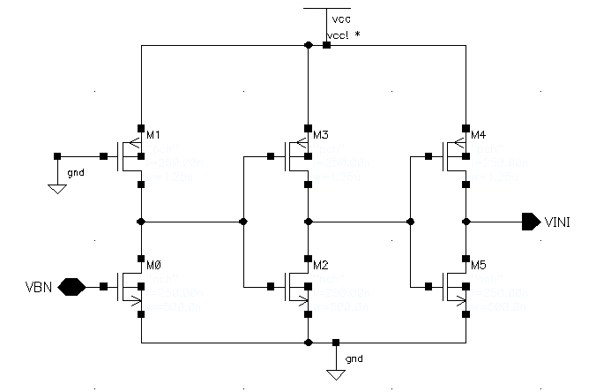
M1

Be sure that M1 is a weak transistor.

