Winter 2006 Volume 1.0

The Southern Ontario Animal Rescue

Howler

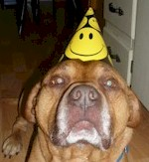

Welcome!

It’s our birthday this month – S.O.A.R. is 1-year old! To celebrate, we have launched our newsletter – “The Howler”!

The purpose of this newsletter is to keep you informed about all dog-related issues – from tips on training, care and feeding to dogs available for fostering and adoption.

We’d also welcome any/all submissions from you – from stories and jokes to cartoons, pictures and articles.

If there’s anything you’d like to see, just let us know and we’ll do our best to include it in the next issue.

Each issue will feature the following:

A dog that is either in our foster program or is
available for adoption.

Happy Beginnings – updates on dogs that have
been adopted.

Upcoming events -- from dog shows to fund raisers.

Anything else we can come up with that will
interest/benefit you.

FOSTER FEATURE

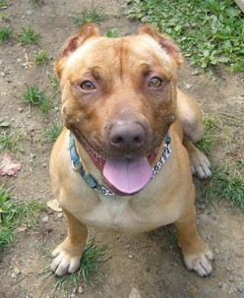

JAMES BOND

Bond is approximately 2 years old. Originally a stray in a shelter facility, he was in danger of being euthanized or sold for research.

Bond came to us in very sad shape – gaping wounds down the left side of his neck & face, terrified and unsure. In fact, he didn’t even know how to play with toys!

We placed him in a wonderful kennel, where they helped us to teach Bond basic manners and, after 6 months, how to play with toys!

Bond needs a foster/adoptive home where he is the only pet. He is wonderful with people of all ages – all he wants is cuddles! Please contact us if you can foster or adopt Bond.
WE URGENTLY NEED FOSTER HOMES!

We are in desperate need of foster homes. There are dogs in need that we cannot help because we simply do not have enough foster homes.

If you are interested in becoming a foster home for one of our dogs or would like more information on fostering, please contact us.

We provide the food and medical care. As a foster, all you have to do is provide the home and love.

Adoption Policies

All rescued dogs have been spayed or neutered, microchipped, fully vaccinated and vet-checked.

Applications are NOT processed on a first-come, first-served basis as we strive to match the right dog to the right home.

If the application is approved, your references will be checked and a home visit will be conducted.

ANNOUNCEMENTS

Our website is located at www.geocities.com/furkidsrescuecanada

We are continually updating our site, so check back often.



Who Are We?

Southern Ontario Animal Rescue’s goal is to find loving, lifetime homes for our dogs. We screen potential adoptive homes carefully, including home visits and follow up visits. All dogs available for adoption have been altered, vaccinated and microchipped.

Our dogs are fostered with real families to ensure that they are sound, good-natured pets. They also come with a lifetime guarantee – If, at any time, for any reason, an adoption does not work out, you may bring the dog back.

Contact:
Jan Paquete (905) 457-1500

Email us at: SOARgeneralinfo@hotmail.com

Mail us at:

The Editor, The Howler
14 Bingham Road
Brampton, ON L6V 2K1

DOG DO’s & DON’T’s
DON’T own a Dog if your sole purpose it to have a “guard dog”.

DON’T own a Dog because you think they are the “coolest, toughest dog”.

DON’T get a Dog if you don’t have the time, patience or inclination to train a dog.

DON’T get a Dog if you don’t believe a dog is part of the family.

DON’T get a Dog if you don’t like physical affection from animals.

DON’T get a Dog if you like to keep your home immaculate.

DON’T get a Dog if you don’t like physical exercise – no matter the weather.

DON’T get a Dog (or any animal) if you are not willing to commit yourself to the animal’s entire lifetime (approximately 9 – 12 years).

DO get a Dog if you enjoy having your dog with you as much as possible.

DO get a Dog if you don’t mind exuberant displays of affection!

DO get a Dog if you don’t mind dog hair – on the floor, your bed, etc.

DO get a Dog if you enjoy walking, jogging and/or hiking – no matter the weather.

DO get a Dog if you want a loyal friend.

DO get a Dog if you enjoy playing tug (or any other game) and having a toy dropped into your lap at anytime as a “subtle” hint.

DO get a Dog if you don’t mind loud snoring or sharing your bed!

HAPPY BEGINNINGS
This section is dedicated to our Dogs who found their “forever homes”.
Each newsletter will feature lucky dogs who have been adopted and are now enjoying loving homes.

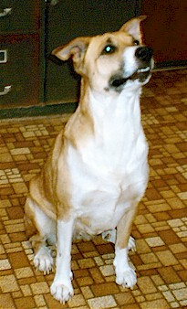

Baby

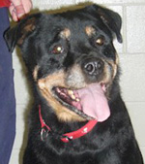

Birdie

Continued next page…

HAPPY BEGINNINGS
(continued)

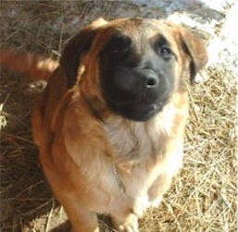

Brady

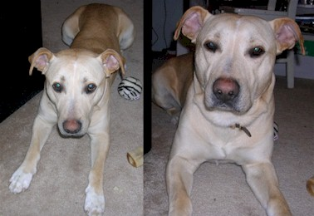

Buddy

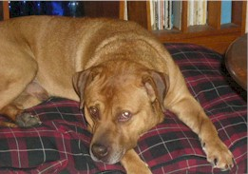

Bugsy

DOG PAW TOWELS
NOW ON SALE!

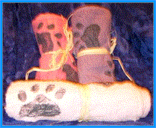

Mud season is on its way! Be prepared with these paw towels – ready to clean all sizes!

Only $5.00 each. This
Includes shipping & handling.

Order yours now by either emailing us at SOARgeneralinfo@hotmail.com or writing to the Editor.

All proceeds go to help Dogs in need.

We will have more Dog buyables in the next issue! Help us help the dogs!

Dear Diva-Dog

This section is a tongue-in-cheek guide for grooming, feeding, behaviour and general health tips. Why not have your Dog send Diva-Dog an email or letter with their concerns – from grooming to understanding why their humans act the way they do!

Dear Diva-Dog,

My humans always shout when the cat and I play tag. Why do they do this?
Daytona

Dear Daytona,

Humans are strange creatures. They don’t seem to understand the prey drive or the hierarchy of the pack. They think we are all equal. My advice to you is to wait until they aren’t around and then chase the cat.
DD

Dear Diva-Dog,

I always seem to get yelled at when I help myself to food. There’s this big container in the kitchen and my humans are always throwing away really good stuff – like bones, fat, tubs with margarine. What’s their problem?
Garbage Lover

Dear Garbage Lover,

Humans, for some strange reason, don’t eat bones or fat and always seem to be throwing things away that are still perfectly good to eat! My suggestion is to only choose one or two things from this bin and hide them somewhere until you can eat them in peace.
DD

WISH LIST

- Leashes
- FLAT Collars
- Blankets
- Beds
- Food
- Toys
- Dishes
- Crates
- Foster & Adoptive Homes

Of course, any monetary donation you wish to make is always very much appreciated.

S.O.A.R. SUPPORTERS

We’d like to take this opportunity to thank the following people/organizations for their continued support, whether it’s items to raffle off, medical services, food, etc. Without their generosity, we would be lost.

PET VALU, Sandalwood Pkwy in Brampton
CALEDON MOUNTAIN VETERINARY HOSPITAL
DAWG DAYZ INN, Hillsburgh
BRAMPTON TANDOORI RESTAURANT
BULK BARN, Brampton
THE HAIR CENTRE, Brampton
PRETTY BOY DOG GROOMING, Brampton

MY BEST FRIEND PET BOUTIQUE, Oakville

COCO’S PET BOUTIQUE, Etobicoke, www.cocos.ca

GRANNIE ANNIE’S

DOGGIE RECIPES!

Granny Annie is very popular in her neighbourhood! She loves to make treats for all the dogs. If you
have a great recipe you’d like to share, send it in!

DUG OUT BONES
2 cups whole-wheat flour
1 tablespoon baking powder
1 cup peanut butter
1/2 cup skim milk
1 egg
dash of salt
Preheat over to 375 degrees Fahrenheit.

In a bowl, combine flour, baking powder and salt. In another bowl, mix peanut butter, milk and egg.

Add wet mixture to dry and mix well.

Turn out dough on a lightly floured surface and knead. Roll out to 1/4 inch thick and cut out shapes.

Place on a greased baking sheet and bake for 20 minutes or until lightly brown. Makes 30 cookies.

FILL OUT OUR SURVEY & WIN A PRIZE!

This newsletter is published to not only help dogs in need, but to help keep you updated on what is happening.

Fill out this survey and mail it back to The Editor (c/o 14 Bingham Road, Brampton, ON L6V 2K1) and we’ll enter you in a draw for a free gift.

1. What do you think of this newsletter?
◻ Great
◻ OK
◻ Could be better (suggestions?)
◻ Terrible (suggestions?)

2. What is your favourite section?
◻ Foster Feature
◻ Dear Diva Dog
◻ Information Articles
◻ Grannie Annie’s Recipes
◻ I like it all

3. Would you consider paying a small amount to continue receiving this newsletter?
◻ Yes ◻ No

4. If yes, what would you consider to be a reasonable one-year subscription rate?
◻ $2.00
◻ $3.00
◻ $5.00
◻ Other amount $___________
◻ Don’t set a price, let us just donate what we want.

5. What would you like to see in future issues?

Additional Comments (feel free to use more paper!):

Name:____________________

Address :_________________

_________________

Phone: ___________________

Email :____________________

The Howler is an independent publication, produced quarterly by private individuals. Its intention is strictly for information only.
This newsletter and its entire contents are Copyrighted © No part may be reproduced in whole or in part without the express written permission of Southern Ontario Animal Rescue.

