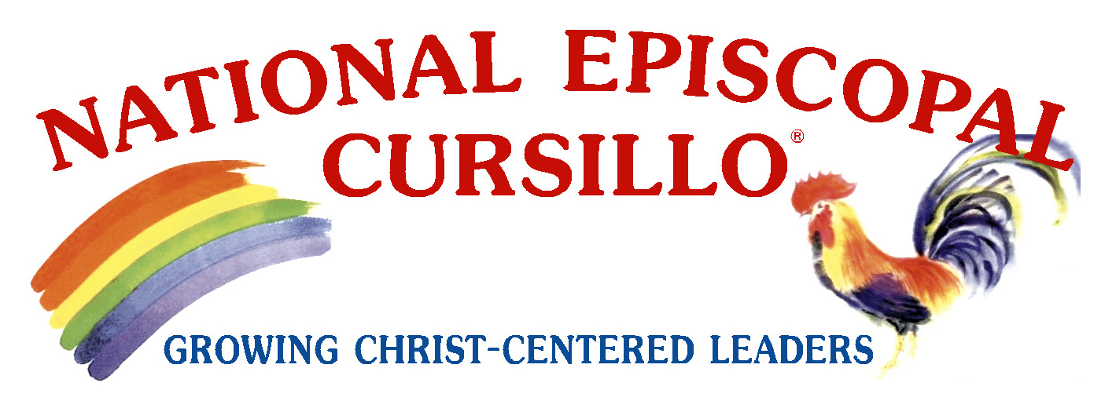

A Statement from the National Episcopal Cursillo Committee

Cursillo has always kept its eyes firmly focused on Jesus and on the Mission. One of the principles of the Cursillo movement is that:

We focus on Christ and His resurrection power in our lives, transforming us into the people He would have us be. Theological disputes and political issues have no part in our agenda.

The Cursillo Movement is a movement that brings together all people, whether they might consider themselves to have a liberal or conservative Christian philosophy or somewhere in between, for the common good of promoting Jesus Christ and God’s Mission. It is Christ-centered and Christ-focused. The Policy of the National Episcopal Cursillo Committee is that it will not be an organization with a political or social agenda. National Episcopal Cursillo is a movement of the Episcopal Church.

We recognize, however, that a number of individuals with connections and interest in the Episcopal Cursillo Movement are no longer affiliated with the Episcopal Church. As a sign of reconciliation, we welcome those still able, as individuals, to be in communion with the local Episcopal Diocesan Bishop and fellow Cursillistas, whether lay or ordained, to participate in the activities of the Cursillo Movement. Furthermore, and always at the Diocesan Bishop’s discretion, we encourage an openness to their continued participation and interest in the activities of the Episcopal Cursillo. It should be understood by all that as a part of their participation, they agree to do so fully for the advancement of Cursillo, be supportive of the mission of Episcopal Cursillo, and agree that they will not promote any political agenda.

What is clear is that National Episcopal Cursillo was created to serve the Episcopal Church in the United States, and we are licensed by the Roman Catholic Church to do that. Despite our personal theological and political views, we are focused on knowing Christ and making Him known to others. That is our call and in doing it lays our greatest joy. Ultreya! Ultreya!!

Let us get on with the day's apostolic action.

Let us all pray for the Church, and one another every day.
National Episcopal Cursillo Committee
May 2008

