WELCOME TO OAKLEY

Congratulations! You have been selected to work at our newest store in the Oakley Family…Metropolis Mall O Store! All training is MANDATORY, informational, and fun- you don’t want to miss a minute!

AGENDA AT A GLANCE: This is not an exact timeline.
Training dates/approximate times:

Wednesday | October 10, 2007
 | 1:00PM–3:00PM  3:00PM – 5:00PM  5:00PM – 6:15PM  6:15PM – 8:15PM  8:15PM – 9:15PM  9:15PM – 10:00PM | Welcome to Oakley  Elevating the Retail Experience  Dinner (not provided)  GUEST Sales Training  Oakley Product History  Review
Thursday | October 11, 2007
 | 1:00PM – 2:00 PM  2:00PM – 5:00 PM  5:00PM – 6:15PM  6:15PM – 8:30PM  8:30PM – 10:00PM | Introduction to Eyewear Technology  Eyewear  Dinner (not provided)  Eyewear Collection Activity  Review
Friday | October 12, 2007
 | 1:00PM – 2:15 PM  2:15PM – 3:15 PM  3:15PM – 5:15PM  5:15PM – 6:30PM  6:30PM – 7:30PM  7:30PM– 9:30PM | Watch  Goggles  Electronics  Dinner (not provided)  Apparel, Footwear, Accessories  Review & Role Plays
Saturday | October 13, 2007 (management team only)
 | 8:00 AM – 11:00 AM | Marketing, HR, Operations, Training Overview

What to Wear:
Dress comfortable; bring a jacket in case the room temperature adjusts.

What to Bring:
Materials will be provided, bring them each day to training. If your budget calls for “brown bagging it”, we have some cool videos you can watch while you munch on your lunch! If you are a snacker feel free to bring your own snacks of choice.

Contact Information:
District Manager | Matt Converse | Cell (925) 997-4279
Store Manager | Jeff Rines | Cell (425) 785-0468
Oakley Trainer | Ashley Vadala | Cell (805) 570-1377
Oakley HR | Jeremy Havlik | Office (949) 900-7220

Where to Meet:

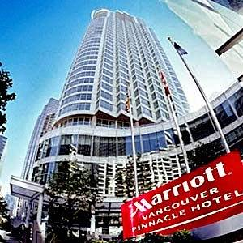

Vancouver Marriott Pinnacle Downtown Hotel
1128 West Hastings Street
Vancouver, V6E4R5
Canada
PHONE: 1-604-684-1128

Training Room Location:
Please ask the Lobby Receptionist

Parking:
$23 a day! We suggest public transportation or carpooling.

