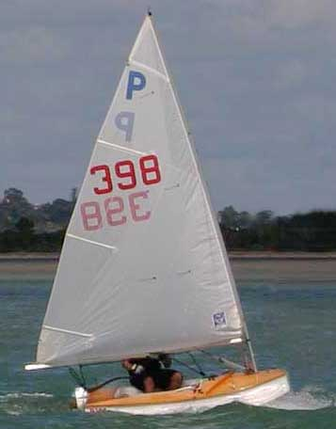

For sale P398 Elliot built
2 alloy rigs
2 as new sails & 4 other cruising sails
2 sets of foils
Beach trolley
$2100
Ph 5205998
0211190955
e-mail - dalmart@xtra.co.nz
Chris Martin

