Optimist for sale

“Impact” 3797
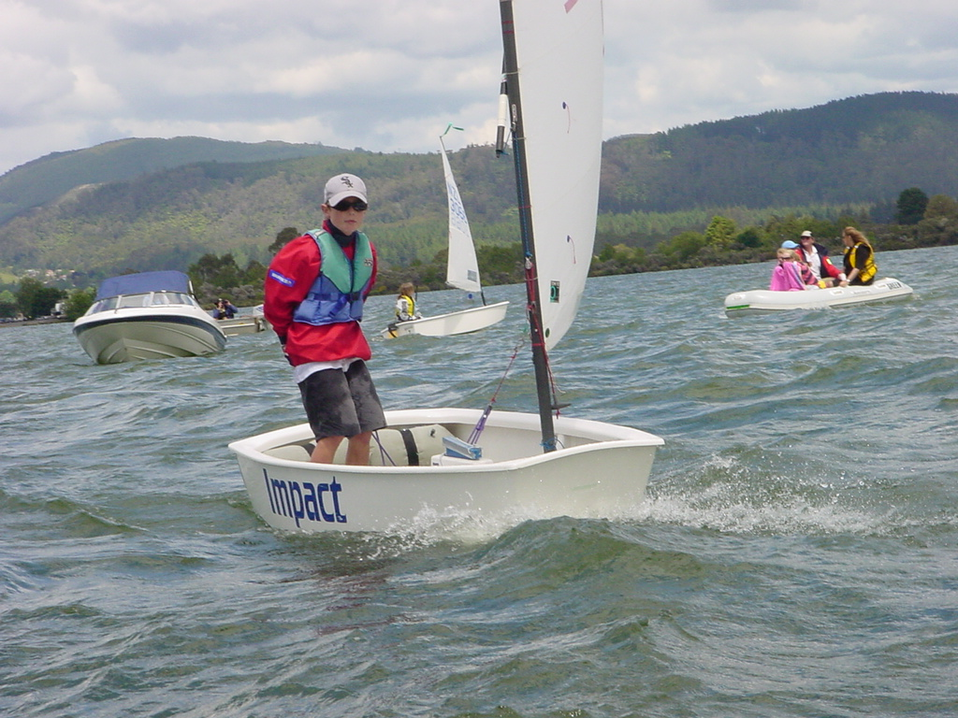

Hull DWR 2001
Giletti rig
DWR foils
Aluminium beach trailer
Sails: 1 club training,
1 Toni Tio racing
All papers
VG condition
Suitable Green or Open fleet
Competitive boat, good results
$2300
Phone: Rob Craigie
Mob: 021 523 767
View @ Glendowie Boating club
Storage berths available
