Do you spend as much time with your child as you would like?

Do you wish you could:
- Share in the wonder of your son or daughter’s childhood?
- Participate with your child as they learn new skills?
- Experience outdoor opportunities with your child?
- Participate with your child in new social settings?
- Just have FUN with your child?

What goes on at meetings?
LOTS! Our meetings allow the kids to get their parents involved in the fun. We have stories and games, and the kids do an easy craft. The host offers a light snack, and the young guides get their parents home early for a decent bedtime.

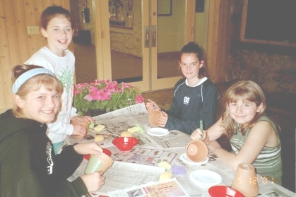

What Age Children?
The Guide Programs are designed for children grades K-6. The program also offers a division for children ages 10 and older called the Trail Program.
Typical Events  - Induction Ceremony  - Canoeing  - Halloween Party  - Fall Campout  - Christmas Carnival  - Sled Riding  Ice Skating  - Winter Campout  - Pinewood Derby  - Maple Festival Parade  - Spring Campout  We schedule numerous events to provide choice; you need not participate in every event. | Aims of Our Program  - To be clean in body and pure in heart  - To be pals forever with my Parent/Child  - To love the sacred circle of my family  - To be attentive while others speak  - To love my neighbor as myself  - To recognize the balance and beauty of nature  Slogans  "Pals Forever”  "Friends Always”

Does it cost anything?
A nominal program and membership fee covers the cost of Geauga YMCA support, a monthly newsletter, and a starter kit that includes first year patches.

The Y refuses to turn anyone away if they cannot afford a membership. Contact the Y for assistance.

How do we join?
It's easy. Contact one of the individuals listed below for more information.

Halloween Party

Join us for our annual Halloween Party November 1, 2003 at the Centerville Mills camp. The party is a potluck event, scheduled for 6-8 p.m.

Contacts
For more information call:

Mark Fagerholm, Territory Governor 543-1949
David Birkhead, YMCA Associate Executive Director,
543-8184

Or visit our website at:
www.geocities.com/geaugaohio/

GEAUGA TERRITORY

YMCA Pioneer Guides
(formerly Y Indian Guides)

YMCA
Centerville Mills
8558 Crackel Rd.
Bainbridge Twp., Oh 44023



