Project 4
Building a Presentation with an Imported Outline and an Inserted Table

Purpose: To demonstrate the ability to create a presentation by importing an outline created in Microsoft Word, add clip art, and insert a table.

Problem: You are a dietitian at a local health center that is offering a free seminar on fast- food fat content. Many of the attendees are recent heart attack patients, and you want to stress the importance of reducing fat in the diet. Your agenda includes comparing the fat content of the top three fast-food restaurants’ menus. You decide you can best do this comparison by creating a table.

Instructions: Perform the following tasks:

1. Start PowerPoint
2. Apply the Presentation design Ocean.
3. On Slide 2, change the slide layout to Text & Clip Art, and insert an appropriate food-related clip art file.
4. On Slide 4, change each bulleted list font size to 24, and change the line spacing to .15 before each paragraph.
5. On Slide 5, change the slide layout to Text over Object, and insert another food-related clip art file.
6. On Slide 6, change each bulleted list font size to 20, and change the line spacing to .2 after each paragraph. Make other slide adjustments if necessary.
7. On Slide 7, apply the Table slide layout as shown in figure PP3A -2 below.
8. Enter the title, Fast-Food Nutrition Information, and center it. Create the table shown in Figure PP3A-2.
9. Check the spelling of your presentation.
10. Save the presentation using the file name, Defatting Your Life

Defatting Your Life

Moderation is Key to Healthy Eating
Fat is required by the body
Kinds of dietary fats
Polyunsaturated
Monounsaturated
Saturated

Polyunsaturated Fats
Liquid at room temperature
Reduce blood cholesterol
Excess may lower “good” cholesterol
Some foods high in polyunsaturated fats
Bagels, lentils, popcorn
Sweet potatoes

Monounsaturated Fats
Found mainly in nut and vegetable oils
Liquid at room temperature
Can be hydrogenated, which makes them more solid
Hydrogenation makes them saturated
Reduce blood cholesterol, but not the “good” kind
Some foods high in monounsaturated fats
Biscuits, cake, chicken
Margarine, oatmeal

Saturated Fats
Found in all meat and dairy products
Found in many plant origin oils
Raise blood cholesterol
Some foods high in saturated fats
Beef, butter, cheese
Fried foods, hot dogs

Read the Nutrition Labels
Observe serving size
Count calories
If you eat more than the serving size, be honest in counting calories
Count total fat grams
Count saturated fat grams
Don’t just count mg’s of cholesterol
Beware of foods with 0 mg’s of cholesterol but high in saturated fat

Figure PP3A - 1
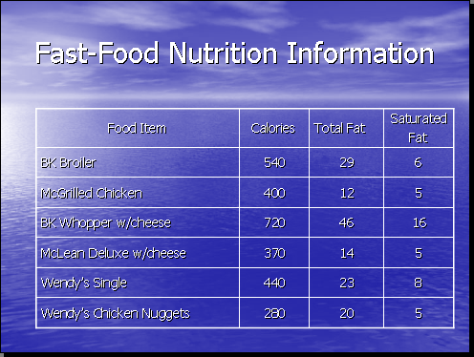

Figure PP3A - 2

