Survival Guide

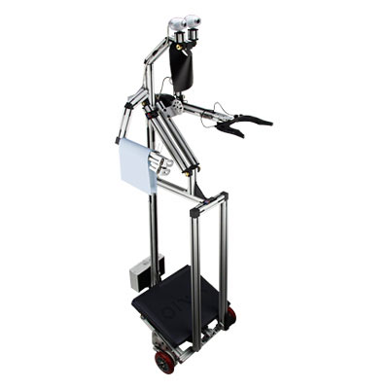

Event: BEST Engineering Competition
Place: Borovetz, Bulgaria
Dates: 19 Mart - 26 Mart 2005

Welcome to the World of BEST…

Check: www.best.eu.org
Check: www.best.eu.org/sofia

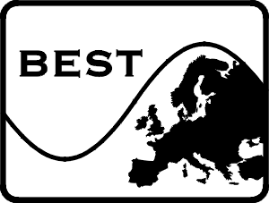
BEST (Board of European Students of Technology) is an organization that promotes communication and idea exchange between technology students throughout Europe. BEST was officially founded at a conference in Berlin, in April 1989. BEST is a non-profit, non-political organization of European Engineering students. Our motto is “To promote Europe among Europeans”.

At present, there is a well-established network of over 66 Local BEST Groups within top-level technical Universities in over 24 European countries. These groups provide information for students regarding the possibilities of studying or participating in research projects abroad, and make efforts to improve their access to equal opportunities and promote international cooperation between them and students associations, academic and business environment, industrial and governmental entities. BEST also collaborates with other organizations, such as AIESEC, ELSA, AEGEE, BONDING that share the same goal for student mobility throughout the EC.

The “BEST Vivaldi Program”, held annually since 1991, consists of a series of courses organized by each Local Group in a field of excellence of its University, and is attended by students from the other member Universities. They include cultural and social activities as well, enabling the participants to discover a new country and culture, as well as to get in touch with other foreign students.

BEST is a promising, rapidly growing organization, which has already served many students, helping them to become more open-minded with respect to globalization, which will be fundamental in their future as citizens of a more closely integrated Europe.

Facts about Bulgaria

Check: www.bulgaria.com
Check: www.travel-bulgaria.com/

Bulgaria is located in South Eastern Europe and borders the Black Sea between Romania and Turkey. The total population is about 7,8 million people with the highest concentrations living in the major cities or towns of Sofia (the capital), Plovdiv, Pleven, Stara, Zagora, Sliven, Varna and Burgas (the last two being cities at the Black Sea coast which boasts 378 km (220 miles) of sandy coastline.

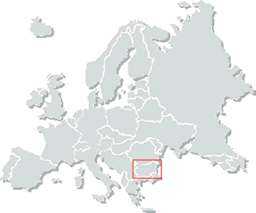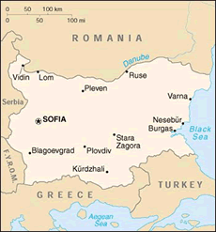

Environment
Bulgaria offers an astonishing array of landscapes, flora and fauna, recreational activities and wildlife. You will discover the magnificent beaches – the numerous ski resorts – the characteristic villages and fascinating architecture – the natural spas and treatment centres – and not to forget: the delicious food!
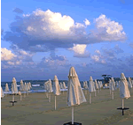
- The Black Sea Coast offers an attractive seaside holiday for rest and recreation. The sunshine record is exceptional - nearly 300 days of sunshine the yearly average. Various opportunities exist for climate and balneo-treatment, yachting, surfing, water skiing, diving, underwater fishing, other aquatic sports and diverse types of entertainment. In addition, opportunities for hiking, cycling, riding, photo-tourism, eco-tourism, and excursions to natural, archaeological and cultural places of interest abound.
- Rila, Pirin, the Rhodopes, Vitosha and the Balkan Mountains offer wonderful possibilities for skiing and mountain hiking. The international resorts of Pamporovo, Borovets and Bansko allows one to enjoy some of the best skiing in Europe - with snow from Christmas to Easter.
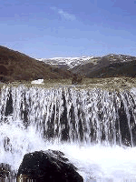
- Bulgaria has more than 600 hot, warm and cold mineral springs of varied physical and chemical contents, mineralisation, curative gases, biologically active trace elements, temperature and curative properties. A number of businesses offer talasso-therapy, pearl baths, underwater massage, phyto-therapy, curative mud, inhalations, manual therapy, paraffin treatment, acupuncture, helio-prophylaxis, ozone and oxygen therapy, slimming procedures, balneo-cosmetics, etc.
- Bulgaria enjoys a network of three national and nine nature parks, a number of reserves and natural places including gorges, steep rocks, and waterfalls.
History
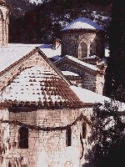
- Bulgaria has over 30,000 historical monuments from different historical epochs, 36 culture reserves, 330 museums and galleries. The Bulgarian lands are ancient crossroads. They were populated from remote antiquity and remember many ancient civilizations.
- The state of Bulgaria has a 1300 year old history and according to the statistics, it is ranked third (after Greece and Italy) for its number of archaeological monuments. The earliest inhabitants of the present Bulgarian lands were the Thracians. Ancient Greek historian Herodotus describes the Thracians as the second biggest tribe in the Ancient world, after the Indians. The most famous Thracians were Spartacus and Orpheus.
People
- Many Bulgarian villages, located in environmentally clean regions, have preserved their traditional outlook and genuine atmosphere for developing rural tourism. They are ready to open their hospitable doors to those willing to share the rich traditions and folklore, agricultural activities, preserved old crafts, and delicious and varied local cuisine.
Cuisine
Bulgaria is a renowned producer and exporter of wine to more than 70 countries in the world. On the territory of Bulgaria there are 12 wineries producing a variety of excellent wines.
Bulgarian food is close to traditional European cuisine. A traditional Bulgarian menu includes bread, yogurt and fresh milk, cheese, tomatoes, paprika, potatoes, onions, beans and fruits, grappa and red or white wine. Food specialities include:
- Shopska salad - prepared from diced tomatoes, fresh cucumbers, green peppers, topped with feta cheese and seasoned with olive oil and parsley
- Mlechna salad - prepared from strained yogurt seasoned with olives, crashed walnuts, finely diced garlic and parsley
- Tarator - cold served soup from yogurt, fresh cucumbers, seasoned with walnuts, garlic and dill
- Sirene po Shopski - feta cheese, diced tomatoes and onion topped with egg and cooked in pottery
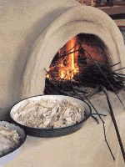
- Kebapche - minced meat rolls seasoned with traditional spices and fine herbs and barbequed
- Kuyfte - minced meat balls seasoned with traditional spices and fine herbs and barbequed
- Shish Kebab - grilled skewered meat, onion and paprika
- Banitsa - baked pumpkin pastry filled with cheese or meet
- Crème Caramel - delicious dessert prepared from fresh milk, eggs and caramelized sugar, similar to the classic French crème brulee.

Economy and political situation
Bulgaria is a former communist country now striving to enter NATO in November 2003 and the European Union, which is expected to be granted in 2007.
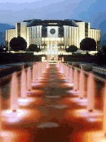
Since 1996, the country has experienced macroeconomic stability and positive growth rates (due in part, to the introduction of a currency board in 1997) and it exists under what is now a stable parliamentary democracy, with a majority in parliament and public consensus on key social and economic priorities.
Bulgaria demonstrates economic growth at 4.5% (one of the highest in Europe), annual inflation at 3.8% and strong growth figures in the tourism industry (up 10% in 2002 compared to 2001). It boasts low rates of taxation across the board and has one of the lowest cost centres in Europe, though the workforce is highly skilled and qualified.
The currency is the Bulgarian Lev (1 Euro = 1.98 Lev) which is already pegged to the Euro.

Weather

The climate in Bulgaria has 4 seasons. March is the last month of the winter. The weather during this month is very unpredictable. It could be very cold. The temperatures variety is between -5 to 15 degrees. That's why we advice you to take clothes both for hot and cold weather.

Other facts

Language: Bulgarian.
Alphabet: Cyrillic. Signs along international motorways, in airports and resorts are also spelled in Roman letters.
Religion: 86.6% of the population is Eastern Orthodox, 13% are Muslims.
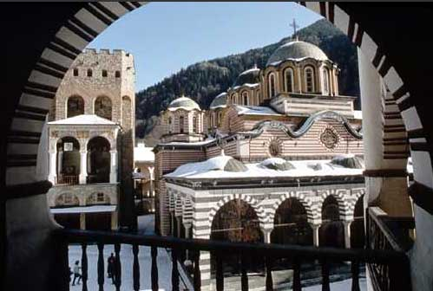
Useful Information
Time Difference: Winter time: GMT +2 hours (October through March).Summer time: GMT +3 hours (April through September)
Voltage: 220 V only
Monetary Units: 1 lev = 100 stotinki. Banknote denominations include 1,00, 2,00, 5,00, 10,00, 20,00 and 50,00 leva, as well as coins of smaller denominations.Working Hoursoffices - 9.00 a.m. to 5.00 p.m. (Monday to Friday) banks - 9.00 a.m. to 3.00 p.m. (Monday to Friday) shops - 10.00 a.m. to 8.00 pm. (Monday to Friday, Saturday until noon)
1 EURO = 1.95 LEVS 1 USD = 1.45 LEVS

Tip: Ask an organizer to come with you when changing money! It’s not dangerous to go alone, but it’s safer to go with one of us!
Some prices:
Product | Price
Bulgarian yoghourt (450ml) | 65 stotinki
Bread | 45 - 70 stotinki
Good beer (500 ml) | >= 80 stotinki
Wine (750 ml) | >=2 levs
Vodka (700 ml) | >=4 levs
Bus ticket | 50 stotinki
Cinema ticket | 3-10 levs

Important Telephone Numbers:
Police – 166 Ambulance – 150 Road assistance - 146
Medical Service: Free first aid and consultation in emergencies:
Currency Exchange: In banks and 24-hour change bureaux. The exchange rate is announced every day.
Passports and Visas: You will need a valid passport with an entry or transit visa which is issued by the embassies and consulates of the Republic of Bulgaria abroad.No entry visas are required for citizens of the countries with which Bulgaria has a visa-free regime, or of organized tourists who have bought a package tour. No entry visas are required for citizens of the EU and EFTA member states. No visas are required for CIS citizens for a stay of one month, provided they are in the possession of a valid passport, a voucher for pre-paid tourist services or if they pay the sum of 40 USD for each day of their stay in the country. For more information, just check http://www.mfa.government.bg/index_en.html

How to get to Sofia:

By Plane:
Check: www.air.bg
Check: http://www.sofia-airport.bg/

The easiest way, for those who can afford it, of course is to get here by plane, if you are one of those lucky guys you can use Bulgaria Air which is the Bulgarian national air company. It's quite famous with it's low rates at about 200$ - 300$ for an open return ticket from almost every European country. You can get some detailed information at www.air.bg. You can check also the web sites of some other companies that have regular flights to Sofia. These are: the British airlines, Air France, Lufthansa, AlItalia, Malev, The Check Airlines, the Austrian airlines...

By Bus:

Check: http://tis.centralnaavtogara.bg

For those who want to save some money on traveling … it could be useful to know that there are some very good Bulgarian bus companies, traveling every day from some of the European capitals. The buses are very good ones, 4* of comfort. / You can get some more information at http://tis.centralnaavtogara.bg /. It's not as good as the plane-trip, but it's quite comfortable …
By Train:

Check: http://www.bdz.bg/
Check: http://www.bdz-rila.com/

The last chance to get to Sofia is using the train companies. The main European railway routes pass through Bulgaria. International trains link Sofia with many European capital cities and the domestic rail network ensures access to all large settlements. Check http://www.bdz-rila.com/ to get detailed information.
By Car:

If someone decides to come here by car, he has to buy the international insurance before departing than all you have to do is to follow the highways and to be careful for the signs showing the right direction to Sofia.. Foreign driving licenses are valid on Bulgarian territory. You can enter the country at the Kalotina Duane if you are coming from Serbia or you can pass trough Romania and enter Bulgaria by the ferry at Kalafat - Vidin.

If you want to come by other known or unknown means please take care of you!

As most of you probably have enough travel experience you can arrange your trip of your own. If anyone needs some additional travel information or cooperation don't be afraid to contact us at: sofia@best.eu.org.

As soon as you know when you arrive in Sofia, let us know. It’s a lot easier for us to organize the arrival day, if we know when to expect you guys!

What to bring ?

Don't Forget:
Useful things which you should take with you.
1. International Passport
2. Visa (if you need it)
3. Official invitation (if we have sent you)
4. Travel & Health insurance
5. International Student Identity Card (ISIC card)
6. Comfortable shoes for walking
7. Suitable clothes for walking in the mountain
8. Typical food and drinks of you country for "International Evening"
9. CD with your favourite and traditional music of your country
10. Small presents for organizers :P
11. Big smile on your face

Accommodation and meals:

Accommodation:

You will stay in a hut in the mountain called Borovetz, in a room with 3 (or 4 persons) beds and bathrooms on each floor. The rooms are very well heated and clean sheets are provided.

Meals:

You will eat home cooked meals in the hut, except the days when we have something else planned. For the international evening, you have to bring with you traditional food and drinks, in order to share it with people from the entire Europe.

English – Bulgarian Dictionary
Some useful phrases and words

English | Bulgarian
I love you! | Obicham te!
Kiss | Tseluvka
How are you? | Kak si?
What is your name? | Kak se kazvash?
My name is ……… | Kazvam se … … …
Where are you from? | Otkade si?
I come from … … … | Az sam ot … … …
How to reach for … ? | Kak da stigna do…?
Thank you! | Blagodaria!
Please | Molia

Contacts:

BEST Local Group Sofia

e-mail: sofia@BEST.eu.org
URL: www.best.eu.org/sofia

Alexander Valov (main organiser)
mobile: +359 89 9815625
e-mail: ati_popo@yahoo.com

Vesselin Genadiev (second main organiser)
mobile: +359 887 758 604
e-mail: vesko@BEST.eu.org

Tzveta Dimitrova (president)
mobile: +359 88 7966501
e-mail: tzveta.dimitrova@BEST.eu.org

