Hi everybody!

For the test I need you to make a web page that looks like the image below. Make a folder with your name in the “FinalTest” folder and store your completed test there. You have a couple of days to do this. I will expect the tests to be on the server by Wednesday night.

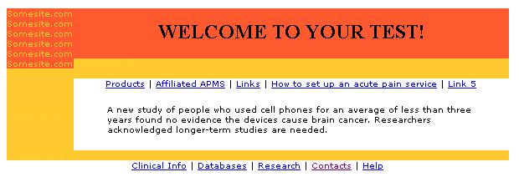

Here is some information that you may need:

Example of a table with one row and two cells:
<table cellspacing=”0” border=”0”>
<tr>
<td></td>
<td></td>
</tr>
</table>

NOTE: The attribute cellspacing ensures that there are not white spaces between the cells. The border attribute is set to zero so that the grid doesn’t show. While you are working on your table make sure that you have this attribute set to something other then zero, it will make troubleshooting way easier. To get a cell with a different colour background you need to use: background=”somecolour” at the cell tag level.

I don’t care if you get the colours correctly or the font. What is important is that you use a table layout and make the page look like mine. Links don’t have to lead anywhere and the text doesn’t have to be the same. REMEMBER: don’t make things difficult for yourselves! Make one row work and then copy the code and edit what you need.

Good luck and Happy Holidays!

