Address : Flat D-1,Bantva Heights, JM
689/4 Jamshed Rd # 3,Karachi.
Tele # : 4911479 , 0300-2757563
Email : hamzak79@hotmail.com

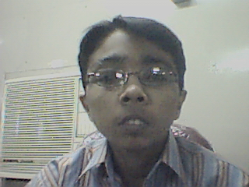

Hamza s/o Muhammed Khanani

Experience:

- Working as Graphic Designer & Movie Editor In Bonanza Garment Industries Since January 2001

Qualification:

- Matriculation In Science (From Karachi Folks High School 1996)
- Intermediate In Commerce (Govt. Islamia Arts & Comm College 1998)
- B.Com (Govt. Islamia Arts & Comm College 2000)

Skills:

- Web Site Designing & Development
- Cd Authoring
- Small Scale Networking
- Movie Editiing

Expertise:

- Macromedia Flash MX
- Macromedia Dreamweaver MX
- Adobe Photoshop 6.0
- Html/Dhtml
- Java Scripting
- Vb Scripting
- Asp
- MS Visual Basic 6.0
- Ulead Movie Studio 7.0

Certification:

- 1 year Diploma in Web Engineering
(Arena Multimedia)

Personal Information:

- Religion: Islam
- Nationality: Pakistani
- Date of Birth: 22nd July,1979
- Marital Status: Single

