Mr. Enriquez Week of February 13th
Homework #4
The following are due on February 17th, 2006.
Your work must be shown, showing only yours answers is not acceptable.
If you cannot show work, explain your solution in words

Monday, February 13th – Supplementary and Complementary Angles
Tuesday, February 14th – Transversals
Find the missing angles
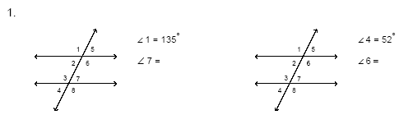
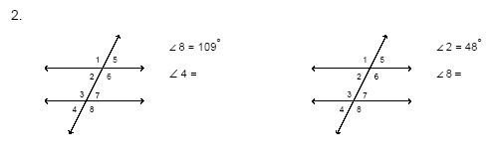
Wednesday, February 15th – Pythagorean Theorem
Find the missing measure in each:
1.) a = 8, b = 15, c = ? 2.) a = 3, c = 5, b = ?
3.) a = 5, b = 12, c = ? 4.) b = 12, c = 15, a = ?

Determine whether each triangle is a right triangle:
5.) 4, 5, 6 6.) 11, 12, 16
7.) 9, 16, 20 8.) 9, 40, 41

