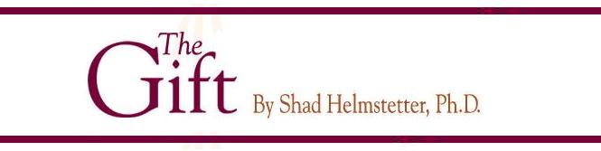

“No other organization can compete or come close to Arbonne International because of the unique ingredients and exceptional heart.”
Dr. Shad Helmstetter
June 10th, 2005
Famous author & renowned speaker, Dr. Shad Helmstetter, after months of third party research, has a new book, releasing in September 2005, that features Arbonne International. The book is titled The Gift, a 220 page invitation to the world to look at this unbelievable company. As a best selling author, Dr. Helmstetter’s books average 7 million copies and he has had repeat appearances on the Oprah Winfrey show, CBS, NBC, ABC, and CNN News.
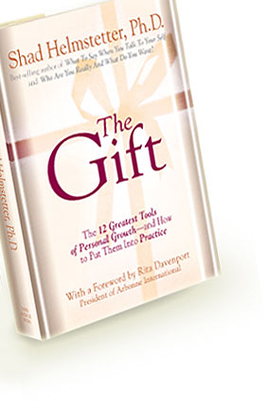
When Dr. Helmstetter takes The Gift on his upcoming book tour in the fall, it will reach the masses and they will all be introduced to this amazing life-changing, dream fulfilling company, Arbonne International. We are well on our way to becoming a household name, the forecasted growth in the next 6 months alone is astounding. Arbonne has reached the tipping point, and this title wave of growth will take those, who have joined Arbonne and established themselves RIGHT NOW to places we’ve only dreamed of.

Receive “The Gift” of Arbonne & get ready for the ride of your life?

